Decan Ruler & Tarot Correspondences

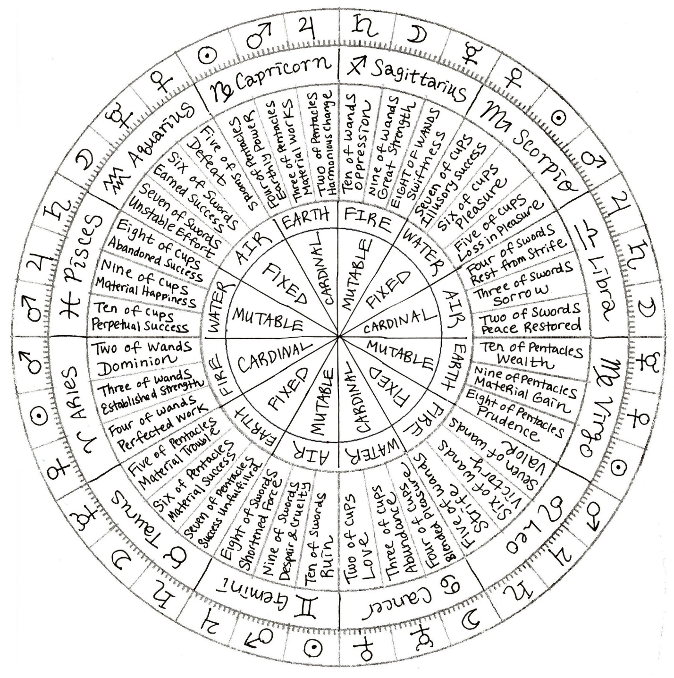

One method of integrating tarot into an astrology reading is to read the tarot card correspondence to the decan ruler of natal planets to further round out your astrological interpretation. For example, let’s say the native’s Moon sign is placed at 22° in Leo. The decan ruler of this Moon sign is thus Mars in Leo. Per the chart above, Mars in Leo corresponds with the Seven of Wands in tarot. In the Thoth, the associated keyword is “Valour.” In the classic Rider Waite Smith imagery, we see a young man at the edge of a cliff brandishing a staff as six others are raised against him. Reading that through the lens of past lives and the Moon sign’s implications in past life astrology, you see someone who often stood in the minority, having to stand your ground alone against the majority, and often in life will feel outnumbered. That theme is likely to bleed into the present life. Overall, we see prevailing themes of valor in this native’s past life, someone who innately possesses a great deal of audacity and courage, especially in the face of danger or battle.
T a r o t & A s t r o l o g y C o r r e s p o n d e n c e s

Rider-Waite-Smith | Upright Keyword | Reversed Keyword | Astrological Correspondence
Key 1 – The Magician | Intellect | Instinct | PLANET | Mercury
Key 2 – High Priestess | Intuition | Emotion | PLANET | Moon
Key 3 – The Empress | Attraction | Barren | PLANET | Venus
Key 4 – The Emperor | Authority | Overpower | ZODIAC SIGN | Aries
Key 5 – The Hierophant | Tradition | Heterodoxy | ZODIAC SIGN | Taurus
Key 6 – The Lovers | Choice | Ambiguity | ZODIAC SIGN | Gemini
Key 7 – The Chariot | Control | Turbulence | ZODIAC SIGN | Cancer
Key 8 – Strength | Compassion | Feral | ZODIAC SIGN | Leo
Key 9 – The Hermit | Wisdom | Intolerance | ZODIAC SIGN | Virgo
Key 10 – Wheel of Fortune | Turning Point | Misalignment | PLANET | Jupiter
Key 11 – Justice | Equilibrium | With Prejudice | ZODIAC SIGN | Libra
Key 13 – Death | Metamorphosis | Inertia | ZODIAC SIGN | Scorpio
Key 14 – Temperance | Attunement | Excess | ZODIAC SIGN | Sagittarius
Key 15 – The Devil | Possession | Severance | ZODIAC SIGN | Capricorn
Key 16 – The Tower | Shock | Upheaval | PLANET | Mars
Key 17 – The Star | Hope | Malady | ZODIAC SIGN | Aquarius
Key 18 – The Moon | Presentment | Speculative | ZODIAC SIGN | Pisces
Key 19 – The Sun | Glory | Disorientation | PLANET | Sun
Key 21 – The World | Consummation | Skepticism | PLANET | Saturn
Two of Wands | Dominion | Expectations | DECAN | Mars in Aries
Three of Wands | Virtue | Oversight | DECAN | Sun in Aries
Four of Wands | Completion | Rite of Passage | DECAN | Venus in Aries
Five of Wands | Competition | Reconciliation | DECAN | Saturn in Leo
Six of Wands | Victory | Mission | DECAN | Jupiter in Leo
Seven of Wands | Valor | Anxiety | DECAN | Mars in Leo
Eight of Wands | Progress | Misfire | DECAN | Mercury in Sagittarius
Nine of Wands | Strength | Depletion | DECAN | Moon in Sagittarius
Ten of Wands | Burden | Reassessment | DECAN | Saturn in Sagittarius
Two of Cups | Affinity | Misunderstanding | DECAN | Venus in Cancer
Three of Cups | Abundance | Waste | DECAN | Mercury in Cancer
Four of Cups | Introspection | Emergence | DECAN | Moon in Cancer
Five of Cups | Disappointment | Moving On | DECAN | Mars in Scorpio
Six of Cups | Contentment | Clinging | DECAN | Sun in Scorpio
Seven of Cups | Intrigue | Purpose Revealed | DECAN | Venus in Scorpio
Eight of Cups | Detachment | Epicurean | DECAN | Saturn in Pisces
Nine of Cups | Happiness | Indulgence | DECAN | Jupiter in Pisces
Ten of Cups | Satiety | Discord | DECAN | Mars in Pisces
Two of Swords | Peace | Wane | DECAN | Moon in Libra
Three of Swords | Strife | Disquiet Mind | DECAN | Saturn in Libra
Four of Swords | Truce | Recuperate | DECAN | Jupiter in Libra
Five of Swords | Defeat | Grief | DECAN | Venus in Aquarius
Six of Swords | Science | Fantasy | DECAN | Mercury in Aquarius
Seven of Swords | Rebel | Scapegoat | DECAN | Moon in Aquarius
Eight of Swords | Impede | Emancipation | DECAN | Jupiter in Gemini
Nine of Swords | Haunted | Ebb & Flow | DECAN | Mars in Gemini
Ten of Swords | Existential Crisis | A New Dawn | DECAN | Sun in Gemini
Two of Pentacles | Change | Adrift | DECAN | Jupiter in Capricorn
Three of Pentacles | Endeavor | Displacement | DECAN | Mars in Capricorn
Four of Pentacles | Power | Recession | DECAN | Sun in Capricorn
Five of Pentacles | Worry | Reclamation | DECAN | Mercury in Taurus
Six of Pentacles | Success | Dearth | DECAN | Moon in Taurus
Seven of Pentacles | Yearning | Neglect | DECAN | Saturn in Taurus
Eight of Pentacles | Diligence | Squandering Talent | DECAN | Sun in Virgo
Nine of Pentacles | Gain | Longing | DECAN | Venus in Virgo
Ten of Pentacles | Prestige | Disengagement | DECAN | Mercury in Virgo

