INTRODUCTION

Spiritual health and its interaction with physical, psychological, and social wellness has been gaining serious attention in medical literature. Let’s consider those perspectives in a discussion on spiritual health and tarot. What is “spiritual health” and why is it a tarot reader’s role to assess it? We’ll be covering different methods for how you can ensure that every tarot reading session is, fundamentally, also a healing session. We’ll also discuss navigating the ethics of health-related questions.

This is a workshop on how to navigate health questions and how to approach tarot as a spiritual healer. During our time together, we will cover faith healing, mental health, and emotional regulation. You’ll have learned the following:

- A seated qi gong exercise for boosting the immune system that you can both integrate into your personal health practices and pass on to your querents;

- Five techniques for increasing serotonin, and why a spiritual healer would want to attain foundational knowledge on these techniques to integrate into tarot readings on health and wellness;

- Metaphysical correspondence tables through the four elements to integrate into tarot card interpretations for health readings;

- An ensō visualization technique for unlocking the gateway to a pillar that harnesses health and healing life forces (qi) to access the tarot for healing purposes; and

- A spiritual cognitive behavioral therapy tarot reading spread.

This handout is a summary review of what we covered during the workshop. Please note that it is a supplement to the PowerPoint presentation. The contents herein should be used in tandem with the PowerPoint slide contents.

OUTLINE OF TOPICS COVERED

- Introduction
- Spiritual health & the spiritual advisor
- Drafting your legal disclaimers
- Delivering a difficult reading
- The tarot healer’s reading objectives
- Five approaches for increasing serotonin
- Figurative health reading of tarot cards
- Ensō visualization technique for psychic health readings
- Correspondence charts for health readings
- Spiritual cognitive behavioral therapy spread
- Affirmations keyed to the tarot

SPIRITUAL HEALTH & THE SPIRITUAL ADVISOR

Spiritual Health
- Assessed subjectively by personal perception of closeness with the transcendent (gods, goddesses, a sentient universe, spirit entities, ancestors, etc. with powers of salvation and divine interference)
- Well-adjusted personality who possesses a strong sense of purpose, self-worth, and who contributes effectively to the community.
- A well-developed understanding of one’s social relationships and social responsibility to others
- Personal religious or philosophical beliefs and practices help the individual to effectively cope with stress, fear, and adversity
- There is now a growing body of peer-reviewed medical research supporting the importance of religion and spirituality to psychiatry, psychological counseling, and pain management
- Rhythmic repetition of certain utterances can reduce the perception of physical pain (examples: repeating “55515” or Buddhist/Vedic mantras)
- Intense and sincerely held religious beliefs in a benevolent and merciful divinity measurably reduces distressing somatic symptoms
  - Studies have found correlations between religiosity and healthier blood cholesterol levels, improved endocrine functions, lowered risk of developing cancer, reduced risk of coronary heart disease, increased cardiovascular health, lower levels of inflammatory markers, and improved immune functions
  - Routine qi gong exercise improves cellular immunity, humoral immunity, increased anti-inflammatory cytokines, and higher white blood cell count and total T cells
Physical Vitality | Psychological Well-Being | Emotional Regulation | Social Responsibility
The body supports the mind and spirit | Effective processing of success, failure, joy, trauma | Mental resilience: balanced temperament | A strong sense of life purpose and self-worth

The spiritual advisor’s role is supportive only. Position yourself as supportive to the querent’s healthcare team.

You cannot replace medical professionals and you should never be consulted in lieu of medical professionals. You are an addition to the querent’s interdisciplinary support team accompanying that individual on the road to recovery.

AVOIDING THE UNAUTHORIZED PRACTICE OF MEDICINE: Do NOT advertise or represent yourself as treating illnesses or afflictions. Do NOT attempt to diagnose, treat, operate on, or prescribe for any physical or mental condition. It is okay to suggest spiritual or religious practices on the basis of faith. Do NOT give medical advice. It is okay to suggest taking more vitamin C, as long as you do not claim to be a doctor.

DRAFTING YOUR LEGAL DISCLAIMERS

If the question presented to you is health-related, then your default reply should include a written disclaimer specific to answering health-related questions, i.e., explicitly stating that you are not a licensed medical professional (and even if you are, you are not acting in that capacity during the course of the tarot reading):

MEDICAL DISCLAIMER: Any wellness practice and holistic health or nutritional insight provided during the course of your tarot reading session is intended for general information purposes only. Please consult with your health care provider before administering any suggestions provided in this reading. If you have diagnosed pre-existing conditions, then do not change your diet before consulting your treating physician. Never take vitamin supplements without first consulting your treating physician. Always apply common sense and prudent discretion to any holistic health information you receive.

You should always have a general disclaimer posted on your point of sales page that clearly states that no tarot reading should be construed as medical, legal, or financial advice. A general disclaimer might look as follows:

A TAROT READING IS SPIRITUAL GUIDANCE: A tarot reading can offer spiritual direction, to help with personal growth and self-reflection. It should never be confused with clinical counseling, psychotherapy, medical advice, dietary advice, legal or financial advice, or qualified therapy from a licensed professional. Always seek multiple perspectives and licensed professional opinions before making any major life decision.

Always communicate, in writing, the following to any querent requesting a reading that relates to physical health, mental health, or that could be construed as relating to health care:

I am a tarot reader and therefore what I provide is spiritual direction. I am not a medical professional, clinical counselor, crisis counselor, psychiatrist, psychologist, or therapist; I am not a nutritionist or dietitian. Nothing herein should be construed as diagnosing or treating your illnesses or afflictions.

Always prioritize the medical opinions of qualified professionals over a tarot reading. The tarot and related spiritual practices should not be interpreted as curing, preventing, or treating any health conditions.

What I can try to do is use the cards to assess the metaphysical energy in your personal environment. This is very much a spiritual, psychic reading, and not a diagnosis.

Any discussions of nutrition, diet, physical activities, conditions, or health-related references should not be confused with a diagnosis. The spiritual practices recommended to assist with your health care plan is not necessarily accepted as evidence-based practices, but rather are faith-based practices.

The guidance of practices, exercises, and techniques I offer have been found anecdotally to be helpful spiritually to some people. Please always maintain a rational, balanced perspective of what the cards have to say.

Please feel free to use any of the provided disclaimer texts word for word or paraphrased—the choice is yours.

DELIVERING A DIFFICULT READING

1 | Cultivating a consistent practice of sympathetic bedside manners. Effectively and compassionately delivering difficult news begins long before the cards are even shuffled. You must build strong rapport with your client, one of warmth and trust.  You are preemptively building a safe space in the event that bad news might need to be delivered. As soon as a session begins, ensure that the client knows that during your time together, nothing is more important to you or more highly valued than that client’s concerns.  Learn active listening skills. Be fully present. Listen carefully to everything the querent is saying to you. Pay attention when the querent speaks. Do not get distracted and do not multi-task while the querent is speaking. Be mindful that your words, facial expressions, and body language are not expressing judgment. Take great care to be patient and non-judgmental. Every so often, repeat back in rephrased language what the querent just said to you. Ask questions and confirm with the querent that you’ve understood where the querent is coming from.
2 | Use conversational, plain language. Do not sugarcoat. This is not the time to throw in occult, Hermetic, philosophical, astrological, or even specialized tarot lingo.  There is also no need to sugarcoat the message. What’s more, presume that your querent is intelligent and intuitive, and would be able to see through any attempts at sugarcoating anyway.
3 | Empathy and clairsentience will take you far. When difficult cards come up in a reading, feel them. Open yourself up receptively as a tarot reader to feel the message of the cards.  When you can clairsentiently feel the pain and suffering that the querent is experiencing, as expressed in the cards in front of you, the querent will immediately interpret that as you fully understanding what they are going through.  When you can feel the pain, the words you say will have more impact. What’s more, you’ll know exactly what to say and how to say it.
3 | An opportunity for conversation or spoken reflection. You might want to integrate into your session time a period after your reading for the querent to speak. Create space and time for the querent to absorb the reading and be prepared to listen, to engage in further interaction.  Practice Tip Consideration. Allow space and time for querent to process the information and for them to ask follow-up questions.
4 | Encourage second opinions. A good medical doctor will encourage you to get a second opinion. We can learn from that. Thus, tarot readers should also encourage that their clients get second opinions. When you openly encourage clients to get second opinions, you also inspire their faith and confidence in you.
5 | Call to action that inspires hope and optimism. There is always a way to restore personal control over a situation. Sometimes we can gain actual control to course-correct, while other times, extenuating tragedy means all we can do is achieve control over our emotions and how we respond to the challenges.  Integrate the five approaches for increasing serotonin as recommendations you give to the querent. Constantly remind yourself of the core objectives of the tarot healer (outlined in a subsequent section of this handout). Make sure you are prioritizing achieving those objectives in the course of every card reading.  As a spiritual guide, the tarot reader must inspire hope and optimism. You have to—sincerely and authentically—show the querent that there is something true and promising to believe in. Shine a light into the darkness.

Starting Point Examples for How to Interpret Difficult Cards in Health Readings

Key 13: Death  Practice Tip: For health readings, use a deck with an untitled Key 13, or without the word “Death” | - I’m hearing a whisper form beyond—‘follow the light.’ You are being guided through a difficult passage, but one with a divine purpose.  - You are being called to focus on the journey, not the destination.  - Note: Avoid talking about death and do not predict death.
Key 15: The Devil | - Toxic social relations are having a detrimental impact on your mental and emotional well-being, and tensions your body is holding on to as a result of that could be causing health concerns  - The Devil card in this context can often alert to a personal safety and security issue. Is this something that resonates? Is there something here we should talk about and address?
Key 16: The Tower | - A necessary albeit painful purging  - Excess heat in the energy body; internal qi overheated or moving too fast; cooling qi or energy needed  - Stress on adrenal glands  - Muscular inflammation or weakness  - Exhausted solar plexus chakra
Five of Cups | - Psychosomatic cause of physical health conditions, i.e., grief  - Your body is unconsciously mourning  - The pain of experiencing loss is having an unconscious impact on your health.
Three of Swords | - Your mind has not fully processed a recent interpersonal conflict and that’s taking hold in your system, causing physical health symptoms to crop up  - Could be an indication of a respiratory condition, or energy imbalance with respiration and the air flow of qi
Four of Swords | - You need rest and relaxation  - After eating meals, are you giving your body enough time to fully digest? Just something to consider being mindful of.  - Weakened defenses. Let’s work on strengthening your body and your mind’s defenses.  - The warrior has returned from the combat zone, but has not yet adjusted to civilian life  - Note: Avoid talking about death and do not predict death.
Eight of Swords | - Current state of stagnation, cramping.  - Let’s think about your quality of life and what psychic or spiritual tools we can work with to help you manage all your stress and the challenges you’re currently facing  - One thing we may be seeing here in the Eight of Swords is hampered oxygen or air flow. Consider adding more aerobic activity to your weekly life routine.
Ten of Swords | - I see multiple chronic conditions. There are many sources of pain, not just one.  - I sense a weakened central meridian of energy bodies. There is a lot of vulnerability down your body’s center. Deep healing is needed.  - “Bloodletting” of negative qi  - Acupuncture or complex surgery
Five of Pentacles | - A cold is setting in. Every personal journey will encounter that dark night of the soul, a period of feeling disconnected, discontent, and spiritually malnourished.  - This could be an indication of excess wind-cold qi per TCM. This results in body weakness, hypersensitivity, frailty, and melancholy, but there are solutions. (Transition into recommendations for spiritual practices that increase serotonin.)  - Lacking a sense of belonging; feelings of alienation.
Seven of Disks  (Thoth: Failure) | - Saturn in Taurus: Body is holding tension near the throat, neck area, or thyroids  - Feelings of ennui, discontent, and not yet having a clear sense of purpose is causing obstructions to your advancement. Spiritual practices to consider: fasting or ritual feasting; grounding, gardening, or being close to nature

THE TAROT HEALER’S READING OBJECTIVES

Positive clinical implications have been found from medical research on the impact of religiosity or spirituality on both physical and mental health. We covered these findings during the workshop. This section rephrases those findings as your key objectives for every tarot reading you deliver:

Objectives for a Tarot Reading to Achieve
1 | To help effectively cope with adversity | Similar to palliative care objectives:  - Optimize quality of life  - Mitigate suffering  - Manage chronic pain  Teach relaxation techniques:  - Qi gong (ex. the seated qi gong exercises covered in class)  - Hypnosis  - Meditation  - Progressive muscle relaxation  - Guided meditation  - Pathworking  - Affirmations and self-empowering suggestion
2 | Alleviate fear, depression, and anxiety
3 | To cultivate positive emotions | Activity Scheduling: It is human nature to put off, avoid, and procrastinate due to deep-seated fears of failure, anxieties around uncertainty, and feeling overwhelmed by the extent of labor required. One technique for overcoming these initial hindrances is to schedule the activities. Scheduling and setting personal alarms or reminders for yourself fosters good habits.  Forced Activation: Mantra recitation in Eastern religious philosophy is a form of forced activation. Repeating a particular mantra as a form of invocation activates a particular spiritual or psychic connection between you and the mode of Divinity you’ve invoked. If you don’t want to work with a mantra, you can repeat an affirmative statement, such as “I am healthy and happy” or “What I send out returns as good fortune and prosperity” at least 108 times daily, while in a calm, relaxed state of mind.  Tarot Affirmations: Note the affirmation that corresponds with the tarot card drawn in a reading. (A subsequent section in this handout includes correspondence tables with my affirmations for the 78 cards, as founded in Holistic Tarot.) Write out the affirmation, almost like a prescription, and instruct the querent to repeat that affirmation daily, for as long as it takes to manifest the desired outcome.  Gratitude Journaling: Instruct the querent to complete sentences such as “Today, I am grateful for…”
  - Happiness  - Gratitude  - Altruism | - Hope and optimism  - Sense of control  - Forgiveness
4 | To help actualize meaning and life purpose | An effective litmus test to see whether you have a strong sense of life purpose and personal worth is to answer the following questions for yourself:  - Who you are. “I am…” Are you open about and proud of your identity markers?  - What you do (or offer). “I…” What is your craft, work product, talent, or occupational specialty?  - Who or what you love. “I love…” Do you know definitively what motivates you to be present? This is to know, fully, what it is you are passionate about.  - How you serve. “I serve my community/world by…”  - Why that’s important. “The work I do advances…”

TAROT READER PRO TIP: When we possess a strong conviction of our life purpose, we have more drive and greater will to thrive. You can do a 5-card reading, pulling one card to answer each of the above five questions under Point #4. In addition to interpreting the cards for the querent, recommend journaling free-writes on their own reflections of the correlation between the cards you pulled and the five prompts.

Revealing Your Life Purpose Spread

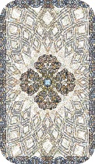  Card 1 | Card 2 | Card 3 | Card 4 | Card 5

Pull a card to answer each of the five questions for revealing your life purpose.

- Shuffle, ask, “Who am I? I am…” and pull Card 1 to reveal an aspect of your identity that the Divine wants you to be cognizant and appreciative of.
- Shuffle, ask, “What great gift do I offer? What is the great work that I do? I…” and pull Card 2.
- For Card 3, shuffle then ask, “Who or what do I love? I love…” or alternatively, “What am I passionate about?”
- For Card 4, “How do I serve this world? I serve my world by…”
- And for Card 5, “Why is the work I do important? The work I do advances…”

Example of How to Read the Cards. For my Card 2, I pulled the Five of Orbs from my SKT Revelation (the Five of Pentacles/Disks). Note: If you’re using the Revelation deck and you ever find yourself needing further guidance, do consult the little white book. I interpreted this as, “I offer faith and hope” through the work that I do.
For Card 5, I pulled the Four of Swords (in the SKT, titled The Convalescent). In the line of work I do, both the legal “day job” and in divination work, I meet people when they are injured, beyond the brink of exhaustion, and often at their lowest point. It is then my job to help heal.
I wanted to share these examples to show how a card that upon first impression might seem less than ideal could, upon deeper reflection, be exactly the card that best expresses your high value and worth.

FIVE APPROACHES FOR INCREASING SEROTONIN

Serotonin is a neurotransmitter that modulates:

- Mood  - Social behavior  - Sleep  - Nausea  - Aging  - Bone density  - Blood pressure | - Knowledge and understanding of experiences and sensations  - Pain  - Memory  - Blood vessel contractions (vasoconstriction)  - Organ development  - Body fat

About 90% of the body’s serotonin is located in the gastro-intestinal (GI) tract. Antidepressant medication functions by interfering with or modifying serotonin. Faith healing has also been found to increase serotonin production.

TAROT HEALER’S PRACTICE TIP: Learning how to control your own body’s neurotransmitters will help you to attain control over your own physiology, and thus better regulate both physical and mental health. Learn techniques for re-wiring your own brain. Ex. Study of MRI scans show that 2.5 hours of meditation per week changes neuropathways in the brain.

1  L  I  G  H  T | Light therapy. Heliotherapy, color therapy, etc. Ancient Egyptians, Greeks, Romans, Inca, Chinese, and Ayurveda used heliotherapy, or sunlight, for the treatment of various health conditions. Phototherapy, or light therapy, is still used today to help manage depression, excessive fatigue, and mood disorders. Chromotherapy, or color therapy, is a form of alternative holistic healing modality. While there is no scientific evidence to support color therapy, it can still offer relaxation benefits and improve spiritual health. Western approaches to chakra work is a form of color therapy.
2  M | Meditation. Prayer, grounding, centering, balancing. Mindfulness meditation alters regions of the brain associated with memory, self-awareness, and compassion, noted medical researchers at Massachusetts General Hospital in Boston and the Harvard Medical Journal. A total of 2.5 hours of meditation exercises per week resulted in observable changes to the brain in MRI imaging, specifically in synthesis of neurotransmitters such as serotonin.
3  A | Aerobic activity. Generating oxygen flow throughout the body. By now, most of us have been educated on the importance and benefits of cardiovascular conditioning. Aerobic exercise activates your immune system, fortifying you to be more resistant to viral illnesses. It also increases serotonin, therefore in the long run, can balance your mental health. The American Heart Association recommends 30 minutes of aerobic exercise at a minimum of 5 days per week. However, safety first! That recommendation is for the general adult population. Those with limiting physical or health conditions will need to modify accordingly.
4  T | Tryptophan-rich foods. Nutrition and food as medicine. Tryptophan is an essential amino acid that helps with the production and maintenance of your body’s neurotransmitters. Notably, the amino acid is used by your body to produce serotonin. Food sources for tryptophan include soy beans, sesame seeds, pumpkin seeds, sunflower seeds, peanuts, in egg whites, milk, fish, and cheese (such as mozzarella). Meats and animal products such as beef, pork, and turkey are tryptophan-rich.
5  H | Hands and healing touch, such as massage therapy or laying on of hands. Alternatively, reiki, acupressure, “tapping,” etc. Massage therapy could possibly help with chronic pain management. The laying on of hands and reiki (a contemporary form of qi gong) has also been reported anecdotally to have physical and emotional health benefits.

TAROT READER PRO TIP: Interpret a tarot card through the lens of these five approaches. Assume every card in your deck is assigned to one of these five serotonin production techniques. When a card comes up in a reading, identify which of the five techniques is indicated by that card.

RECOMMENDED APPROACH: The experienced tarot reader will individually determine the best approach for corresponding the five techniques with the 78 tarot cards. Generally, there are two approaches I might recommend:
The first is to assign the first four techniques to the four elements: FIRE to light or heliotherapy; WATER to the laying on of hands or reiki (for the religious or faith component to these modes of therapy); AIR to aerobic activity (for breath work); and EARTH to tryptophan-rich foods and nutrition. Then always add the fifth technique as a recommendation to the querent. Example: The Moon card, for its Water correspondence, is assigned to technique #4, so that’s what would be recommended. Additionally, meditation would also be recommended alongside technique #4.
The second is to commit the list of these five techniques to memory and when a card comes up, look specifically at the imagery on the card or scry into the art composition to intuit which of the five techniques that card is indicating. The way I remember the five is with the mnemonic “Light MATH” – (1) Light therapy, (2) Meditation, (3) Aerobic activity, (4) Tryptophan-rich foods, (5) Hands (for massage, reiki, acupressure, tapping, etc.).

REMINDER: There are no incontrovertible right or wrong correspondences. Accuracy hinges on how well you’ve programmed your deck. Always start by forming a strong bond with the deck of cards you’re holding in your hands. Once a strong bond is established, “teach” your deck, or program it keyed to certain metaphysical correspondences as assigned by you.

Other Neurotransmitters of Significance

OXYTOCIN | ENDORPHIN | DOPAMINE
Facilitates social bonding, love, and emotional attachment. Oxytocin is released from the pituitary gland and into the bloodstream in response to activities such as intercourse, orgasm, or giving birth. It causes in-group social bonding and pair bonding. | Relieves pain and alleviates stress; turns off pain to help you survive. Endorphins are an endogenous opioid, or a class of molecules produced in the brain and circulated throughout your organ systems to regulate pain endurance and stress response. | Regulates pleasure, focus, and drive; how motivated are you; satisfaction. Released by neurons or nerve cells, the key role of dopamine is motivating you into action. It drives ambition in addition to desire.

FIGURATIVE HEALTH READING OF TAROT CARDS

1 | “I see a half-rotten peach, but it lives.” Work with the specific artist’s illustrations of the cards.  For example, a psychic has a vision of a half-rotten peach blossom, but it still grows into stone fruit. This was a prognostication that a woman in a coma would indeed wake up, but paralyzed on one side of her body; nonetheless, she would still live and thrive.  If the Seven of Pentacles card is illustrated by the artist as eight crystals buried underground with a figure excavating the ground with a pick axe, this could be interpreted figuratively as the growth of tumors or a viral infection.  A Swords card illustrated by the artist as a figure cutting into a heart with a dagger could be interpreted figuratively as an omen that surgery is needed. Cards depicting many swords stuck into a body might be a reference to acupuncture as a possible cure option. A reader might interpret The Moon card as referencing the distant past, and therefore genetic causes for a condition (i.e., ancestors, and an illness inherited from ancestors).
2 | The imagery and tarot symbolism are sympathetic metaphors. Swords might call to mind needles, testing, surgery, acupuncture, acupressure points, etc. Cups might call to mind having to take medicine in order to heal the matter. A dominance of the element Water might literally be telling the querent to drink more water and hydrate. Wands or the element of Fire might relate to vitality, energy or motivation levels, or drive. Specific imagery of Coins or Pentacles buried underground might indicate latent growths or infections inside the body.

TAROT READER PRO TIP: You can “program” your go-to workhorse reading deck for more accurate and specific health readings. Restore the deck in order (i.e., Major Arcana in numerical sequence, Minors in a suit and numerological order that makes sense to you).
When you see a card, study it for what it might indicate figuratively and also in terms of metaphysical correspondences (per the reference tables provided in this handout). Psychically assign those meanings to that card. Do this for all cards in the deck. Repeat the programming until you intuit that your workhorse reading deck has been successfully programmed, with your intended meanings assigned to each card.

ENSO VISUALIZATION TECHNIQUE FOR PSYCHIC HEALTH READINGS

1 | Visualize the sky. Your mind is the numinous and infinite open sky. | This visualization links your finite mind to the infinite of the universe and space-time. Visualizing your mind as an open heavenly sky expands your consciousness’s reach, so that you can experience information and transcendental insight well beyond your Self.
2 | Visualize the ensō. The sacred circle reveals the gateway. | The zen circle, or ensō signifies the numinous void and the omnipresent universe; visualizing the casting of a circle is the key that unlocks the gateways.
3 | Visualize the seal of Hermes at its center. The caduceus as the key. | Psychically produce the key that will unlock the zen (ensō) circle gateway. As tarot healers, we’re using the caduceus, which although used mistakenly in the place of the Rod of Asclepius, is often a representation for medicine. Since Hermes is the divinity governing the tarot (per Crowley), it only makes sense that we envision the caduceus as our key.
4 | Visualize the lapis lazuli pillar of light. The medicine master’s pillar of healing life force. | A lapis lazuli light appears as a disk but you know it to be a pillar. This cylindrical pillar is being absorbed into you through your third eye, that space in between your brows. When the cylindrical pillar connects into your third eye, you in turn are connected to the Medicine Master’s Pillar of Healing Lapis Lazuli Light. In the East, this lapis lazuli light is a symbol of health and healing.  Now focus on the animated lapis lazuli light, feeling its beneficent qi life force getting absorbed into you and amplifying your psychic abilities as a spiritual healer.
5 | Shuffle your cards and repeat three times: “Thank you for showing me the way.”
6 | Draw a card and apply the methodical approach to health readings. | As you draw it, slowly from the deck, visualize it with a lapis lazuli aura. Your hand, too, as it approaches the cards, is enveloped by a lapis lazuli aura.

TAROT READER PRO TIP: Before you start a health reading, run through the ensō meditation/visualization technique. Merge a vision of the open sky with the universe of your mind and see the ensō cicle appear. Then manifest a key, in the form of a sigil or seal. Use the key to unlock the ensō gateway. Visualize a lapis lazuli healing light shine out from the gateway and connect into your third eye chakra. Immediately you’re attuned to the universal pillar of healing, and you’re channeling the ancient Medicine Master.

CORRESPONDENCE CHARTS FOR HEALTH READINGS

 | 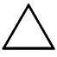  fIRE | 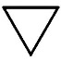  wATER | 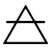  aIR | 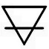  eARTH
mINOR  aRCANA | Wands | Cups | Swords | Pentacles
mAJOR  aRCANA | 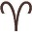 4 Emperor  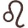 8/11 Strength  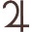 10 Wheel of Fortune  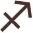 14 Temperance  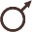 16 The Tower   19 The Sun  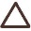 20 Judgement | 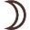 2 High Priestess  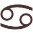 7 The Chariot  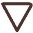 12 Hanged Man  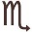 13 Death  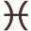 18 The Moon | 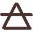 0 The Fool  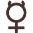 1 Magician  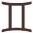 6 The Lovers   11/8 Justice  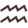 17 The Star | 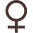 3 Empress  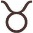 5 Hierophant  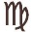 9 The Hermit  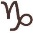 15 The Devil  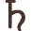 21 The World
HEALTH  CORNERSTONE | Physiological  Drive, Willpower | Spiritual or Emotional | Psychological; Mindfulness | Societal Role; Security, Safety
Holistic  COnnection | Vitality of Spirit  Body’s Physiology | Mind’s Wellbeing  Social Relations | Body’s Physiology  Mind’s Wellbeing | Social Relations  Vitality of Spirit
Psychic | Clairvoyance | Clairsentience | Claircognizance | Clairaudience
Phase of Matter | Plasma | Liquid | Gas | Solid
Essential  Nutrients | Proteins  Carbohydrates | Water  Electrolytes  (Hydration) | Vitamins  Folic Acid | Potassium  Calcium  Electrolytes
Nutritional  Insights | Heart Healthy  Cellular Production  Build Body Tissue | Homeostasis  Replenish Blood | Synthesis of Collagen | Minerals-Rich Food  Cellular Function
Organs | Liver  Gall Bladder  Heart  Small Intestine | Liver  Gallbladder  Kidneys  Urinary Tract | Lungs  Large Intestine | Spleen  Pancreas  Stomach
Organ  Systems | Cardiovascular  Circulatory (Blood Vessels)  Nervous  Reproductive (TCM) | Exocrine  Skeletal (TCM)  [Detoxifying]  Reproductive (TCM) | Exocrine  Respiratory  Skin & Hair | Digestive  Lymphatic (TCM)  Muscular (TCM)  Skeletal (Agrippa)  Reproductive (Agrippa)
Brain  Function | Voluntary  Movement | Involuntary  Movement | Language  Memory | Language  Discernment
lIFE fUNCTION | Vitality (Energy) | Emotions | Intellections | Work Product (Body)
Action | Lightwork  Civil Service | Purification  Metamorphosis | Completion  Self-Knowledge | Shadow Work  Release
Alchemical | Sulfur  Citrinitas | Water  Albedo | Mercury  Rubedo | Salt  Negredo
Four Temperaments | Choleric  Ruling  Obsessive  Dominance | Phlegmatic  Leaning  Sensitive  Supportive | Sanguine  Socially Adept  Hysterical  Inspirational | Melancholic  Avoiding  Depressed  Conscientious
Greek God Archetype | Prometheus | Apollo | Epimetheus | Dionysus
MBTI Archetype | Artisan | Guardian | Idealist | Rational
Four Humors | Yellow Bile | White Phlegm (Secretions) | Blood (Red) | Black Bile
Gemstones | Carnelian, Sunstone  Garnet, Red Goldstone  Red Agate, Fire Opal | Fluorite, Moonstone  Selenite, Pearls, [Seashells]  Blue Lace Agate | Chrysocolla, Iolite  Sodalite, Amethyst  Blue Tiger Eye | Green Aventurine  Smoky Quartz  Dark Jaspers, Hematite
Oils  & Herbs | Bergamot, Ginger  Garlic, Angelica, Allspice, Saffron | Aloe Vera, Chamomile  Lavender, Calendula | Marjoram, Mint  Myrrh, Valerian, Cinnamon, Star Anise | Oak, Yarrow, Nettle, Honey,  Patchouli, Soy, Vetivert, Walnut
Animal  Spirits | Cat, Fox, Salamander  Firefly, Lion, Tiger | Dolphin, Heron, Scorpion, Swan, Tortoise, Lamb, Seahorse, Dove | Butterfly, Owl, Raven, Bat, Hummingbird, Monkey | Wolf, Bear, Bull, Elephant, Goat, Rabbit
Shape | Triangle (Pyramid) | Circle (Sphere) | Ellipse (Orbit) | Square (Cube)

HOT AND COLD BALANCES IN THE FOUR ELEMENTS

FIRE | WATER | AIR | EARTH
DRY:  Depletion. Broad but not deep. Restless. Consumed by one drive. Dehydration and irritated skin. | DAMP/Hefty:  Stagnation. Deep but not broad. Heaviness. Water retention. Per TCM theory, leading cause of cancer development. | WINDY:  Too easily affected by others. Self-doubt. Weakened defenses. Migraines, congestion, sneezing, liver imbalance. | DAMP/Weary:  Stiffness. Fatigue.  Over-exerted. Low energy. Insomnia. Melancholic. Foggy mind. Light sensitivity.
EXCESS HEAT (qi): Expansion and proliferation. Congestion. Volatility. Agitation. Too much social media (“modern” life). Excess cortisol or adrenaline. Symptoms: Sore throat, constipation, yellow phlegm, darker urine. |  | EXCESS COLD (qi): Contraction and stagnation. Constriction. Stress. Cramping. More prone to arthritis. Self-limiting behavior. Anxiety. Low immunity. Weak digestion. Symptoms: Spasms, chills, cold hands and feet; stiffness.

The modern high-tech lifestyle is said to induce excess heat, so if that is the type of lifestyle you lead, then you’d want more cooling foods in your daily diet.
COOLING FOODS (yin): Cucumbers, cabbage, bok choy, lettuce, daikon radish, spinach, sweet corn, zucchini, tomatoes, cantaloupe, watermelon, pears, mung beans, soy milk, alfalfa sprouts, seaweed, mint.

Preparation Methods: Salads, steaming, simmering, light sauté, low heat slow-cooking.
However, most highly sensitive people, psychics, and intuitives, as a broad-strokes general rule of thumb, tend to be yin-dominant, and therefore run a greater risk of excess yin than excess yang. If you tend to have cold hands and feet and get cold easily with some frailty or a weaker immune system, then you could have excess cold, in which case you’d want to balance that out with more warming foods in your daily diet.
WARMING FOODS (yang): Garlic, red dates (jujubes), cherries, hawthorn fruit, lychees, mangoes, peaches, chives, leeks, mustard greens, onions, mussels, game meats such as chicken, duck, beef, venison, or lamb, eggs, brown sugar, cinnamon, chili, cloves, coffee, ginger.

Preparation Methods: Grilling, frying, high heat baking.

Elemental Correspondences to the Human Anatomy

FIRE | WATER | AIR | EARTH
Cardiovascular  Blood circulation, transport of nutrients, amino acids, electrolytes, hormones; health of red blood cells; homeostasis; iron intake, folic acid, vitamin B12 | Endocrine  Pineal gland, pituitary, thyroid, adrenal, pancreas, testis or ovary; neural control; glucose level; mood, stress; sensory perception | Respiratory  Ventilation of the body; gas exchange; sinuses; nose; pharynx; larynx; trachea; lungs; diaphragm; breathing issues | Skeletal  Bones, cartilage; supporting structure; calcium and phosphate levels; nutrient levels in protein, magnesium, fluorite, or potassium
Muscular  Muscles, posture, movement, physical strength, body heat; chronic pain; inflammation of muscle tissue; muscle weakness; nutrient levels for protein, niacin, or B vitamins | Urinary  Kidneys, ureters, bladder, urethra; waste regulation; metabolites; internal toxins; check nutrient levels of potassium, sodium, or phosphorous | Nervous  Brain; spinal cord; nervous tissue; neurons; signal function between the cells; nutrient levels for omega-3, choline, vitamins E & K | Integumentary  Skin; sweat glands; pores; epidermis, dermis, and hypodermis; hair and nails; Vitamin D levels; collagen levels; disease or injury to the skin; check fatty acids intake; zinc, biotin
Reproductive  (Male). Sex organs; hormones, virility, sexual reproduction functions; genitalia; coenzyme Q10, folate, zinc, or B vitamin levels | Reproductive  (Female). Menstrual issues, sex organs; fertility; hormones; check iron levels; folic acid and calcium | Lymphatic  Immune system; lymph nodes; thoracic duct or thymus; spleen; lymph fluid; check vitamins C and E intake | Digestive  Gastrointestinal tract; tongue, salivary glands; pancreas; liver; gallbladder; digestive issues; mouth and teeth

Agrippa’s Medieval Medical Astrology Correspondences

The Sacred Seven Planetary Correspondences
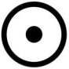 | Sun | Heart, circulatory system; cardiovascular system; spine, and respiratory system; male organs; face, eyes, and head area; Third eye chakra. Reason and intuition duality; shen spirit essence; clarity of thought and insight
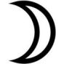 | Moon | Digestive system, lymphatic system; sixth sense and pineal gland; female organs; crown, top of head; Crown chakra. Spiritual knowledge. The soul. Weakened moon energy can indicate soul fragmentation.
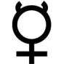 | Mercury | Brain, central nervous system, thyroids, the five physical senses, hands; lymphatic system; neck area; Throat chakra. Knowledge, perspective, truth-seeking, expression of views; guilt can be a major blockage to throat
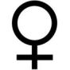 | Venus | Throat, kidneys, pancreas; urinary system; metabolism; also, ovaries and reproductive system; immune system; upper center of body; Heart chakra. Compassion, charity, altruism, openness and ability to love others
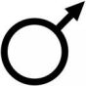 | Mars | Adrenal glands; muscular system; immune system; gut and center of body; Solar plexus chakra. Wheel of Force. Achievement; personal power
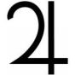 | Jupiter | Pituitary gland; liver; thighs; lower center of body; Sacral chakra. Sexuality; hopes and fears; innovation; emotional plane; creativity, arts.
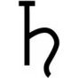 | Saturn | Integumentary system (skin, hair, nails; exocrine glands); teeth; skeletal system; lower part of body; Root chakra. Foundation; safety, security, stability; combat skills; survival instinct; sense of belonging

Twelve Zodiac Signs Correspondences
Aries  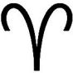  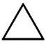 | Head, brain, face, eyes; vision; solar plexus chakra  Spiritual Practices:  Yoga, martial arts, vision therapy or visual training, psychic training | Libra  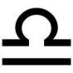  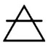 | Lumbar, kidneys, skin; skin conditions; heart chakra  Spiritual Practices:  Music or sound therapy, massage therapy, aura clearing; art therapy
Taurus  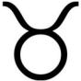 | Throat, neck, thyroid; heart chakra; throat chakra  Spiritual Practices:  Fasting or ritual feasting; grounding, closeness to nature; hand mudras | Scorpio  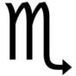  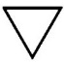 | Reproductive organs, bowels; solar plexus chakra  Spiritual Practices:  Ceremonial magic; tantric practices; shamanism; dream yoga; dreamwork
Gemini  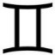 | Nervous system, lungs, arms, shoulders; throat chakra  Spiritual Practices:  Mindfulness meditation, channeling, fellowship; signing or mantra recitation | Sagittarius  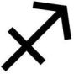 | Liver, sciatic nerve, lower back, spine, thighs, hips; sacral chakra  Spiritual Practices: Spiritual retreat; world travel; journaling; a pilgrimage; sacred vows
Cancer  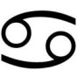 | Chest, heart, hands; crown chakra  Spiritual Practices:  Poetry, past life exploration, solitude; purification ritual | Capricorn  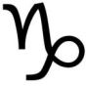 | Calves, legs, knees, joints, bones, skeleton; root chakra  Spiritual Practices:  Connecting to animal totems; tulpa summoning; tai chi; martial arts
Leo  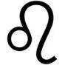 | Upper back, heart, spine; third eye chakra  Spiritual Practices:  Dance, art therapy, tai chi, outdoor group activities; ritual use of mandalas | Aquarius  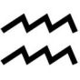 | Circulatory system, blood, ankles, calves; root chakra  Spiritual Practices:  Mindful meditation, affirmation work, energy healing; charity work
Virgo  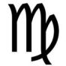 | Stomach, digestive system; throat chakra  Spiritual Practices:  Qi gong, energy healing, aromatherapy, thaumaturgy; intensive study of sacred texts | Pisces  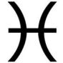 | Feet, toes, lymphatic system; immune system; sacral chakra; crown chakra  Spiritual Practices:  Purification ritual, mantra recitation, shielding; acts of mercy and forgiveness

AVOID EVEN THE APPEARANCE OF A MEDICAL DIAGNOSIS: Never claim that you can use the tarot to diagnose the querent’s condition or affliction. Do clearly state that you are using medieval medical astrology and elemental correspondences in a faith-based practice of divination.

Example. Querent thinks he might have an autoimmune disease, and quite specifically, is convinced he has Hashimoto, though he has not been diagnosed with it from a medical doctor. He thinks it might be going undiagnosed or misdiagnosed, so he wants a tarot reading to confirm his speculations. After sending him clearly written legal disclaimers, you proceed with a spiritual tarot reading of the situation. You pull The Empress card (astrology: Venus).

DO NOT SAY yes or no to whether Querent has Hashimoto or an autoimmune disease, because there is a high risk such a querent would misinterpret you to his detriment.

Instead, SAY, “Well, The Empress card in tarot corresponds with Venus, and per medical astrology, Venus corresponds with the immune system, upper center of your body, and your heart chakra. I cannot diagnose your condition and you need to keep the lines of communication open with your doctor. What I can say is there seems to be energy obstructions, or tension in these noted areas of your body. In the meantime, make sure your regular diet is including sufficient potassium and calcium rich foods, and make sure your body is getting adequate electrolytes.”

(True story: A few years later, Querent was in fact diagnosed with Hashimoto’s. Interestingly, low electrolytes is a common effect those with Hashimoto’s have. Electrolytes are minerals critical in the body’s biochemical process, and include potassium and calcium.)

Example. Querent tells you she is suffering from depression and her prescribed meds aren’t working for her anymore. She thinks something is wrong with her on a spiritual level and comes to you for a tarot reading. The crucial card you pull is the Six of Cups.

DO NOT SAY, “You have a medical problem with your gallbladder.”

Instead, SAY, “I’m sensing an energy knot or blockage around the gallbladder area. Your mental state is an unconscious reaction to your body’s discomfort due to that energy block. Meditations and color therapy to strengthen your solar plexus chakra could help.”

(True story: The querent went to see a doctor and discovered she had gallstones. In her case, depression was her body’s way of trying to alert her to the untreated gallstones. Clinical research has also found that patients with gallstones, or cholelithiasis, are more prone to developing depression.)

Wu Xing (Five Phases) and Human Function Correspondences
 |  | 木 Wood |  |  | 火 Fire | 土 Earth |  | 金 Metal |  | 水 Water
Eight Trigrams |  | Thunder  Wind |  |  | Fire | Earth  Mountain |  | Heaven  Lake |  | Water
Western Four Elements |  | Fire | Water |  | Fire | Earth |  | Air |  | Water
Sense |  | Sight |  |  | Touch | Taste |  | Smell |  | Hearing
Organ Yin |  | Liver |  |  | Heart | Spleen, Pancreas |  | Lungs |  | Kidneys
Organ Yang |  | Gall Bladder |  |  | Small Intestine | Stomach |  | Large Intestine |  | Bladder, Urinary
Organ Systems or Functions |  | Endocrine  Metabolism  Reproductive |  |  | Nervous  Cardiovascular  Circulatory | Muscular  Lymphatic  Digestive |  | Respiratory  Integumentary  Skin & Hair |  | Skeletal  Urinary  Detoxifying
Chemical Composition |  | Carbohydrates |  |  | Lipids | Proteins |  | Nucleic Acids |  | Water
Foods | Oats, wheat  vegetables, chicken, sour fruits, plum, pickled foods |  |  | Corn, amaranth grain, dry or fried meats, barbecue, pheasant, apricots, sweet potatoes, goji, alfalfa |  |  | Barley, millet, mushrooms, beef, cereal, root vegetables, pumpkin, nuts honey, candies, jujubes, soy | Rice, duck, freshwater seafood, spicy foods, peaches, white sesame, bananas, pears, winter melon, daikon, cumin | Beans, soups, seafood, cool drinks, wine, water chestnut, raisins, tea, seaweed
Body Part |  | Tendons |  |  | Blood Vessels | Muscles |  | Skin |  | Bones
Taste |  | Sour |  |  | Bitter | Sweet |  | Pungent |  | Salty
Brain Function |  | Language |  |  | Voluntary Movement | Judgment |  | Memory |  | Involuntary Movement
Color |  | Green |  |  | Red | Yellow |  | White |  | Blue
Fruit Offering |  | Plum |  |  | Apricot | Jujube |  | Peach |  | Water Chestnut
Minerals |  | Turritella Agate  Petrified Wood |  |  | Cinnabar  Carnelian | Lodestone  Bloodstone |  | Malachite  Gold, Silver |  | Fluorite  Selenite
Feng Shui |  | Trees, plants  wood decks  columns  paper, books  bamboo, resin |  |  | Triangular forms  bright lighting  fireplace, stove, bright red-orange warm colors | Clay, terracotta  stone, ceramic  marble, granite mountains, square forms  neutral tones |  | Clocks, metals electronics  wind instrument  weaponry  metal jewelry |  | Rivers, lakes  mirrors, glass  fountains  aquariums
Mental |  | Sensitivity |  |  | Motivation | Clarity |  | Intuition |  | Empathy
Finger |  | Index |  |  | Middle | Thumb |  | Ring |  | Little
Personality |  | Charity  Benevolence  Generosity  Openness |  |  | Leadership  Passion  Sensuality  Avarice, Greed | Confidence  Diligence  Patience  Perseverance |  | Courageousness  Independence  Communication  Rationalism |  | Diplomacy  Congeniality  Sociability  Mercurial
Virtue |  | Kindness |  |  | Discipline | Dignity |  | Incorruptibility |  | Wisdom
Human Stage of Life |  | Childhood |  |  | Young Adulthood | Adulthood |  | Old Age/  Retirement |  | Twilight  Years
Last Digit of Year |  | 4, 5 |  |  | 6, 7 | 8, 9 |  | 0, 1 |  | 2, 3

The Human Body Clock and Qi Energy Flow
Wu Xing | Hours | Area of Active Qi Flow and Correspondences
Metal  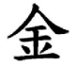 | 3:00 am – | Lungs. Qi of the respiratory system most active. These are also the hours that the unconscious mind is most active and most stimulated by Qi, specifically of dreamwork, underworld journeying, spirit contacts, and ancestral memory. Through gas exchange and that interaction between personal Qi and collective Qi, the body is expelling baneful and pestilent energy. Healthy skin and the olfactory senses are regulated during the Metal hours.
 | 4:59 am
 | 5:00 am – | Large Intestine. Qi of the gastrointestinal tract and digestive system is most active. Personal Qi is collecting in the colon and rectum. These are the best hours to awaken from sleep, to hydrate, and to release the bowels. This is an ideal time for meditation or light exercise. Qi is also stimulating the seat of Jing essence and the root chakra.
 | 6:59 am
Earth  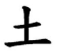 | 7:00 am – | Stomach. Qi continues to be active in the digestive system, moving upward in the body. These are the best hours for digestion and maintenance of digestive health, which is determined by the body’s activities during these hours. Intake of nutrient-rich foods is best during these hours.
 | 8:59 am
 | 9:00 am – | Spleen. Qi is active in the immune system; the Qi of red blood cells is also active. Metabolic health is determined by the body’s activities during these hours. Ideal to be doing work and mentally active; exercise the mental capacity. Challenge the mental faculties for optimal health.
 | 10:59 am
Fire  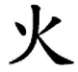 | 11:00 am – | Heart. Qi moves more actively through the blood stream and is active in the muscles. The body’s activities during these hours determine circulatory and muscular health. Making sure the body is physically active and the mind is highly alert during these hours is optimal. Socialization also helps keep the Qi healthy and increases vitality.
 | 12:59 pm
 | 1:00 pm – | Small Intestine. During these hours, personal Qi is facilitating the body’s absorption of minerals and nutrients, such as vitamin B₁₂. This is a time to let the mental faculties rest. Letting the body and spirit rest and conserve energy is optimal during these hours.
 | 2:59 pm
Water  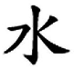 | 3:00 pm – | Bladder. Increase intake of water during these hours. Qi is most active in the urinary bladder. Intake of fluids to hydrate the body helps to keep the Qi clean and clear. Make a conscious effort to facilitate that flow of Qi through increased water intake. Active, routine, engaged work and physical movement are also advised during these hours. Healthy bones and skeletal system are also determined during the Water hours.
 | 4:59 pm
 | 5:00 pm – | Kidneys. Qi flows from the urinary bladder to the kidneys. These are the best hours to eat a nutrient-rich meal. The body’s activities during these hours determine the health of the kidneys and nervous system. Qi is also active in the lower part of the spinal cord. Healthy habits during these hours lead to healthy blood pressure levels. These are the hours that Qi can strengthen bone marrow and the body’s ability to maintain homeostasis. These are the most important hours for ensuring the mind and heart are calm.
 | 6:59 pm
Fire | 7:00 pm – | Pericardium. Qi continues upward into the pericardium, around the heart and chest area. The vascular system and lymphatic system are regulated by the Qi during these hours. The body’s Qi is strongest during these hours. This is also considered the best time for conception and leisurely activities.
 | 8:59 pm
 | 9:00 pm – | Thyroid and Adrenals. Qi is most active in the endocrine system, especially the thyroids. Avoid eating during these hours. This is the time when the body is transferring energy to optimize its functions, regulating its temperature and its metabolism. Qi is now slowly moving downward into the adrenal glands.
 | 10:59 pm
Wood  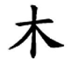 | 11:00 pm – | Gall Bladder. Qi is most active in the gall bladder and regulating the body’s bile. These are also the hours of cellular repair. Sleep and rest is critical during these hours for the body to regenerate. The eyes, eyesight, and a person’s innate sense of goodwill toward others is regulated during the Wood hours.
 | 12:59 am
 | 1:00 am – | Liver. Qi moves in to the liver and continues to detoxify the body. Qi helps facilitate the production of biochemical during this time. Qi is also active in the unconscious mind, specifically for the processing of life experiences.
 | 2:59 am

TAROT READER PRO TIP: If your client identifies a specific area of the body, consider offering insight into the human body clock per Traditional Chinese Medicine (TCM).

Sample Hypothetical #1: Querent requests a tarot reading on what might be the energetic source cause of chronic throat issues, unexplained coughing, and pain in the neck/throat area. Proceed with a card reading, then supplement with the additional guidance on TCM: Throat or thyroid issues could relate to the endocrine system, which oversees the release of hormones into our bloodstream. Qi energy in your own body flows through the thyroid and adrenals between 9 pm – 11 pm, more so than others, Querent should avoid eating during these hours. Perform healing techniques, reiki, acupressure, or meditation exercises during these hours routinely to help your body heal these areas.

Sample Hypothetical #2: If you notice that Querent suffers from skin conditions such as psoriasis, cystic acne, etc., then in terms of Eastern/Taoist spiritual beliefs, this is often attributed to a hyperactive unconscious mind. Often an additional chronic symptom such a Querent would experience is gastrointestinal and digestive issues, or a weaker root chakra. Most likely there is imbalance in Metal qi (from the Chinese five phases, or elements Wu Xing). Whether the imbalance is excess Metal or weakened Metal will depend on assessment of other factors. If you are not studied in TCM, then keep your insight to the term “imbalance” and do not get into excess vs. weakened.
Do not point out the Querent’s skin condition! Instead, simply address the possible condition of (1) a hyperactive unconscious mind, (2) weakened root chakra, and therefore meditation or qi gong practices to help strengthen the root chakra, (3) possible imbalance of Metal in Querent’s qi energy body composition, which corresponds with the western element Air, and (4) potential GI tract and/or respiratory issues that Querent should follow-up on with a primary care physician.
Also offer the guidance that restful, uninterrupted sleep between 3 am and 7 am is especially crucial for such a querent.

SPIRITUAL COGNITIVE BEHAVIORAL THERAPY SPREAD

- Formulate the health-related question you’d like answers for.
  - If you’ve been experiencing a chronic physical health condition or an undiagnosed issue, you can ask about that
  - If you’ve been experiencing challenges to mental health, present that as the question
  - If a significant event recently happened to you and you are still trying to process it, ask: “What do I most need to know about…?”
  - You can do a quick check-in and simply ask the cards to give you a general assessment of your current spiritual health
- Shuffle your deck.
- Follow the subsequent prompts for assessing each of the four cards.

 | Card 1  Bottom | Crux of the matter. Getting to the root of the problem at hand. This card identifies the source and cause of the challenges or suffering that the querent is experiencing. Core thesis of issue. This is the most important point for you to know.
  Card 3
  Card 2 | Card 4
  Card 1
 | Card 2  Left | Unproductive pattern. Identify why the querent has not solved the problem yet. This card reveals the recurring issue, and therefore what needs to change. Spotlights negative behavior or negative patterns so that the querent can be aware of them.
 | Card 3  Top | Reconstruction and change. Re-frame the situation. This card offers insights on how to reshape negative thinking. This is the Path of Light that reveals how to change. Card 3 guides you on how to reshape negative thinking.
 | Card 4  Right | New behavior to implement. Call to action. The fourth and final card is a summary of the solution. This card will reveal practical techniques or approaches to implement to help overcome the negative patterns and stop the recurring problem.

Card 1 | (a) Interpret the card as you normally would for a reading.
 | (b) Per the elemental correspondence of the card, identify whether the root cause is physiological, emotional, psychological, or social. | Fire | Physiological; there is an issue with vitality, drive, or willpower
 |  | Water | Interpersonal hurt that is having an unconscious impact; issue of a spiritual or emotional nature
 |  | Air | Psychological; lacking mindfulness; unable to process the experience of hurt
 |  | Earth | Stress or anxiety over social responsibility (financial problem, social isolation, a food, clothing or safety issue, lack of security)
 | (c) Based on the elemental correspondence, reflect on the question.  This is addressing what might be going on in terms of mental health. | Fire | Is the joie de vivre lackluster, and therefore unable to support what the mind and body wants to do?
 |  | Water | Is there an emotional imbalance due to challenges with intimacy? Are emotions too temperamental?
 |  | Air | Has there been trauma or a failure that has not been effectively processed by the mind?
 |  | Earth | Is a strong sense of self-worth and life purpose lacking?
 | (d) Where is the core imbalance?  This is the interconnection that needs strengthening so that you can be productive. | Fire | Vitality of Spirit Body’s Physiology  Body holding tension in: Circulatory, arteries, cardiovascular. Head, eyes, heart, colon, or spine.
 |  | Water | Mind’s Wellbeing Social Relations  Body holding tension in: Pituitary, endocrine, urinary tract, liver. Chest, hands, sex organs, bowels, or feet.
 |  | Air | Body’s Physiology Mind’s Wellbeing  Body holding tension in: Respiratory, lymph nodes, legs, skin or hair. Lungs, arms, kidneys, or lumbar.
 |  | Earth | Social Relations Vitality of Spirit  Body holding tension in: Thyroids, organs in abdomen, bones. Throat, neck, digestive system, or joints.
 | (e) Where has a knot of tension formed, as a result of what’s been going on? | Note the organs and organ systems that correspond with the element of Card 1.  Apply your intuition. Which of the listed organs or organ systems for your element most resonates with you, as a psychic, as where you might be holding tension, where there could be an energy congestion that is then causing the mental or psychological stress you’re experiencing? Or vice versa– your stress and anxiety is having the most detrimental impact on a particular part of your body, and Card 1 tells you where.
Card 2 | (a) Interpret the card as you normally would for a reading. Card 2 reveals to you the roadblock you currently face in your path. This is also a card revealing unresolved issues or a recurring problem or theme. This is why you’re not advancing the way you’d like. You need to address this issue.
 | (b) The card’s element gives you instruction on which of the four clairs to activate.  Psychically identify what needs to heal or change. | Fire | Clairvoyance. I see… [a vision]
 |  | Water | Clairsentience. I feel… [articulate your emotions]
 |  | Air | Claircognizance. I know that… [an instant download comes]
 |  | Earth | Clairaudience. I can hear… [listen with your psychic ear]
 | (c) This is another, a secondary location in the body that’s tense, and where you are holding emotional pain in a physiological way. | Fire | Circulatory, arteries, cardiovascular. Head, eyes, heart, colon, or spine.
 |  | Water | Pituitary, endocrine, urinary tract, liver. Chest, hands, sex organs, bowels, or feet.
 |  | Air | Respiratory, lymph nodes, legs, skin or hair. Lungs, arms, kidneys, or lumbar.
 |  | Earth | Thyroids, organs in abdomen, bones. Throat, neck, digestive system, or joints.
 | (d) Hot/cold balance in your body per the elemental correspondence of Card 2. | Fire | DRY: Depletion. Broad but not deep. Restless. Consumed by one drive.
 |  | Water | DAMP/Hefty: Stagnation. Deep but not broad. Heaviness. Water retention.
 |  | Air | WINDY: Too easily affected by others. Self-doubt. Weakened defenses.
 |  | Earth | DAMP/Weary: Stiffness. Fatigue.  Over-exerted. Low energy. Insomnia. Melancholic.
Card 3 | (a) Interpret the card as you normally would for a reading. Card 3 reveals how to heal or change. This is revealing of how you can reshape your own negative thinking. This is the change that must happen.
 | (b) What is Card 3 telling you about how you can cope with adversity? | - Techniques for managing depression and anxiety:  - Oracle cards for supporting difficult decision-making  - Conversations exploring lifestyle changes to improve quality of life
 | (c) The affirmation assigned to your Card 3 will help you to cultivate the positive emotions needed to advance from your status quo.
 | (d) What does Card 3 reveal to you about your current aspiration, which is a key milestone in achieving your sense of life purpose?
 | (e) Which of the five techniques for increasing serotonin does Card 3 instruct to you? | 1. Light therapy (heliotherapy, sunlight, color therapy, etc.)  2. Meditation  3. Aerobic activity (increasing oxygen flow throughout your body)  4. Tryptophan-rich foods (food as medicine)  5. Healing hands (reiki, EFT tapping, laying on of hands, acupressure, etc.)
 | (f) Based on the element, identify the health and nutrition message corresponding.  This is addressing what might be going on in terms of physical health. | Fire | Body needs more protein. Focus on cardiovascular & blood health.
 |  | Water | Body needs to hydrate more. Drink more green tea, eat cabbage and watercress, and more fresh fruits.
 |  | Air | You might not be getting your body’s needed daily vitamin intake. Focus on respiratory and lung health. Eat more collagen-rich foods for better skin health.
 |  | Earth | Consider a more potassium or calcium rich diet to maintain cellular function. Focus on digestive, lymphatic, and bone health.
 | (g) This is the sub-issue within the greater question of your life purpose that you most need to focus on right now at this stage of life. | Major Arcana | Who you are. “I am…” Are you open about and proud of your identity markers?
 |  | Wands | What you do (or offer). “I…” What is your craft, work product, talent, or occupational specialty?
 |  | Cups | Who or what you love. “I love…” This is what motivates you to be present.
 |  | Swords | How you serve. “I serve my community/world by…”
 |  | Pentacles | Why that’s important. “The work I do advances…”
Card 4 | (a) Interpret the card as you normally would for a reading. Think of Card 4 as an “Action Required” card. This is Spirit giving you a call to action. There is a “to-do” here.
 | (b) What phase of inner alchemy does Card 4 correspond with? | Fire | Lightwork. Becoming the “Wise One.” You are a conduit for the Divine. To be a torchbearer. Be motivated to serve.
 | (b) What phase of inner alchemy does Card 4 correspond with? | Water | Union of the anima and animus—a spiritual awakening. Purification; to clear of impurities. Metamorphosis.
 | (b) What phase of inner alchemy does Card 4 correspond with? | Air | Attaining self-knowledge. Birthing a new personality to manifest wholeness. Completion of the work.
 | (b) What phase of inner alchemy does Card 4 correspond with? | Earth | Shadow work. Neutralizing fears and insecurities. Spiritual detachment and release. Sovereignty by liberation.
 | (c) Source a stone amulet corresponding with the element of your Card 4. | Fire | Carnelian, sunstone, red goldstone, red agate, fire opal, red jasper
 |  | Water | Fluorite, moonstone, selenite, blue lace agate
 |  | Air | Iolite, sodalite, blue tiger eye, amethyst, chrysocolla
 |  | Earth | Green aventurine, smoky quartz, dark jasper, hematite
 | (d) Anoint the stone you’ve chosen with an essential oil corresponding with the element | Fire | Bergamot, ginger, angelica
 |  | Water | Chamomile, lavender, jasmine, rose
 |  | Air | Marjoram, peppermint, myrrh, valerian
 |  | Earth | Oak, vetivert, patchouli, cedarwood
 | (e) Ritually anoint the stone as you repeat the tarot affirmation that corresponds with the card you drew for Card 4. Select a date during the corresponding moon phase to perform the ritual. | Fire | New Moon. This is to invite in new opportunities, a rebirth, regeneration, initiation, to advance new projects, to sow seeds and resolutions, and to improve your health.
 |  | Water | Waxing Moon. This is to grow, to innovate, to attract luck, wealth, love, and to bless. This is to beautify. This will amplify assertiveness and cultivate action.
 |  | Air | Full Moon. This is to actualize power and manifestation. A transformation is to take place. This is also for protection and defense. To fortify.
 |  | Earth | Waning Moon. This is to harvest that which has already come to its peak, and then to release the rest. This is severance of that which no longer serves. This is release and bloodletting. Detoxing your space.

TAROT READER PRO TIP: Share this four-card spread (or your modified variation of it) with your client as “homework” after their reading session with you, though they will be applying a much simpler approach to the spread than the above guided steps. You’re sharing with your client methods of spiritual reflection inspired by cognitive behavioral therapy.

Writing and Journaling. Recommend that the querent keep a journal. Revisit the spread of four cards at the end of each week to remind yourself of what still needs to be done, to track your own changes and path to recovery. Track the progress of whether you’ve been answering the call to action.

Their Own Check-Ins with the Spread. Recommend a beginner-friendly oracle deck (preferably one with oracle message written on the cards) for the querent to use with this spread. Whenever the querent is in need of spiritual guidance, but doesn’t yet amount to getting a formal reading from you, they can use a simple oracle deck with this spread. They can then journal and free-write their reflections on how they interpret the four cards. This is a great way to help them cope with adversity.

AFFIRMATIONS KEYED TO THE TAROT
From Holistic Tarot (North Atlantic Books, 2015)

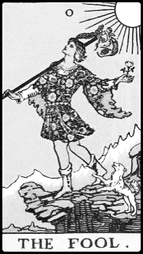 | 0 - Fool | 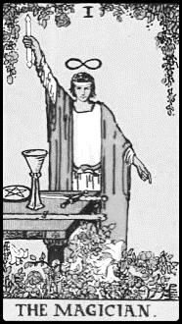 | 1 - Magician
 | Affirmation: I am a different person now, undaunted by the unknown, ready to soar into the sun. |  | Affirmation: The power of my mind can influence others. I use what I have to manifest my goals.
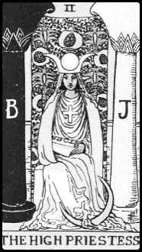 | 2 - High Priestess | 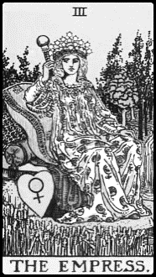 | 3 - Empress
 | Affirmation: I possess the clairvoyance to see myself through any obstacle. There is no need to seek the counsel of others. I trust myself. |  | Affirmation: I enjoy abundance and plenitude. My hopes manifest into great successes. I live a fertile life filled with fruition.
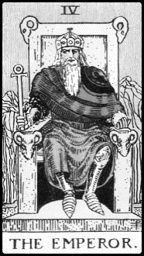 | 4 - Emperor | 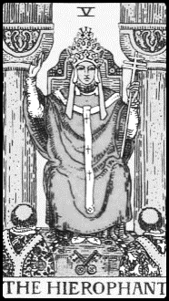 | 5 - Hierophant
 | Affirmation: They follow when I command. To command them, I manifest the conviction and also the integrity of their ruler. |  | Affirmation: I uphold tradition and lead by example with my values. (If reversed: I am an iconoclast and thrive on nonconformity).
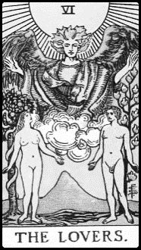 | 6 - Lovers | 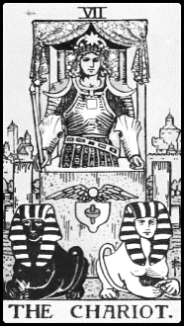 | 7 - Chariot
 | Affirmation: My greatest resource is my passion. When faced with a choice, I choose that which brings me closer to the divine. |  | Affirmation: My abilities of discipline and audacity empower me to be the commander general of my own destiny.
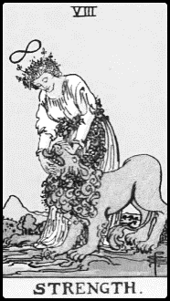 | 8 - Strength | 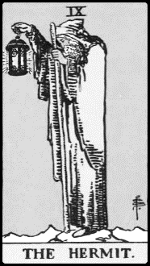 | 9 - Hermit
 | Affirmation: My compassion is my fortitude and I use that trait to tame the wild beast of circumstance. |  | Affirmation: I heed the wisdom of sages. Introspection is the inner light that illuminates my lantern.
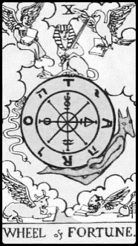 | 10 - Wheel of Fortune | 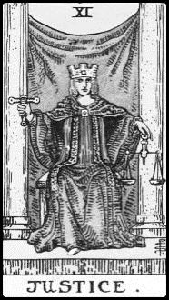 | 11 - Justice
 | Affirmation: I summon my powers to spin the Wheel of Fortune in my favor. Greatness is my destiny. My life changes for the better. |  | Affirmation: I am both the sword and the scales and embrace justice with my mind, not my heart. I always do what is right.

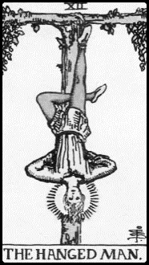 | 12 - Hanged Man | 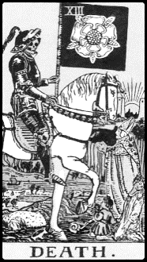 | 13 - Death
 | Affirmation: I choose to sacrifice myself for the greater good of others, and for that I am remembered and honored. |  | Affirmation: The pain of change yields in time and the new beginning to come brings me catharsis. It is the dawn of a new sunrise.
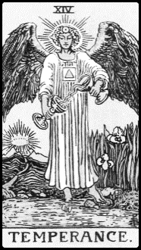 | 14 – Temperance | 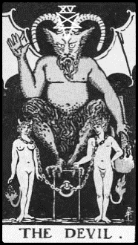 | 15 – Devil
 | Affirmation: I find balance between my extremes and allow my higher self to guide me. I heal myself through moderation. |  | Affirmation: I vanquish my own inner demons. I detach from superficial bonds and begin my journey out of darkness.
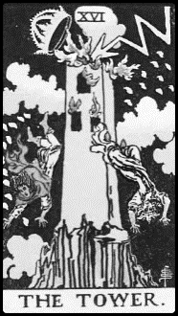 | 16 – Tower | 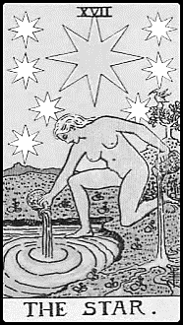 | 17 – Star
 | Affirmation: I reach skyward for noble reasons beyond my vanity. I detach and thus ascend from my ego. No matter the fall, I get back up and thrive. |  | Affirmation: I am a beacon of hope to others. With my goodness I revitalize the life around me. My mind is at peace.
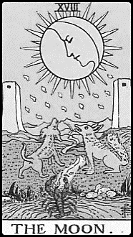 | 18 – Moon | 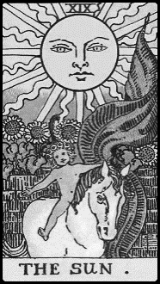 | 19 – Sun
 | Affirmation: It’s not that I’m changing; it’s that I’m finally revealing. Emotion and intuition converge to guide me. |  | Affirmation: I attain the highest echelons of success and glory because the heavens shine righteously in my favor.
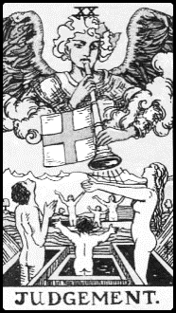 | 20 - Judgement | 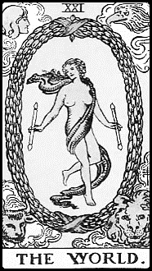 | 21 - World
 | Affirmation: I reach the right epiphany at the end of this road and the pain I endure come to reveal its higher spiritual purpose. |  | Affirmation: This is the time I complete my magnum opus and realize my life’s purpose. I am meant for greatness and I am on the right path for achieving that greatness.

TAROT READER PRO TIP: Copy and paste these tables into a separate document file. Review the assigned affirmations for all cards. Keep the ones you like and delete the ones you don’t. Replace with your own affirmation correspondences for the cards. Your resource of tarot affirmations is a way for you to help querents find the path of light in their readings. Affirmations can help us to re-program negative self-talk, and often an integral part to spiritual cognitive behavioral therapy.

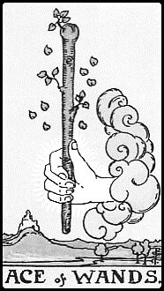 | Ace of Wands | 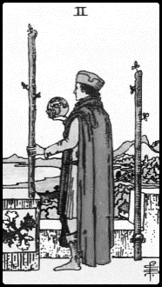 | Two of Wands
 | Affirmation: It’s no longer just a dream; it’s now my reality. I start a new journey and a new chapter of opportunities in my life. |  | Affirmation: To achieve greatness, I venture far from what I once knew. I surpass the past and begin on a path of conquest and triumph.
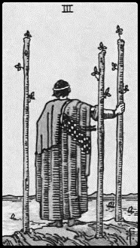 | Three of Wands | 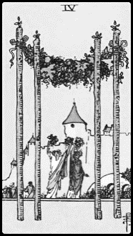 | Four of Wands
 | Affirmation: My investments pay off and what I send out returns in fortuitous abundance. |  | Affirmation: I bring harmony and balance to my surroundings. My work brings me happiness and contentment.
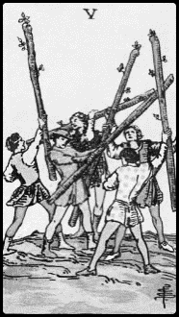 | Five of Wands | 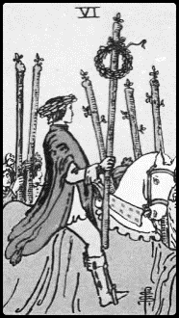 | Six of Wands
 | Affirmation: I prevail over my competition, whether that rival is another or my own inner insecurities. |  | Affirmation: Despite initial setbacks, I succeed. I gain the admiration and respect of those around me. I am victorious.
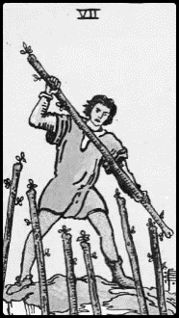 | Seven of Wands | 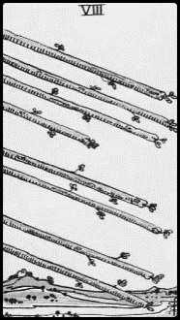 | Eight of Wands
 | Affirmation: I stand my ground and defeat those who try to overpower me. I fight for what is right. I stand up for myself, especially when others will not. |  | Affirmation: I won’t slow down, I won’t stop. I aim and shoot for my goals. I see my target and never take my eyes off it.
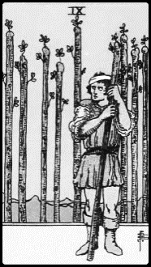 | Nine of Wands | 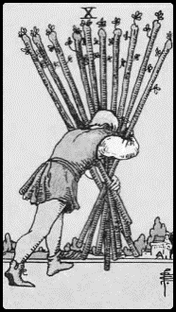 | Ten of Wands
 | Affirmation: I let love and faith in to my life. I can let my guard down. It’s okay to show my vulnerabilities. |  | Affirmation: I put my own needs first and I don’t let others push their responsibilities onto me.
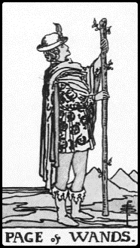 | Page of Wands | 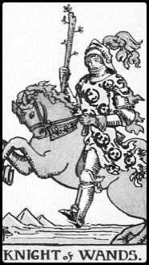 | Knight of Wands
 | Affirmation: I am not afraid of adventure. I am not afraid of the quest. I am motivated to succeed. |  | Affirmation: My passion is my galloping horse, not my weapon. I finish what I start. I am not afraid of rocky terrain.
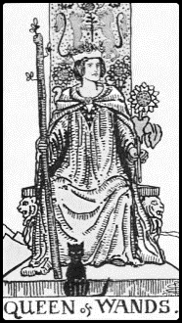 | Queen of Wands | 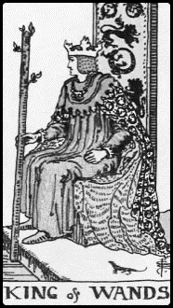 | King of Wands
 | Affirmation: My power of attraction and easy confidence will be the way I materialize my goals. With a genuine smile, I win them over. |  | Affirmation: I conquer with my domineering, headstrong spirit. I am a noble ruler born of fire. I claim my power. I command authority.

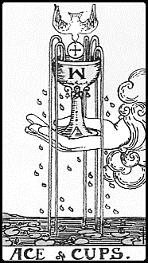 | Ace of Cups | 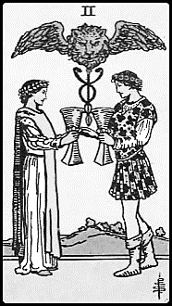 | Two of Cups
 | Affirmation: My heart leads me to what will fulfill me most, to discover my personal holy grail. |  | Affirmation: My best friend will see me through these times of hardship. Compassion heals. Love prevails.
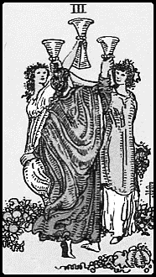 | Three of Cups | 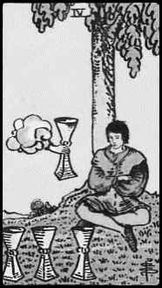 | Four of Cups
 | Affirmation: I can find the humor amidst the tragedy. I choose friends who love and respect me, who won’t judge me for my choices. |  | Affirmation: I don’t need others to tell me what I want. I will find the answers I seek by looking inward.
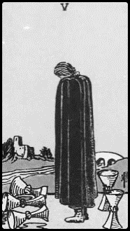 | Five of Cups | 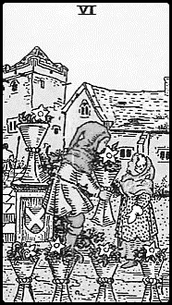 | Six of Cups
 | Affirmation: I am more blessed than I realize. I have just enough left to rebuild. I choose to be hopeful and optimistic. |  | Affirmation: My past does not determine my future. My present and who I choose to be are what matter.
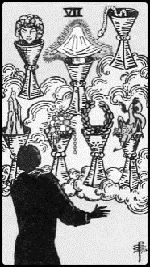 | Seven of Cups | 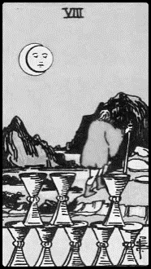 | Eight of Cups
 | Affirmation: I forego the easy temptation of riches and fame and instead choose what matters most to my heart. |  | Affirmation: I serve a higher spiritual purpose and that purpose is to guide the masses toward a greater good.
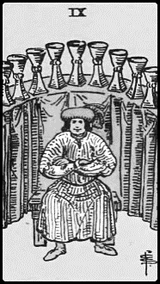 | Nine of Cups | 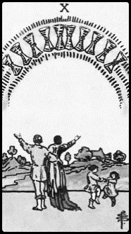 | Ten of Cups
 | Affirmation: I am accomplished and I am respected. My past daydreams become my present reality. |  | Affirmation: I am a role model for my family and I am the impetus for them to achieve new heights of happiness.
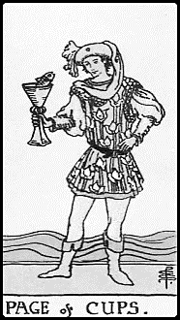 | Page of Cups | 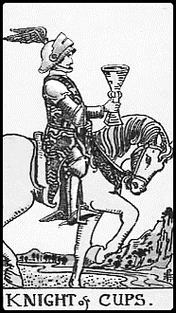 | Knight of Cups
 | Affirmation: I am blessed by my muses with constant creative flow. I am a visionary. |  | Affirmation: My charisma and gift of expression and communication sway the majority in my favor.
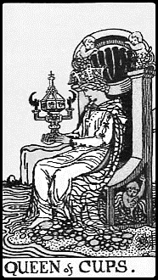 | Queen of Cups | 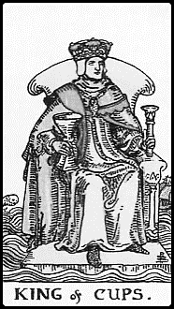 | King of Cups
 | Affirmation: My empathy and display of tenderness wins their loyalty. |  | Affirmation: I lead by example and conquer with my diplomacy.

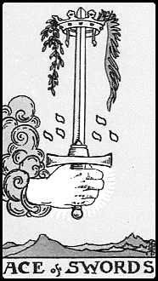 | Ace of Swords | 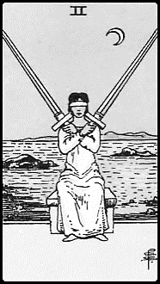 | Two of Swords
 | Affirmation: I am the warrior philosopher destined for greatness. |  | Affirmation: I make the right choices every time. I draw from my intelligence and my keen intuition.
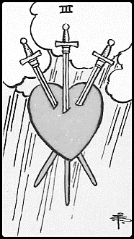 | Three of Swords | 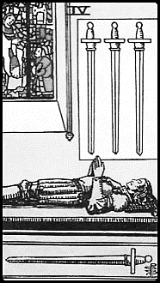 | Four of Swords
 | Affirmation: Yes, I braved a severe storm of the heart, but my scars strengthen, not weaken me. |  | Affirmation: With my prayers I summon health and harmony into my life. I do not worry about what I cannot change.
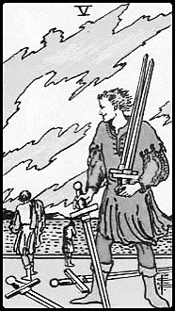 | Five of Swords | 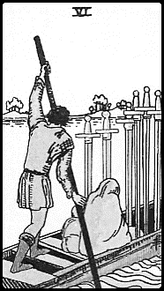 | Six of Swords
 | Affirmation: I am a fighter who wins my battles, but I take care to win by ingenuity, not cunning. |  | Affirmation: I have made peace with my past and leave it behind. My journey now takes me afar to start anew.
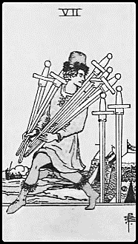 | Seven of Swords | 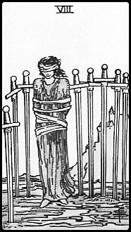 | Eight of Swords
 | Affirmation: When the odds are against me, I can one-up the odds by not playing by their rules. |  | Affirmation: My creativity releases me from every hardship. My thoughts empower me, not limit me. All my problems have a solution.
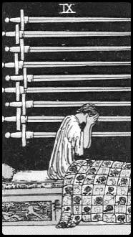 | Nine of Swords | 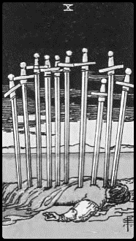 | Ten of Swords
 | Affirmation: I let go of all sorrow and shed tears to sanctify my conscience. I embrace the night. |  | Affirmation: I rise again because there is gold in my horizon. Hardships always work out for my higher good.
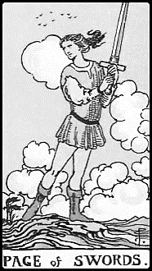 | Page of Swords | 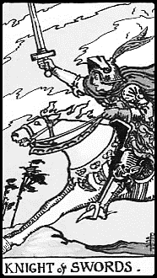 | Knight of Swords
 | Affirmation: I am born to excel, born to reach the top. I push myself to prevail above all others. |  | Affirmation: I am a strong, fearsome competitor and I defeat my challengers.
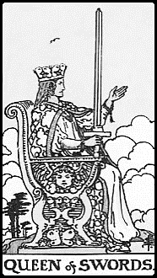 | Queen of Swords | 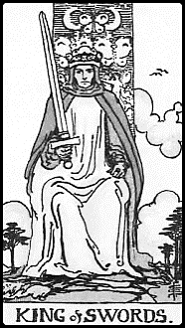 | King of Swords
 | Affirmation: I accomplish my goals through my intellect and acumen, but I won’t forget to nurture my soft skills as well. |  | Affirmation: I lead with my righteous campaign and wield influence with my logic, reason, and power of rhetoric.

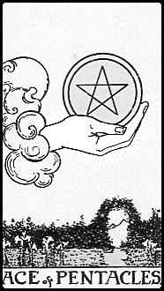 | Ace of Pentacles | 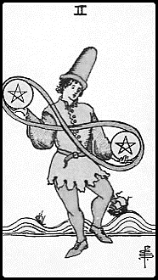 | Two of Pentacles
 | Affirmation: I attract financial gains. Opportunities flow into my life effortlessly. |  | Affirmation: I can do it all; I can have it all. Spirit takes care of my every material need.
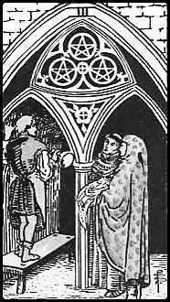 | Three of Pentacles | 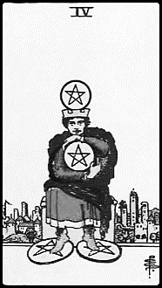 | Four of Pentacles
 | Affirmation: I am recognized for my talent. I work with everything I’ve got to perfect my magnum opus. |  | Affirmation: I am prudent with my resources, but not miserly. I create prosperity by sharing with others.
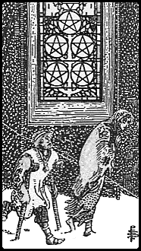 | Five of Pentacles | 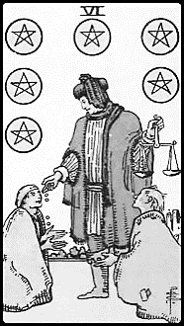 | Six of Pentacles
 | Affirmation: I persevere through hardships and embrace the light of my faith to see me past the winter. |  | Affirmation: My charity to others returns riches to me six-fold. Abundance is my birthright.
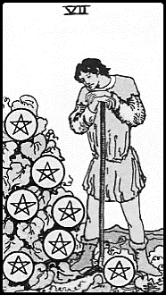 | Seven of Pentacles | 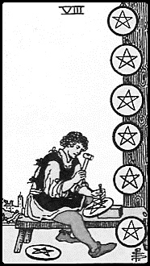 | Eight of Pentacles
 | Affirmation: I have worked hard and now I am in a state of abundance and personal fulfillment. |  | Affirmation: I continue the diligent and humble pursuit of my craft, anticipating the day I become the master.
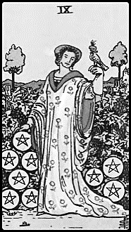 | Nine of Pentacles | 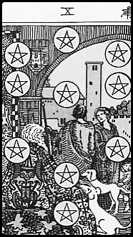 | Ten of Pentacles
 | Affirmation: I take pleasure in my own solitude. Though my stature intimidates them, I will not stop trusting in the good of people. |  | Affirmation: My acumen, investments, and efforts bring great status and success to my family.
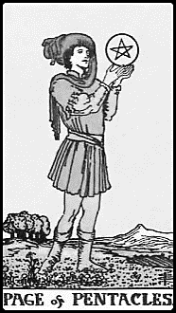 | Page of Pentacles | 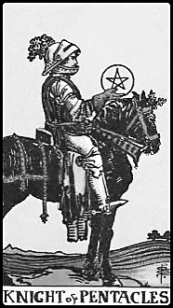 | Knight of Pentacles
 | Affirmation: What I have to offer this world matters a great deal. My mark will make all the difference. |  | Affirmation: My methods attract success. I prosper because I am thorough, dedicated, and unwavering in my convictions.
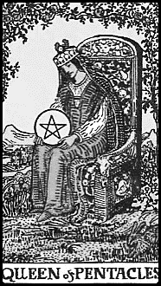 | Queen of Pentacles | 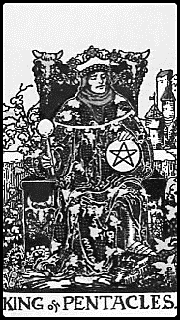 | King of Pentacles
 | Affirmation: I have the poise of an aristocrat. My enterprises flourish because I am resourceful and clever. |  | Affirmation: My astuteness and sound judgment brings great prosperity to my domain. I am accomplished and I attract great wealth.

CONTINUED EDUCATION

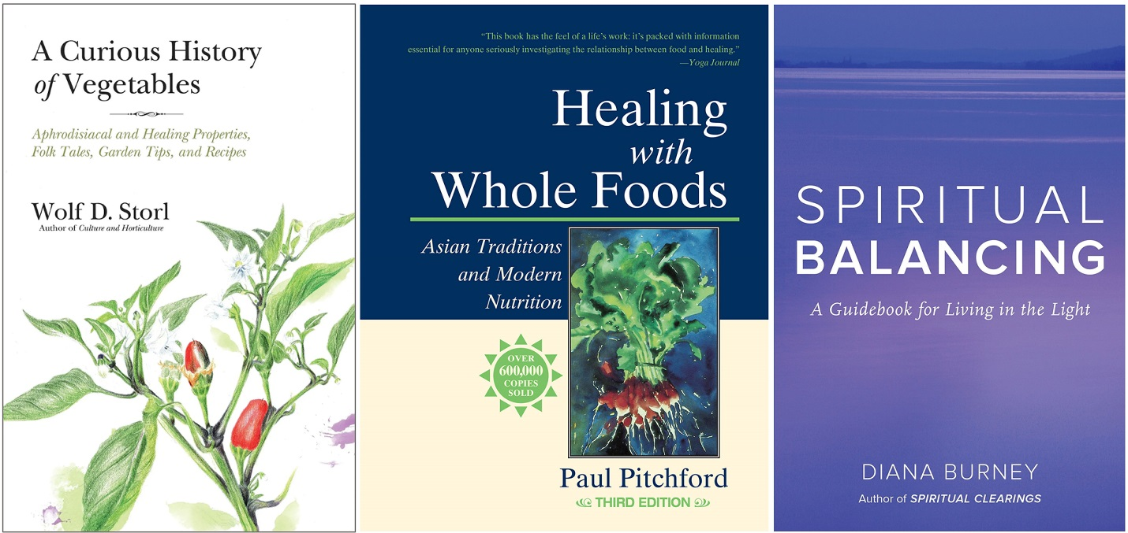
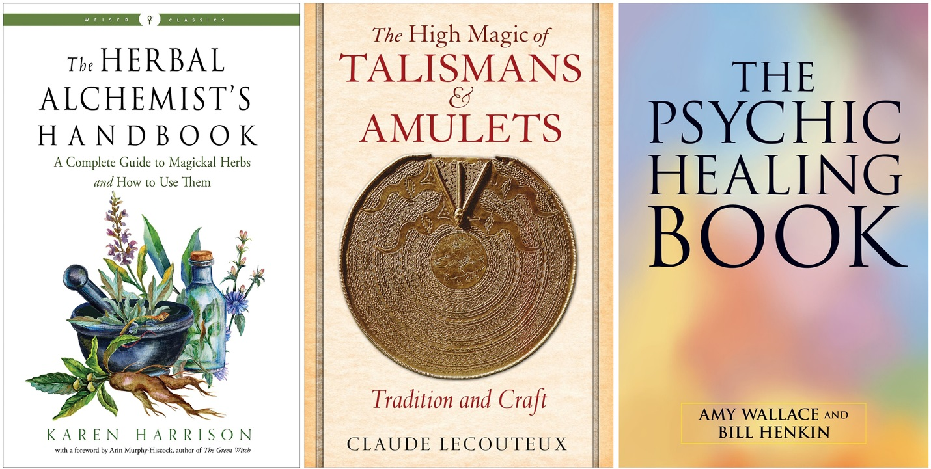

- A Curious History of Vegetables: Aphrodisiacal and Healing Properties, Folk Tales, Garden Tips, and Recipes by Wolf D. Storl. Spotlights both common and lesser known vegetables, history of cultivation, folk beliefs, and equal treatment of science-backed nutritional and spiritual-metaphysical healing properties. You’ll teach yourself the healing properties of common vegetables that your clients can conveniently integrate into their regular diets to heal with food.
- Healing with Whole Foods: Asian Traditions and Modern Nutrition by Paul Pitchford. A comprehensive treatise on food as medicine for the modern era, and aligns with what I’ve learned in Traditional Chinese Medicine (TCM). Offers solid general nutritional advice; an accessible primer on TCM. You’ll want to highlight, mark up, and sticker-tab this textbook and consult it frequently to give your clients practical advice on how to heal through food and general nutrition, especially when they come up as elemental correspondences to the tarot card readings.
- Spiritual Balancing: A Guidebook for Living in the Light by Diana Burney. The timbre of this book is “New Age,” but if you sift through it with a critical eye, there is still a lot of practical content that can be integrated into your spiritual counseling practice. For example, learn and then teach your clients how to work with Violet Fire for transcendental experiences; learn about various spiritual power tools that you can then share with your clients to show them ways to achieve personal control over impossible situations. This text also includes a basic primer on soul fragmentation and soul retrieval. [Self-Promo Note: I’ll be covering these topics in an end chapter of my forthcoming I Ching, The Oracle book, to be released in 2023]
- The Herbal Alchemist’s Handbook: A Complete Guide to Magickal Herbs and How to Use Them by Karen Harrison. A reference book of planetary herbal correspondences per European folk healing modalities. Gives basic instructions on blending oils, incense, and bath salts. Some contradictions with TCM and Ayurvedic Medicine, but a great general text for magical intentions and witchcraft with herbs. A great recipe book for concocting anointing oils, incense blends, and bath salts that you can recommend to clients.
- The High Magic of Talismans & Amulets: Tradition and Craft by Claude Lecouteux. A wealth of information on historical talismans and amulets, which can be used as inspiration for crafting your own. Learn historical talismans that you can then relay to querents to nurture religiosity. Chapter in here dedicated to the medicine of amulets and talismans. This book is a reference guide for how you can teach talismanic magic to your clients, or recommend specific magical talismans to help with their concerns.
- The Psychic Healing Book by Amy Wallace and Bill Henkin. Classic techniques for learning how to become a psychic healer. Long considered an essential primer for budding psychics, many of the techniques from this book can be integrated into your spiritual counseling work as a tarot healer.

ABOUT YOUR WORKSHOP INSTRUCTOR

Hi! I’m Benebell Wen. I’m the author of Holistic Tarot (2015), The Tao of Craft (2016), and the forthcoming I Ching, The Oracle: A Practical Guide to the Book of Changes (forthcoming 2023). I also illustrated the Spirit Keeper’s Tarot. Learn more about my work at benebellwen.com.

I’m a lawyer licensed in California and New York and have practiced for the last fifteen years. I currently serve as a senior director and legal counsel for a healthcare provider network. Previous to that, I worked in-house at a county hospital system. Prior to transitioning into healthcare law, I worked in venture capital and private equities.

Download all workshop files: benebellwen.com/2022/10/07/tarotheals
Password: nwtsbell

