Trigrams for Spell-Crafting Uses in Traditional Asian Witchcraft
Trigram | Spell-Crafting Correspondences | Trigram | Spell-Crafting Correspondences
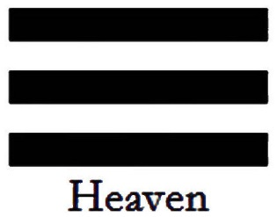 | A creative, expansive force. Petitioning a god or goddess. Increasing the health and vitality of personal shen, and enlivening qi. Pursuit of the Great Work. Essential to craft philosopher’s stone. Attunement to inner divinity. | 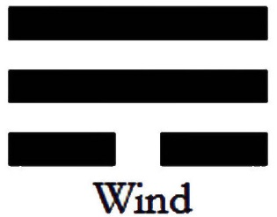 | An adaptable, flexible, and pliable force. Prosperity, gains in wealth and finances, material or financial gains. Money magic. Immediate business success. Road clearing to increase flow of qi and vitality.
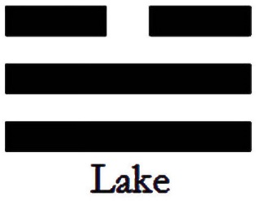 | A nourishing, sustaining, and fertilizing force. Enhancing creativity, innovation; fruition. Safe pregnancy; child-bearing. Creating a servitor. Nurturing new life and legacies.  Long-term business success. | 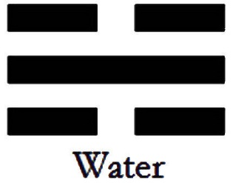 | A flowing, fluent, shifting, and indefinite force. Employment, career matters, professional development. Keeping the momentum of an energy you’ve already initiated. Changing the status quo. Shape-shifting.
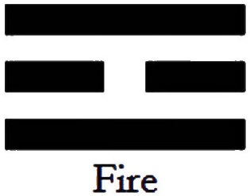 | A radiating, innovative, and clarifying force. Victory, receiving honors, winning awards and accolades. Promotion. Public recognition. Advancement. Ingenuity. Applied sciences; technical know-how. | 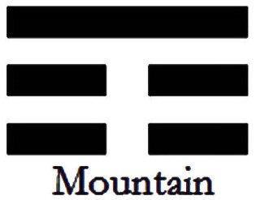 | A preserving, stabilizing, balancing force. Academic success. Cultivating knowledge and education. Doing well on an exam or graduating with honors and distinctions. Intellectual advancements. Activate inner genius.
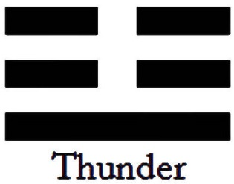 | An inciting, arousing, divisive force. Ancestral connections. Warding and protecting the home. Defensive magic. Safeguarding family, community, state. To agitate qi energy; persuade. | 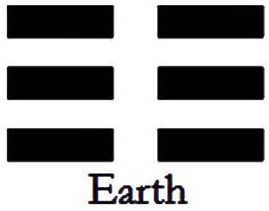 | A steeping, descending, impregnating, engulfing force. Dual Purpose: (1) Love, romance, and relationships. (2) Connection to the underworld or ghosts; hexes, curses.

