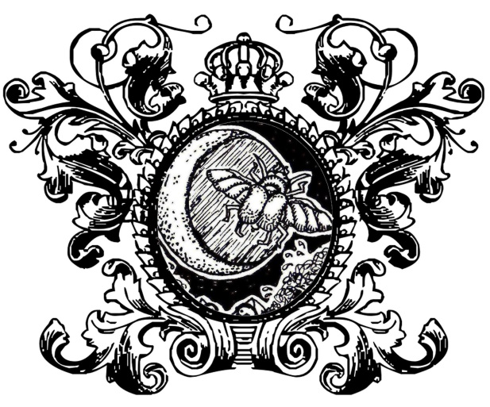

TAROT STUDY JOURNAL

Tarot de Marseille
Rider-Waite-Smith
Crowley-Harris Thoth
Spirit Keeper’s Tarot

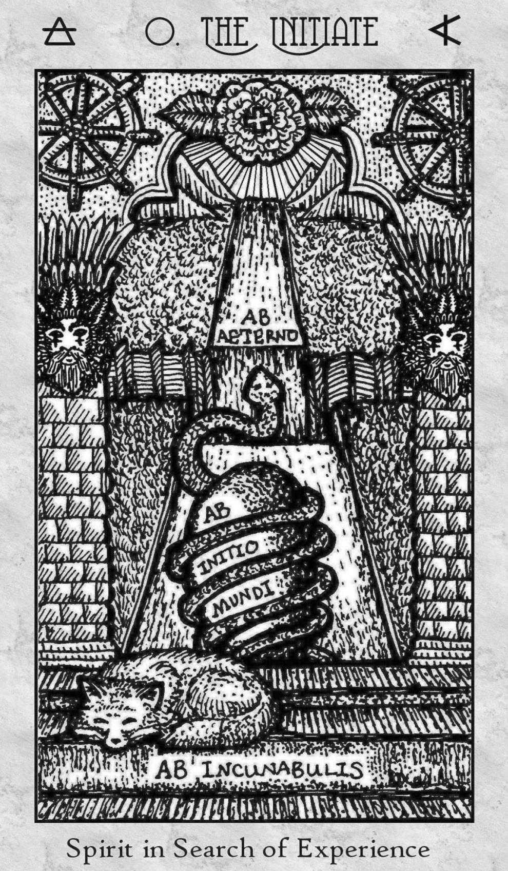

JOURNAL CONTENTS

Tarot Key Reference Tables | 4
Cyclopedia of Card Meanings | 31
Portfolio of Tarot Spreads | 345
The Four Elements: Tarot Correspondences | 367

TAROT KEY
REFERENCE TABLES
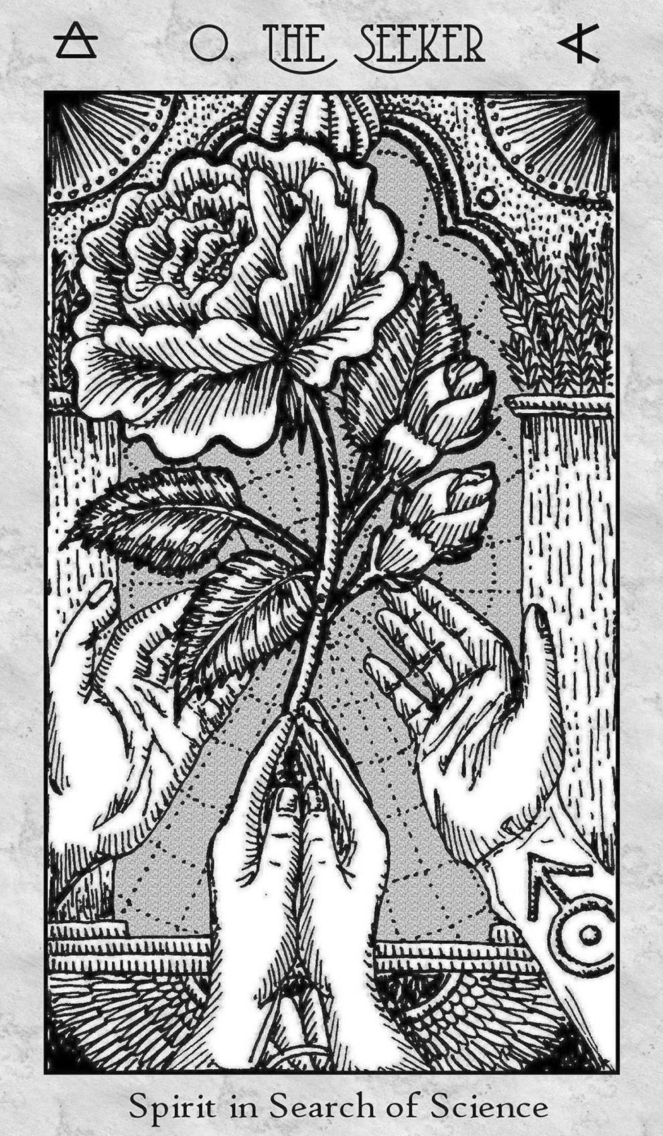
RWS KEYWORDS & REFERENCES FOR THE OPENING OF THE KEY

Rider-Waite-Smith | Keywords |  | Metaphysical  Correspondence | Card Counting
Rider-Waite-Smith | Upright | Reversed | Metaphysical  Correspondence | Card Counting
Key 0 – The Fool | Harbinger | Indiscretion | Air | 3
Key 1 – The Magician | Manifestation | Transformation | Mercury | 9
Key 2 – High Priestess | Perceptivity | Hypocrisy | Moon | 9
Key 3 – The Empress | Abundance | Unproductive | Venus | 9
Key 4 – The Emperor | Dominion | Overpower | Aries | 12
Key 5 – The Hierophant | Tradition | Heterodoxy | Taurus | 12
Key 6 – The Lovers | Moral Choice | Intrusion | Gemini | 12
Key 7 – The Chariot | Control | Turbulence | Cancer | 12
Key 8 – Strength | Compassion | Feral | Leo | 12
Key 9 – The Hermit | Wisdom | Impiety | Virgo | 12
Key 10 – Wheel of For. | Turning Point | Misalignment | Jupiter | 9
Key 11 – Justice | Equilibrium | With Prejudice | Libra | 12
Key 12 – Hanged Man | Sacrifice | Martyrdom | Water | 3
Key 13 – Death | Metamorphosis | Inertia | Scorpio | 12
Key 14 – Temperance | Attunement | Excess | Sagittarius | 12
Key 15 – The Devil | Possession | Severance | Capricorn | 12
Key 16 – The Tower | Shock | Upheaval | Mars | 9
Key 17 – The Star | Hope | Malady | Aquarius | 12
Key 18 – The Moon | Presentment | Speculative | Pisces | 12
Key 19 – The Sun | Glory | Disorientation | Sun | 9
Key 20 – Judgement | Salvation | Misconception | Fire | 3
Key 21 – The World | Consummation | Skepticism | Saturn | 9
Ace of Wands | Opportunity | Procrastination | Sacred Fire | 11
Two of Wands | Aspirations | Expectations | Mars in Aries | 2
Three of Wands | Validation | Oversight | Sun in Aries | 3
Four of Wands | Prosperity | Rite of Passage | Venus in Aries | 4
Five of Wands | Competition | Reconciliation | Saturn in Leo | 5
Six of Wands | Tribute | Mission | Jupiter in Leo | 6
Seven of Wands | Defiance | Anxiety | Mars in Leo | 7
Eight of Wands | Progress | Misfire | Mercury in Sagit. | 8
Nine of Wands | Defense | Depletion | Moon in Sagittarius | 9
Ten of Wands | Burden | Reassessment | Saturn in Sagittarius | 10
Page of Wands | Creativity | Insecurity | Earth in Fire | 7 / 11
Knight of Wands | Intrepid | Intimidated | Air in Fire | 4 / 12
Queen of Wands | Power of Attraction | Capitulation | Water in Fire | 4 / 13
King of Wands | Grandeur | Doctrinaire | Fire in Fire | 4 / 14
Ace of Cups | Fulfillment | Superficiality | Holy Water | 11
Two of Cups | Affinity | Misunderstanding | Venus in Cancer | 2
Three of Cups | Jubilee | Hedonism | Mercury in Cancer | 3
Four of Cups | Introspection | Emergence | Moon in Cancer | 4
Five of Cups | Regret | Moving On | Mars in Scorpio | 5
Six of Cups | Reminiscence | Clinging | Sun in Scorpio | 6
Seven of Cups | Decoys | Purpose Revealed | Venus in Scorpio | 7
Eight of Cups | Detachment | Epicurean | Saturn in Pisces | 8
Nine of Cups | Wish Granted | Greed & Gluttony | Jupiter in Pisces | 9
Ten of Cups | Felicity | Discord | Mars in Pisces | 10
Page of Cups | Dreamer | Quixotic | Earth in Water | 7 / 11
Knight of Cups | Charisma | Discomfiture | Air in Water | 4 / 12
Queen of Cups | The Empath | Manipulation | Water in Water | 4 / 13
King of Cups | Diplomacy | Commotion | Fire in Water | 4 / 14
Ace of Swords | Conquest | Disruption | Sword of the Spirit | 11
Two of Swords | Dueling Missions | Abatement | Moon in Libra | 2
Three of Swords | Strife | Disquiet Mind | Saturn in Libra | 3
Four of Swords | Recuperate | Infirmity | Jupiter in Libra | 4
Five of Swords | Machiavellian | Contrition | Venus in Aquarius | 5
Six of Swords | Migration | Yearning Escape | Mercury in Aquarius | 6
Seven of Swords | Rebel | Scapegoat | Moon in Aquarius | 7
Eight of Swords | Limbo | Emancipation | Jupiter in Gemini | 8
Nine of Swords | Haunted | Ebb & Flow | Mars in Gemini | 9
Ten of Swords | Existential Crisis | Defeat | Sun in Gemini | 10
Page of Swords | Decisive Action | Fallen Angel | Earth in Air | 7 / 11
Knight of Swords | Warrior | Warpath | Air in Air | 4 / 12
Queen of Swords | Indomitable | Elitism | Water in Air | 4 / 13
King of Swords | Intellectualism | Ulterior Motives | Fire in Air | 4 / 14
Ace of Pentacles | Profit | Miles to Go | Bread of Life | 11
Two of Pentacles | Aggregate | Adrift | Jupiter in Capricorn | 2
Three of Pentacles | Investiture | Displacement | Mars in Capricorn | 3
Four of Pentacles | Parsimony | Recession | Sun in Capricorn | 4
Five of Pentacles | Adversity | Reclamation | Mercury in Taurus | 5
Six of Pentacles | Beneficence | Dearth | Moon in Taurus | 6
Seven of Pentacles | Efflorescence | Neglect | Saturn in Taurus | 7
Eight of Pentacles | Diligence | Squandering Talent | Sun in Virgo | 8
Nine of Pentacles | Refinement | Longing | Venus in Virgo | 9
Ten of Pentacles | Prestige | Disengagement | Mercury in Virgo | 10
Page of Pentacles | Scholarship | Materialism | Earth in Earth | 7 / 11
Knight of Pentacles | Methodic | Timidity | Air in Earth | 4 / 12
Queen of Pentacles | Capital | Vulnerability | Water in Earth | 4 / 13
King of Pentacles | Establishment | Shortsighted | Fire in Earth | 4 / 14

COURT CARDS FOR SIGNIFICATORS (TRADITIONAL)

Court Card | Rider-Waite-Smith | Thoth
King / Knight of Wands | Man w/ Sun Sign  Aries, Leo, or Sagittarius | Sun or Rising Sign b/w  21° Scorpio and 20° Sagittarius
King / Knight of Cups | Man w/ Sun Sign  Cancer, Scorpio, or Pisces | Sun or Rising Sign b/w  21° Aquarius and 20° Pisces
King / Knight of Swords | Man w/ Sun Sign  Gemini, Libra, or Aquarius | Sun or Rising Sign b/w  21° Taurus and 20° Gemini
King / Knight of  Pentacles/Disks | Man w/ Sun Sign  Taurus, Virgo, or Capricorn | Sun or Rising Sign b/w  21° Leo and 20° Virgo
Queen of Wands | Woman w/ Sun Sign  Aries, Leo, or Sagittarius | Sun or Rising Sign b/w  21° Pisces and 20° Aries
Queen of Cups | Woman w/ Sun Sign  Cancer, Scorpio, or Pisces | Sun or Rising Sign b/w  21° Gemini and 20° Cancer
Queen of Swords | Woman w/ Sun Sign  Gemini, Libra, or Aquarius | Sun or Rising Sign b/w  21° Virgo and 20° Libra
Queen of Pentacles/Disks | Woman w/ Sun Sign  Taurus, Virgo, or Capricorn | Sun or Rising Sign b/w  21° Sagittarius and 20° Capricorn
Knight / Prince of Wands | Boy w/ Sun Sign  Aries, Leo, or Sagittarius | Sun or Rising Sign b/w  21° Cancer and 20° Leo
Knight / Prince of Cups | Boy w/ Sun Sign  Cancer, Scorpio, or Pisces | Sun or Rising Sign b/w  21° Libra and 20° Scorpio
Knight / Prince of Swords | Boy w/ Sun Sign  Gemini, Libra, or Aquarius | Sun or Rising Sign b/w  21° Capricorn and 20° Aquarius
Knight / Prince of Pentacles/Disks | Boy w/ Sun Sign  Taurus, Virgo, or Capricorn | Sun or Rising Sign b/w  21° Aries and 20° Taurus
Page / Princess of Wands | Girl w/ Sun Sign  Aries, Leo, or Sagittarius | [ Princess cards  are not used  as significators ]
Page / Princess of Cups | Girl w/ Sun Sign  Cancer, Scorpio, or Pisces | [ Princess cards  are not used  as significators ]
Page / Princess of Swords | Girl w/ Sun Sign  Gemini, Libra, or Aquarius | [ Princess cards  are not used  as significators ]
Page / Princess of Pentacles/Disks | Girl w/ Sun Sign  Taurus, Virgo, or Capricorn | [ Princess cards  are not used  as significators ]

CARD TITLES COMPARATIVE REFERENCE TABLE

Tarot de Marseille | Rider-Waite-Smith | Thoth | Spirit Keeper’s Tarot
0: The Fool | 0: The Fool | 0: The Fool | 0: The Initiate  0: The Seeker  0: The Keeper
I: The Magician  (or The Juggler) | I: The Magician | I: The Magus  (or The Juggler) | 1: The Magus
II: The Popess | II: The High Priestess | II: The Priestess  (or The High Priestess) | 2: The Priestess
III: The Empress | III: The Empress | III: The Empress | 3: The Empress
IV: The Emperor | IV: The Emperor | IV: The Emperor | 4: The Emperor
V: The Pope | V: The Hierophant | V: The Hierophant | 5: The Holy See
VI: The Lovers | VI: The Lovers | VI: The Lovers  (or The Brothers) | 6: The Lovers
VII: The Chariot | VII: The Chariot | VII: The Chariot | 7: The Chariot
VIII: Justice  [XI: Strength] | VIII: Strength | VIII: Adjustment  [XI: Lust] | 8: The Force
IX: The Hermit | IX: The Hermit | IX: The Hermit | 9: The Erudite
X: The Wheel of Fortune | X: Wheel of Fortune | X: Fortune | 10: Wheel of Life
XI: Strength  [VIII: Justice] | XI: Justice | XI: Lust  [VIII: Adjustment] | 11: The Chancellor
XII: The Hanged Man | XII: The Hanged Man | XII: The Hanged Man | 12: The Outlaw
XIII: Death  (Untitled) | XIII: Death | XIII: Death | 13: The Reaper
XIV: Temperance | XIV: Temperance | XIV: Art | 14: The Angel
XV: The Devil | XV: The Devil | XV: The Devil | 15: The Demon
XVI: The Tower  (or The House of God) | XVI: The Tower | XVI: The Tower  (or War) | 16: The Tower

Tarot de Marseille | Rider-Waite-Smith | Thoth | Spirit Keeper’s Tarot
XVII: The Star | XVII: The Star | XVII: The Star | 17: The Healer
XVIII: The Moon | XVIII: The Moon | Key XVIII: The Moon | 18: The Necromancer
XIX: The Sun | XIX: The Sun | Key XIX: The Sun | 19: The Warrior
XX: The Judgment | XX: Judgment | Key XX: The Aeon | 20: Apocalypse
XXI: The World | XXI: The World | Key XXI: The Universe | 21: New World Order
Ace of Batons | Ace of Wands | Root of the Powers of Fire | Sacred Fire  Ace of Scepters
Two of Batons | Two of Wands | Two of Wands: Dominion | The Discerning One  Two of Scepters
Three of Batons | Three of Wands | Three of Wands: Virtue | The Politic  Three of Scepters
Four of Batons | Four of Wands | Four of Wands: Completion | The Demiurge  Four of Scepters
Five of Batons | Five of Wands | Five of Wands: Strife | The Contender  Five of Scepters
Six of Batons | Six of Wands | Six of Wands: Victory | The Champion  Six of Scepters
Seven of Batons | Seven of Wands | Seven of Wands: Valour | The Dark Horse  Seven of Scepters
Eight of Batons | Eight of Wands | Eight of Wands: Swiftness | The Sharpshooter  Eight of Scepters
Nine of Batons | Nine of Wands | Nine of Wands: Strength | The Malaise  Nine of Scepters
Ten of Batons | Ten of Wands | Ten of Wands: Oppression | The Burdened One  Ten of Scepters
Page of Batons | Page of Wands | Princess of Wands | Stronghold of the Flame  Page of Scepters

Tarot de Marseille | Rider-Waite-Smith | Thoth | Spirit Keeper’s Tarot
Knight of Batons | Knight of Wands | Prince of Wands | The Shining Flame  Knight of Scepters
Queen of Batons | Queen of Wands | Queen of Wands | The Golden Shield  Queen of Scepters
King of Batons | King of Wands | Knight of Wands | Archangel of Glory  King of Scepters
Ace of Cups | Ace of Cups | Root of the Powers of Water | Holy Water  Ace of Chalices
Two of Cups | Two of Cups | Two of Cups: Love | The Joined One  Two of Chalices
Three of Cups | Three of Cups | Three of Cups: Abundance | The Kindred  Three of Chalices
Four of Cups | Four of Cups | Four of Cups: Luxury | The Hollow Void  Four of Chalices
Five of Cups | Five of Cups | Five of Cups: Disappointment | The Grotesque  Five of Chalices
Six of Cups | Six of Cups | Six of Cups: Pleasure | The Memory Keeper  Six of Chalices
Seven of Cups | Seven of Cups | Seven of Cups: Debauch | The Corrupter  Seven of Chalices
Eight of Cups | Eight of Cups | Eight of Cups: Indolence | The Defector  Eight of Chalices
Nine of Cups | Nine of Cups | Nine of Cups: Happiness | The Wish Granted  Nine of Chalices
Ten of Cups | Ten of Cups | Ten of Cups: Satiety | The Joyous One  Ten of Chalices
Page of Cups | Page of Cups | Princess of Cups | Stronghold of the Grail  Page of Chalices
Knight of Cups | Knight of Cups | Prince of Cups | The Shining Dew  Knight of Chalices

Tarot de Marseille | Rider-Waite-Smith | Thoth | Spirit Keeper’s Tarot
Queen of Cups | Queen of Cups | Queen of Cups | The Ivory Shield  Queen of Chalices
King of Cups | King of Cups | Knight of Cups | Archangel of Healing  King of Chalices
Ace of Swords | Ace of Swords | Root of the Powers of Air | Sacred Cinnabar  Ace of Swords
Two of Swords | Two of Swords | Two of Swords: Peace | The Blind Seer  Two of Swords
Three of Swords | Three of Swords | Three of Swords: Sorrow | The Bereaved  Three of Swords
Four of Swords | Four of Swords | Four of Swords: Truce | The Convalescent  Four of Swords
Five of Swords | Five of Swords | Five of Swords: Defeat | The Hector  Five of Swords
Six of Swords | Six of Swords | Six of Swords: Science | The Ferryman  Six of Swords
Seven of Swords | Seven of Swords | Seven of Swords: Futility | The Rogue  Seven of Swords
Eight of Swords | Eight of Swords | Eight of Swords: Interference | The Captor  Eight of Swords
Nine of Swords | Nine of Swords | Nine of Swords: Cruelty | The Haunt  Nine of Swords
Ten of Swords | Ten of Swords | Ten of Swords: Ruin | The Destroyer  Ten of Swords
Page of Swords | Page of Swords | Princess of Swords | Stronghold of the Zephyrs  Page of Swords
Knight of Swords | Knight of Swords | Prince of Swords | The Shining Winds  Knight of Swords
Queen of Swords | Queen of Swords | Queen of Swords | The Scarlet Shield  Queen of Swords

Tarot de Marseille | Rider-Waite-Smith | Thoth | Spirit Keeper’s Tarot
King of Swords | King of Swords | Knight of Swords | Archangel Commander  King of Swords
Ace of Coins | Ace of Pentacles | Root of the Powers of Earth | Bread of Life  Ace of Orbs
Two of Coins | Two of Pentacles | Two of Disks: Change | The Nocturne  Two of Orbs
Three of Coins | Three of Pentacles | Three of Disks: Works | The Mason  Three of Orbs
Four of Coins | Four of Pentacles | Four of Disks: Power | The Conservator  Four of Orbs
Five of Coins | Five of Pentacles | Five of Disks: Worry | The Vagabond  Five of Orbs
Six of Coins | Six of Pentacles | Six of Disks: Success | The Giver  Six of Orbs
Seven of Coins | Seven of Pentacles | Seven of Disks: Failure | The Gardener  Seven of Orbs
Eight of Coins | Eight of Pentacles | Eight of Disks: Prudence | The Journeyman  Eight of Orbs
Nine of Coins | Nine of Pentacles | Nine of Disks: Gain | The Eminence  Nine of Orbs
Ten of Coins | Ten of Pentacles | Ten of Disks: Wealth | The Dynasty  Ten of Orbs
Page of Coins | Page of Pentacles | Princess of Disks | Stronghold of the Vale  Page of Orbs
Knight of Coins | Knight of Pentacles | Prince of Disks | The Shining Quarry  Knight of Orbs
Queen of Coins | Queen of Pentacles | Queen of Disks | The Ebony Shield  Queen of Orbs
King of Coins | King of Pentacles | Knight of Disks | Archangel of Mysteries  King of Orbs

KEY CORRESPONDENCES FOR THE MAJOR ARCANA

Element | Major Arcanum | Hebrew Letter | Pitch | Color Wave | Golden Dawn
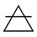 | Key 0 – The Fool | Aleph | E | Pale Yellow | Air
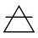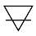 | Key 1 – The Magician | Beth | E | Bold Yellow | Mercury
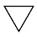 | Key 2 – High Priestess | Gimmel | G sharp | Blue | Moon
 | Key 3 – The Empress | Daleth | F sharp | Emerald | Venus
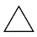 | Key 4 – The Emperor | Heh | C | Scarlet Red | Aries
 | Key 5 – The Hierophant | Vav | C sharp | Red-Orange | Taurus
 | Key 6 – The Lovers | Zain | D | Orange | Gemini
 | Key 7 – The Chariot | Cheth | D sharp | Amber | Cancer
 | Key 8 – Strength | Teth | E | Lime | Leo
 | Key 9 – The Hermit | Yod | F | Chartreuse | Virgo
 | Key 10 – Wheel of For. | Kaph | A sharp | Violet | Jupiter
 | Key 11 – Justice | Lamed | F sharp | Emerald | Libra
 | Key 12 – Hanged Man | Mem | G sharp | Dark Blue | Water
 | Key 13 – Death | Nun | G | Blue-Green | Scorpio
 | Key 14 – Temperance | Samekh | G sharp | Blue | Sagittarius
 | Key 15 – The Devil | Ayin | A | Blue-Violet | Capricorn
 | Key 16 – The Tower | Peh | C | Scarlet Red | Mars
 | Key 17 – The Star | Tzaddi | A sharp | Violet | Aquarius
 | Key 18 – The Moon | Qoph | B | Magenta | Pisces
 | Key 19 – The Sun | Resh | D | Orange | Sun
 | Key 20 – Judgement | Shin | C | Carnelian | Fire
 | Key 21 – The World | Tav | (rest note) | Indigo | Saturn

Golden Dawn derives its 12 zodiac attributions and 3 elemental attributions from the Sepher Yetzirah but revised the 7 planetary attributions to follow their own theosophical system of planetary attributions.

KEY CORRESPONDENCES FOR THE MAJOR ARCANA

Major Arcanum | Sefirot Path | Modern  Astrology | Hebrew  Letter | Phoenician Alphabet
Key 0 – The Fool | Keter to Chokhmah | ♅ | א | 
Key 1 – The Magician | Keter to Binah | ☿ | ב | 
Key 2 – High Priestess | Keter to Tiferet | ☽ | ג | 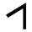
Key 3 – The Empress | Chokhmah to Binah | ♀ | ד | 
Key 4 – The Emperor | Chokhmah to Tiferet |  | ה | 
Key 5 – The Hierophant | Chokhmah to Chesad |  | ו | 
Key 6 – The Lovers | Binah to Tiferet |  | ז | 
Key 7 – The Chariot | Binah to Gevurah |  | ח | 
Key 8 – Strength | Chesad to Gevurah |  | ט | 
Key 9 – The Hermit | Chesad to Tiferet |  | י | 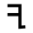
Key 10 – Wheel of For. | Chesad to Netzach | ♃ | כ | 
Key 11 – Justice | Gevurah to Tiferet |  | ל | 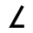
Key 12 – Hanged Man | Gevurah to Hod | ♆ | מ | 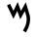
Key 13 – Death | Tiferet to Netzach |  | נ | 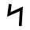
Key 14 – Temperance | Tiferet to Yesod |  | ס | 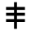
Key 15 – The Devil | Tiferet to Hod |  | ע | 
Key 16 – The Tower | Netzach to Hod | ♂ | פ | 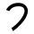
Key 17 – The Star | Netzach to Yesod |  | צ | 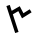
Key 18 – The Moon | Netzach to Malkuth |  | ק | 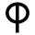
Key 19 – The Sun | Hod to Yesod | ☉ | ר | 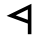
Key 20 – Judgement | Hod to Malkuth |  | ש | 
Key 21 – The World | Yesod to Malkuth | ♄ | ת | 

KEY CORRESPONDENCES FOR THE MAJOR ARCANA

Reconciliation and synthesis of Hermetic, Theosophical, and Mary K. Greer texts.

Major Arcanum | Personality Number | Soul  Number | Theosophical Septenary | Attribute  Manifested
Key 0 – The Fool | 22 | 4 | ------- | Inaugurate
Key 1 – The Magician | 1 | 1 | Self | Focus, Mastery
Key 2 – High Priestess | 2 | 2 | Soul | Esoteric Knowledge
Key 3 – The Empress | 3 | 3 | Will | Creativity, Mettā
Key 4 – The Emperor | 4 | 4 | Desire | Temporal Power
Key 5 – The Hierophant | 5 | 5 | Force | Spiritual Power
Key 6 – The Lovers | 6 | 6 | Astral | Passion
Key 7 – The Chariot | 7 | 7 | Material | Creating Change
Key 8 – Strength | 8 | 8 | Self | Audacity, Bravura
Key 9 – The Hermit | 9 | 9 | Soul | Wisdom, Guidance
Key 10 – Wheel of For. | 10 | 1 | Will | Consequence, Karma
Key 11 – Justice | 11 | 2 | Desire | Truth, Veracity
Key 12 – Hanged Man | 12 | 3 | Force | Mindfulness
Key 13 – Death | 13 | 4 | Astral | Transmutation
Key 14 – Temperance | 14 | 5 | Material | Equanimity
Key 15 – The Devil | 15 | 6 | Self | Rapture
Key 16 – The Tower | 16 | 7 | Soul | Demolish, Oust
Key 17 – The Star | 17 | 8 | Will | Healing, Mending
Key 18 – The Moon | 18 | 9 | Desire | Revealing
Key 19 – The Sun | 19 | 1 | Force | Heroic Acts
Key 20 – Judgement | 20 | 2 | Astral | Epiphany, Announce
Key 21 – The World | 21 | 3 | Material | Divine Androgyne

According to Greer, the Personality Number is the first theosophical reduction of the sum of your birth month, birth day, and birth year, down to 1 through 22. If that number is a single digit, then that is also your Soul Number. If the Personality Number is double digits, then reduce the double digits to a single digit, 1 through 9, and that is your Soul Number. Ex. For someone born March 18, 1988, the Personality Number is 11 (The Chancellor) and the Soul Number is 2 (The Priestess). The Personality Number is your innate character, disposition, persona, and temperament. It’s your psyche. The Soul Number sheds light on your life purpose, the Great Work destined by your soul, and how best you personally contribute to the greater good. Soul Numbers 1-3 have 3 Keys; all others have 2.

SKT PIP CARDS AND DECAN RULERSHIP CORRESPONDENCES

Tarot Card | Dates | Decan Ruler, Sun’s Degree
Two of Scepters | Mar. 21 – Mar. 30 | Mars in Aries 0° - 10°
Three of Scepters | Mar. 31 – Apr. 10 | Sun in Aries 11° - 20°
Four of Scepters | Apr. 11 – Apr. 20 | Venus in Aries 21° - 30°
Five of Scepters | Jul. 21 – Aug. 1 | Saturn in Leo 0° - 10°
Six of Scepters | Aug. 2 – Aug. 10 | Jupiter in Leo 11° - 20°
Seven of Scepters | Aug. 11 – Aug. 22 | Mars in Leo 21° - 30°
Eight of Scepters | Nov. 23 – Dec. 2 | Mercury in Sagittarius 0° - 10°
Nine of Scepters | Dec. 3 – Dec. 12 | Moon in Sagittarius 11° - 20°
Ten of Scepters | Dec. 13 – Dec. 20 | Saturn in Sagittarius 21° - 30°
Two of Chalices | Jun. 21 – Jul. 1 | Venus in Cancer 0° - 10°
Three of Chalices | Jul. 2 – Jul. 12 | Mercury in Cancer 11° - 20°
Four of Chalices | Jul. 13 – Jul. 20 | Moon in Cancer 21° - 30°
Five of Chalices | Oct. 23 – Nov. 1 | Mars in Scorpio 0° - 10°
Six of Chalices | Nov. 2 – Nov. 11 | Sun in Scorpio 11° - 20°
Seven of Chalices | Nov. 12 – Nov. 22 | Venus in Scorpio 21° - 30°
Eight of Chalices | Feb. 19 – Feb. 28 | Saturn in Pisces 0° - 10°
Nine of Chalices | Mar. 1 – Mar. 10 | Jupiter in Pisces 11° - 20°
Ten of Chalices | Mar. 11 – Mar. 20 | Mars in Pisces 21° - 30°
Two of Swords | Sep. 23 – Oct. 2 | Moon in Libra 0° - 10°
Three of Swords | Oct. 3 – Oct. 12 | Saturn in Libra 11° - 20°
Four of Swords | Oct. 13 – Oct. 22 | Jupiter in Libra 21° - 30°
Five of Swords | Jan. 20 – Jan. 29 | Venus in Aquarius 0° - 10°
Six of Swords | Jan. 31– Feb. 8 | Mercury in Aquarius 11° - 20°
Seven of Swords | Feb. 9 – Feb. 18 | Moon in Aquarius 21° - 30°
Eight of Swords | May 21 – May 30 | Jupiter in Gemini 0° - 10°
Nine of Swords | Jun. 1 – Jun. 10 | Mars in Gemini 11° - 20°
Ten of Swords | Jun. 11 – Jun. 20 | Sun in Gemini 21° - 30°
Two of Orbs | Dec. 21 – Dec. 30 | Jupiter in Capricorn 0° - 10°
Three of Orbs | Dec. 31 – Jan. 9 | Mars in Capricorn 11° - 20°
Four of Orbs | Jan. 10 – Jan. 19 | Sun in Capricorn 21° - 30°
Five of Orbs | Apr. 21 – Apr. 30 | Mercury in Taurus 0° - 10°
Six of Orbs | May 1 – May 10 | Moon in Taurus 11° - 20°
Continued from previous page

Tarot Card | Dates | Decan Ruler, Sun’s Degree
Seven of Orbs | May 11 – May 20 | Saturn in Taurus 21° - 30°
Eight of Orbs | Aug. 23 – Sep. 1 | Sun in Virgo 0° - 10°
Nine of Orbs | Sept. 2 – Sep. 11 | Venus in Virgo 11° - 20°
Ten of Orbs | Sep. 12 – Sep. 22 | Mercury in Virgo 21° - 30°

THE FOUR ELEMENTS AND HUMAN ORGAN SYSTEMS

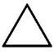  Fire | 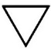  Water | 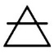  Air | 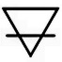  Earth
Cardiovascular  Blood circulation, transport of nutrients, amino acids, electrolytes, hormones; health of red blood cells; homeostasis; iron intake, folic acid, vitamin B12 | Endocrine  Pineal gland, pituitary, thyroid, adrenal, pancreas, testis or ovary; neural control; glucose level; mood, stress; sensory perception | Respiratory  Ventilation of the body; gas exchange; sinuses; nose; pharynx; larynx; trachea; lungs; diaphragm; breathing issues | Skeletal  Bones, cartilage; supporting structure; calcium and phosphate levels; nutrient levels in protein, magnesium, fluorite, or potassium
Muscular  Muscles, posture, movement, physical strength, body heat; chronic pain; inflammation of muscle tissue; muscle weakness; nutrient levels for protein, niacin, or B vitamins | Urinary  Kidneys, ureters, bladder, urethra; waste regulation; metabolites; internal toxins; check nutrient levels of potassium, sodium, or phosphorous | Nervous  Brain; spinal cord; nervous tissue; neurons; signal function between the cells; nutrient levels for omega-3, choline, vitamins E & K | Integumentary  Skin; sweat glands; pores; epidermis, dermis, and hypodermis; hair and nails; Vitamin D levels; collagen levels; disease or injury to the skin; check fatty acids intake; zinc, biotin
Reproductive  (Male). Sex organs; hormones, virility, sexual reproduction functions; genitalia; coenzyme Q10, folate, zinc, or B vitamin levels | Reproductive  (Female). Menstrual issues, sex organs; fertility; hormones; check iron levels; folic acid and calcium | Lymphatic  Immune system; lymph nodes; thoracic duct or thymus; spleen; lymph fluid; check vitamins C and E intake | Digestive  Gastrointestinal tract; tongue, salivary glands; pancreas; liver; gallbladder; digestive issues; mouth and teeth

Medical Astrology: Twelve Zodiac Signs Correspondences
Aries | Head, brain, face, eyes; vision; solar plexus chakra  Spiritual Practices:  Yoga, martial arts, vision therapy or visual training, psychic training | Libra | Lumbar, kidneys, skin; skin conditions; heart chakra  Spiritual Practices:  Music or sound therapy, massage therapy, aura clearing; art therapy
Taurus | Throat, neck, thyroid; heart chakra; throat chakra  Spiritual Practices:  Fasting or ritual feasting; grounding, closeness to nature; hand mudras | Scorpio | Reproductive organs, bowels; solar plexus chakra  Spiritual Practices:  Ceremonial magic; tantric practices; shamanism; dream yoga; dreamwork
Gemini | Nervous system, lungs, arms, shoulders; throat chakra  Spiritual Practices:  Mindfulness meditation, channeling, fellowship; signing or mantra recitation | Sagittarius | Liver, sciatic nerve, lower back, spine, thighs, hips; sacral chakra  Spiritual Practices:  Spiritual retreat; world travel; journaling; a pilgrimage; sacred vows
Cancer | Chest, heart, hands; crown chakra  Spiritual Practices:  Poetry, past life exploration, solitude; purification ritual | Capricorn | Calves, legs, knees, joints, bones, skeleton; root chakra  Spiritual Practices:  Connecting to animal totems; tulpa summoning; tai chi; martial arts
Leo | Upper back, heart, spine; third eye chakra  Spiritual Practices:  Dance, art therapy, tai chi, outdoor group activities; ritual use of mandalas | Aquarius | Circulatory system, blood, ankles, calves; root chakra  Spiritual Practices:  Mindful meditation, affirmation work, energy healing; charity work
Virgo | Stomach, digestive system; throat chakra  Spiritual Practices:  Qi gong, energy healing, aromatherapy, thaumaturgy; intensive study of sacred texts | Pisces | Feet, toes, lymphatic system; immune system; sacral chakra; crown chakra  Spiritual Practices:  Purification ritual, mantra recitation, shielding; acts of mercy and forgiveness

Medical Astrology: The Sacred Seven Planetary Correspondences
Sun | Heart, circulatory system; cardiovascular system; spine, and respiratory system; male organs; face, eyes, and head area; Third eye chakra
Moon | Digestive system, lymphatic system; sixth sense and pineal gland; female organs; crown, top of head; Crown chakra
Mercury | Brain, central nervous system, thyroids, the five physical senses, hands; lymphatic system; neck area; Throat chakra
Venus | Throat, kidneys, pancreas; urinary system; metabolism; also, ovaries and reproductive system; immune system; upper center of body; Heart chakra
Mars | Adrenal glands; muscular system; immune system; gut and center of body; Solar plexus chakra
Jupiter | Pituitary gland; liver; thighs; lower center of body; Sacral chakra
Saturn | Integumentary system (skin, hair, nails; exocrine glands); teeth; skeletal system; lower part of body; Root chakra

THE FOUR ELEMENTS, FOUR SUITS, AND TIMING CORRESPONDENCES

Fire  Scepters | Water  Chalices | Air  Swords | Earth  Orbs
Days or  Short-Term | Months or  In Gestation | Weeks or  Peaking Soon | Years or  Long-Term
Spring | Summer | Fall | Winter
New Moon | Waxing Moon | Full Moon | Waning Moon

GEMATRIA: THE SKT MAJOR ARCANA AND THE SEMITIC ALPHABET

Major Arcanum | Hebrew Letter | Phoenician Alphabet | Primary Force(s); Path Color; Esoteric Title  Thirty-Two Paths of Wisdom (W. Wescott)
0: Seeker | א  Alef | Ox | Scintillating; The Spiritual Self & Supreme Mysteries (Activating); Bright Pale Yellow; The Spirit of the Aether
1: Magus | ב  Bet | House | Transparency; The Spiritual Self & Supreme Mysteries (Formative); Yellow; Theme of Life and Death; The Magus of Power
2: Priestess | ג  Gimel | Camel | Uniting; Blue; Theme of Peace and War; Princess of the Silver Star
3: Empress | ד  Dalet | Door | Illuminating; The Spiritual Self & Supreme Mysteries (Balancing); Emerald Green; Theme of Wisdom and Folly; Daughter of the Mighty Ones
4: Emperor | ה  He | Window | Constituting; Scarlet; Sun of the Morning, Chief Among the Mighty
5: Holy See | ו  Vav | Nail | Triumphal; Red-Orange; The Magus of the Eternal
6: Lovers | ז  Zayin | Sword | Disposing; Orange; Children of the Voice; Oracle of the Mighty Gods
7: Chariot | ח  Chet | Courtyard | Influence; Red-Orange; Child of the Powers of the Waters; Lord of the Triumph of Light
8: Force | ט  Tet | Snake | Activities ; The Higher Self & Greater Mysteries (Balancing); Yellow-Green; Daughter of the Flaming Sword
9: Erudite | י  Yod | Hand | Will; The Higher Self & Greater Mysteries (Activating); Yellow-Green; The Prophet of the Eternal; Magus of the Voice of Power
10: Wheel  of Life | כ  Kaf | Fist | Conciliation; Violet; Theme of Riches and Poverty; Lord of the Forces of Life
11: Chancellor | ל  Lamed | Goad | Faithful; The Higher Self & Greater Mysteries (Formative); Emerald Green; Daughter of the Lords of Truth; Ruler of the Balance

Continued from previous page

Major Arcanum | Hebrew Letter | Phoenician Alphabet | Primary Force(s); Path Color; Esoteric Title  Thirty-Two Paths of Wisdom (W. Wescott)
12: Outlaw | מ  Mem | Water | Stable; Deep Blue; Sacred Water; The Spirit of the Mighty Waters
13: Reaper | נ  Nun | Fish | Imaginative; Green-Blue; Movement; The Child of the Great Transformers; Lord of the Gate of Death
14: Angel | ס  Samech | Peg | Probation; Blue; Daughter of the Reconcilers, Bringer Forth of Life
15: Demon | ע  Ayin | Eye | Renovating; Indigo; Mirth; The Lord of the Gates of Matter; Child of the Forces of Time
16: Tower | פ  Pay | Mouth | Exciting; The Personality & Lesser Mysteries (Balancing); Scarlet; Theme of Grace and Indignation; The Lord of the Hosts of the Mighty
17: Healer | צ  Tsade | Hook | Natural; The Personality & Lesser Mysteries (Formative); Violet; Imagination; The Daughter of the Firmament; Dweller Between the Waters
18: Necromancer | ק  Qof | Ear | Corporeal; Crimson; Sleep; The Ruler of Flux and Reflux, Child of the Sons of the Mighty
19: Warrior | ר  Resh | Head | Collecting; The Personality & Lesser Mysteries (Activating); Orange; Theme of Fertility-Barrenness; The Lord of the Fire of the World
20: Apocalypse | ש  Shin | Tooth | Perpetual; Glowing Orange Scarlet; The Primal Fire; The Spirit of the Primal Fire
21: New  World Order | ת  Tav | Cross | Administrative; Indigo; Theme of Power and Servitude; The Great One of the Night of Time

GEMATRIA: THE SKT MAJOR ARCANA AND CHINESE GAN-ZHI

The 22 Majors and the 22 Gan-Zhi in Traditional Regular Script
  Major Arcanum | Heavenly  Stem | Earthly  Branch
  0  Seeker | 乙  (yǐ)
  1: Magus |  | 辰  (chén)
  2: Priestess | 癸  (guǐ)
  3: Empress | 辛  (xīn)
  4: Emperor | 庚  (gēng)
  5: Holy See |  | 戌  (xū)
  6: Lovers |  | 巳  (sì)
  7: Chariot |  | 寅  (yín)
  8:  orce | 丁  (ding)
  9: Erudite | 戊  (wù)
  10: Wheel  of Life |  | 午  (wǔ)
  Major Arcanum | Heavenly  Stem | Earthly  Branch
  11: Chancellor | 甲  (jiǎ)
  12: Outlaw |  | 丑  (chǒu)
  13: Reaper |  | 亥  (hài)
  14: Angel |  | 申  (shēn)
  15: Demon | 己  (jǐ)
  16: Tower |  | 子  (zǐ)
  17: Healer |  | 酉  (yǒu)
  18: Necromancer | 壬  (rén)
  19: Warrior | 丙  (bing)
  20: Apocalypse |  | 未  (wèi)
  21: New  World Order |  | 卯  (mǎo)

The 22 Majors and the 22 Gan-Zhi in Ancient Oracle Bone and Seal Script

  Major Arcanum | Heavenly  Stem | Earthly  Branch
  0: Se  ker | 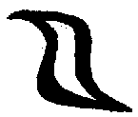
  1: Magus |  | 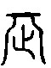
  2: Priestess | 
  3: Empress | 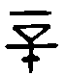
  4: Emperor | 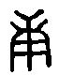
  5: Holy See |  | 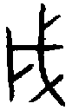
  6: Lovers |  | 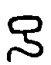
  7: Chariot |  | 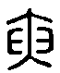
  8: Force | 
  9: Erudite | 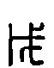
  10: Wheel  of Life |  | 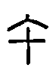
  Major Arcanum | Heavenly  Stem | Earthly  Branch
  11: Chancellor | 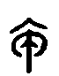
  12: Outlaw |  | 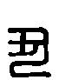
  13: Reaper |  | 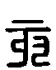
  14: Angel |  | 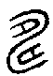
  15: Demon | 
  16: Tower |  | 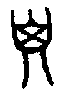
  17: Healer |  | 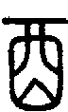
  18: Necromancer | 
  19: Warrior | 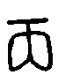
  20: Apocalypse |  | 
  21: New  World Order |  | 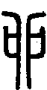

Heavenly Stem Correspondences

Heavenly Stem | Binary | Wu Xing  Direction | Image: Essential Nature | Correspondences | Tarot Card
甲  (jiǎ) | Yang | Wood  East | The trunk of a tree: social justice | Initiations, surge, push; sprouting and breaking through earth; artistic or literary endeavors; raising generative or regenerative power; justice | Key 11  Chancellor
乙  (yǐ) | Yin | Wood  East | Bamboo shoot: mercy and compassion | Early development; movement around barriers; flexibility, adaptability; absolve past transgressions; ensure success of new business ventures; facilitate transition into new life stage | Key 0  Seeker  (Initiate)  (Keeper)
丙  (bing) | Yang | Fire  South | The sun: extroverted strength and intelligence | Expansion; knowledge and understanding; gaining clarity; career success; performing arts; social status and gains; public recognition for merits | Key 19  Warrior
丁  (ding) | Yin | Fire  South | The cauldron: warmth and nurture; alchemy | Full manifestation; peak of strength; magician’s secret power; increase Qi; amplify transmutation; spiritual cultivation | Key 8  Force

Heavenly Stem | Binary | Wu Xing  Direction | Image: Essential Nature | Correspondences | Tarot Card
戊  (wù) | Yang | Earth  Center | Mountain: integrity and stability | Flourishing; luxury; prosperity, stability and security, ensure longevity; also used to create obstacles and impediments to thwart another’s success | Key 9  Erudite
己  (jǐ) | Yin | Earth  Center | Soil: creation, procreation, fertility, birth | Distinction; hidden gifts; the occulted; promote creativity and fertility; ensure safe childbirth; artistic energy | Key 15  Demon
庚  (gēng) | Yang | Metal  West | Iron ore, the sword: decisiveness; the sharp and analytical mind | Ripeness; assure victory in combat or litigation; social, political, or military success; strike back to defeat another | Key 4 Emperor
辛  (xīn) | Yin | Metal  West | Gold jewelry, bronze vase: elegance, refinement, nobility | Harvest; enhance beauty or romantic attraction; enhance wit, charm, social graces; gains in status; use to cause misery or hardship to another; use to inflict suffering on another | Key 3 Empress
壬  (rén) | Yang | Water  North | Rivers, waterfalls: commerce, cultivation | Life begins to form in the womb; forge clear path to success; generate Qi to improve physical health and vitality; mitigate illness; health magic | Key 18  Necro-  mancer
癸  (guǐ) | Yin | Water  North | Snowfall, morning dew: gentle influence, wisdom | Prophesy; divine knowledge gained; communion with Heaven; facilitate prophetic and intuitive abilities | Key 2  Priestess

Earthly Branch Correspondences

Earthly Branch | Correspondences | Tarot Card
寅  (yín) | Advancement forward; first signs of growth sprouting from the ground; competition, combat, bravery, increasing willpower  Wu Xing: Wood  Zodiac Sign: Tiger  Calendar Yr.: Early Spring, Feb 3-20 | Key 7  Chariot
卯  (mǎo) | Flourishing; a surge; fertility, relationships, luxury, domestic bliss, compassion  Wu Xing: Wood; Metal  Zodiac Sign: Rabbit  Calendar Yr.: Mid-Spring, Mar 5-22 | Key 21  New World Order
辰  (chén) | Full awakening; ambitions, achievement, raising power of the magician; innovation  Wu Xing: Wood; Earth  Zodiac Sign: Dragon  Calendar Yr.: Late Spring, Apr 4-21 | Key 1 Magus
巳  (sì) | Near ripeness; science, innovation, scholarship, psychic powers, raising intuitive ability; defensive magic, protection  Wu Xing: Fire  Zodiac Sign: Snake  Calendar Yr.: Early Summer, May 5-22 | Key 6  Lovers
午  (wǔ) | Growth at its peak; successful social engagements; business prosperity, material abundance, gains in social status  Wu Xing: Fire  Zodiac Sign: Horse  Calendar Yr.: Midsummer, Jun 5-22 | Key 10  Wheel of Life
未  (wèi) | Fully ripe; uncertainty; unknowns; mediation, temperance, harmony, adding resources where it was lacking  Wu Xing: Fire  Zodiac Sign: Sheep  Calendar Yr.: Late Summer, Jul 6-24 | Key 20  Apocalypse

Earthly Branch | Correspondences | Tarot Card
未  (wèi) | Fully ripe; uncertainty; unknowns; mediation, temperance, harmony, adding resources where it was lacking  Wu Xing: Fire | Zodiac Sign: Sheep  Calendar Yr.: Late Summer, Jul 6-24 | Key 20  Apocalypse
申  (shēn) | Expansion; intelligence, wit, increasing talent; versatility; ingenuity; health and personal vitality  Wu Xing: Metal | Zodiac Sign: Monkey  Calendar Yr.: Early Autumn, Aug 7-24 | Key 14 Angel
酉  (yǒu) | Gathering and fermenting after an abundance harvest; gains in social status; teaching profession; entertainment; arts and culture  Wu Xing: Metal | Zodiac Sign: Rooster  Calendar Yr.: Mid-Autumn, Sep 7-24 | Key 17  Healer
戌  (xū) | Retreating from visibility; health and vitality; resources; legal matters; career development; political favor, social prominence and popularity  Wu Xing: Metal; Earth | Zodiac Sign: Dog  Calendar Yr.: Late Autumn, Oct 8-24 | Key 5  Holy See
亥  (hài) | Seed awaiting its next growth cycle; tranquility, domestic sphere, improving health, defensive magic, protection from harm  Wu Xing: Water | Zodiac Sign: Boar  Calendar Yr.: Early Winter, Nov 7-23 | Key 13  Reaper
子  (zǐ) | Yang occulted in yin: life inside a womb; money magic; business success; financial investments; use to thwart another’s financial or business success; property  Wu Xing: Water | Zodiac Sign: Rat  Calendar Yr.: Mid-Winter, Dec 6-23 | Key 16  Tower
丑  (chǒu) | Intertwining energy; growing first roots; defensive magic, protection from harm; professional or personal stability; year-round prosperity; security; health  Wu Xing: Water; Earth | Zodiac Sign: Ox  Calendar Yr.: Late Winter, Jan 5-21 | Key 12  Outlaw
TAROT & THE TREE OF LIFE

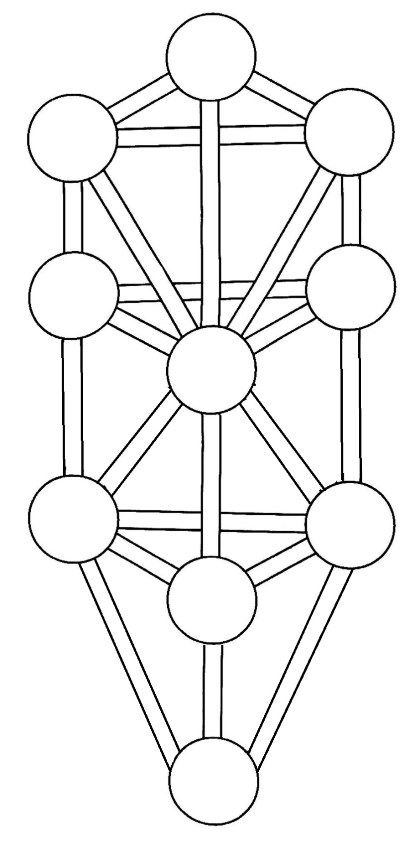
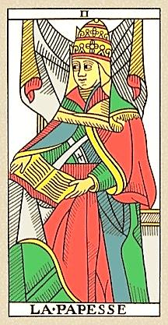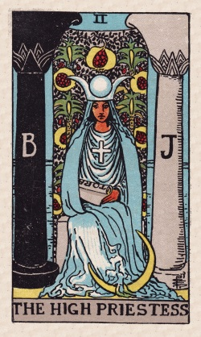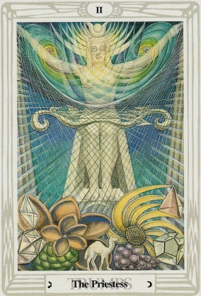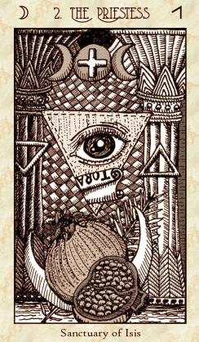

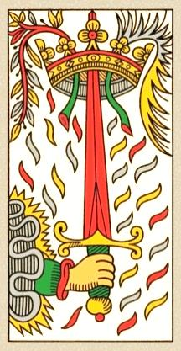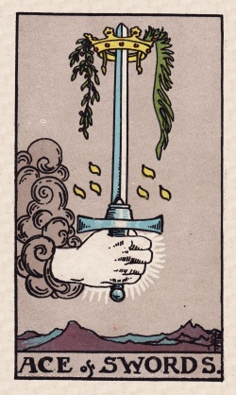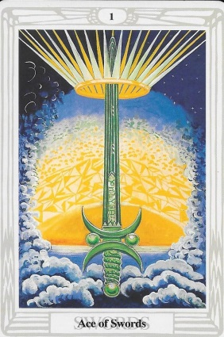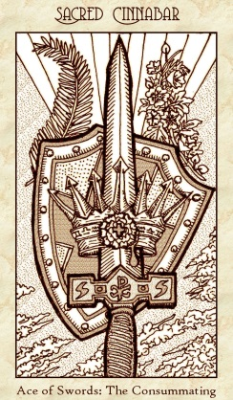

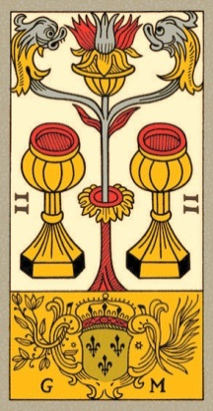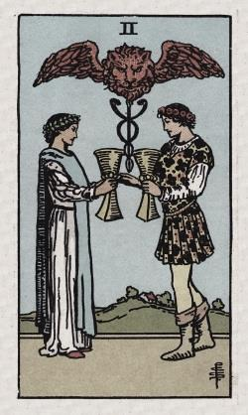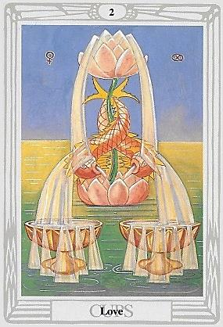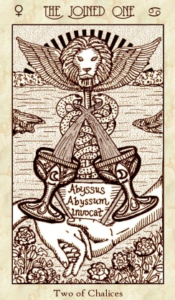

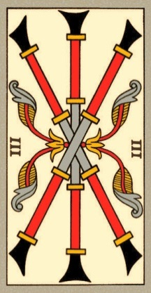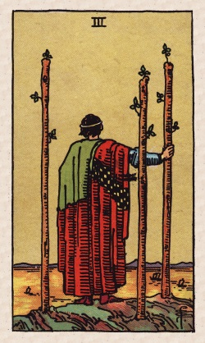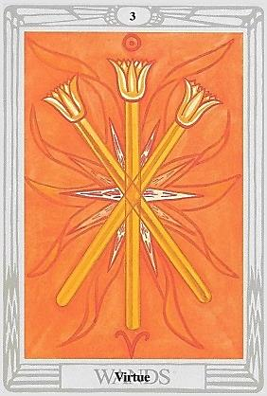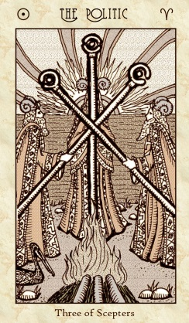

CYCLOPEDIA OF
TAROT CARD MEANINGS

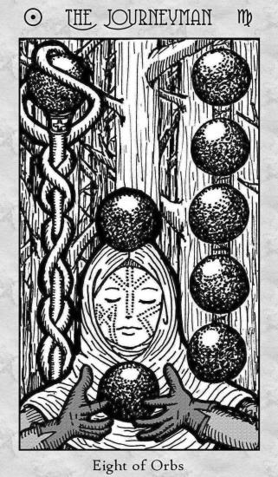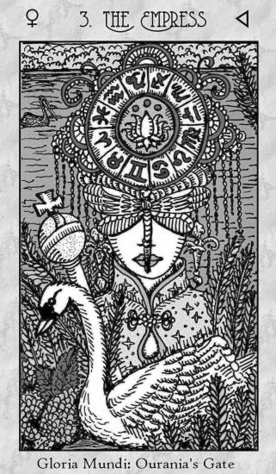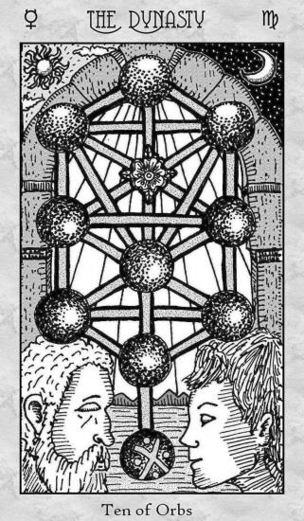

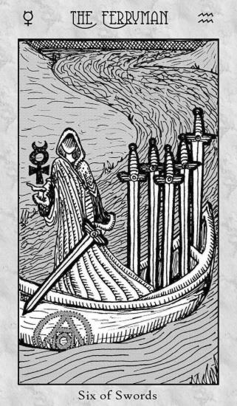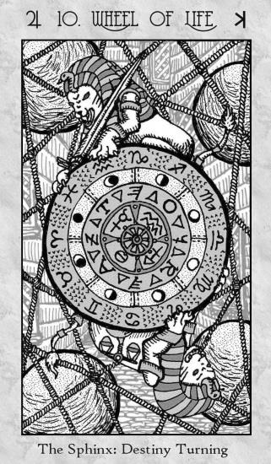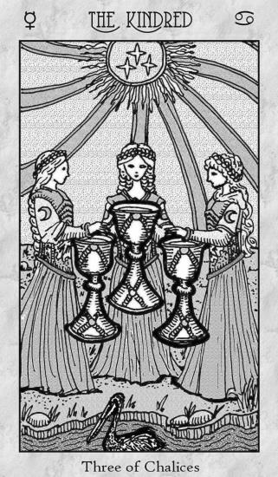

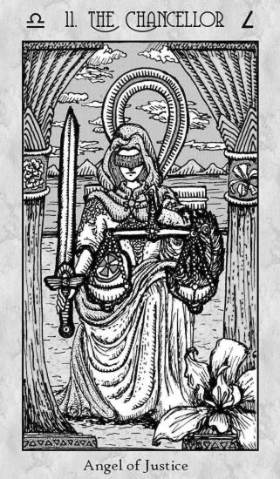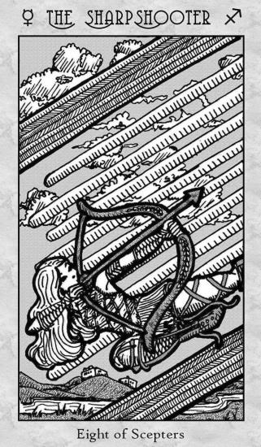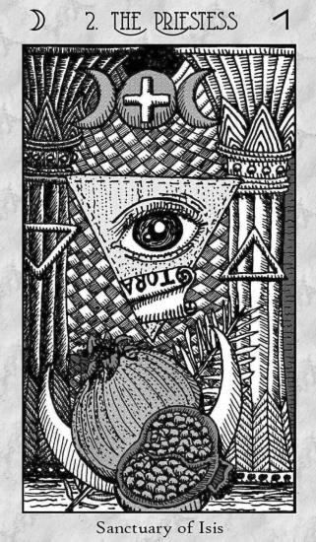
T A R O T C A R D M E A N I N G S
M A J O R A R C A N A

Key 0: The Fool

Key 0: The Initiate
Key 0: The Seeker
Key 0: The Keeper

Themes and Keywords:

Astrological Correspondences:

Kabbalistic Correspondences:

I Ching Correspondences:

Affirmations:

Tarot de Marseilles | Key 0: The Fool

Rider-Waite-Smith | Key 0: The Fool

Crowley-Harris Thoth | Key 0: The Fool

Spirit Keeper’s Tarot | Key 0: The Initiate

Spirit Keeper’s Tarot | Key 0: The Seeker

Spirit Keeper’s Tarot | Key 0: The Keeper

Key 0 Notes

Pathworking with this Key:

Talismanic or Spell-Crafting Uses:

Notes on Energy Healing with this Key:

Key Messages and Meaning when this Card is Stalking You:

T A R O T C A R D M E A N I N G S
M A J O R A R C A N A

Key I: The Magician

Key 1: The Magus

Themes and Keywords:

Astrological Correspondences:

Kabbalistic Correspondences:

I Ching Correspondences:

Affirmations:

Tarot de Marseilles | Key I: The Bateleur or The Juggler
Also: The Mountebank (Charlatan; Swindler; Trickster)

Rider-Waite-Smith | Key I: The Magician

Crowley-Harris Thoth | Key I: The Magus

Spirit Keeper’s Tarot | Key 1: The Magus

Key I Notes

Pathworking with this Key:

Talismanic or Spell-Crafting Uses:

Notes on Energy Healing with this Key:

Key Messages and Meaning when this Card is Stalking You:

T A R O T C A R D M E A N I N G S
M A J O R A R C A N A

Key II: The High Priestess

Key 2: The Priestess

Themes and Keywords:

Astrological Correspondences:

Kabbalistic Correspondences:

I Ching Correspondences:

Affirmations:

Tarot de Marseilles | Key II: The Popess

Rider-Waite-Smith | Key II: The High Priestess

Crowley-Harris Thoth | Key II: The High Priestess

Spirit Keeper’s Tarot | Key 2: The Priestess

Key II Notes

Pathworking with this Key:

Talismanic or Spell-Crafting Uses:

Notes on Energy Healing with this Key:

Key Messages and Meaning when this Card is Stalking You:

T A R O T C A R D M E A N I N G S
M A J O R A R C A N A

Key III: The Empress

Key 3: The Empress

Themes and Keywords:

Astrological Correspondences:

Kabbalistic Correspondences:

I Ching Correspondences:

Affirmations:

Tarot de Marseilles | Key III: The Empress

Rider-Waite-Smith | Key III: The Empress

Crowley-Harris Thoth | Key III: The Empress

Spirit Keeper’s Tarot | Key 3: The Empress

Key III Notes

Pathworking with this Key:

Talismanic or Spell-Crafting Uses:

Notes on Energy Healing with this Key:

Key Messages and Meaning when this Card is Stalking You:

T A R O T C A R D M E A N I N G S
M A J O R A R C A N A

Key IV: The Emperor

Key 4: The Emperor

Themes and Keywords:

Astrological Correspondences:

Kabbalistic Correspondences:

I Ching Correspondences:

Affirmations:

Tarot de Marseilles | Key IV: The Emperor

Rider-Waite-Smith | Key IV: The Emperor

Crowley-Harris Thoth | Key IV: The Emperor

Spirit Keeper’s Tarot | Key 4: The Emperor

Key IV Notes

Pathworking with this Key:

Talismanic or Spell-Crafting Uses:

Notes on Energy Healing with this Key:

Key Messages and Meaning when this Card is Stalking You:

T A R O T C A R D M E A N I N G S
M A J O R A R C A N A

Key V: The Pope

Key 5: The Holy See

Themes and Keywords:

Astrological Correspondences:

Kabbalistic Correspondences:

I Ching Correspondences:

Affirmations:

Tarot de Marseilles | Key V: The Pope

Rider-Waite-Smith | Key V: The Hierophant

Crowley-Harris Thoth | Key V: The Hierophant

Spirit Keeper’s Tarot | Key 5: The Holy See

Key V Notes

Pathworking with this Key:

Talismanic or Spell-Crafting Uses:

Notes on Energy Healing with this Key:

Key Messages and Meaning when this Card is Stalking You:

T A R O T C A R D M E A N I N G S
M A J O R A R C A N A

Key VI: The Lovers

Key 6: The Lovers

Themes and Keywords:

Astrological Correspondences:

Kabbalistic Correspondences:

I Ching Correspondences:

Affirmations:

Tarot de Marseilles | Key VI: The Lovers

Rider-Waite-Smith | Key VI: The Lovers

Crowley-Harris Thoth | Key VI: The Lovers (or The Brothers)

Spirit Keeper’s Tarot | Key 6: The Lovers

Key VI Notes

Pathworking with this Key:

Talismanic or Spell-Crafting Uses:

Notes on Energy Healing with this Key:

Key Messages and Meaning when this Card is Stalking You:

T A R O T C A R D M E A N I N G S
M A J O R A R C A N A

Key VII: The Chariot

Key 7: The Chariot

Themes and Keywords:

Astrological Correspondences:

Kabbalistic Correspondences:

I Ching Correspondences:

Affirmations:

Tarot de Marseilles | Key VII: The Chariot

Rider-Waite-Smith | Key VII: The Chariot

Crowley-Harris Thoth | Key VII: The Chariot

Spirit Keeper’s Tarot | Key 7: The Chariot

Key VII Notes

Pathworking with this Key:

Talismanic or Spell-Crafting Uses:

Notes on Energy Healing with this Key:

Key Messages and Meaning when this Card is Stalking You:

T A R O T C A R D M E A N I N G S
M A J O R A R C A N A

Key VIII: Strength

Key XI: Strength (Marseilles) | Key XI: Lust (Thoth)

Key 8: The Force

Themes and Keywords:

Astrological Correspondences:

Kabbalistic Correspondences:

I Ching Correspondences:

Affirmations:

Tarot de Marseilles | Key XI: Strength
Note: This entry is out of numerological order due to the Key 8 and Key 11 switch between the Marseilles/Thoth and the Rider-Waite-Smith.

Rider-Waite-Smith | Key VIII: Strength

Crowley-Harris Thoth | Key XI: Lust
Note: This entry is out of numerological order due to the Key 8 and Key 11 switch between the Marseilles/Thoth and the Rider-Waite-Smith.

Spirit Keeper’s Tarot | Key 8: The Force

Key VIII Strength & Key XI Strength/Lust Notes

Pathworking with this Key:

Talismanic or Spell-Crafting Uses:

Notes on Energy Healing with this Key:

Key Messages and Meaning when this Card is Stalking You:

T A R O T C A R D M E A N I N G S
M A J O R A R C A N A

Key IX: The Hermit

Key 9: The Erudite

Themes and Keywords:

Astrological Correspondences:

Kabbalistic Correspondences:

I Ching Correspondences:

Affirmations:

Tarot de Marseilles | Key IX: The Hermit

Rider-Waite-Smith | Key IX: The Hermit

Crowley-Harris Thoth | Key IX: The Hermit

Spirit Keeper’s Tarot | Key 9: The Erudite

Key IX Notes

Pathworking with this Key:

Talismanic or Spell-Crafting Uses:

Notes on Energy Healing with this Key:

Key Messages and Meaning when this Card is Stalking You:

T A R O T C A R D M E A N I N G S
M A J O R A R C A N A

Key X: Wheel of Fortune

Key 10: Wheel of Life

Themes and Keywords:

Astrological Correspondences:

Kabbalistic Correspondences:

I Ching Correspondences:

Affirmations:

Tarot de Marseilles | Key X: The Wheel of Fortune

Rider-Waite-Smith | Key X: Wheel of Fortune

Crowley-Harris Thoth | Key X: Fortune

Spirit Keeper’s Tarot | Key 10: Wheel of Life

Key X Notes

Pathworking with this Key:

Talismanic or Spell-Crafting Uses:

Notes on Energy Healing with this Key:

Key Messages and Meaning when this Card is Stalking You:

T A R O T C A R D M E A N I N G S
M A J O R A R C A N A

Key XI: Justice

Key VIII: Justice (Marseilles) | Key VIII: Adjustment (Thoth)

Key 11: The Chancellor

Themes and Keywords:

Astrological Correspondences:

Kabbalistic Correspondences:

I Ching Correspondences:

Affirmations:

Tarot de Marseilles | Key VIII: Justice
Note: This entry is out of numerological order due to the Key 8 and Key 11 switch between the Marseilles/Thoth and the Rider-Waite-Smith.

Rider-Waite-Smith | Key XI: Justice

Crowley-Harris Thoth | Key VIII: Adjustment
Note: This entry is out of numerological order due to the Key 8 and Key 11 switch between the Marseilles/Thoth and the Rider-Waite-Smith.

Spirit Keeper’s Tarot | Key 11: The Chancellor

Key XI Justice & Key VIII Justice/Adjustment Notes

Pathworking with this Key:

Talismanic or Spell-Crafting Uses:

Notes on Energy Healing with this Key:

Key Messages and Meaning when this Card is Stalking You:

T A R O T C A R D M E A N I N G S
M A J O R A R C A N A

Key XII: The Hanged Man

Key 12: The Outlaw

Themes and Keywords:

Astrological Correspondences:

Kabbalistic Correspondences:

I Ching Correspondences:

Affirmations:

Tarot de Marseilles | Key XII: The Hanged Man

Rider-Waite-Smith | Key XII: The Hanged Man

Crowley-Harris Thoth | Key XII: The Hanged Man

Spirit Keeper’s Tarot | Key 12: The Outlaw

Key XII Notes

Pathworking with this Key:

Talismanic or Spell-Crafting Uses:

Notes on Energy Healing with this Key:

Key Messages and Meaning when this Card is Stalking You:

T A R O T C A R D M E A N I N G S
M A J O R A R C A N A

Key XIII: Death

Key 13: The Reaper

Themes and Keywords:

Astrological Correspondences:

Kabbalistic Correspondences:

I Ching Correspondences:

Affirmations:

Tarot de Marseilles | Key XIII: Death (or Untitled)

Rider-Waite-Smith | Key XIII: Death

Crowley-Harris Thoth | Key XIII: Death

Spirit Keeper’s Tarot | Key 13: The Reaper

Key XIII Notes

Pathworking with this Key:

Talismanic or Spell-Crafting Uses:

Notes on Energy Healing with this Key:

Key Messages and Meaning when this Card is Stalking You:

T A R O T C A R D M E A N I N G S
M A J O R A R C A N A

Key XIV: Temperance

Key 14: The Angel

Themes and Keywords:

Astrological Correspondences:

Kabbalistic Correspondences:

I Ching Correspondences:

Affirmations:

Tarot de Marseilles | Key XIV: Temperance

Rider-Waite-Smith | Key XIV: Temperance

Crowley-Harris Thoth | Key XIV: Art

Spirit Keeper’s Tarot | Key 14: The Angel

Key XIV Notes

Pathworking with this Key:

Talismanic or Spell-Crafting Uses:

Notes on Energy Healing with this Key:

Key Messages and Meaning when this Card is Stalking You:

T A R O T C A R D M E A N I N G S
M A J O R A R C A N A

Key XV: The Devil

Key 15: The Demon

Themes and Keywords:

Astrological Correspondences:

Kabbalistic Correspondences:

I Ching Correspondences:

Affirmations:

Tarot de Marseilles | Key XV: The Devil

Rider-Waite-Smith | Key XV: The Devil

Crowley-Harris Thoth | Key XV: The Devil

Spirit Keeper’s Tarot | Key 15: The Demon

Key XV Notes

Pathworking with this Key:

Talismanic or Spell-Crafting Uses:

Notes on Energy Healing with this Key:

Key Messages and Meaning when this Card is Stalking You:

T A R O T C A R D M E A N I N G S
M A J O R A R C A N A

Key XVI: The Tower

Key 16: The Tower

Themes and Keywords:

Astrological Correspondences:

Kabbalistic Correspondences:

I Ching Correspondences:

Affirmations:

Tarot de Marseilles | Key XVI: The Tower (or The House of God)

Rider-Waite-Smith | Key XVI: The Tower

Crowley-Harris Thoth | Key XVI: The Tower (or War)

Spirit Keeper’s Tarot | Key 16: The Tower

Key XVI Notes

Pathworking with this Key:

Talismanic or Spell-Crafting Uses:

Notes on Energy Healing with this Key:

Key Messages and Meaning when this Card is Stalking You:

T A R O T C A R D M E A N I N G S
M A J O R A R C A N A

Key XVII: The Star

Key 17: The Healer

Themes and Keywords:

Astrological Correspondences:

Kabbalistic Correspondences:

I Ching Correspondences:

Affirmations:

Tarot de Marseilles | Key XVII: The Star

Rider-Waite-Smith | Key XVII: The Star

Crowley-Harris Thoth | Key XVII: The Star

Spirit Keeper’s Tarot | Key 17: The Healer

Key XVII Notes

Pathworking with this Key:

Talismanic or Spell-Crafting Uses:

Notes on Energy Healing with this Key:

Key Messages and Meaning when this Card is Stalking You:

T A R O T C A R D M E A N I N G S
M A J O R A R C A N A

Key XVIII: The Moon

Key 18: The Necromancer

Themes and Keywords:

Astrological Correspondences:

Kabbalistic Correspondences:

I Ching Correspondences:

Affirmations:

Tarot de Marseilles | Key XVIII: The Moon

Rider-Waite-Smith | Key XVIII: The Moon

Crowley-Harris Thoth | Key XVIII: The Moon

Spirit Keeper’s Tarot | Key 18: The Necromancer

Key XVIII Notes

Pathworking with this Key:

Talismanic or Spell-Crafting Uses:

Notes on Energy Healing with this Key:

Key Messages and Meaning when this Card is Stalking You:

T A R O T C A R D M E A N I N G S
M A J O R A R C A N A

Key XIX: The Sun

Key 19: The Sun

Themes and Keywords:

Astrological Correspondences:

Kabbalistic Correspondences:

I Ching Correspondences:

Affirmations:

Tarot de Marseilles | Key XIX: The Sun

Rider-Waite-Smith | Key XIX: The Sun

Crowley-Harris Thoth | Key XIX: The Sun

Spirit Keeper’s Tarot | Key 19: The Warrior

Key XIX Notes

Pathworking with this Key:

Talismanic or Spell-Crafting Uses:

Notes on Energy Healing with this Key:

Key Messages and Meaning when this Card is Stalking You:

T A R O T C A R D M E A N I N G S
M A J O R A R C A N A

Key XX: Judgement

Key 20: Apocalypse

Themes and Keywords:

Astrological Correspondences:

Kabbalistic Correspondences:

I Ching Correspondences:

Affirmations:

Tarot de Marseilles | Key XX: The Judgment

Rider-Waite-Smith | Key XX: The Judgement

Crowley-Harris Thoth | Key XX: The Aeon

Spirit Keeper’s Tarot | Key 20: Apocalypse

Key XX Notes

Pathworking with this Key:

Talismanic or Spell-Crafting Uses:

Notes on Energy Healing with this Key:

Key Messages and Meaning when this Card is Stalking You:

T A R O T C A R D M E A N I N G S
M A J O R A R C A N A

Key XXI: The World

Key 21: New World Order

Themes and Keywords:

Astrological Correspondences:

Kabbalistic Correspondences:

I Ching Correspondences:

Affirmations:

Tarot de Marseilles | Key XXI: The World

Rider-Waite-Smith | Key XXI: The World

Crowley-Harris Thoth | Key XXI: The Universe

Spirit Keeper’s Tarot | Key 21: New World Order

Key XXI Notes

Pathworking with this Key:

Talismanic or Spell-Crafting Uses:

Notes on Energy Healing with this Key:

Key Messages and Meaning when this Card is Stalking You:

T A R O T C A R D M E A N I N G S
M I N O R A R C A N A

The Aces

Ace of Wands

Sacred Fire | Ace of Scepters | The Awakening

Themes and Keywords:

Astrological Correspondences:

Kabbalistic Correspondences:

I Ching Correspondences:

Affirmations:

Tarot de Marseilles | Ace of Batons (or Sceptres)

Rider-Waite-Smith | Ace of Wands

Crowley-Harris Thoth | Ace of Wands (Roots of the Power of Fire)

Spirit Keeper’s Tarot | Sacred Fire | Ace of Scepters: The Awakening

Ace of Wands Notes

Pathworking with this Key:

Talismanic or Spell-Crafting Uses:

Notes on Energy Healing with this Key:

Key Messages and Meaning when this Card is Stalking You:

T A R O T C A R D M E A N I N G S
M I N O R A R C A N A

The Aces

Ace of Cups

Holy Water | Ace of Chalices | The Purifying

Themes and Keywords:

Astrological Correspondences:

Kabbalistic Correspondences:

I Ching Correspondences:

Affirmations:

Tarot de Marseilles | Ace of Cups

Rider-Waite-Smith | Ace of Cups

Crowley-Harris Thoth | Ace of Cups (Roots of the Power of Water)

Spirit Keeper’s Tarot | Holy Water | Ace of Chalices: The Purifying

Ace of Cups Notes

Pathworking with this Key:

Talismanic or Spell-Crafting Uses:

Notes on Energy Healing with this Key:

Key Messages and Meaning when this Card is Stalking You:

T A R O T C A R D M E A N I N G S
M I N O R A R C A N A

The Aces

Ace of Swords

Sacred Cinnabar | Ace of Swords | The Consummating

Themes and Keywords:

Astrological Correspondences:

Kabbalistic Correspondences:

I Ching Correspondences:

Affirmations:

Tarot de Marseilles | Ace of Swords

Rider-Waite-Smith | Ace of Swords

Crowley-Harris Thoth | Ace of Swords (Roots of the Power of Air)

Spirit Keeper’s Tarot | Sacred Cinnabar
Ace of Swords: The Consummating

Ace of Swords Notes

Pathworking with this Key:

Talismanic or Spell-Crafting Uses:

Notes on Energy Healing with this Key:

Key Messages and Meaning when this Card is Stalking You:

T A R O T C A R D M E A N I N G S
M I N O R A R C A N A

The Aces

Ace of Pentacles

Bread of Life | Ace of Orbs | The Darkening

Themes and Keywords:

Astrological Correspondences:

Kabbalistic Correspondences:

I Ching Correspondences:

Affirmations:

Tarot de Marseilles | Ace of Coins

Rider-Waite-Smith | Ace of Pentacles

Crowley-Harris Thoth | Ace of Disks (Roots of the Power of Earth)

Spirit Keeper’s Tarot | Bread of Life | Ace of Orbs: The Darkening

Ace of Pentacles Notes

Pathworking with this Key:

Talismanic or Spell-Crafting Uses:

Notes on Energy Healing with this Key:

Key Messages and Meaning when this Card is Stalking You:

T A R O T C A R D M E A N I N G S
M I N O R A R C A N A

The Twos

Two of Wands

Two of Scepters: The Discerning One

Themes and Keywords:

Astrological Correspondences:

Kabbalistic Correspondences:

I Ching Correspondences:

Affirmations:

Tarot de Marseilles | Two of Batons (Sceptres)

Rider-Waite-Smith | Two of Wands

Crowley-Harris Thoth | Two of Wands: Dominion

Spirit Keeper’s Tarot | Two of Scepters: The Discerning One

Two of Wands Notes

Pathworking with this Key:

Talismanic or Spell-Crafting Uses:

Notes on Energy Healing with this Key:

Key Messages and Meaning when this Card is Stalking You:

T A R O T C A R D M E A N I N G S
M I N O R A R C A N A

The Twos

Two of Cups

Two of Chalices: The Joined One

Themes and Keywords:

Astrological Correspondences:

Kabbalistic Correspondences:

I Ching Correspondences:

Affirmations:

Tarot de Marseilles | Two of Cups

Rider-Waite-Smith | Two of Cups

Crowley-Harris Thoth | Two of Cups: Love

Spirit Keeper’s Tarot | Two of Chalices: The Joined One

Two of Cups Notes

Pathworking with this Key:

Talismanic or Spell-Crafting Uses:

Notes on Energy Healing with this Key:

Key Messages and Meaning when this Card is Stalking You:

T A R O T C A R D M E A N I N G S
M I N O R A R C A N A

The Twos

Two of Swords

Two of Swords: The Blind Seer

Themes and Keywords:

Astrological Correspondences:

Kabbalistic Correspondences:

I Ching Correspondences:

Affirmations:

Tarot de Marseilles | Two of Swords

Rider-Waite-Smith | Two of Swords

Crowley-Harris Thoth | Two of Swords: Peace

Spirit Keeper’s Tarot | Two of Swords: The Blind Seer

Two of Swords Notes

Pathworking with this Key:

Talismanic or Spell-Crafting Uses:

Notes on Energy Healing with this Key:

Key Messages and Meaning when this Card is Stalking You:

T A R O T C A R D M E A N I N G S
M I N O R A R C A N A

The Twos

Two of Pentacles

Two of Orbs: The Nocturne

Themes and Keywords:

Astrological Correspondences:

Kabbalistic Correspondences:

I Ching Correspondences:

Affirmations:

Tarot de Marseilles | Two of Coins

Rider-Waite-Smith | Two of Pentacles

Crowley-Harris Thoth | Two of Disks: Change

Spirit Keeper’s Tarot | Two of Orbs: The Nocturne

Two of Pentacles Notes

Pathworking with this Key:

Talismanic or Spell-Crafting Uses:

Notes on Energy Healing with this Key:

Key Messages and Meaning when this Card is Stalking You:

T A R O T C A R D M E A N I N G S
M I N O R A R C A N A

The Threes

Three of Wands

Three of Scepters: The Politic

Themes and Keywords:

Astrological Correspondences:

Kabbalistic Correspondences:

I Ching Correspondences:

Affirmations:

Tarot de Marseilles | Three of Batons (Sceptres)

Rider-Waite-Smith | Three of Wands

Crowley-Harris Thoth | Three of Wands: Virtue

Spirit Keeper’s Tarot | Three of Scepters: The Politic

Three of Wands Notes

Pathworking with this Key:

Talismanic or Spell-Crafting Uses:

Notes on Energy Healing with this Key:

Key Messages and Meaning when this Card is Stalking You:

T A R O T C A R D M E A N I N G S
M I N O R A R C A N A

The Threes

Three of Cups

Three of Chalices: The Kindred

Themes and Keywords:

Astrological Correspondences:

Kabbalistic Correspondences:

I Ching Correspondences:

Affirmations:

Tarot de Marseilles | Three of Cups

Rider-Waite-Smith | Three of Cups

Crowley-Harris Thoth | Three of Cups: Abundance

Spirit Keeper’s Tarot | Three of Chalices: The Kindred

Three of Cups Notes

Pathworking with this Key:

Talismanic or Spell-Crafting Uses:

Notes on Energy Healing with this Key:

Key Messages and Meaning when this Card is Stalking You:

T A R O T C A R D M E A N I N G S
M I N O R A R C A N A

The Threes

Three of Swords

Three of Swords: The Bereaved

Themes and Keywords:

Astrological Correspondences:

Kabbalistic Correspondences:

I Ching Correspondences:

Affirmations:

Tarot de Marseilles | Three of Swords

Rider-Waite-Smith | Three of Swords

Crowley-Harris Thoth | Three of Swords: Sorrow

Spirit Keeper’s Tarot | Three of Swords: The Bereaved

Three of Swords Notes

Pathworking with this Key:

Talismanic or Spell-Crafting Uses:

Notes on Energy Healing with this Key:

Key Messages and Meaning when this Card is Stalking You:

T A R O T C A R D M E A N I N G S
M I N O R A R C A N A

The Threes

Three of Pentacles

Three of Orbs: The Mason

Themes and Keywords:

Astrological Correspondences:

Kabbalistic Correspondences:

I Ching Correspondences:

Affirmations:

Tarot de Marseilles | Three of Coins

Rider-Waite-Smith | Three of Pentacles

Crowley-Harris Thoth | Three of Disks: Works

Spirit Keeper’s Tarot | Three of Orbs: The Mason

Three of Pentacles Notes

Pathworking with this Key:

Talismanic or Spell-Crafting Uses:

Notes on Energy Healing with this Key:

Key Messages and Meaning when this Card is Stalking You:

T A R O T C A R D M E A N I N G S
M I N O R A R C A N A

The Fours

Four of Wands

Four of Scepters: The Demiurge

Themes and Keywords:

Astrological Correspondences:

Kabbalistic Correspondences:

I Ching Correspondences:

Affirmations:

Tarot de Marseilles | Four of Batons (Sceptres)

Rider-Waite-Smith | Four of Wands

Crowley-Harris Thoth | Four of Wands: Completion

Spirit Keeper’s Tarot | Four of Scepters: The Demiurge

Four of Wands Notes

Pathworking with this Key:

Talismanic or Spell-Crafting Uses:

Notes on Energy Healing with this Key:

Key Messages and Meaning when this Card is Stalking You:

T A R O T C A R D M E A N I N G S
M I N O R A R C A N A

The Fours

Four of Cups

Four of Chalices: The Hollow Void

Themes and Keywords:

Astrological Correspondences:

Kabbalistic Correspondences:

I Ching Correspondences:

Affirmations:

Tarot de Marseilles | Four of Cups

Rider-Waite-Smith | Four of Cups

Crowley-Harris Thoth | Four of Cups: Luxury

Spirit Keeper’s Tarot | Four of Chalices: The Hollow Void

Four of Cups Notes

Pathworking with this Key:

Talismanic or Spell-Crafting Uses:

Notes on Energy Healing with this Key:

Key Messages and Meaning when this Card is Stalking You:

T A R O T C A R D M E A N I N G S
M I N O R A R C A N A

The Fours

Four of Swords

Four of Swords: The Convalescent

Themes and Keywords:

Astrological Correspondences:

Kabbalistic Correspondences:

I Ching Correspondences:

Affirmations:

Tarot de Marseilles | Four of Swords

Rider-Waite-Smith | Four of Swords

Crowley-Harris Thoth | Four of Swords: Truce

Spirit Keeper’s Tarot | Four of Swords: The Convalescent

Four of Swords Notes

Pathworking with this Key:

Talismanic or Spell-Crafting Uses:

Notes on Energy Healing with this Key:

Key Messages and Meaning when this Card is Stalking You:

T A R O T C A R D M E A N I N G S
M I N O R A R C A N A

The Fours

Four of Pentacles

Four of Orbs: The Conservator

Themes and Keywords:

Astrological Correspondences:

Kabbalistic Correspondences:

I Ching Correspondences:

Affirmations:

Tarot de Marseilles | Four of Coins

Rider-Waite-Smith | Four of Pentacles

Crowley-Harris Thoth | Four of Disks: Power

Spirit Keeper’s Tarot | Four of Orbs: The Conservator

Four of Pentacles Notes

Pathworking with this Key:

Talismanic or Spell-Crafting Uses:

Notes on Energy Healing with this Key:

Key Messages and Meaning when this Card is Stalking You:

T A R O T C A R D M E A N I N G S
M I N O R A R C A N A

The Fives

Five of Wands

Five of Scepters: The Contender

Themes and Keywords:

Astrological Correspondences:

Kabbalistic Correspondences:

I Ching Correspondences:

Affirmations:

Tarot de Marseilles | Five of Batons (Sceptres)

Rider-Waite-Smith | Five of Wands

Crowley-Harris Thoth | Five of Wands: Strife

Spirit Keeper’s Tarot | Five of Scepters: The Contender

Five of Wands Notes

Pathworking with this Key:

Talismanic or Spell-Crafting Uses:

Notes on Energy Healing with this Key:

Key Messages and Meaning when this Card is Stalking You:

T A R O T C A R D M E A N I N G S
M I N O R A R C A N A

The Fives

Five of Cups

Five of Chalices: The Grotesque

Themes and Keywords:

Astrological Correspondences:

Kabbalistic Correspondences:

I Ching Correspondences:

Affirmations:

Tarot de Marseilles | Five of Cups

Rider-Waite-Smith | Five of Cups

Crowley-Harris Thoth | Five of Cups: Disappointment

Spirit Keeper’s Tarot | Five of Chalices: The Grotesque

Five of Cups Notes

Pathworking with this Key:

Talismanic or Spell-Crafting Uses:

Notes on Energy Healing with this Key:

Key Messages and Meaning when this Card is Stalking You:

T A R O T C A R D M E A N I N G S
M I N O R A R C A N A

The Fives

Fives of Swords

Five of Swords: The Hector

Themes and Keywords:

Astrological Correspondences:

Kabbalistic Correspondences:

I Ching Correspondences:

Affirmations:

Tarot de Marseilles | Five of Swords

Rider-Waite-Smith | Five of Swords

Crowley-Harris Thoth | Five of Swords: Defeat

Spirit Keeper’s Tarot | Five of Swords: The Hector

Five of Swords Notes

Pathworking with this Key:

Talismanic or Spell-Crafting Uses:

Notes on Energy Healing with this Key:

Key Messages and Meaning when this Card is Stalking You:

T A R O T C A R D M E A N I N G S
M I N O R A R C A N A

The Fives

Five of Pentacles

Five of Orbs: The Vagabond

Themes and Keywords:

Astrological Correspondences:

Kabbalistic Correspondences:

I Ching Correspondences:

Affirmations:

Tarot de Marseilles | Five of Coins

Rider-Waite-Smith | Five of Pentacles

Crowley-Harris Thoth | Five of Disks: Worry

Spirit Keeper’s Tarot | Five of Orbs: The Vagabond

Five of Pentacles Notes

Pathworking with this Key:

Talismanic or Spell-Crafting Uses:

Notes on Energy Healing with this Key:

Key Messages and Meaning when this Card is Stalking You:

T A R O T C A R D M E A N I N G S
M I N O R A R C A N A

The Sixes

Six of Wands

Six of Scepters: The Champion

Themes and Keywords:

Astrological Correspondences:

Kabbalistic Correspondences:

I Ching Correspondences:

Affirmations:

Tarot de Marseilles | Six of Batons (Sceptres)

Rider-Waite-Smith | Six of Wands

Crowley-Harris Thoth | Six of Wands: Victory

Spirit Keeper’s Tarot | Six of Scepters: The Champion

Six of Wands Notes

Pathworking with this Key:

Talismanic or Spell-Crafting Uses:

Notes on Energy Healing with this Key:

Key Messages and Meaning when this Card is Stalking You:

T A R O T C A R D M E A N I N G S
M I N O R A R C A N A

The Sixes

Six of Cups

Six of Chalices: The Memory Keeper

Themes and Keywords:

Astrological Correspondences:

Kabbalistic Correspondences:

I Ching Correspondences:

Affirmations:

Tarot de Marseilles | Six of Cups

Rider-Waite-Smith | Six of Cups

Crowley-Harris Thoth | Six of Cups: Pleasure

Spirit Keeper’s Tarot | Six of Chalices: The Memory Keeper

Six of Cups Notes

Pathworking with this Key:

Talismanic or Spell-Crafting Uses:

Notes on Energy Healing with this Key:

Key Messages and Meaning when this Card is Stalking You:

T A R O T C A R D M E A N I N G S
M I N O R A R C A N A

The Sixes

Six of Swords

Six of Swords: The Ferryman

Themes and Keywords:

Astrological Correspondences:

Kabbalistic Correspondences:

I Ching Correspondences:

Affirmations:

Tarot de Marseilles | Six of Swords

Rider-Waite-Smith | Six of Swords

Crowley-Harris Thoth | Six of Swords: Science

Spirit Keeper’s Tarot | Six of Swords: The Ferryman

Six of Swords Notes

Pathworking with this Key:

Talismanic or Spell-Crafting Uses:

Notes on Energy Healing with this Key:

Key Messages and Meaning when this Card is Stalking You:

T A R O T C A R D M E A N I N G S
M I N O R A R C A N A

The Sixes

Six of Pentacles

Six of Orbs: The Giver

Themes and Keywords:

Astrological Correspondences:

Kabbalistic Correspondences:

I Ching Correspondences:

Affirmations:

Tarot de Marseilles | Six of Coins

Rider-Waite-Smith | Six of Pentacles

Crowley-Harris Thoth | Six of Disks: Success

Spirit Keeper’s Tarot | Six of Orbs: The Giver

Six of Pentacles Notes

Pathworking with this Key:

Talismanic or Spell-Crafting Uses:

Notes on Energy Healing with this Key:

Key Messages and Meaning when this Card is Stalking You:

T A R O T C A R D M E A N I N G S
M I N O R A R C A N A

The Sevens

Seven of Wands

Seven of Scepters: The Dark Horse

Themes and Keywords:

Astrological Correspondences:

Kabbalistic Correspondences:

I Ching Correspondences:

Affirmations:

Tarot de Marseilles | Seven of Batons (Sceptres)

Rider-Waite-Smith | Seven of Wands

Crowley-Harris Thoth | Seven of Wands: Valour

Spirit Keeper’s Tarot | Seven of Scepters: The Dark Horse

Seven of Wands Notes

Pathworking with this Key:

Talismanic or Spell-Crafting Uses:

Notes on Energy Healing with this Key:

Key Messages and Meaning when this Card is Stalking You:

T A R O T C A R D M E A N I N G S
M I N O R A R C A N A

The Sevens

Seven of Cups

Seven of Chalices: The Corrupter

Themes and Keywords:

Astrological Correspondences:

Kabbalistic Correspondences:

I Ching Correspondences:

Affirmations:

Tarot de Marseilles | Seven of Cups

Rider-Waite-Smith | Seven of Cups

Crowley-Harris Thoth | Seven of Cups: Debauch

Spirit Keeper’s Tarot | Seven of Chalices: The Corrupter

Seven of Cups Notes

Pathworking with this Key:

Talismanic or Spell-Crafting Uses:

Notes on Energy Healing with this Key:

Key Messages and Meaning when this Card is Stalking You:

T A R O T C A R D M E A N I N G S
M I N O R A R C A N A

The Sevens

Seven of Swords

Seven of Swords: The Rogue

Themes and Keywords:

Astrological Correspondences:

Kabbalistic Correspondences:

I Ching Correspondences:

Affirmations:

Tarot de Marseilles | Seven of Swords

Rider-Waite-Smith | Seven of Swords

Crowley-Harris Thoth | Seven of Swords: Futility

Spirit Keeper’s Tarot | Seven of Swords: The Rogue

Seven of Swords Notes

Pathworking with this Key:

Talismanic or Spell-Crafting Uses:

Notes on Energy Healing with this Key:

Key Messages and Meaning when this Card is Stalking You:

T A R O T C A R D M E A N I N G S
M I N O R A R C A N A

The Sevens

Seven of Pentacles

Seven of Orbs: The Gardener

Themes and Keywords:

Astrological Correspondences:

Kabbalistic Correspondences:

I Ching Correspondences:

Affirmations:

Tarot de Marseilles | Seven of Coins

Rider-Waite-Smith | Seven of Pentacles

Crowley-Harris Thoth | Seven of Disks: Failure

Spirit Keeper’s Tarot | Seven of Orbs: The Gardener

Seven of Pentacles Notes

Pathworking with this Key:

Talismanic or Spell-Crafting Uses:

Notes on Energy Healing with this Key:

Key Messages and Meaning when this Card is Stalking You:

T A R O T C A R D M E A N I N G S
M I N O R A R C A N A

The Eights

Eight of Wands

Eight of Scepters: The Sharpshooter

Themes and Keywords:

Astrological Correspondences:

Kabbalistic Correspondences:

I Ching Correspondences:

Affirmations:

Tarot de Marseilles | Eight of Batons (Sceptres)

Rider-Waite-Smith | Eight of Wands

Crowley-Harris Thoth | Eight of Wands: Swiftness

Spirit Keeper’s Tarot | Eight of Scepters: The Sharpshooter

Eight of Wands Notes

Pathworking with this Key:

Talismanic or Spell-Crafting Uses:

Notes on Energy Healing with this Key:

Key Messages and Meaning when this Card is Stalking You:

T A R O T C A R D M E A N I N G S
M I N O R A R C A N A

The Eights

Eight of Cups

Eight of Chalices: The Defector

Themes and Keywords:

Astrological Correspondences:

Kabbalistic Correspondences:

I Ching Correspondences:

Affirmations:

Tarot de Marseilles | Eight of Cups

Rider-Waite-Smith | Eight of Cups

Crowley-Harris Thoth | Eight of Cups: Indolence

Spirit Keeper’s Tarot | Eight of Chalices: The Defector

Eight of Cups Notes

Pathworking with this Key:

Talismanic or Spell-Crafting Uses:

Notes on Energy Healing with this Key:

Key Messages and Meaning when this Card is Stalking You:

T A R O T C A R D M E A N I N G S
M I N O R A R C A N A

The Eights

Eight of Swords

Eight of Swords: The Captor

Themes and Keywords:

Astrological Correspondences:

Kabbalistic Correspondences:

I Ching Correspondences:

Affirmations:

Tarot de Marseilles | Eight of Swords

Rider-Waite-Smith | Eight of Swords

Crowley-Harris Thoth | Eight of Swords: Interference

Spirit Keeper’s Tarot | Eight of Swords: The Captor

Eight of Swords Notes

Pathworking with this Key:

Talismanic or Spell-Crafting Uses:

Notes on Energy Healing with this Key:

Key Messages and Meaning when this Card is Stalking You:

T A R O T C A R D M E A N I N G S
M I N O R A R C A N A

The Eights

Eight of Pentacles

Eight of Orbs: The Journeyman

Themes and Keywords:

Astrological Correspondences:

Kabbalistic Correspondences:

I Ching Correspondences:

Affirmations:

Tarot de Marseilles | Eight of Coins

Rider-Waite-Smith | Eight of Pentacles

Crowley-Harris Thoth | Eight of Disks: Prudence

Spirit Keeper’s Tarot | Eight of Orbs: The Journeyman

Eight of Pentacles Notes

Pathworking with this Key:

Talismanic or Spell-Crafting Uses:

Notes on Energy Healing with this Key:

Key Messages and Meaning when this Card is Stalking You:

T A R O T C A R D M E A N I N G S
M I N O R A R C A N A

The Nines

Nines of Wands

Nine of Scepters: The Malaise

Themes and Keywords:

Astrological Correspondences:

Kabbalistic Correspondences:

I Ching Correspondences:

Affirmations:

Tarot de Marseilles | Nine of Batons (Sceptres)

Rider-Waite-Smith | Nine of Wands

Crowley-Harris Thoth | Nine of Wands: Strength

Spirit Keeper’s Tarot | Nine of Scepters: The Malaise

Nine of Wands Notes

Pathworking with this Key:

Talismanic or Spell-Crafting Uses:

Notes on Energy Healing with this Key:

Key Messages and Meaning when this Card is Stalking You:

T A R O T C A R D M E A N I N G S
M I N O R A R C A N A

The Nines

Nine of Cups

Nine of Chalices: The Wish Granted

Themes and Keywords:

Astrological Correspondences:

Kabbalistic Correspondences:

I Ching Correspondences:

Affirmations:

Tarot de Marseilles | Nine of Cups

Rider-Waite-Smith | Nine of Cups

Crowley-Harris Thoth | Nine of Cups: Happiness

Spirit Keeper’s Tarot | Nine of Chalices: The Wish Granted

Nine of Cups Notes

Pathworking with this Key:

Talismanic or Spell-Crafting Uses:

Notes on Energy Healing with this Key:

Key Messages and Meaning when this Card is Stalking You:

T A R O T C A R D M E A N I N G S
M I N O R A R C A N A

The Nines

Nine of Swords

Nine of Swords: The Haunt

Themes and Keywords:

Astrological Correspondences:

Kabbalistic Correspondences:

I Ching Correspondences:

Affirmations:

Tarot de Marseilles | Nine of Swords

Rider-Waite-Smith | Nine of Swords

Crowley-Harris Thoth | Nine of Swords: Cruelty

Spirit Keeper’s Tarot | Nine of Swords: The Haunt

Nine of Swords Notes

Pathworking with this Key:

Talismanic or Spell-Crafting Uses:

Notes on Energy Healing with this Key:

Key Messages and Meaning when this Card is Stalking You:

T A R O T C A R D M E A N I N G S
M I N O R A R C A N A

The Nines

Nine of Pentacles

Nine of Orbs: The Eminence

Themes and Keywords:

Astrological Correspondences:

Kabbalistic Correspondences:

I Ching Correspondences:

Affirmations:

Tarot de Marseilles | Nine of Coins

Rider-Waite-Smith | Nine of Pentacles

Crowley-Harris Thoth | Nine of Disks: Gain

Spirit Keeper’s Tarot | Nine of Orbs: The Eminence

Nine of Pentacles Notes

Pathworking with this Key:

Talismanic or Spell-Crafting Uses:

Notes on Energy Healing with this Key:

Key Messages and Meaning when this Card is Stalking You:

T A R O T C A R D M E A N I N G S
M I N O R A R C A N A

The Tens

Ten of Wands

Ten of Scepters: The Burdened One

Themes and Keywords:

Astrological Correspondences:

Kabbalistic Correspondences:

I Ching Correspondences:

Affirmations:

Tarot de Marseilles | Ten of Batons (Sceptres)

Rider-Waite-Smith | Ten of Wands

Crowley-Harris Thoth | Ten of Wands: Oppression

Spirit Keeper’s Tarot | Ten of Scepters: The Burdened One

Ten of Wands Notes

Pathworking with this Key:

Talismanic or Spell-Crafting Uses:

Notes on Energy Healing with this Key:

Key Messages and Meaning when this Card is Stalking You:

T A R O T C A R D M E A N I N G S
M I N O R A R C A N A

The Tens

Ten of Cups

Ten of Chalices: The Joyous One

Themes and Keywords:

Astrological Correspondences:

Kabbalistic Correspondences:

I Ching Correspondences:

Affirmations:

Tarot de Marseilles | Ten of Cups

Rider-Waite-Smith | Ten of Cups

Crowley-Harris Thoth | Ten of Cups: Satiety

Spirit Keeper’s Tarot | Ten of Chalices: The Joyous One

Ten of Cups Notes

Pathworking with this Key:

Talismanic or Spell-Crafting Uses:

Notes on Energy Healing with this Key:

Key Messages and Meaning when this Card is Stalking You:

T A R O T C A R D M E A N I N G S
M I N O R A R C A N A

The Tens

Ten of Swords

Ten of Swords: The Destroyer

Themes and Keywords:

Astrological Correspondences:

Kabbalistic Correspondences:

I Ching Correspondences:

Affirmations:

Tarot de Marseilles | Ten of Swords

Rider-Waite-Smith | Ten of Swords

Crowley-Harris Thoth | Ten of Swords: Ruin

Spirit Keeper’s Tarot | Ten of Swords: The Destroyer

Ten of Swords Notes

Pathworking with this Key:

Talismanic or Spell-Crafting Uses:

Notes on Energy Healing with this Key:

Key Messages and Meaning when this Card is Stalking You:

T A R O T C A R D M E A N I N G S
M I N O R A R C A N A

The Tens

Ten of Pentacles

Ten of Orbs: The Dynasty

Themes and Keywords:

Astrological Correspondences:

Kabbalistic Correspondences:

I Ching Correspondences:

Affirmations:

Tarot de Marseilles | Ten of Coins

Rider-Waite-Smith | Ten of Pentacles

Crowley-Harris Thoth | Ten of Disks: Wealth

Spirit Keeper’s Tarot | Ten of Orbs: The Dynasty

Ten of Pentacles Notes

Pathworking with this Key:

Talismanic or Spell-Crafting Uses:

Notes on Energy Healing with this Key:

Key Messages and Meaning when this Card is Stalking You:

T A R O T C A R D M E A N I N G S
M I N O R A R C A N A

The Kings (RWS) / Knights (Thoth)

King of Wands

Archangel of Glory (King of Scepters)

Themes and Keywords:

Astrological Correspondences:

Kabbalistic Correspondences:

I Ching Correspondences:

Affirmations:

Tarot de Marseilles | King of Batons (Sceptres)

Rider-Waite-Smith | King of Wands

Crowley-Harris Thoth | Knight of Wands

Spirit Keeper’s Tarot | King of Scepters: Angel of Art and Grace
ARCHANGEL OF GLORY

King of Wands Notes

Pathworking with this Key:

Talismanic or Spell-Crafting Uses:

Notes on Energy Healing with this Key:

Key Messages and Meaning when this Card is Stalking You:

T A R O T C A R D M E A N I N G S
M I N O R A R C A N A

The Kings (RWS) / Knights (Thoth)

King of Cups

Archangel of Healing (King of Chalices)

Themes and Keywords:

Astrological Correspondences:

Kabbalistic Correspondences:

I Ching Correspondences:

Affirmations:

Tarot de Marseilles | King of Cups

Rider-Waite-Smith | King of Cups

Crowley-Harris Thoth | Knight of Cups

Spirit Keeper’s Tarot | King of Chalices: Angel Who Salves and Purifies
ARCHANGEL OF HEALING

King of Cups Notes

Pathworking with this Key:

Talismanic or Spell-Crafting Uses:

Notes on Energy Healing with this Key:

Key Messages and Meaning when this Card is Stalking You:

T A R O T C A R D M E A N I N G S
M I N O R A R C A N A

The Kings (RWS) / Knights (Thoth)

King of Swords

Archangel Commander (King of Swords)

Themes and Keywords:

Astrological Correspondences:

Kabbalistic Correspondences:

I Ching Correspondences:

Affirmations:

Tarot de Marseilles | King of Swords

Rider-Waite-Smith | King of Swords

Crowley-Harris Thoth | Knight of Swords

Spirit Keeper’s Tarot | King of Swords: Angel of Storms and Battles
ARCHANGEL COMMANDER

King of Swords Notes

Pathworking with this Key:

Talismanic or Spell-Crafting Uses:

Notes on Energy Healing with this Key:

Key Messages and Meaning when this Card is Stalking You:

T A R O T C A R D M E A N I N G S
M I N O R A R C A N A

The Kings (RWS) / Knights (Thoth)

King of Pentacles

Archangel of Mysteries (King of Orbs)

Themes and Keywords:

Astrological Correspondences:

Kabbalistic Correspondences:

I Ching Correspondences:

Affirmations:

Tarot de Marseilles | King of Coins

Rider-Waite-Smith | King of Pentacles

Crowley-Harris Thoth | Knight of Disks

Spirit Keeper’s Tarot | King of Orbs: Angel Who Illuminates the Shadow
ARCHANGEL OF MYSTERIES

King of Pentacles Notes

Pathworking with this Key:

Talismanic or Spell-Crafting Uses:

Notes on Energy Healing with this Key:

Key Messages and Meaning when this Card is Stalking You:

T A R O T C A R D M E A N I N G S
M I N O R A R C A N A

The Queens

Queen of Wands

The Golden Shield (Queen of Scepters)

Themes and Keywords:

Astrological Correspondences:

Kabbalistic Correspondences:

I Ching Correspondences:

Affirmations:

Tarot de Marseilles | Queen of Batons (Sceptres)

Rider-Waite-Smith | Queen of Wands

Crowley-Harris Thoth | Queen of Wands

Spirit Keeper’s Tarot | Queen of Scepters: Power and Authority of Fire
THE GOLDEN SHIELD

Queen of Wands Notes

Pathworking with this Key:

Talismanic or Spell-Crafting Uses:

Notes on Energy Healing with this Key:

Key Messages and Meaning when this Card is Stalking You:

T A R O T C A R D M E A N I N G S
M I N O R A R C A N A

The Queens

Queen of Cups

The Ivory Shield (Queen of Chalices)

Themes and Keywords:

Astrological Correspondences:

Kabbalistic Correspondences:

I Ching Correspondences:

Affirmations:

Tarot de Marseilles | Queen of Cups

Rider-Waite-Smith | Queen of Cups

Crowley-Harris Thoth | Queen of Cups

Spirit Keeper’s Tarot | Queen of Chalices: Power and Authority of Water
THE IVORY SHIELD

Queen of Cups Notes

Pathworking with this Key:

Talismanic or Spell-Crafting Uses:

Notes on Energy Healing with this Key:

Key Messages and Meaning when this Card is Stalking You:

T A R O T C A R D M E A N I N G S
M I N O R A R C A N A

The Queens

Queen of Swords

The Scarlet Shield (Queen of Swords)

Themes and Keywords:

Astrological Correspondences:

Kabbalistic Correspondences:

I Ching Correspondences:

Affirmations:

Tarot de Marseilles | Queen of Swords

Rider-Waite-Smith | Queen of Swords

Crowley-Harris Thoth | Queen of Swords

Spirit Keeper’s Tarot | Queen of Swords: Power and Authority of Air
THE SCARLET SHIELD

Queen of Swords Notes

Pathworking with this Key:

Talismanic or Spell-Crafting Uses:

Notes on Energy Healing with this Key:

Key Messages and Meaning when this Card is Stalking You:

T A R O T C A R D M E A N I N G S
M I N O R A R C A N A

The Queens

Queen of Pentacles

The Ebony Shield (Queen of Orbs)

Themes and Keywords:

Astrological Correspondences:

Kabbalistic Correspondences:

I Ching Correspondences:

Affirmations:

Tarot de Marseilles | Queen of Coins

Rider-Waite-Smith | Queen of Pentacles

Crowley-Harris Thoth | Queen of Disks

Spirit Keeper’s Tarot | Queen of Orbs: Power and Authority of Earth
THE EBONY SHIELD

Queen of Pentacles Notes

Pathworking with this Key:

Talismanic or Spell-Crafting Uses:

Notes on Energy Healing with this Key:

Key Messages and Meaning when this Card is Stalking You:

T A R O T C A R D M E A N I N G S
M I N O R A R C A N A

The Knights (RWS) / Princes (Thoth)

Knight of Wands

The Shining Flame (Knight of Scepters)

Themes and Keywords:

Astrological Correspondences:

Kabbalistic Correspondences:

I Ching Correspondences:

Affirmations:

Tarot de Marseilles | Knight of Batons (Sceptres)

Rider-Waite-Smith | Knight of Wands

Crowley-Harris Thoth | Prince of Wands

Spirit Keeper’s Tarot | Knight of Scepters: Lightning and the Pyre
THE SHINING FLAME

Knight of Wands Notes

Pathworking with this Key:

Talismanic or Spell-Crafting Uses:

Notes on Energy Healing with this Key:

Key Messages and Meaning when this Card is Stalking You:

T A R O T C A R D M E A N I N G S
M I N O R A R C A N A

The Knights (RWS) / Princes (Thoth)

Knight of Cups

The Shining Dew (Knight of Chalices)

Themes and Keywords:

Astrological Correspondences:

Kabbalistic Correspondences:

I Ching Correspondences:

Affirmations:

Tarot de Marseilles | Knight of Cups

Rider-Waite-Smith | Knight of Cups

Crowley-Harris Thoth | Prince of Cups

Spirit Keeper’s Tarot | Knight of Chalices: Waters and Waves
THE SHINING DEW

Knight of Cups Notes

Pathworking with this Key:

Talismanic or Spell-Crafting Uses:

Notes on Energy Healing with this Key:

Key Messages and Meaning when this Card is Stalking You:

T A R O T C A R D M E A N I N G S
M I N O R A R C A N A

The Knights (RWS) / Princes (Thoth)

Knight of Swords

The Shining Winds (Knight of Swords)

Themes and Keywords:

Astrological Correspondences:

Kabbalistic Correspondences:

I Ching Correspondences:

Affirmations:

Tarot de Marseilles | Knight of Swords

Rider-Waite-Smith | Knights of Swords

Crowley-Harris Thoth | Prince of Swords

Spirit Keeper’s Tarot | Knight of Swords: A Swirling Gale
THE SHINING WINDS

Knight of Swords Notes

Pathworking with this Key:

Talismanic or Spell-Crafting Uses:

Notes on Energy Healing with this Key:

Key Messages and Meaning when this Card is Stalking You:

T A R O T C A R D M E A N I N G S
M I N O R A R C A N A

The Knights (RWS) / Princes (Thoth)

Knight of Pentacles

The Shining Quarry (Knight of Orbs)

Themes and Keywords:

Astrological Correspondences:

Kabbalistic Correspondences:

I Ching Correspondences:

Affirmations:

Tarot de Marseilles | Knight of Coins

Rider-Waite-Smith | Knight of Pentacles

Crowley-Harris Thoth | Prince of Disks

Spirit Keeper’s Tarot | Knight of Orbs: Wild and Fertile Land
THE SHINING QUARRY

Knight of Pentacles Notes

Pathworking with this Key:

Talismanic or Spell-Crafting Uses:

Notes on Energy Healing with this Key:

Key Messages and Meaning when this Card is Stalking You:

T A R O T C A R D M E A N I N G S
M I N O R A R C A N A

The Pages (RWS) / Princesses (Thoth)

Page of Wands

Stronghold of the Flame (Page of Scepters)

Themes and Keywords:

Astrological Correspondences:

Kabbalistic Correspondences:

I Ching Correspondences:

Affirmations:

Tarot de Marseilles | Page of Batons (Sceptres)

Rider-Waite-Smith | Page of Wands

Crowley-Harris Thoth | Princess of Wands

Spirit Keeper’s Tarot | Page of Scepters: Herald of the Awakening
STRONGHOLD OF THE FLAME

Page of Wands Notes

Pathworking with this Key:

Talismanic or Spell-Crafting Uses:

Notes on Energy Healing with this Key:

Key Messages and Meaning when this Card is Stalking You:

T A R O T C A R D M E A N I N G S
M I N O R A R C A N A

The Pages (RWS) / Princesses (Thoth)

Page of Cups

Stronghold of the Grail (Page of Chalices)

Themes and Keywords:

Astrological Correspondences:

Kabbalistic Correspondences:

I Ching Correspondences:

Affirmations:

Tarot de Marseilles | Page of Cups

Rider-Waite-Smith | Page of Cups

Crowley-Harris Thoth | Princess of Cups

Spirit Keeper’s Tarot | Page of Chalices: Herald of the Purifying
STRONGHOLD OF THE GRAIL

Page of Cups Notes

Pathworking with this Key:

Talismanic or Spell-Crafting Uses:

Notes on Energy Healing with this Key:

Key Messages and Meaning when this Card is Stalking You:

T A R O T C A R D M E A N I N G S
M I N O R A R C A N A

The Pages (RWS) / Princesses (Thoth)

Page of Swords

Stronghold of the Zephyrs (Page of Swords)

Themes and Keywords:

Astrological Correspondences:

Kabbalistic Correspondences:

I Ching Correspondences:

Affirmations:

Tarot de Marseilles | Page of Swords

Rider-Waite-Smith | Page of Swords

Crowley-Harris Thoth | Princess of Swords

Spirit Keeper’s Tarot | Page of Swords: Herald of the Consummating
STRONGHOLD OF THE ZEPHYRS

Page of Swords Notes

Pathworking with this Key:

Talismanic or Spell-Crafting Uses:

Notes on Energy Healing with this Key:

Key Messages and Meaning when this Card is Stalking You:

T A R O T C A R D M E A N I N G S
M I N O R A R C A N A

The Pages (RWS) / Princesses (Thoth)

Page of Pentacles

Stronghold of the Vale (Page of Orbs)

Themes and Keywords:

Astrological Correspondences:

Kabbalistic Correspondences:

I Ching Correspondences:

Affirmations:

Tarot de Marseilles | Page of Coins

Rider-Waite-Smith | Page of Pentacles

Crowley-Harris Thoth | Princess of Disks

Spirit Keeper’s Tarot | Page of Orbs: Herald of the Darkening
STRONGHOLD OF THE VALE

Page of Pentacles Notes

Pathworking with this Key:

Talismanic or Spell-Crafting Uses:

Notes on Energy Healing with this Key:

Key Messages and Meaning when this Card is Stalking You:

PORTFOLIO OF
TAROT SPREADS

P O R T F O L I O O F T A R O T S P R E A D S

Name of Spread:
Created By:
Use/Themes:

P O R T F O L I O O F T A R O T S P R E A D S

Name of Spread:
Created By:
Use/Themes:

P O R T F O L I O O F T A R O T S P R E A D S

Name of Spread:
Created By:
Use/Themes:

P O R T F O L I O O F T A R O T S P R E A D S

Name of Spread:
Created By:
Use/Themes:

P O R T F O L I O O F T A R O T S P R E A D S

Name of Spread:
Created By:
Use/Themes:

P O R T F O L I O O F T A R O T S P R E A D S

Name of Spread:
Created By:
Use/Themes:

P O R T F O L I O O F T A R O T S P R E A D S

Name of Spread:
Created By:
Use/Themes:

P O R T F O L I O O F T A R O T S P R E A D S

Name of Spread:
Created By:
Use/Themes:

P O R T F O L I O O F T A R O T S P R E A D S

Name of Spread:
Created By:
Use/Themes:

P O R T F O L I O O F T A R O T S P R E A D S

Name of Spread:
Created By:
Use/Themes:

P O R T F O L I O O F T A R O T S P R E A D S

Name of Spread:
Created By:
Use/Themes:

P O R T F O L I O O F T A R O T S P R E A D S

Name of Spread:
Created By:
Use/Themes:

P O R T F O L I O O F T A R O T S P R E A D S

Name of Spread:
Created By:
Use/Themes:

P O R T F O L I O O F T A R O T S P R E A D S

Name of Spread:
Created By:
Use/Themes:

P O R T F O L I O O F T A R O T S P R E A D S

Name of Spread:
Created By:
Use/Themes:

P O R T F O L I O O F T A R O T S P R E A D S

Name of Spread:
Created By:
Use/Themes:

P O R T F O L I O O F T A R O T S P R E A D S

Name of Spread:
Created By:
Use/Themes:

P O R T F O L I O O F T A R O T S P R E A D S

Name of Spread:
Created By:
Use/Themes:

P O R T F O L I O O F T A R O T S P R E A D S

Name of Spread:
Created By:
Use/Themes:

P O R T F O L I O O F T A R O T S P R E A D S

Name of Spread:
Created By:
Use/Themes:

P O R T F O L I O O F T A R O T S P R E A D S

Name of Spread:
Created By:
Use/Themes:

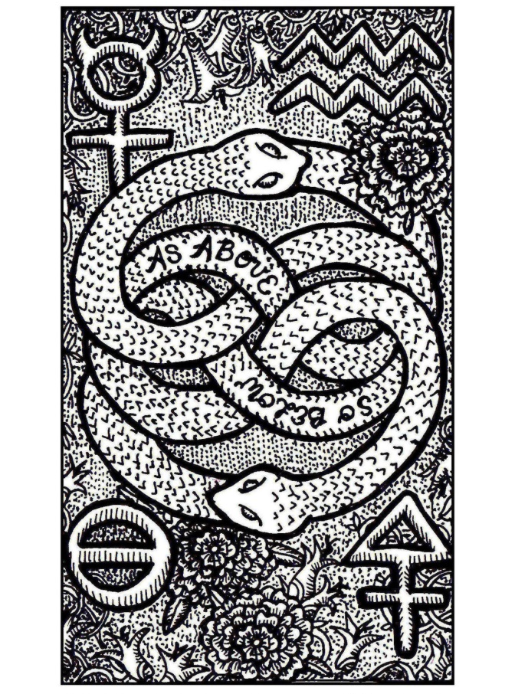

THE FOUR ELEMENTS:
TAROT CORRESPONDENCES

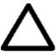  Fire | 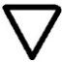  Water | 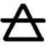  Air | 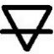  Earth
FIXED SIGN  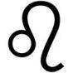  Leo | FIXED SIGN  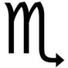  Scorpio | FIXED SIGN  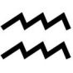  Aquarius | FIXED SIGN  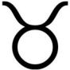  Taurus
AGRICULTURAL CALENDAR  July – August  Harvest | AGRICULTURAL CALENDAR  Oct. – Nov.  Barren | AGRICULTURAL  CALENDAR  Jan. – Feb.  Forecast | AGRICULTURAL CALENDAR  April – May  Sowing Seeds
DIRECTIVE TO THE MAGUS  To Dare | DIRECTIVE TO THE MAGUS  To Keep Silent | DIRECTIVE TO THE MAGUS  To Know | DIRECTIVE TO THE MAGUS  To Do
ANIMAL  Lion  Salamander | ANIMAL  Eagle  Dolphin | ANIMAL  Human  Butterfly | ANIMAL  Bull  Rabbit
HOUSE TITLE  Palace of Fortunes | HOUSE TITLE  Power to Transform | HOUSE TITLE  Seer of  Futures | HOUSE TITLE  Gate of  Hades
CORE IMPULSE  “I Will” | CORE IMPULSE  “I Desire” | CORE IMPULSE  “I Know” | CORE IMPULSE  “I Have”
PLANNING PHASE  Test | PLANNING PHASE  Risk | PLANNING PHASE  Execute | PLANNING PHASE  Dream
Inspirational  Motivational  Confident  Enthusiastic  Exploratory  Trailblazer  Pioneering  Clairvoyant  “Fiery, Oriental” | Artistic  Sensitive  Empathic  Compassionate  Protective  Nurturing  Spiritual  Clairsentient  “Watery, Northern” | Intellectual  Analytical  Expressive  Logical  Rational  Warrior  Advocate  Claircognizant  “Aerial, Occidental” | Diligent  Comprehensive  Grounded  Responsible  Perceptive  Resourceful  Industrialist  Clairaudient  “Earthly, Southern”
Numerology:  1 5 9 | Numerology:  2 6 | Numerology:  3 7 | Numerology:  4 8

Altar Tool  Wand (Scepter) | Altar Tool  Chalice | Altar Tool  Blade (Athame) | Altar Tool  Pentacle
PSYCHIC SENSE  Clairvoyance | PSYCHIC SENSE  Clairsentience | PSYCHIC SENSE  Claircognizance | PSYCHIC SENSE  Clairaudience
Moon Phase  New Moon | Moon Phase  First Qtr. Moon | Moon Phase:  Full Moon | Moon Phase:  Last Qtr. Moon
AREAS OF MAGIAN STUDY  Pyromancy  Bone Divination  Runes, Ogham | AREAS OF MAGIAN STUDY  Hydromancy  Mediumship  Energy Clearing | AREAS OF MAGIAN STUDY  Aeromancy  Astrology  Palmistry | AREAS OF MAGIAN STUDY  Geomancy  Herbalism  Energy Healing
AREAS OF PERSONAL STUDY  Technical Study in the Arts; Specialized Skills; Career Development | AREAS OF PERSONAL STUDY  Creative Study in the Arts; Networking; Relationship Building | AREAS OF PERSONAL STUDY  Systemic Study of the Sciences; Technology; Communications; Media | AREAS OF PERSONAL STUDY  Asset Management  Business  Personal Finance  Health Science
ALCHEMICAL PHASE  Citrinitas  Solar Dawn  Stage of  the Sun  The Red King | ALCHEMICAL PHASE  Albedo  Purification  Stage of  the Moon  The White Queen | ALCHEMICAL PHASE  Rubedo  Manifestation  Materializing the Philosopher’s Stone  A Magnum Opus | ALCHEMICAL PHASE  Nigredo  Decay  Stage of  Neutralization  The Raven
SACRED RELIC  Scepter of Destiny | SACRED RELIC  Holy Grail | SACRED RELIC  Sword of  the Spirit | SACRED RELIC  Bread of Life
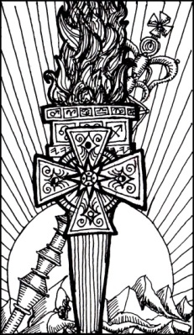 | 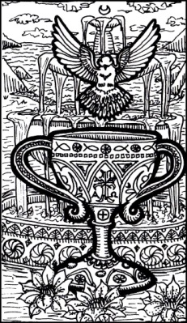 | 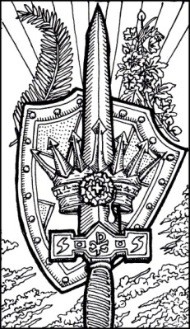 | 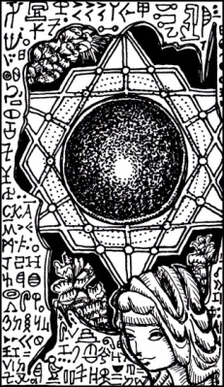

FIRE  Correspondences | 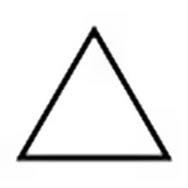
Directionality:
Season:
Zodiac Signs:
Astrological Houses:
Moon Phases:
Kabbalistic World:
Alchemical Phase:
Ritual Tool:
Psychic Ability:

Gemstones, Oils, Herbs, and/or Crystal Correspondences:
Animal Correspondences:
Success Factors:

Color Correspondences:
Corresponding Areas of Life:
Archetypes or Deities that Personify Fire:
Major Arcana Keys:
Minor Arcana Keys:
WATER  Correspondences | 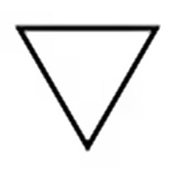
Directionality:
Season:
Zodiac Signs:
Astrological Houses:
Moon Phases:
Kabbalistic World:
Alchemical Phase:
Ritual Tool:
Psychic Ability:

Gemstones, Oils, Herbs, and/or Crystal Correspondences:
Animal Correspondences:
Success Factors:

Color Correspondences:
Corresponding Areas of Life:
Archetypes or Deities that Personify Water:
Major Arcana Keys:
Minor Arcana Keys:
AIR  Correspondences | 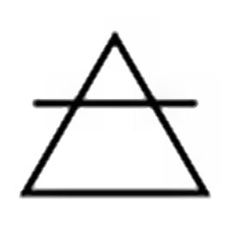
Directionality:
Season:
Zodiac Signs:
Astrological Houses:
Moon Phases:
Kabbalistic World:
Alchemical Phase:
Ritual Tool:
Psychic Ability:

Gemstones, Oils, Herbs, and/or Crystal Correspondences:
Animal Correspondences:
Success Factors:

Color Correspondences:
Corresponding Areas of Life:
Archetypes or Deities that Personify Air:
Major Arcana Keys:
Minor Arcana Keys:
EARTH  Correspondences | 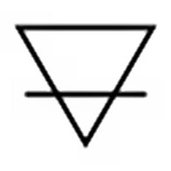
Directionality:
Season:
Zodiac Signs:
Astrological Houses:
Moon Phases:
Kabbalistic World:
Alchemical Phase:
Ritual Tool:
Psychic Ability:

Gemstones, Oils, Herbs, and/or Crystal Correspondences:
Animal Correspondences:
Success Factors:

Color Correspondences:
Corresponding Areas of Life:
Archetypes or Deities that Personify Fire:
Major Arcana Keys:
Minor Arcana Keys:
