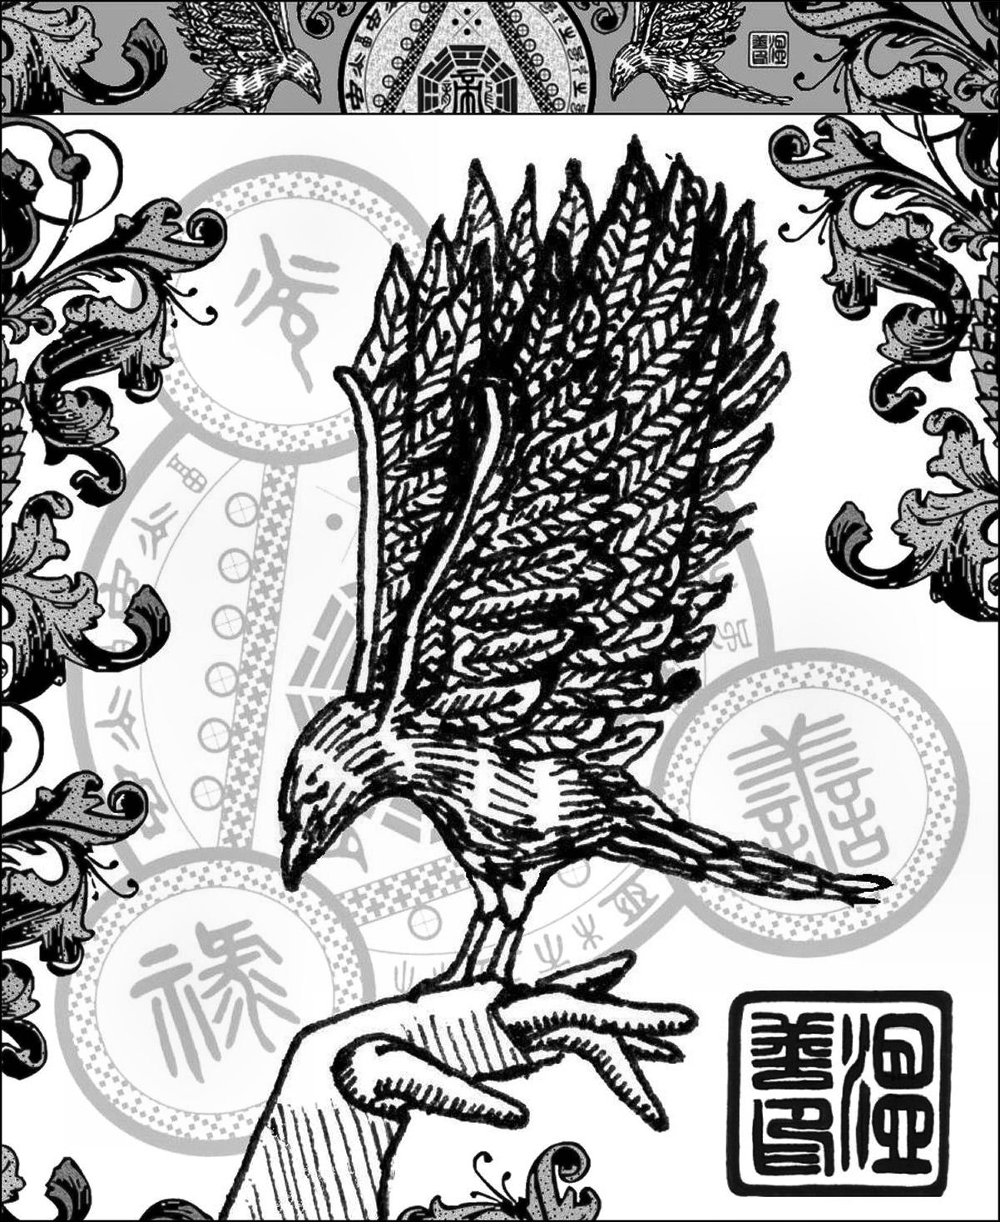

TAROT READINGS DIARY

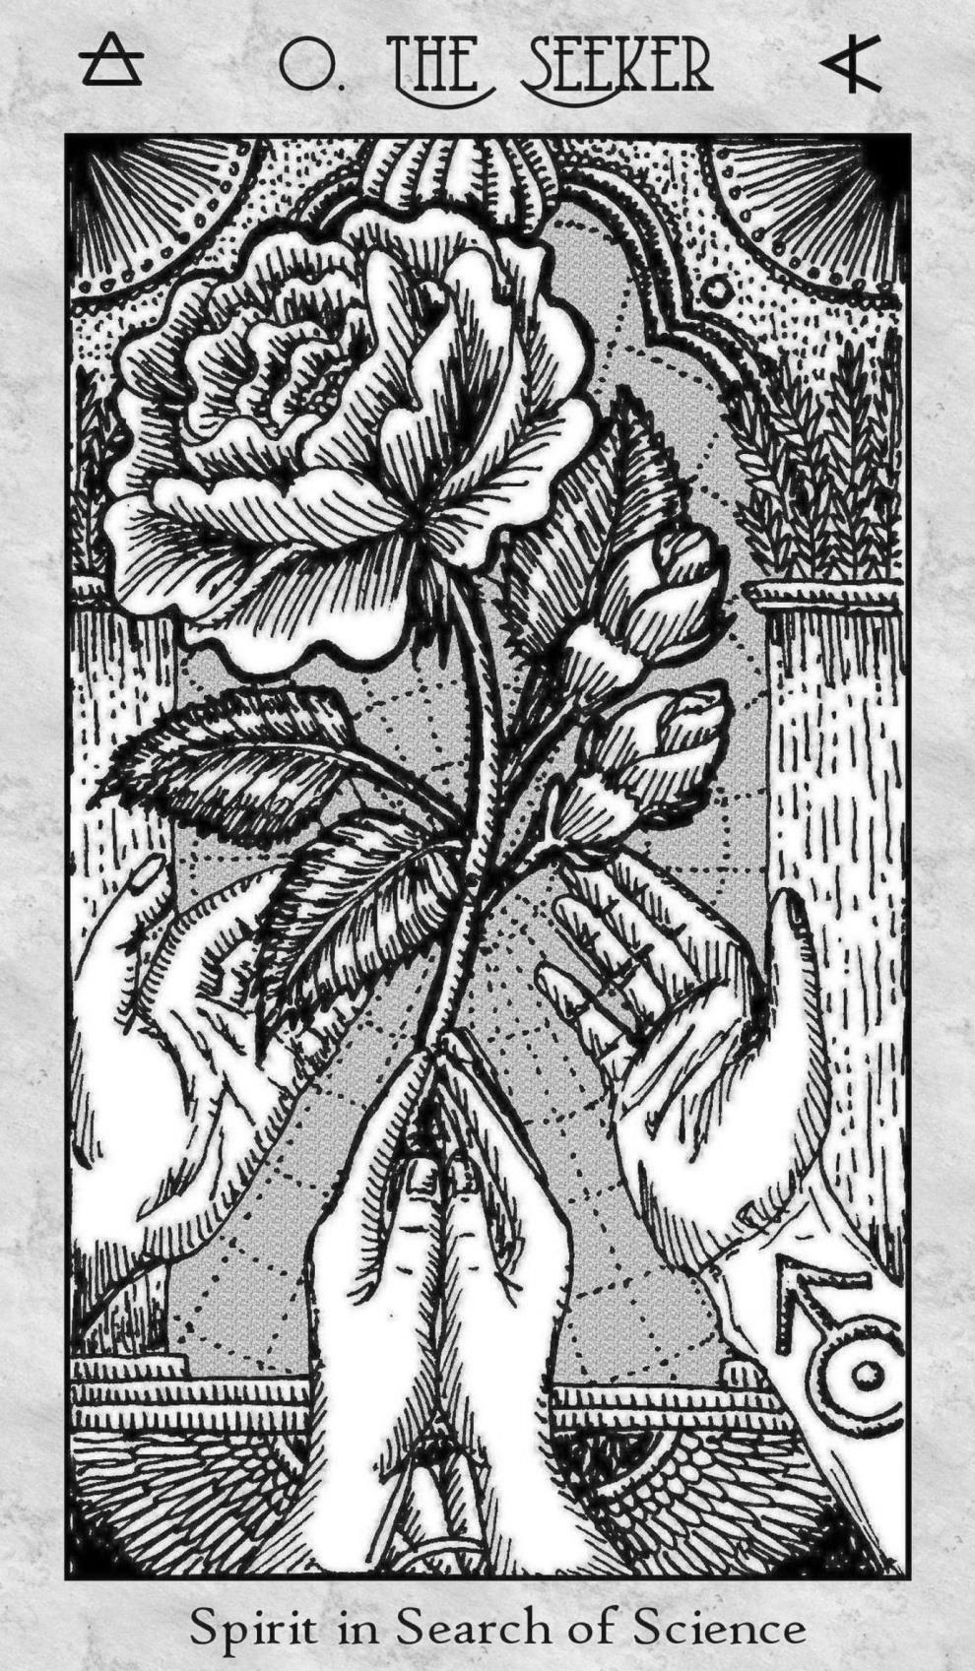

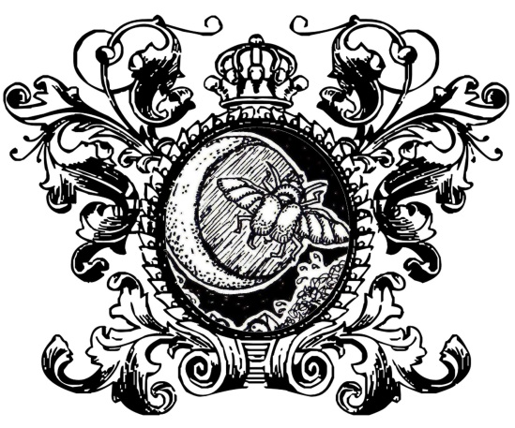

DIARY CONTENTS

Log of Notes from the SKT Esoteric Tarot Course | 4
Extra Note Taking Pages | 101
Personal Tarot Readings | 117
Extra Pages for Personal Reading Notes | 251
SKT Quick Reference Card Meanings | 275
I Ching Trigram Correspondences | 311

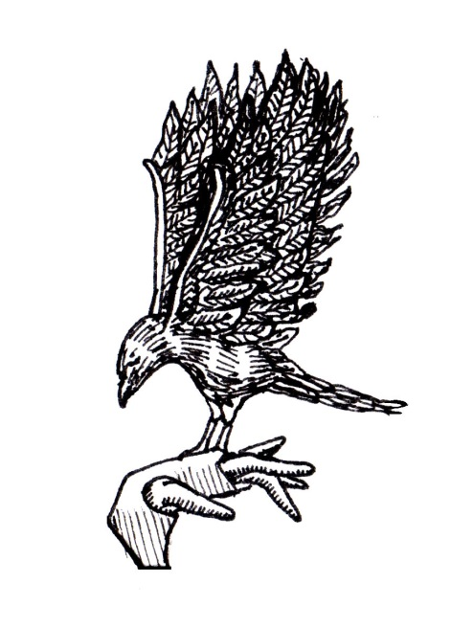

LOG OF NOTES
FROM THE SKT
ESOTERIC TAROT
COURSE

Introduction (Series I and Series II) + Deck Creator’s Intentions

Consecrating Your Deck + Initiation and Tarot

Beginner Tarot and the SKT Deck

Reading the SKT Deck Intuitively

Key 0 and the Significator

The Major Arcana

The Empyrean Courts

Scepters: Ace to Ten

Chalices: Ace to Ten

Swords: Ace to Ten

Orbs: Ace to Ten

The Minor Arcana

Interpreting Signs and Omens

Dialogue with an Angel

Spirit Interactions and Tarot

The Angel and The Demon

Kundalini Awakening and Tarot

The Akashic Records and Tarot

Ritual Magic and Tarot

Pathworking, Astral Journeying, Final Remarks

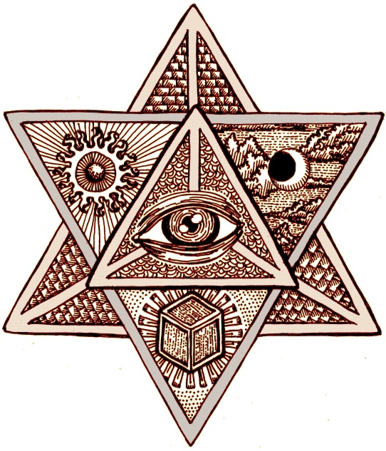

EXTRA NOTE TAKING PAGES

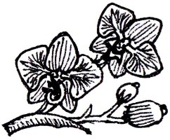

PERSONAL
TAROT READINGS

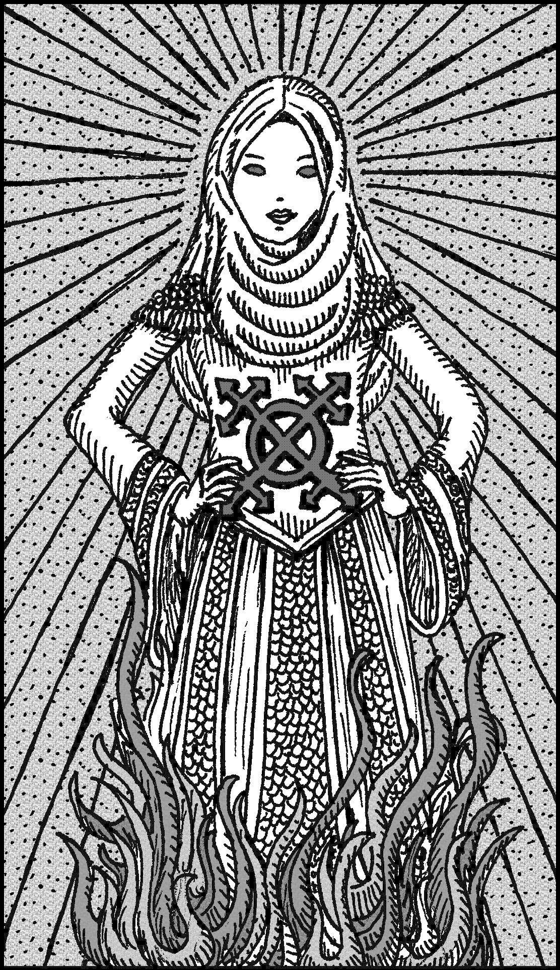

Angel Who Records, whose Hand seals upon the Book of Remembrance, who bears witness to All to enumerate every deed, since Creation, from the beginning of the world to this day, from my cradle to my grave, I invoke you to read to me, to show me, to transcribe upon my heart, to place upon the mantle of my mind the pages of the Book I petition for.

Let it be the Truth. Let that Truth, come what may, ever be used to work the Highest Good. And so may it be.

Date of Reading:
Key 0 Significator Used (if any):
Question:
Spread or Diagram of Reading:
Label the diagram with card position indications (as applicable) and the cards drawn
Quick First Impression:

Reading Interpretation & Insights:

Post-Reading Reflection & Feedback

Date of Reading:
Date of Post-Reading Notes:

Date of Reading:
Key 0 Significator Used (if any):
Question:
Spread or Diagram of Reading:
Label the diagram with card position indications (as applicable) and the cards drawn
Quick First Impression:

Reading Interpretation & Insights:

Post-Reading Reflection & Feedback

Date of Reading:
Date of Post-Reading Notes:

Date of Reading:
Key 0 Significator Used (if any):
Question:
Spread or Diagram of Reading:
Label the diagram with card position indications (as applicable) and the cards drawn
Quick First Impression:

Reading Interpretation & Insights:

Post-Reading Reflection & Feedback

Date of Reading:
Date of Post-Reading Notes:

Date of Reading:
Key 0 Significator Used (if any):
Question:
Spread or Diagram of Reading:
Label the diagram with card position indications (as applicable) and the cards drawn
Quick First Impression:

Reading Interpretation & Insights:

Post-Reading Reflection & Feedback

Date of Reading:
Date of Post-Reading Notes:

Date of Reading:
Key 0 Significator Used (if any):
Question:
Spread or Diagram of Reading:
Label the diagram with card position indications (as applicable) and the cards drawn
Quick First Impression:

Reading Interpretation & Insights:

Post-Reading Reflection & Feedback

Date of Reading:
Date of Post-Reading Notes:

Date of Reading:
Key 0 Significator Used (if any):
Question:
Spread or Diagram of Reading:
Label the diagram with card position indications (as applicable) and the cards drawn
Quick First Impression:

Reading Interpretation & Insights:

Post-Reading Reflection & Feedback

Date of Reading:
Date of Post-Reading Notes:

Date of Reading:
Key 0 Significator Used (if any):
Question:
Spread or Diagram of Reading:
Label the diagram with card position indications (as applicable) and the cards drawn
Quick First Impression:

Reading Interpretation & Insights:

Post-Reading Reflection & Feedback

Date of Reading:
Date of Post-Reading Notes:

Date of Reading:
Key 0 Significator Used (if any):
Question:
Spread or Diagram of Reading:
Label the diagram with card position indications (as applicable) and the cards drawn
Quick First Impression:

Reading Interpretation & Insights:

Post-Reading Reflection & Feedback

Date of Reading:
Date of Post-Reading Notes:

Date of Reading:
Key 0 Significator Used (if any):
Question:
Spread or Diagram of Reading:
Label the diagram with card position indications (as applicable) and the cards drawn
Quick First Impression:

Reading Interpretation & Insights:

Post-Reading Reflection & Feedback

Date of Reading:
Date of Post-Reading Notes:

Date of Reading:
Key 0 Significator Used (if any):
Question:
Spread or Diagram of Reading:
Label the diagram with card position indications (as applicable) and the cards drawn
Quick First Impression:

Reading Interpretation & Insights:

Post-Reading Reflection & Feedback

Date of Reading:
Date of Post-Reading Notes:

Date of Reading:
Key 0 Significator Used (if any):
Question:
Spread or Diagram of Reading:
Label the diagram with card position indications (as applicable) and the cards drawn
Quick First Impression:

Reading Interpretation & Insights:

Post-Reading Reflection & Feedback

Date of Reading:
Date of Post-Reading Notes:

Date of Reading:
Key 0 Significator Used (if any):
Question:
Spread or Diagram of Reading:
Label the diagram with card position indications (as applicable) and the cards drawn
Quick First Impression:

Reading Interpretation & Insights:

Post-Reading Reflection & Feedback

Date of Reading:
Date of Post-Reading Notes:

Date of Reading:
Key 0 Significator Used (if any):
Question:
Spread or Diagram of Reading:
Label the diagram with card position indications (as applicable) and the cards drawn
Quick First Impression:

Reading Interpretation & Insights:

Post-Reading Reflection & Feedback

Date of Reading:
Date of Post-Reading Notes:

Date of Reading:
Key 0 Significator Used (if any):
Question:
Spread or Diagram of Reading:
Label the diagram with card position indications (as applicable) and the cards drawn
Quick First Impression:

Reading Interpretation & Insights:

Post-Reading Reflection & Feedback

Date of Reading:
Date of Post-Reading Notes:

Date of Reading:
Key 0 Significator Used (if any):
Question:
Spread or Diagram of Reading:
Label the diagram with card position indications (as applicable) and the cards drawn
Quick First Impression:

Reading Interpretation & Insights:

Post-Reading Reflection & Feedback

Date of Reading:
Date of Post-Reading Notes:

Date of Reading:
Key 0 Significator Used (if any):
Question:
Spread or Diagram of Reading:
Label the diagram with card position indications (as applicable) and the cards drawn
Quick First Impression:

Reading Interpretation & Insights:

Post-Reading Reflection & Feedback

Date of Reading:
Date of Post-Reading Notes:

Date of Reading:
Key 0 Significator Used (if any):
Question:
Spread or Diagram of Reading:
Label the diagram with card position indications (as applicable) and the cards drawn
Quick First Impression:

Reading Interpretation & Insights:

Post-Reading Reflection & Feedback

Date of Reading:
Date of Post-Reading Notes:

Date of Reading:
Key 0 Significator Used (if any):
Question:
Spread or Diagram of Reading:
Label the diagram with card position indications (as applicable) and the cards drawn
Quick First Impression:

Reading Interpretation & Insights:

Post-Reading Reflection & Feedback

Date of Reading:
Date of Post-Reading Notes:

Date of Reading:
Key 0 Significator Used (if any):
Question:
Spread or Diagram of Reading:
Label the diagram with card position indications (as applicable) and the cards drawn
Quick First Impression:

Reading Interpretation & Insights:

Post-Reading Reflection & Feedback

Date of Reading:
Date of Post-Reading Notes:

Date of Reading:
Key 0 Significator Used (if any):
Question:
Spread or Diagram of Reading:
Label the diagram with card position indications (as applicable) and the cards drawn
Quick First Impression:

Reading Interpretation & Insights:

Post-Reading Reflection & Feedback

Date of Reading:
Date of Post-Reading Notes:

Date of Reading:
Key 0 Significator Used (if any):
Question:
Spread or Diagram of Reading:
Label the diagram with card position indications (as applicable) and the cards drawn
Quick First Impression:

Reading Interpretation & Insights:

Post-Reading Reflection & Feedback

Date of Reading:
Date of Post-Reading Notes:

Date of Reading:
Key 0 Significator Used (if any):
Question:
Spread or Diagram of Reading:
Label the diagram with card position indications (as applicable) and the cards drawn
Quick First Impression:

Reading Interpretation & Insights:

Post-Reading Reflection & Feedback

Date of Reading:
Date of Post-Reading Notes:

Date of Reading:
Key 0 Significator Used (if any):
Question:
Spread or Diagram of Reading:
Label the diagram with card position indications (as applicable) and the cards drawn
Quick First Impression:

Reading Interpretation & Insights:

Post-Reading Reflection & Feedback

Date of Reading:
Date of Post-Reading Notes:

Date of Reading:
Key 0 Significator Used (if any):
Question:
Spread or Diagram of Reading:
Label the diagram with card position indications (as applicable) and the cards drawn
Quick First Impression:

Reading Interpretation & Insights:

Post-Reading Reflection & Feedback

Date of Reading:
Date of Post-Reading Notes:

Date of Reading:
Key 0 Significator Used (if any):
Question:
Spread or Diagram of Reading:
Label the diagram with card position indications (as applicable) and the cards drawn
Quick First Impression:

Reading Interpretation & Insights:

Post-Reading Reflection & Feedback

Date of Reading:
Date of Post-Reading Notes:

Date of Reading:
Key 0 Significator Used (if any):
Question:
Spread or Diagram of Reading:
Label the diagram with card position indications (as applicable) and the cards drawn
Quick First Impression:

Reading Interpretation & Insights:

Post-Reading Reflection & Feedback

Date of Reading:
Date of Post-Reading Notes:

Date of Reading:
Key 0 Significator Used (if any):
Question:
Spread or Diagram of Reading:
Label the diagram with card position indications (as applicable) and the cards drawn
Quick First Impression:

Reading Interpretation & Insights:

Post-Reading Reflection & Feedback

Date of Reading:
Date of Post-Reading Notes:

Date of Reading:
Key 0 Significator Used (if any):
Question:
Spread or Diagram of Reading:
Label the diagram with card position indications (as applicable) and the cards drawn
Quick First Impression:

Reading Interpretation & Insights:

Post-Reading Reflection & Feedback

Date of Reading:
Date of Post-Reading Notes:

Date of Reading:
Key 0 Significator Used (if any):
Question:
Spread or Diagram of Reading:
Label the diagram with card position indications (as applicable) and the cards drawn
Quick First Impression:

Reading Interpretation & Insights:

Post-Reading Reflection & Feedback

Date of Reading:
Date of Post-Reading Notes:

Date of Reading:
Key 0 Significator Used (if any):
Question:
Spread or Diagram of Reading:
Label the diagram with card position indications (as applicable) and the cards drawn
Quick First Impression:

Reading Interpretation & Insights:

Post-Reading Reflection & Feedback

Date of Reading:
Date of Post-Reading Notes:

Date of Reading:
Key 0 Significator Used (if any):
Question:
Spread or Diagram of Reading:
Label the diagram with card position indications (as applicable) and the cards drawn
Quick First Impression:

Reading Interpretation & Insights:

Post-Reading Reflection & Feedback

Date of Reading:
Date of Post-Reading Notes:

Date of Reading:
Key 0 Significator Used (if any):
Question:
Spread or Diagram of Reading:
Label the diagram with card position indications (as applicable) and the cards drawn
Quick First Impression:

Reading Interpretation & Insights:

Post-Reading Reflection & Feedback

Date of Reading:
Date of Post-Reading Notes:

Date of Reading:
Key 0 Significator Used (if any):
Question:
Spread or Diagram of Reading:
Label the diagram with card position indications (as applicable) and the cards drawn
Quick First Impression:

Reading Interpretation & Insights:

Post-Reading Reflection & Feedback

Date of Reading:
Date of Post-Reading Notes:

EXTRA PAGES FOR
PERSONAL READING NOTES

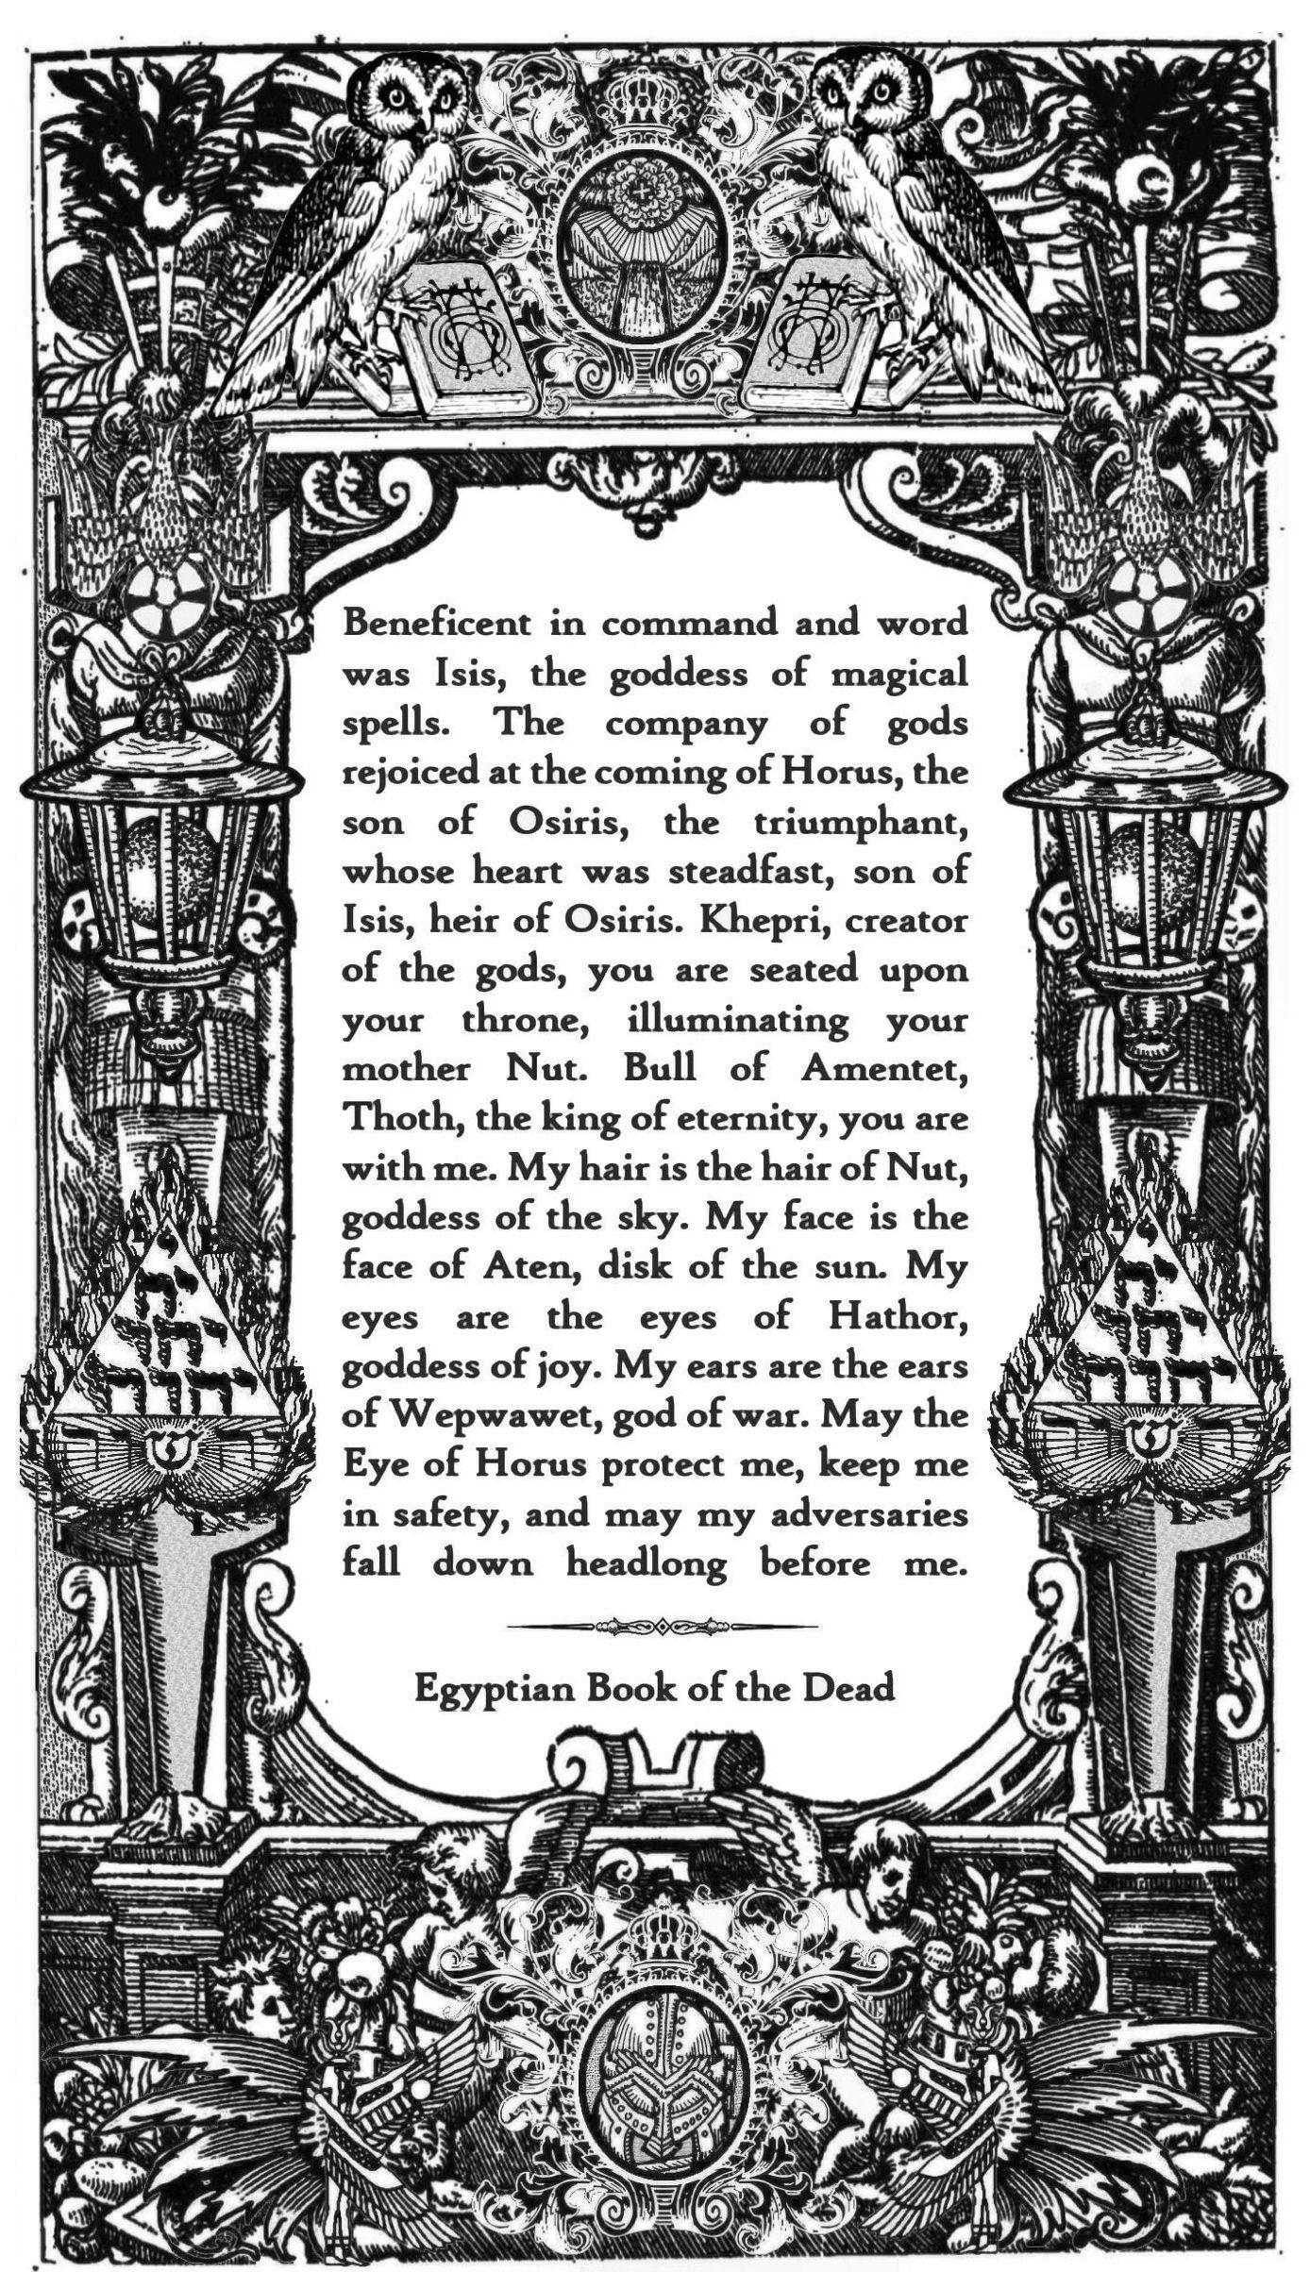

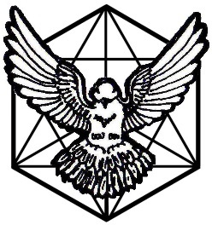

SKT
SHORT-FORM
QUICK REFERENCE
CARD MEANINGS

Major Arcana: Primordial Realm
Reading the Top Captions
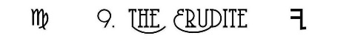
The top caption on each Major Arcanum features the elemental or astrological correspondence at left; the center is the name of the spirit as revealed to me that occupies the depths beneath the pulse point of the classic tarot Key; and to the right is the associated Logos, or letter from the Proto-Canaanite/Phoenician alphabet corresponding with that Key.
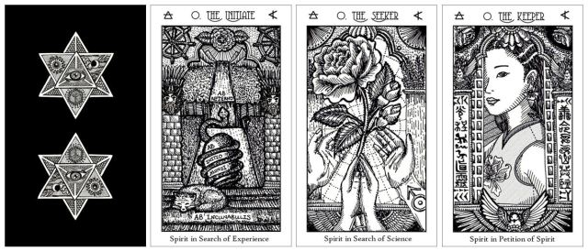
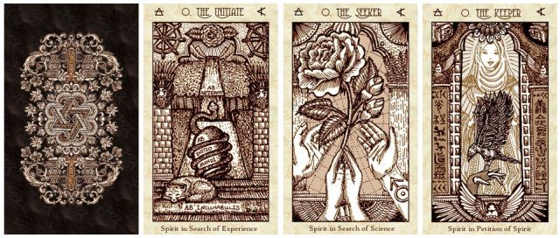
The Significator
The Spirit Keeper’s Tarot deck is designed with the intention of using one of the three offered versions of Key 0, the classic Fool card in tarot, as the significator card—the card in the deck that represents you or your inquiry. It is a sympathetic representation of your space-time, which anchors the cards with your personal energetic imprint. Begin a reading by choosing one of the three Key 0s to be your significator card.
Key 0: The Initiate personifies a return to spring, starting a new cycle of growth. Ab incunabulis: from cradle to grave; ab aeterno: since the beginning. Use The Initiate for Key 0 when inquiring about a new undertaking, when a Path has not yet been chosen or taken, or when insight is needed on which road to take forward. Use The Initiate as your significator card when what is sought is experience. How might you decide between potential paths? Are you embarking on a fresh start in life? What is your potential anyway? Ab initio mundi: from the beginning of the world to this day. Do you need a little divine guidance on how to map out your Path? Access the cards through The Initiate as your significator.
Key 0: The Seeker is The Fool who seeks answers, who seeks to know. This is you in search of specific guidance. Use The Seeker for Key 0 when divinatory insight is sought, when the adept needs guidance mid-stream along a path, or when you seek divine counsel on a material matter.
Key 0: The Keeper is The Fool who has become practiced and learned in a spiritual path and now engages in a more interactive relationship with the many names and many faces of the Holy Spirit. Use The Keeper for spirit contacts, connecting to the angelic or divine realms, Akashic Records readings, or mediumship readings. Also use the Keeper when working with the cards in ritual magic. Using The Keeper for Key 0 will enliven the deck immediately and open it to spirit communications.
First Septenary
Integrate the Self
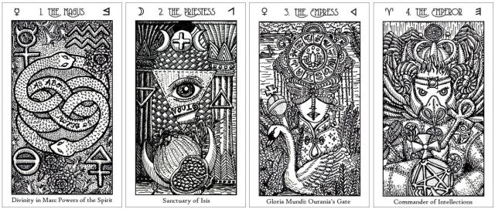
Key 1: The Magus. The Magus is the personification of creative thought. When this Key appears to you, the call to action is exercising the powers of your mind and you will achieve your greatest potential. The Magus appears to you now to help you manifest discipline and focus toward mastery over your own innate talents. Never forget: you have the capability to manifest your thoughts into reality. That is the divinity in man and the powers embedded within your spirit. Embody the alchemist and transmute what is of little value to what is of great value. Invent, reinvent.
Key 2: The Priestess. This is Sophia, or Wisdom personified. She guides you toward the deepening and broadening of your knowledge. Aspire for scholarship to wield the power of discernment. The Priestess is the Queen of the Angels. When The Priestess appears to you, she instructs on the cultivation of your wisdom and intuition. The summation of choices you have made and the landscape of thoughts you have painted for yourself have taken you to the threshold of a particular Path, and now is the time to venture deeper, farther. Here is the wellspring of magic.
Key 3: The Empress. The Empress appears to those who are on the verge of producing a Work of worthy admiration. The magic of The Empress transforms your hopes into reality. A divinity of Universal Love is present in your life path and The Empress appearing to you is the affirmation you need for acknowledging that presence. Gloria Mundi is the muse for poets, writers, artists, and musicians. The Empress also embodies the spirit of Rhetoric. She wields the art of persuasion.
Key 4: The Emperor. When The Emperor appears to you, your power of self-determination is being affirmed. You have the power to determine what is and what will be for yourself. Your task: define your destination, and then lead the charge. The Emperor appears when you are being called to direct and reign. Overcome your fears, because it is now time for you to conquer new frontier. Wield your authority with aplomb.
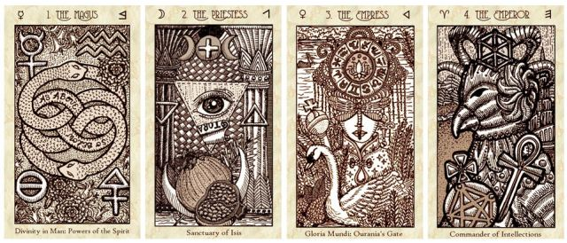

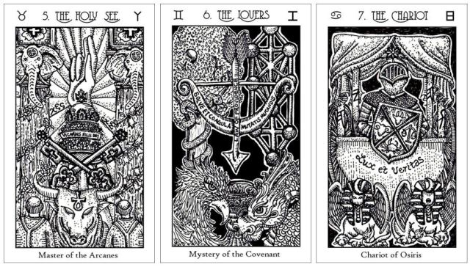
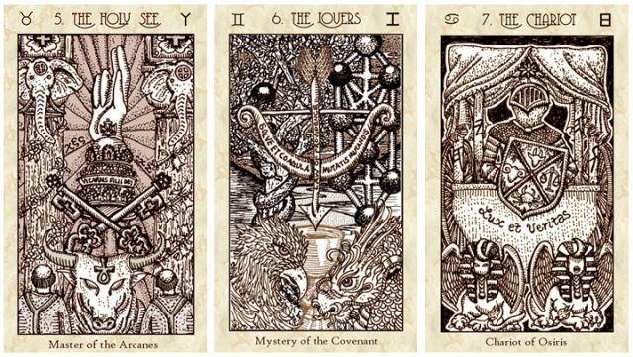
Key 5: The Holy See. When The Holy See appears to you, you are confronting what you have inherited and are now tasked to evaluate that inheritance with individual responsibility. This is the spirit of sovereignty over your soul purpose. When The Holy See appears to you, it’s time to evaluate your material culture and social norms. Discern for yourself whose interpretation of the Arcanes is the correspondence that rings true with your divine higher genius. When Key 5 appears to you, take care that you are not following a false prophet. Restrain your indulgences.
Key 6: The Lovers. The Lovers is the spirit of pairs. This is our internal binary. Solve et coagula: dissolve and concentrate, a maxim of the alchemists. The Lovers portend the sacred marriage of your higher self and your ego. You are at a crossroads and your next step is to choose between two paths. Key 6 appears to you when you must decide between instant gratification or delayed gratification. When The Lovers card appears, it can also be a call to evaluate your interpersonal matters. In modernity, The Lovers card might appear so that attention can be called toward a romantic relationship or to the themes of Eros.
Key 7: The Chariot. The Chariot is the spirit that helps you create change. You have attained a certain mastery of knowledge, and now you must determine how you will use that knowledge to innovate. The Chariot is an omen that you’re gaining momentum. You possess mastery of knowledge and skills that now drive you farther along your Path. When The Chariot card appears, you have arrived at a critical milestone and are in active movement toward victory. Success will come to the one who refuses to stop fighting. Keep going.
Second Septenary
Integrate the Cosmos
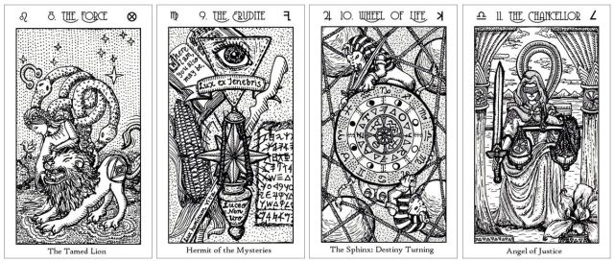
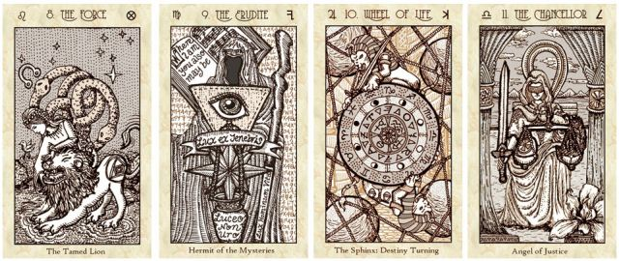

Key 8: The Force. This is the spirit of mastery over your own fears. You’re awakening to higher consciousness. The Force is the personification of audacity to achieve personal miracles. In spite of all the obstacles you’ve endured, you prevail, you persist, you domineer. When the beast growls at the maiden, instead of responding with violence or with fear, the maiden shows love, kindness, and compassion. Her loving-kindness tames the lion. With patience and fortitude, you overcome the initial setbacks. You are held in high esteem.
Key 9: The Erudite. Lux ex tenebris: this is the inner light of wisdom and guidance that shines through the darkness. The Erudite bears this message: as you walk through the valley of darkness, fear no evil, for the Holy One is with you. The Holy One’s rod and staff shall comfort you so that you always shine, but never burn—luceo non uro.
The Erudite is the prophecy of a wise teacher. This is someone who has learned and mastered many subjects, and therefore possesses great knowledge as broad in scope as that knowledge is deep. When The Erudite appears to you, here is your second message: Shine with the light of the heavens. Shine for others, so others can see themselves and the world clearer. Light the life of humanity—lux hominum vita.
Key 10: Wheel of Life. When Key 10 appears to you, you are at a major turning point in your life. This is the symbol of changing cycles and even the cycles of our mind, how we change our perspectives based on the evolution of our experiences. This is also our karma and the law of causation. This is the guardian spirit present during a major shift.
Key10 is the card of change, and a major one at that. What had been up will come down, and what had been down will rise up. One way of thinking will change and your soul will evolve. Yet this Key 10 is specially consecrated and fortified to protect you. The Wheel is in fact a shield. This is Hemuset rising, Egyptian goddess of fate and protection.
Key 11: The Chancellor. This spirit represents rectification measures that counter karmic consequences. It is the spirit guiding you toward balanced judgment and making clear decisions. Do not judge based on appearances. Choose balanced action, balanced words, and balanced thought.
When The Chancellor appears to you, it is a call to make the necessary adjustments so that you might restore balance. The Angel of Justice arrives when all considerations have been duly weighed and the resulting outcome of the choices you’ve made, your actions and your speech has now been determined. Key 11 marks that point when the truth comes out. The scales of your life are about to get tipped so that balance can be maintained.
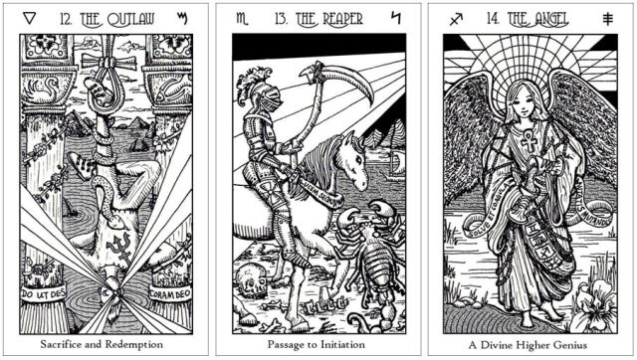
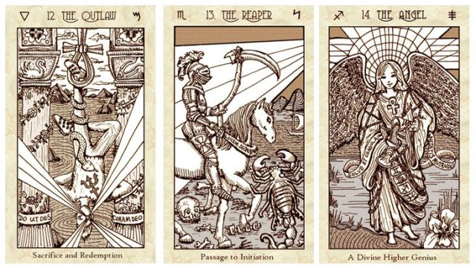
Key 12: The Outlaw. Examine your situation from a different perspective. Be the outlier. This is the spirit designating how we break from establishment to serve a higher purpose. A guardian spirit has come to support you as you scrutinize both the fundamentalism around you and the personal dogma embedded deep within. Key 12 sends the message of psychic mindfulness. Tap in to your own deep sea of unconscious. This is the heretical, the eccentric, the dissident. This is the rejection of authority and rebellion against establishment. The Outlaw appears to you when the answer is to operate outside of and in contention with the established rules of institution. Do ut des: I give that you may give. Coram Deo: you are in the presence of God.
Key 13: The Reaper. Lucem sequimur: follow the Light. You are being guided through an initiation phase and the suffering you experience serves a greater divine purpose. A change that you know in your heart is imminent but have been denying is the change that you will face. The Reaper appears to you when the circumstances you face call for this gentle reminder: All is not fair to the human perception. You toil for the Bread of Life until sweat seethes from your brow, and yet that Life will be taken away no matter who you are or what you have done. Ashes to ashes, dust to dust. That is the purpose and the absence of purpose to human Genesis. Endure through the difficult changes to come and when those winds of change have settled, you will find yourself better for it. There will be rebirth after this death.
Key 14: The Angel. This is where it gets better. Mutatis mutandis: the necessary changes have been made. When The Angel appears to you, it is an omen that troubles are passing, pains subsiding, and you are growing closer to God. The Angel is your patron deity. Genius, in Greco-Roman lore, is one’s tutelary deity, or a guardian spirit that protects an individual person. It is your daimon from your cradle to your grave, the realization of an inner divine.
Circumstances in your life path have converged and a work of personal inspiration becomes your productivity. You realize your innate talents and bring into material being that which is extraordinary. This is the primordial spirit of exceptionalism. “Genius hits a target no one else can see.” (Arthur Schopenhauer, 1788-1860)
When The Angel appears to you, take a moment to intuit the pulses of energy in the space around you. Can you feel the presence of the daimon? Do you know that you are watched over and looked after? Your Angel is not at liberty to prevent every turn of suffering in your life, required to stand by and watch as you suffer the slings of your own fortunes, enduring the penance of your mistakes. Know that every time your Angel is authorized to divert harm away from you, harm has been diverted.
Third Septenary
Integrate the Divine
Key 15: The Demon. You know you’ve begun the final prong of your spiritual journey when you’re thrust into a battle with the Typhon. This is the mental and emotional chains of bondage you must break, and to break those chains, you must see clearly that those chains have always been an illusion. The Demon is the primordial spirit of harm, and most often than not, self-harm. This is self-sabotage. The Demon is the personification of interferences that undermine our pursuit of our aspirations or the advancement of our knowledge and wisdom. The Demon is that which holds us back. When The Demon appears, you are letting forces of harm inhibit your progress. You have been surrendering your self-control. The Demon is thus trying to alert you to manipulation, abuse, deception, or undue influences that are causing you sabotage in the long-term. When The Demon appears, a usurper lurks nearby.
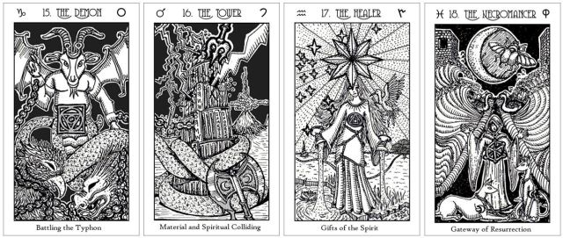
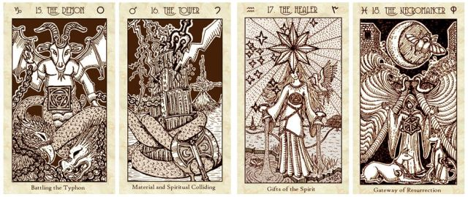
Key 16: The Tower. The Tower is the spirit of disappointment when you feel what you have worked hard for is not propelling you toward the higher ground you desire. The spirit of The Tower appears when the message you need to hear is this: change your direction. Before the physical construction of your Great Work can manifest, you must build a solid inner foundation. Focus on that inner foundation and then when the conditions are ripe, the physical construction of your Great Work will manifest. This is the moment your material and spiritual worlds collide. The spirit of The Tower appears to you now in an effort to guide you through the challenge of dismantling your own preconceived notions. A talisman is given to you: a battle axe, which you must wield to remove the obstacles in your way. Heed these teachings: there can be joy in sorrow and stability in change. Lux mentis lux orbis: light of the mind, light of the world. Key 16 can also be an omen of armed conflict.
Key 17: The Healer. You have overcome a brutal yet necessary trial in your life, and now your Holy Guardian Angel returns to heal your battle wounds. The Healer appears to mend what was broken. Capax Dei: capable of receiving the Divine. The mind is formed in the image of God, and in that, it is capable of Divinity. Your capacity of holding Divinity within you is now being revealed. The goblets pour forth Hope and Faith—hope and faith in yourself that you are capable of greatness. Key 17 is the Star of the Magi and when The Healer appears to you, the fragments of your broken world will be healed. This is the omen of restoration, of rebuilding, salving, and alleviating your pains. When The Healer is making her presence known to you, it is the prophecy that a blessing is soon to be conferred.
Key 18: The Necromancer. When the Key 18 appears to you, the matter at hand is steeped in ambiguity. You cannot rely on superficial impressions; instead, trust your psychic responses. The Necromancer appears to help you see beyond physical perception. This is the spirit of your own imagination, an imagination that shines now so that the Truth can be illuminated. The Necromancer appears when you are coming toward the crossroads of having to endure through a dark night of the soul. The Necromancer will be your guide and ally through the darkest night. Yet there is prophecy here: journeying through the dark night of your soul will take you onto the path that leads to your Holy Grail. The Necromancer is also the spirit of resurrection. The parting seas depicted on the card symbolize climactic miracle. Through the doubt and mystery, maintain an unwavering faith and that is what powers resurrection and miracle.
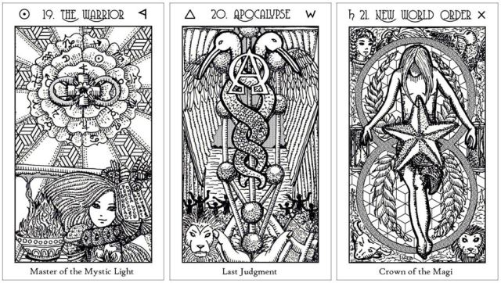
Key 19: The Warrior. Key 19, the Sun of the Magi, signifies competence and reciprocity. Here we see your consciousness expanding. The Master of the Mystic Light appears to you when you are on the verge of confronting potential with Reason and Truth, through which you shall create Goodness. Goodness is Creation with purpose arrived at through Reason and Truth. Here is victory in the battles you’ve fought for your own independence. You’ve broken all chains. You’ve detached yourself from that which had tried to control your will. And now your light shines freely out into the world. The Warrior is also the spirit of fighting to protect others, fighting in service. This is success and glory you achieve not for yourself, but so you can be in the empowered position to help others thrive and grow. This is the spirit of heroic acts. Inscribed upon The Warrior’s gloves: libertas perfundet omnia luce: freedom floods all things with light, and luceat lux vestra: let your light shine. You are now liberated and triumphant.
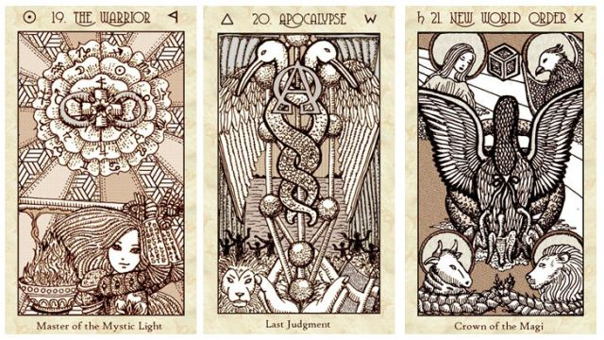
Key 20: Apocalypse. This is the spirit presented upon your path when you have arrived at a point of no return. What has transpired is now irreversible. “The only way out is through.” (Robert Frost, 1874-1963). This is that moment of full realization for why all that has happened to you has happened. The Apocalypse is the spirit of revelation, when the answers that were hidden before are now obvious. This is the alpha and the omega, the beginning and the end. When the Apocalypse appears in divination with other cards, it adds an emphasis of significant spiritual importance to those other cards. Pay closer attention when Key 20 is present. The Apocalypse is a mythic personification of an event horizon—this is a space-time in which no event that comes subsequent can affect the outcome, because all that could have affected it has either transpired or not transpired. The Apocalypse card appears when you have crossed the boundary of where gravitational pull over you is such that turning back is impossible.
Key 21: New World Order. This is the spirit you encounter when a cycle has come to its completion. Great balance and stability come when the catalyst has succeeded at creating a new zeitgeist. You are the New World Order who brings positive change to the zeitgeist. You are the catalyst. This is the spirit of you succeeding at creating the change you have wanted to see in your world. What do you see in your world right now that is broken or causes suffering? What is your dream of how your world can be repaired? The New World Order is the spirit ready and by your side, aiding you, guiding you, so that you can truly and fully embody the catalyst to a most wonderful change, a change that will make the world you live in a much better place for all. The New World Order ushers in a period of renaissance and unification. When Key 21 appears to you, it is the divinatory mark of a new epoch in your life path. With it comes a dramatic change to your world. This is the spirit of a great power rising.
Minor Arcana: Seven Upper Realms
The RWS equivalent to Scepters is Wands; Chalices is Cups; Swords is Swords; and Orbs is Pentacles. In the Thoth, the equivalents are Scepters to Wands; Chalices to Cups; Swords to Swords; and Orbs to Disks.
SKT | RWS | Thoth
Scepters | Wands | Wands
Chalices | Cups | Cups
Swords | Swords | Swords
Orbs | Pentacles | Disks

Seven Upper Realms of the Minor Arcana
The Aces: Nucleic Seeds
The Twos: Provision
The Threes: Fruition
Holy Guardians of Fire
Holy Guardians of Water
Holy Guardians of Air
Holy Guardians of Earth

Archangels are the tarot Kings. Shields are the tarot Queens. The Shining Ones are tarot Knights and the Strongholds are tarot Pages.
Reading the Top Captions
After the Aces in the Minor Arcana, the Twos and onward feature top captions that give the decan rulership of the Key.
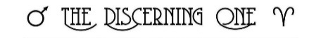
For example, The Discerning One (Two of Scepters) corresponds astrologically with the decan ruler Mars in Aries.
Realm of Aces: Nucleic Seeds
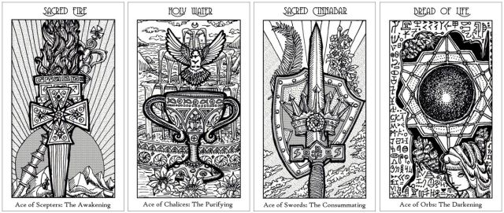
Sacred Fire. Ace of Scepters: A switch inside you has turned on your creativity, productivity, and ingenuity. Fire is alchemizing in your world, materializing as a creative project, an innovative new venture, entrepreneurship, or the spark of inspiration for a passion project. This is also a new direction in career development. This is the Awakening stage of your Path. Fire is the element now abundant in your world. Manifest your next great achievement by harnessing and transmuting that Fire.
Holy Water. Ace of Chalices: You are being cleansed. You will find the inner peace you seek. Water is alchemizing in your world, materializing as concord and fruitful development in home and family, the domestic sphere, or promising prospects in love and relationships. Your soul is being purified by what is to come. Unions are forged. What fills you will wash away past hurt. There is renewal. Water is the element now abundant in your world. Manifest your next great achievement by harnessing and transmuting that Water.
Sacred Cinnabar. Ace of Swords: Realization comes to you in an instant and your knowledge will deepen. Air is alchemizing in your world, materializing as intellectual property, achievement of glory, or social advancement. If you take up the sword to fight, to work, to invest the effort and toil, then victory will be yours. You conquer others when you conquer yourself. High achievement. Air is the element now abundant in your world. Manifest your next great achievement by harnessing and transmuting that Air.
Bread of Life. Ace of Orbs: Plenitude of resources. Earth is alchemizing in your world, materializing as an investment that yields fruition, or a new undertaking in matters relating to personal economics and commerce. When this card appears to you, you are about to receive that which shall nourish you spiritually and also bring you a sense of worldly prosperity. What is to come will feed the many. The Ace of Orbs endows you with beginning access to the Sacred Mysteries and the beginning stage of acquiring the Gift of Prophecy. You will achieve the capability to do what it is you seek to do. Earth is the element now abundant in your world. Manifest your next great achievement by harnessing and transmuting that Earth.
Realm of Twos: Provision
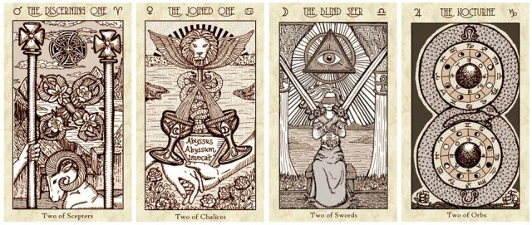
The Discerning One. Two of Scepters: Determine your boundaries and define the scope of your own dominion. This is a moment for you to map out your ambition. Exercise discernment before you proceed any further on this path you’ve chosen. Look out to the horizon and discern whether this is the sea you want to embark from. Decide: do you want the kingdom or do you want an empire? Make a choice between the familiar and the unfamiliar.
The Joined One. Two of Chalices: In external alchemy, The Joined One guides us to choose our allies. It designates an outer accord, but also an inner accord. In internal alchemy, this spirit guides us to unite our anima and animus. This is the spirit of two becoming one, and an omen of Perfected Love, love in all its divine forms. Abyssus abyssum invocat: sea calls to sea, or the depths of me calls out to the depths of you. Do not neglect the relationships you cherish, both those with other persons and those with the spirit world.
The Blind Seer. Two of Swords: The Blind Seer helps us navigate the stalemate between the Ego and the Self. The twin swords, or twin paths, form the cross that you bear. You have yet to attain the realization you need to make an intelligent, reasoned decision. So take the time to look inward. Arrive at an inner peace and restore a sense of calm before you proceed any further.
The Nocturne. Two of Orbs: Work harder and double down—shoulder more commitments and steer your ship through the rough tides. Carpe noctem: work at your dreams late into the night, harder than everybody else, and the gods will reward you for your dedication. The Nocturne is balancing change after the dark night of the soul. It bears good tidings, because this is the spirit of commerce, enterprise, and far-reaching new ventures after past failures and disappointments. Forming a lemniscate around the twin promises of product is the alchemical Black Dragon gnawing its own tail, and this is the totem, the daimon brought before you by The Nocturne: the Black Dragon’s venom is also the Great Medicine. Past suffering sires future opportunity.
Realm of Threes: Fruition
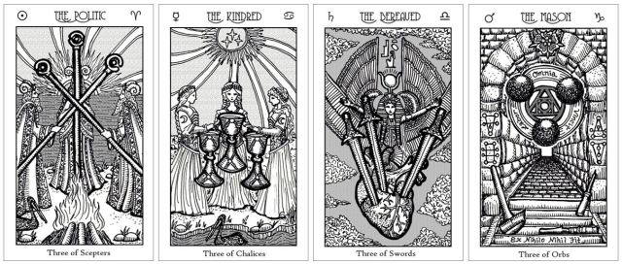
The Politic. Three of Scepters: The Politic is an omen validating glory achieved through diplomacy, tact, pragmatism, and prudence. The Three of Scepters portends expedient success. This is the spirit of ingenuity and wielding your personal brilliance, social intelligence, and psychic dexterity to successfully navigate complicated social or political situations. This is the spirit of established strength by your side. Here, we also see powerful allies supporting you in your endeavor.
The Kindred. Three of Chalices: The Kindred is the spirit of affinity within the tribe. This is abundance in love, camaraderie, and the prophecy of jubilee to come. A personal zenith point is reached in your community relations. This spirit also appears when you need a reminder to tend to the familial and tribal relations that matter the most to you.
The Bereaved. Three of Swords: The Bereaved is sabotage after fruition, but there is a foretelling of resurrection through the story of Isis mourning her husband, the god Osiris, and the coming conception of Horus. This is the spirit of bereavement by your side. This is sorrow, mourning, sadness, and deprivation of love. Yet this is also the power of resurrection after sorrow.
The Mason. Three of Orbs: Upon the first stair: ex nihilo nihil fit, the philosophy that every Work is built or comes from a preexisting Work. The Mason is completion and inauguration, with a materialized work product to show for yourself. It is the spirit of merit by your side, of hard work and dedication that pays off. This is the spirit of architecture, of construction, and material works erected brick by brick, stone by stone. Labor omnia vincit: Hard work conquers all.
The Four Empyrean Courts
SKT | RWS | Thoth
Archangels | Kings | Knights
Shields | Queens | Queens
Shining Ones | Knights | Princes
Strongholds | Pages | Princesses

Kings: The Archangels
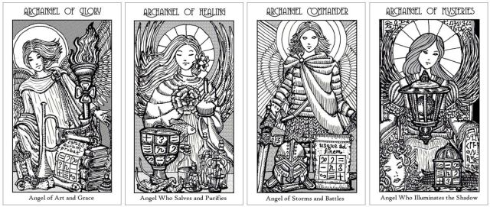
Archangel of Glory. King of Scepters: The King of Scepters is the Archangel of Glory, who holds up the torch beckoning you to pursue greater scholarship or cultivation of the arts. The Archangel of Glory is a divine teacher of the arts and all forms of academia. This is the Angel now by your side to facilitate success in artistic, literary, academic, or scholarly endeavors. Appearing to you is a spirit guide for career success. Ignus aurum probat: fire tests gold. The Archangel of Glory is calling upon you to expand your dominion and conquer new ground in matters pertaining to career advancement, creative endeavors, personal glory, passion projects, and that which will come to define your legacy.
Archangel of Healing. King of Chalices: The King of Chalices is the Archangel of Healing, a reigning angel over the healing arts and purification of mind, body, and soul. She presents herself to you now to guide you through precarious times, and she is here, by your side, to salve, to heal, and to purify what is currently diseased, debilitated, feeble, or unwell. This Archangel appears to those who most need healing. She has a tender place in her heart for those who are like fish out of water, caring for them the most. Here is a spirit guide for mending your wounds. The Archangel of Healing is calling upon you to expand your dominion and conquer new ground in matters pertaining to empathy, compassion, personal spirituality, your psychic spirit, emotional wellbeing, home and family matters, your domestic realm or internal sphere, and to expand the sphere of personal relationships that support you.
Archangel Commander. King of Swords: The King of Swords is the lead commander of the Divine Forces. Usque ad finem—we shall fight to the very end. He is the most powerful and most formidable of Heaven’s Warriors. His full title is the Archangel Commander of the Light. The Archangel Commander appears to you now to bring strength, conviction, courage, and manifest fearlessness. He is tasked to assist you with navigating the storms, inner and outer, and to defeat any demons that threaten to harm you. The Archangel Commander is calling upon you to expand your dominion and conquer new ground in matters pertaining to your public or external sphere, your reputation, community or social engagements, to expand the breadth of your knowledge, and to expand the breadth of sciences you have mastery over.
The King of Swords is your divine warrior who will lead heavenly armies against your adversaries. When the Commander of the Light appears to you, it is because you need reinforcement and now that spiritual reinforcement has come, led at the helm by your greatest champion, the Archangel Commander. You’re preparing for a fight, and the Archangel Commander appears to you now in advocacy of your cause.
Archangel of Mysteries. King of Orbs: The King of Orbs is the Archangel of Mysteries. Another one of her many names is the Archangel of Revelations. She is a beneficent guide connected to the underworld, one authorized to act as an intermediary and mediator between the angelic realm still subservient to the Divine and the realm of the fallen angels. She can also traverse through all of the lower realms to guide lost souls. The Archangel of Mysteries appears now because these qualities and powers of protection of hers are needed by you. She is calling upon you to expand your dominion and conquer new ground in matters pertaining to your material resources, to cultivate a stronger, more resilient material and financial foundation for yourself and for your loved ones, and to be more industrious, to acquire more for yourself so that you are in a better position to pursue your Great Work.
The King of Orbs illuminates the darkness for you, who are about to traverse the realms of shadow. You are about to uncover great mysteries. This is the Archangel who protects you against all forms of darkness along your initiatory path of discovery. The King of Orbs is the Great Provider. You, too, are a Great Provider to others.
With her lantern, the Archangel of Mysteries illuminates crossroads; she is the great master of spells and incantations. The ears of corn symbolize the seeds of spiritual enlightenment through the erudite study of esoteric practices. You manifest your material abundance through spiritual abundance.
Queens: The Shields
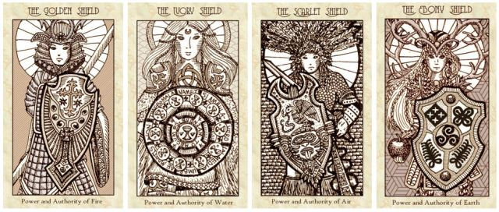
When Shields appear to you in your divinatory readings, it is not a time for expansion, but rather, it is a time to preserve, reserve, protect yourself, and to deepen what is already within your scope. This is about achieving new depths, not about conquering new ground. Nurture, further develop, and bring to mastery what is already in your hands.
The Golden Shield. Queen of Scepters: You are shielded against those who are sending you psychic arrows of envy, ill will, resentment, someone who covets what you have and who is just waiting for a vulnerable opening to strike. Thus, the Golden Shield defends you, and this spirit is now making his presence known so that the angelic Power of Fire can keep you safe, healthy, and flourishing. A male ancestor or one from your paternal lineage can appear to you through the Golden Shield.
The Ivory Shield. Queen of Chalices: You are shielded against ailments, disease, and infirmity. Malefic energies that can cause malady or emotional afflictions are present in your space, challenging your vitality, and so the Ivory Shield appears in your path to help you preserve your own wellness. Inscribed around the Queen’s shield: Though I walk through the valley of the shadow of death, I will fear no evil, for You are with me.
Her shield features the mmusuyidee, a West African symbol of purification and protection. When the Queen of Chalices appears, you may be experiencing a dark night of your own soul, an alchemical darkening stage of your life path, and she is here to give you shelter, to accompany you by your side as you make your way out of danger. She is your defender as you walk through the valley of shadows. Know that she is present. Know that you are not alone in your dark hour. A female ancestor or one from your maternal lineage can appear to you through the Ivory Shield.
The Scarlet Shield. Queen of Swords: He, the Queen of Swords, is a Shorn One, an Aztec warrior priest who shall be your formidable line of defense as you charge forth confidently to face your battles. His shield features an eagle devouring a serpent: a divine omen from the gods. When The Scarlet Shield appears to you, he is making his presence known so that you might go forth into combat, taking your stand, with might and confidence. When The Scarlet Shield appears, it is time for you to stand your ground, hold your position, and this warrior priest is here, ready to face the fight with you. A male ancestor or one from your paternal lineage can appear to you through the Scarlet Shield. Seventeen points tattooed on his dominant hand mark his great triumphs.
The Ebony Shield. Queen of Orbs: The Queen of Orbs brings nourishment so that you have the vitality to accomplish your goals and the strength to overcome your challenges. She bears the apple of knowledge that will fortify you with all that you need to be your most resourceful. The Ebony Shield brings protection around your wealth, luck, gains, and earthly dominion so that others cannot take what is yours. When The Ebony Shield appears to you, she is making her presence known so that you might take prudent action to preserve your assets and capital. Save, invest, and be more mindful of your security. A female ancestor or one from your maternal lineage can appear to you through the Ebony Shield.
Knights: The Shining Ones
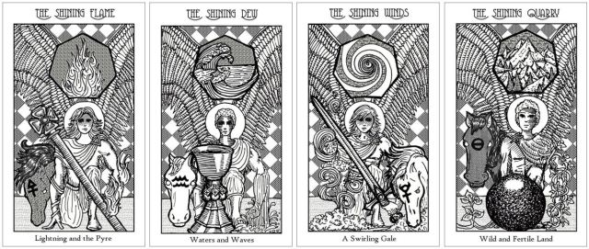
When Knights appear to you in your divinatory readings, it is time to take action. You need to act. You have been complacent for far too long and you have permitted talents, gifts, and blessings to lay dormant. Activate that which you currently have with an addition of the element that the Knight holds dominion over and you will achieve what it is you most seek to achieve.
The Shining Flame. Knight of Scepters: You are now being given divine instruction to alchemize the elemental nature of Fire, to advance your professional work. Transmuted Fire is the driving force that will help you accelerate, hasten, and advance your progress. Crystallization is happening: the creation of something that will soon take defined, concrete form.
This Knight is also a spiritual guide who appears to you to lead you to an awakening. The appearance of this card is a prophecy that awakening is imminent. A spark of creativity will lead you to incredible productivity.
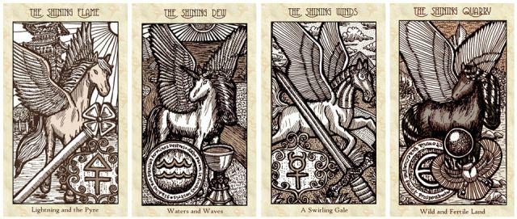
The Shining Dew. Knight of Chalices: You are now being given divine instruction to alchemize the elemental nature of Water, to enhance social charisma. Transmuted Water helps you decelerate, slow down your frenetic movements, find your calming center, and reflect. Fluidity is the quality of being like water, as is the Taoist philosophy of wu wei, and The Shining Dew is here to guide you toward free-flow so you might roll with the waves and let the natural movements of karma take you where you need to go. The Knight of Chalices is your guide as you navigate the waters of destiny. Slowing down and achieving an inner calm will lead you to wielding incredible soft power over others, which in turn endows you with the influence you’ve sought to have. When this card appears in a divinatory reading, Spirit is telling you to sublimate what is deep within your psyche into the material world as creative or artistic product—allow your soul to be visible.
The Shining Winds. Knight of Swords: You are now being given divine instruction to alchemize the elemental nature of Air, to win a battle. The alchemical instructions this spirit brings to you now is this: conform to a shape of reference that is around you and be a flowing form of energy. While yielding yourself to the established forms and framework around you, accelerate your activities, because the conditions are ripe for your advancement and you will make great progress soon.
This spirit is the active key of illuminated consciousness, the confirmation of a fully-formed idea bound for manifestation, so long as progressive action is taken. When the Knight of Swords appears in a reading, mind and body are acting in collaboration toward achieving your goal. This is the card that prophesies imminent victory, so long as you continue your proactive progress along the Path you have chosen. The Shining Winds is the card that confirms full realization and understanding of a dilemma and figuring out how to troubleshoot or solve that dilemma. Now, what is left to do is to act upon the solution. This card also marks the need to change your personality so you can advance further on your Path, so that mind and body can be aligned. Shift your mindset and you will accomplish more.
The Shining Quarry. Knight of Orbs: You are now being given divine instruction to alchemize the elemental nature of Earth, to increase your material resources, assets, and to cultivate fruitful abundance. The alchemical instructions the spirit brings you is this: crystallize your work ethic into something finally solid and tangible; create definitions. Then slow down, decelerate so that you have a chance to reflect and meditate. You do not need to be on the path of rapid increase, not yet. Now is the time to cultivate your resources organically, taking it slow, without giving in to the temptation of urgency. Be methodical. The Shining Quarry marks the encounter with one’s own earth nature and making sense of our material attachments. There will be realized outcome in your personal economics, finances, property matters, business, income, or earnings. The Shining Quarry is here as a guardian spirit to help you navigate the work cut out for you: having to build a stronger, earthly foundation so that you can increase your access to sources and thus bring about the success you have been seeking. Et omnia quaecumque faciet prosperabuntur (“and in all things he does he shall prosper”)—persist forth and your efforts shall be successful. The Shining Quarry is with you to make certain of that.
Pages: The Strongholds
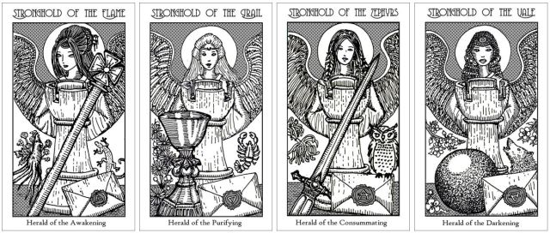
When a Stronghold (Page) appears in your reading, the sealed envelope signifies that she comes bearing you a message from beyond. Pull an additional card to receive the message.

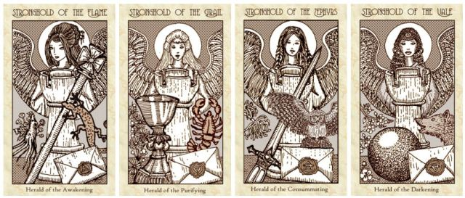
Stronghold of the Flame. Page of Scepters: The Stronghold of the Flame, or Page of Scepters, comes bearing an important message to you or an opportunity about career matters, schooling, creative or artistic endeavors, employment, or passion projects.
The Page of Scepters appears as affirmation of a coming adventure, a quest that will be presented to you. Your creativity and ingenuity will be the deciding factors on how you navigate that quest. The presence of the Stronghold of the Flame can also be an emissary sent by a solar deity, a divinity of the Fires, of agriculture or artisans, or a pantheon from the southern hemisphere.
Stronghold of the Grail. Page of Chalices: The Stronghold of the Grail comes bearing an important message to you or an opportunity about matters relating to love, relationships, domestic affairs, or your spiritual path. The Page of Chalices is the Stronghold here to help you become better attuned to your emotions, helping you in your pursuit of true happiness. She appears to you when you need further guidance on your path to finding your personal Holy Grail.
The presence of the Stronghold of the Grail can also be an emissary sent by a lunar deity, a divinity of the Waters, of medicine, or a pantheon from the northern hemisphere.
Stronghold of the Zephyrs. Page of Swords: The Stronghold of the Zephyrs, or Page of Swords, comes bearing an important message to you or an opportunity about your social status, community relations, a political or legal matter, higher education, greater social network that you are a part of or engaged with, or a matter pertaining closely to your pursuit of glory. The Page of Swords appears as affirmation of victory to come if you agree to take on the challenges and walk through the gauntlet. The presence of the Stronghold of the Zephyrs can also be an emissary sent by a deity of war, battles, or storms, a divinity of the skies, winds, or Air, or a pantheon from the eastern hemisphere.
Stronghold of the Vale. Page of Orbs: The Stronghold of the Vale comes bearing an important message to you or an opportunity about your assets and resources, money or business matters, and that which relates to your personal economics and industry. When the Stronghold of the Vale appears in a reading, the offer, events, or opportunities to come are ones that will help you to make your mark in your world. These are opportunities for establishing yourself.
Perhaps there is a mundane matter you are facing at the moment or will face. The Page of Orbs may appear to you to offer insights on how best to navigate that situation. The Stronghold of the Vale appears when you need to hear whispers of counsel on what measures to take next. Of all the Pages, she is most connected to the everyday ongoings of your world, of mortal and earthly life. She also appears to guide you through shadow work.
The presence of the Stronghold of the Vale can also be an emissary sent from the underworld, a divinity of the earth, vegetation, a divinity of wealth, a liminal deity, one of crossroads, thresholds, and gateways, or a pantheon from the western hemisphere.
Minor Arcana: Seven Lower Realms
Seven Lower Realms of the Minor Arcana
The Realm of Fours: Building
The Realm of Fives: Expanding
The Realm of Sixes: Nurturing
The Realm of Sevens: Reasoning
The Realm of Eights: Manifesting
The Realm of Nines: Culminating
The Realm of Tens: Mounting

Realm of Fours: Building
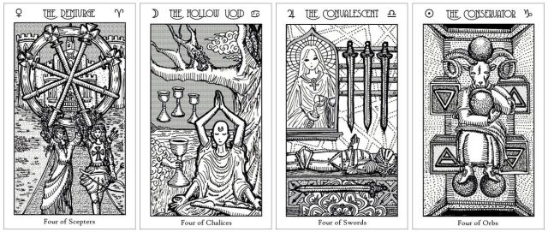
The Demiurge. Four of Scepters: The Demiurge builds our physical platform of success. This is the attending spirit who guides your intangible idea into tangible work product in the material world. The Demiurge marks progress, achievement attained, and is the spirit presence with you through a momentous rite of passage. The Demiurge is the spirit to help you cull from the spiritual or intellectual plane and bring perfected work into form on the physical plane.
The Hollow Void. Four of Chalices: The Hollow Void builds our psychic inner platform for spiritual strength. This is the spirit presence with you as you look inward, reflect, meditate, and reach independent insight on why there is the hollow void. This is the spirit that helps you to conduct reevaluation. How do you find meaning in that which feels meaningless? The Hollow Void is the spirit here to help you navigate personal sensations of worldly discontent. Here, a sorceress goddess of magic and healing signified by the scorpion perched in the tree, has compelled a divine hand to offer you waters blended from the Mystic Sea and Sea of Awareness—spiritual revelation and attainment of worldly knowledge that will fill that hollow void.
The Convalescent. Four of Swords: The Convalescent is the net loss after construction. This is needed rest and restoration after enduring strife. The Convalescent is the spirit of nursing you back to full health. Here, we see imagery reminiscent of both Key 13: The Reaper and Key 14: The Angel, a subversion of the classical Death and the Maiden motif. The Convalescent is the spirit of a transition phase and is present along your path when you experience affliction. This is the spirit to bring you rehabilitation after fighting battles. Fortune comes to you after you have taken the time to restore both inner and outer balance in your life.
The Conservator. Four of Orbs: The Conservator is the maintenance work, investments, and natural resources needed in reign, rule, and order. This is the spirit presented in your life path when you are demonstrating an inordinate attachment to the material.
This is earthly power you are clinging desperately to, at the expense of greater spiritual realization. The Conservator is both the spirit of that which is empirical and orderly, efficient and pragmatic, and also that which is self-serving, covetous, and parsimonious.
Realm of Fives: Expanding
The Contender. Five of Scepters: The Contender is the spirit of a zero sum game. This is the spirit appearing before you when you face competition. This is the battle, the contention you fight for domination. This is the spirit who helps you through a rivalry for supremacy. There is strife in your world, and The Contender is the spirit here to help you navigate that strife.
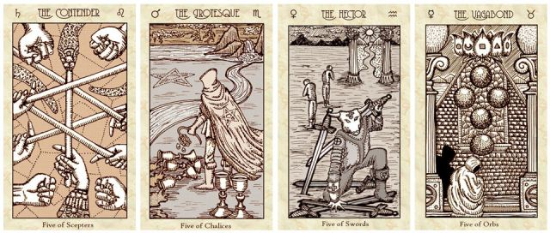
The Grotesque. Five of Chalices: The Grotesque is loss after the waning of joy, a personal feeling of disfigurement, a mystery, and unseen power rising. When your blood, sweat, and tears have been expended without yielding fruition or meaning, The Grotesque is the spirit who will appear by your side. Yet behind The Grotesque are two intact chalices, symbolic of powers and personal talismans to help navigate social circumstances where you feel like the disfigured one, the outcast, and to gift you with arcane powers that have always been reserved for the grotesque ones.
Your differences, which others have denigrated, are the very powers and talismans that will catapult you above all others and toward greatness. The Grotesque is the spirit here to guide you on that daunting aspiration.
The Hector. Five of Swords: Hector was the greatest warrior of ancient Troy, and through that namesake, The Hector is the spirit of indomitable strength, but it is indomitable strength at any cost. The Five of Swords marks a defeat of your opponents by unfair advantage. The Five of Swords denotes an imbalance of power in the situation at hand. Heed also: the Hector is the spirit of that which upon first impression is predicted by all to be victorious, but who will end in defeat if you do not learn the important lessons The Hector is here trying to impart to you. Indomitable strength does not come from lording your power over others; it comes from using your charisma to sway others.
The Vagabond. Five of Orbs: The Vagabond is the spirit of alienation and feeling alienated. Crowning the holy temple is a lotus blossom that features five petals symbolizing the five aggregates of suffering: sensation, consciousness, physical forms, perception, and thought forms. The Vagabond appears by your side when you are the wanderer with no sense of home or identity. This is the spirit that comes to you when your spirit is restless and when you are in search of meaning. This is the spirit who will teach you toughness and resilience, but does so by putting you through the gauntlet of material trouble.
Realm of Sixes: Nurturing
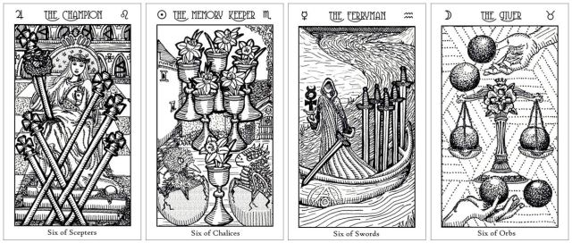
The Champion. Six of Scepters: The Champion is the spirit of victory. When the Six of Scepters appears, success will be yours. Yet here we are reminded there are two sides to victory. The Champion can bring wisdom, wealth, seed, life, dominance, peace, and grace, as noted in the Seven Double Letters corresponding with the Sacred Seven planetary rulers in the back wall archways.
Likewise, The Champion can bring folly, poverty, desolation, death, subjugation, war, and ugliness. The imagery of the spirit here conveys the core of the message: to be the champion, one must be oblivious to pain. For there to be victory, there must be self-sacrifice. If you seek to defeat your opponents in competition or combat, then with the support of The Champion, you will be victorious, though with it comes personal sacrifice. Victory always necessitates personal sacrifice.
The Memory Keeper. Six of Chalices: The Memory Keeper is the spirit of reminiscence. Who you once were is trying to speak and reach out to who you are now. Listen to the whispers from the past, for they send premonitions of the future. Initiate an open dialogue between the Past and the Present. The Memory Keeper is your custodian of memories, both fond and adverse, the reflection of your inner child. When The Memory Keeper appears to you in a reading, the past and the present converge.
The Ferryman. Six of Swords: The Ferryman navigates us to calmer waters. When The Ferryman appears to you, you are about to embark upon a journey in the hopes of leaving behind turbulent waters and achieving earned success. The success factors that The Ferryman endows you with are intellectualism, acute and accurate analysis, and claircognizance. Plans move forward. You are being guided across what you previously thought was an impossible obstacle to overcome.
The Giver. Six of Orbs: Let the karmic circle remain unbroken: give to receive; receive, but give back. The Giver is the spirit of provision. Seeking anonymity, The Giver shows only the hand in offering. Yet know this about one of the many names for The Giver: Anesidora—the “Giver of Gifts.” In the Six of Orbs, we also see the divine blessings of Demeter, who gifts you with material success. When The Giver appears to you, the spirit of nurture is all around you. Give freely, mercifully and you shall receive freely, and mercifully.
Realm of Sevens: Reasoning
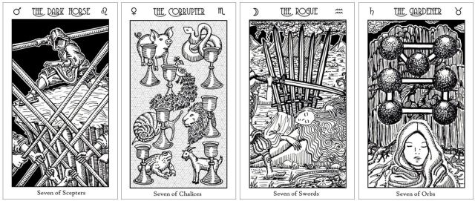
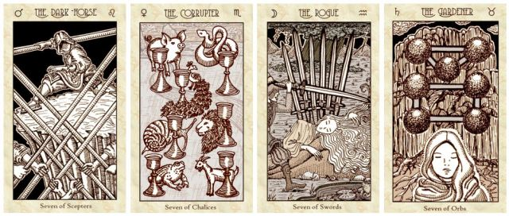
The Dark Horse. Seven of Scepters: The Dark Horse is the underdog who blindsides the naysayers and will emerge victorious. When you are being cornered or are outnumbered, The Dark Horse appears to you, ready to stand shoulder to shoulder with you as you take on your opposition. You will emerge in prominence and glory: take that fighting stance and ready yourself.
The Dark Horse is marginalization personified, and yet this spirit is extraordinary in both strength and stealth. This is the spirit of valor who has come now to empower you with courage. When outnumbered, you resist.
The Corrupter. Seven of Chalices: The Corrupter is the master of sophistry—superficially your current reasoning seems plausible, but it’s fallacious. The Corrupter is a spirit who appears to you now as a threshold guardian, cautioning you to redirect yourself. The Corrupter personifies the pursuit of wisdom that derails into folly, wealth that leads to poverty, the sowing of seeds that becomes desolation, seeking dominance but finding subjugation; it is peace that becomes war, or well-intentioned grace that becomes ugliness.
The Corrupter is illusory success and wishful thinking. You’re dreaming big but acting small. We see the allegory of the seven sins. The pig is gluttony, the snake for envy, peacock for pride, snail for sloth, lion for wrath, toad for avarice, and the goat for lust. The symbology here is taken from the 18th century Tableau de Francois-Marie Balanant.
Do not act on impulse. When The Corrupter appears to you, rethink that idea you’ve been contemplating: it might not be prudent. Also, pay closer scrutiny to your environment: there are poisons around. The Seven of Chalices is falsehood appearing as truth. This spirit appearing to you is a warning that misleading perceptions abound.
The Rogue. Seven of Swords: The Rogue is mischief personified. Here you see the story of Loki cutting off Sif’s beautiful golden locks of hair while she slept. Sif is the Norse goddess of the earth, of plenitude and the grains, affinity, fertility, family, marriage, Mother of Might and Magnificence. She was also a seer. The mind, the thought plane, and the intellect are the weakening barriers to materialized success. The Seven of Swords denotes an unstable mind, and unstable efforts.
The Rogue is the spirit of cunning and scheming. We see compromised integrity. Yet The Rogue is also the personification of one who is misunderstood, so when this spirit appears to you, you are the rogue in pursuit of an undertaking that diverges from the mainstream. You may get blowback for it, and yet take heart that the toad on the lily pad is symbolic of a rainmaker, an omen of ambition that begets plenitude, while the snail calls in the grace of The Eminence, the blessings of the Nine of Orbs. A little bit of roguish behavior is called for if you seek to achieve your goal. You are being challenged to confront an ethical dilemma. Will you choose to follow the rules, or will you break them?
The Gardener. Seven of Orbs: The Gardener is the nature spirit of low magic, and the spirit of harvest. When The Gardener appears, close by is the presence of an earth goddess. The Seven of Orbs card is a threshold, a special nexus point between the physical realm and the spirit realm. The Gardener calls to mind the Magna Mater, the goddess Cybele, and She appears to you now to help you take what is formless matter within your mind and spirit to yield meritorious work product and a presentment of harvest. The Gardener is also a spirit who oversees low magic and can be called upon to assist with the Craft, utilizing herbs, stones, roots, oils, and the crafting of charms. The Gardener appears to you when you are experiencing success unfulfilled. The Seven of Orbs is a liminal gateway between states of consciousness.
When The Gardener appears to you, know that you’ve got an idea, a design, or concept worth investing in, and if you see it through to fruition, you will achieve the security, stability, and material abundance you’ve been seeking.
Realm of Eights: Manifesting
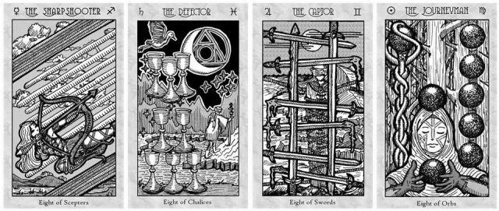
The Sharpshooter. Eight of Scepters: Swift movement abounds around you. This is the spirit of marksmanship. When the Eight of Scepters appears, it bears notice to pay attention to messages being directed at you coming from your world, for Spirit is presenting itself through the words of those speaking to you. The Eight of Scepters is the spirit of inbound tidings that bear your name.
When The Sharpshooter appears in a tarot spread, pay attention to what she is aiming and shooting at in the context of the spread’s landscape. What she points at is what Spirit is directing you to pay your attention to.
The Sharpshooter might be appearing to you as a protégé of Anat, an old Canaanite maiden goddess of war. She might also be a messenger from Artemis. Perhaps she is a priestess-daughter of Minerva, or Pallas Athena. The Sharpshooter in the Eight of Scepters is the spirit oft called upon to be an emissary into our world to deliver messages from a divine feminine embodying courage, wisdom, military strategy, war and battles, or a patron goddess of the arts. When The Sharpshooter appears to you, such a divine consciousness is calling to you.
The Defector. Eight of Chalices: This is the spirit of abandoned success. The Defector is the spirit personification of abandoning one path to walk a contrasting and entirely different one. This is walking away from what you have otherwise devoted a great deal of effort to, and not looking back. This is the spiritual quest for that which will be more emotionally fulfilling.
The five chalices stacked on the ground symbolize the material work that The Defector leaves behind. The three hovering above symbolize the beliefs and ideologies The Defector now abandons. When the Eight of Chalices appears, you are at the foot of a steep mountain, about to embark onto challenging, yet personally fulfilling terrain. Wisdom will be attained and the path of that mountain is the path toward achieving your Great Work, toward fulfilling your life purpose.
The scarlet ibis with wings outstretched, flying overhead is the material manifestation of a guardian deity who will be overseeing your difficult journeying ahead. The Defector is the guardian spirit guiding you to abandon illusory success and to scale new heights in a different direction. This is the start of a difficult journey, but a journey that will take you to where you want to be.
The Captor. Eight of Swords: You are feeling bound by the Threads of Fate. You’re being pulled in so many oppositional directions that now you cannot move in any direction at all.
When The Captor appears to you, it is a message from beyond warning you that there has been undue interference to your path. The themes here are having to confront the evils of oppression, aggressions of those in a superior position to hurt those who are helpless and meek, feelings of isolation, but also, that prophecies will be delivered to you through your dreams. When The Captor appears to you, begin paying closer attention to your dreams.
This is the spirit of shortened force, of obstruction. When the Eight of Swords appears to you, take immediate action toward unbinding yourself and cutting loose from all that is trying to hold you down. The way out is not to exert your own force against the oppression, but to use the oppression against itself. Instead of struggling with your own strength to escape the bindings, use the blades of the swords blocking your path to cut yourself free.
The Journeyman. Eight of Orbs: The Journeyman is the spirit of apprenticeship, of perfecting one’s craft, of routine work that leads to mastery. This is also the spirit of prudence. When The Journeyman appears to you, you are being called to apply discipline, a strong work ethic, and perseverance to hone your skills in a particular trade.
The Journeyman is the grind of dedicated work, practice, and careful, methodical study of a specialized craft. Note the orb set into a master’s staff: this is prophetic of an adept who is currently an apprentice, but who will someday exceed the master. It has been foretold: you will become The Warrior, or The Erudite, or perhaps it is The Healer. One of these three paths manifested—that is the prophecy of The Journeyman.
Behind the Journeyman and into the dark woods: can you see the forest through the trees? When The Journeyman appears to you, look again at your surroundings. Can you discern the holistic pattern from the details? Try to understand the bigger picture.
Realm of Nines: Culminating
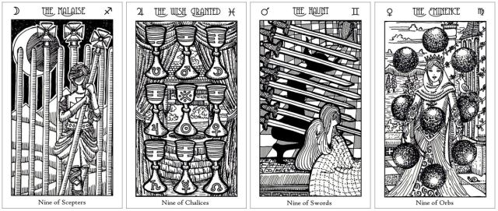
The Malaise. Nine of Scepters: The Malaise is the questioning of purpose and why we suffer. It is the wearing away of vitality and innocence when we’ve seen too much of suffering in this physical world. When the spirit of The Malaise appears to you, engage in grand strategy. Summon all the power within you and direct it outward, now. The Nine of Scepters is the spirit of great strength.
This is also the personification of malaise, reflecting back at you so you can see clearly your own feelings of debility or weakening health. This is the spirit of despair, pessimism, or cynicism. Do not reduce yourself to feelings of apathy. Feeling feelings, and passions, even when they hurt, are the necessary gauntlets to overcome so that wisdom and transcendence might be attained.
Note the resilience of the figure in this imagery. The Nine of Scepters is a powerful key against debility, weakening, or despair. The Malaise appears to remind you of the powerful defensive magic that you are capable of conjuring to protect yourself and to revitalize what has been depleted. The Malaise can be a sign that you need to take better care at shielding yourself.
The Wish Granted. Nine of Chalices: Nine chalices are arranged in the formation of a magic square, a grid that denotes power. This is the spirit of personal happiness achieved after earning material gains. The Wish Granted is the neverending blessing of abundance. All that you conceive of will manifest, is manifesting.
This is one of the more profound keys in the tarot architecture. The Nine of Chalices is a channel through which gift-giving deities of old folklore can pass through and bless you.
The imagery here is symbolic of a sacred space within your own inner temple. The well is iconic of Mimir’s Well from Nordic mythos, where Odin’s eye was sacrificed. At Mimir’s Well is where you will find wise counsel from the gods. Drink from Mimir’s Well to gain knowledge.
When this card appears to you, focus on each of the nine chalices in turn, reciting, “Light, Love, Life” three times (3x3=9). As you focus on one chalice, recite “Light,” then focus your line of sight onto the next chalice over, recite “Love,” and on over again, “Life.” Move to the next row and repeat so that each chalice has received your focus and the utterance of one word from the recitation. Such a ritual ensures that the wish you have petitioned for shall be granted by the gift-giving gods of old lore.
The Haunt. Nine of Swords: Restful sleep eludes a figure, who sits upright in bed, face buried in hand, in slight fetal position. The astrological glyphs of planets and signs stitched into the bedding signify the fate, circumstances, and consequences of your own action that you now lie in. This is also how you feel: you are haunted and bound by your fate. Behind the slatted wall of swords is a dark horned shadow.
The shadow is The Haunt. The background is an illusion of space, a seemingly endless, spacious checkered room (emblematic of Hermetic duality) that leads through an archway to an endless hall. As Aleister Crowley calls it, this is the “cathedral of the damned.” This is anxiety personified, anxiety about what your future holds, because at least for the moment, your perception of your present is bleak.
And yet what the imagery on the Nine of Swords card reflects back to show you is that your perception is an illusion of space. You feel despair over the cruelty in this world and you are not wrong, but you are wrong about your helplessness. The Haunt is the haunting of our own past actions, our inner demons that we have not resolved, our regrets, and the actions we have taken both against others and against ourselves.
The Haunt is also your spirit ally and an appearance during divination made by The Haunt could be this beneficent spirit detecting malefic energies or psychic poison arrows in your vicinity and alerting you of such presence. Thus, The Haunt is often a sign to conduct a full spiritual cleansing, banishing, and to engage in more proactive shielding or personal protection rituals.
The Eminence. Nine of Orbs: The Eminence is the spirit personification of upward mobility and material fruition, born out of our own hard work. All that we have done and invested in has propelled us to the top. And yet now that we are at the top…are we feeling isolated and alone? All that glitters is not gold… The woman pictured here in the Nine of Orbs is the same woman pictured in the Nine of Swords, and yet upon first impression, they appear so different. Inner lives versus outer lives can be unrecognizable from one another.
Nevertheless, The Eminence appears as your spirit ally and when she makes her presence, she is here to support your endeavors toward elevating rank, reputation, and to increase your material gains. When the Nine of Orbs appears in your reading, this is the message from Spirit to heed: Everything is for the best in the best of all possible worlds (an aphorism from Voltaire).
Realm of Tens: Mounting
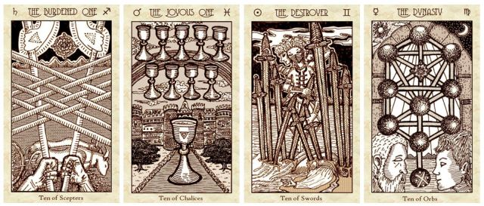
The Burdened One. Ten of Scepters: The spirit resident in this card is the carrier of sorrows. The Burdened One is oppression we bring onto ourselves when we don’t temper or when we have acquiesced to others using us as their beasts of burden. The series of decisions you have made along the way have led up to this culminating point of unduly carrying the responsibilities of others.
Are the Hands of Spirit holding the rods to help you carry the weight of your load? Or are the Hands of Spirit presenting the burden to you to test your strength, resolve, and perseverance? Is this a Divine Trial or Divine Assistance?
The mystic rose at the center, between the Hands symbolize a secret, a mystery, indicating that you don’t know everything. There are greater reasons for why you are where you are. There is purpose and you are not yet privy to what that purpose is. The Ten of Scepters is the card of laborious tasks.
The Joyous One. Ten of Chalices: The Joyous One is happiness we have earned. This is the prognostication of spiritual fulfillment. Creativity becomes productivity, and productivity leads you on a directed path toward contentment. The glyph etched upon the large chalice in the foreground is the emblem of the Holy Womb, of Hagia Sophia or Holy Wisdom. The Ten of Chalices appearing before you signifies the appearance of God the Mother. The rainbow across the heavens is an omen: perpetual success. The Joyous One is an omen of fertility, and that which was in the figurative womb shall mature and ripen into a great spiritual and emotional reward for you. When this spirit appears before you, it reflects back for you to see how along your path, you have developed your wisdom, your intelligence, and your agape love. The Ten of Chalices is an affirmation that your learned skills, intellect, and acumen have matured. The Joyous One is the personification of wisdom attained. When this card appears for you, it is an affirmation from the Holy Spirit of your spiritual maturation. The card can also appear to remind you that you are complete, that your life and world is perfected and harmonious as it is right now, that it is not necessary for you to pine for more. Bask in the blessings you’ve been given.
The Destroyer. Ten of Swords: The Destroyer is ruin personified. Here you are watching the Dance of Kali, a wave of catharsis crashing onto the shores of your psyche. The Destroyer is downfall as a consequence of our acts. There has been a Fall from Grace. The Destroyer appearing before you can be an omen from a death spirit or a triple goddess motif portending doom, destruction, or plunder. If you have erred and let pride or glory corrupt you, then The Destroyer is here to cut down that pride and glory so that you might find your way back onto the rectified path of wisdom. If you have been unduly betrayed or hurt by another, then The Destroyer is here to pull the swords out from your back and will ravage vengeance on your behalf. What goes around will come around. The Destroyer is here to warn you of deception afoot, treachery, perhaps even treason that threatens your wellbeing. Be cautious of your environment and who you’re trusting.
The Dynasty. Ten of Orbs: The Dynasty is wealth multiplied. In the foreground, the old man faces the young man—they personify inheritance, legacy, and the multigenerational dynasty. This card portends advancing prestige. The Dynasty is the spirit of collective power that strengthens a tribe. The theme here is successorship. It can also suggest the personal impact on you of much greater national or global affairs. Something greater going on in the collective has reached down to directly affect you, at the individual and personal level. What the Ten of Orbs portends is gains to be had from that impact.
While the Ten of Orbs marks a pinnacle of material wealth and success, the Book of Thoth reminds us that the success will quickly go inert, and from that inertia, degenerate and rot, if the pinnacle is not immediately put to productive use toward the greater good. Thus, with the benefits and gains you shall reap, you must direct those benefits and gains toward a greater good. Do not harvest all the blessings for yourself.

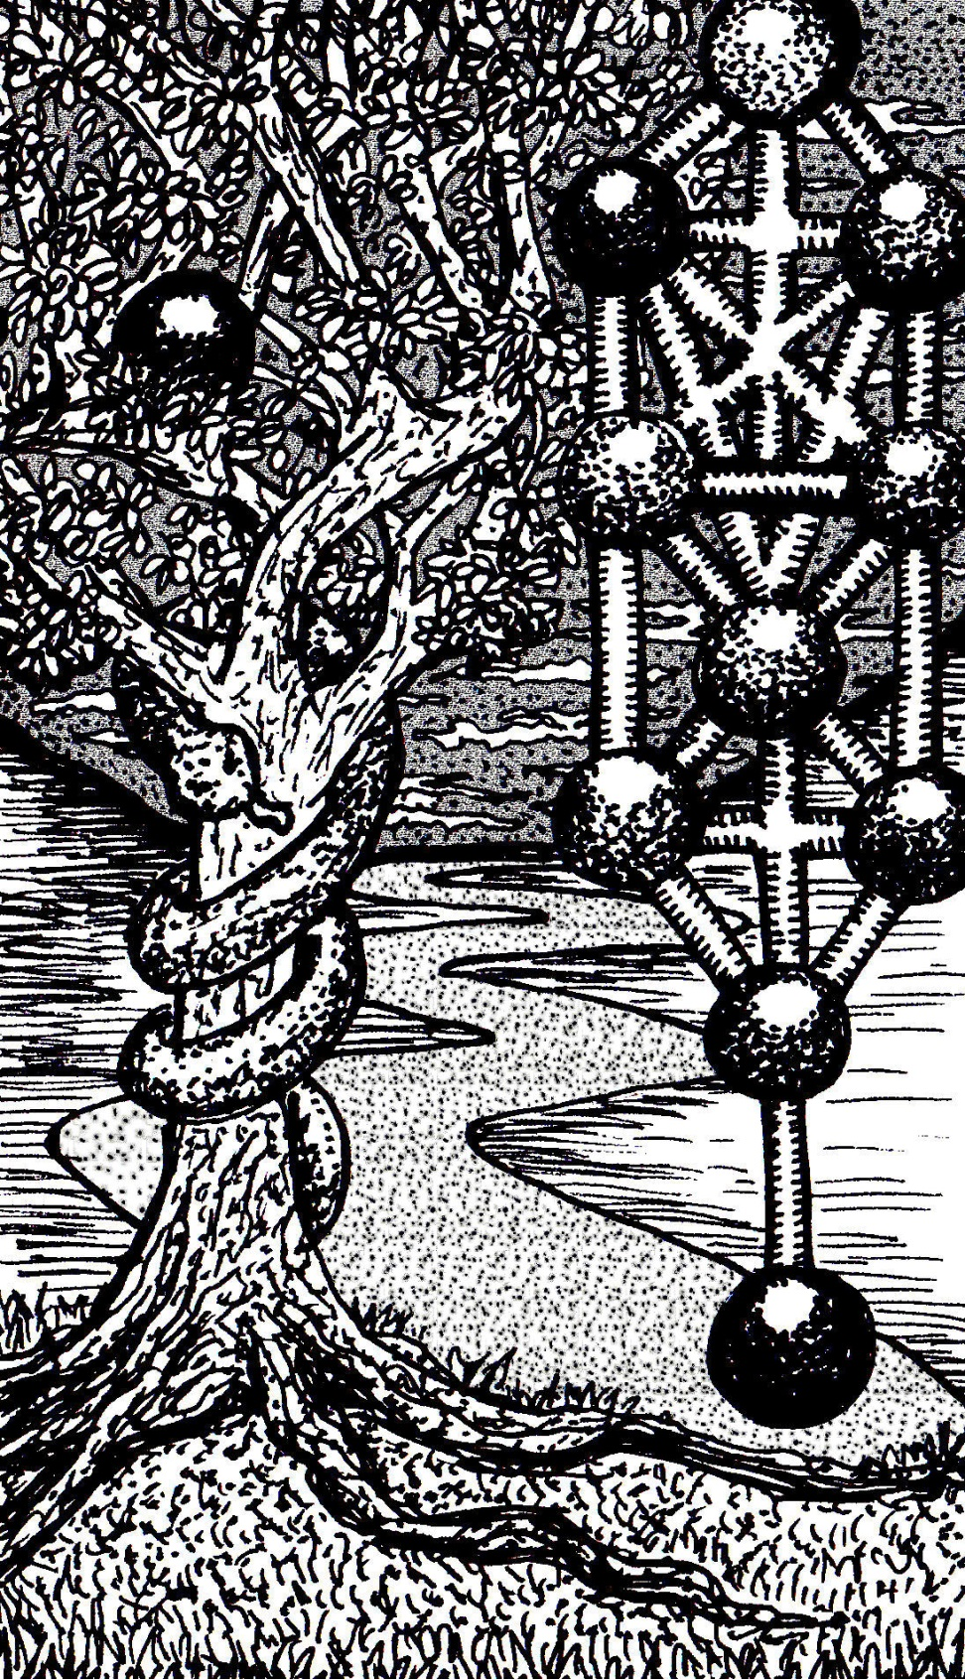

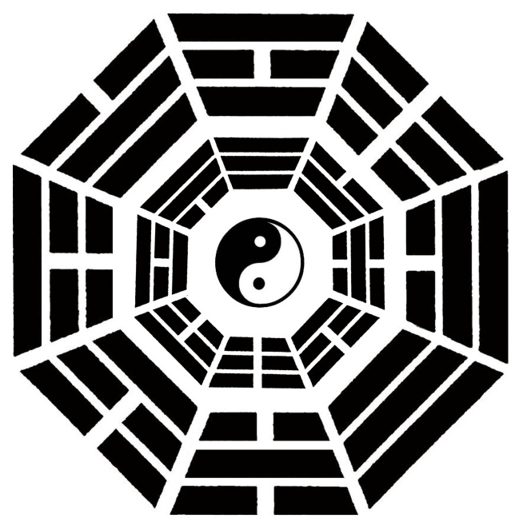

I CHING TRIGRAM CORRESPONDENCES

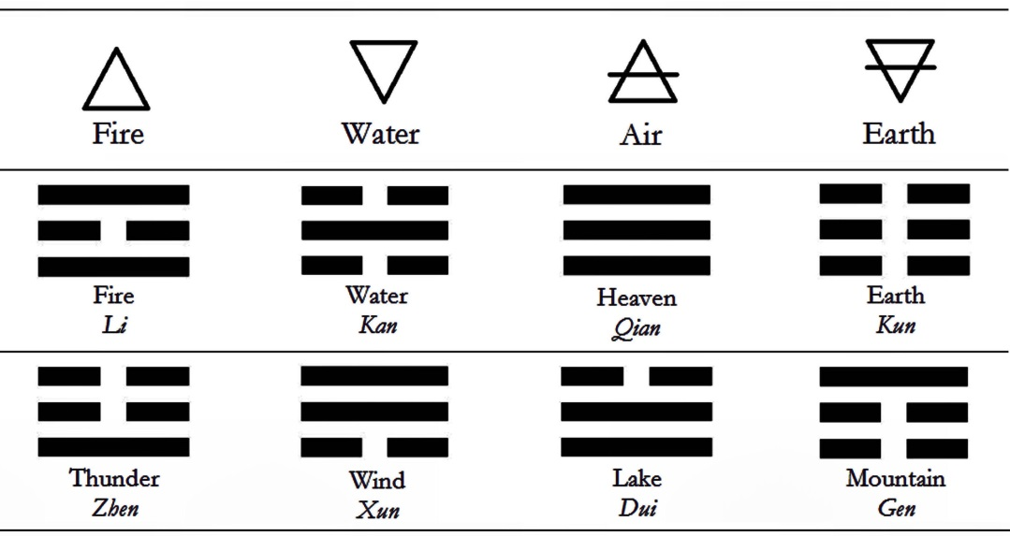

Heaven  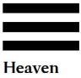 | Lake   | Fire   | Thunder  
Wind  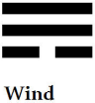 | Water  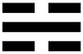 | Mountain   | Earth  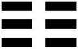

Pairs of cards in the tarot can form I Ching hexagrams with each card’s trigram correspondence. The earlier card dealt always forms the lower trigram and the later card forms the upper trigram. The hexagram’s entry can then be consulted in any Book of Changes.

Six Major Arcana cards are assigned “(Double)” to indicate a Formula of God:

- Key 1 – The Magus  - Key 7 – The Chariot  - Key 8 – The Force | - Key 11 – The Chancellor  - Key 14 – The Angel  - Key 18 – The Necromancer

Thus, in divination, the other trigram produced is doubled to form the hexagram. If two “(Double)” cards are drawn, then Divine Light is making its presence known, but no words of revelation will be given at this time.

Tarot Arcana | Trigram
Key 0 – Initiate, Seeker, Keeper | Heaven
Key 1 – Magus | (Double)
Key 2 – Priestess | Water
Key 3 – Empress | Heaven
Key 4 – Emperor | Fire
Key 5 – Holy See | Mountain
Key 6 – Lovers | Lake
Key 7 – Chariot | (Double)
Key 8 – Force | (Double)
Key 9 – Erudite | Mountain
Key 10 – Wheel of Life | Wind
Key 11 – Chancellor | (Double)
Key 12 – Outlaw | Water
Key 13 – Reaper | Wind
Key 14 – Angel | (Double)
Key 15 – Demon | Earth
Key 16 – Tower | Thunder
Key 17 – Healer | Lake
Key 18 – Necromancer | (Double)
Key 19 – Warrior | Fire
Key 20 – Apocalypse | Thunder
Key 21 – New World Order | Earth
Ace of Scepters, Sacred Fire | Fire
Two of Scepters, Discerning One | Thunder
Three of Scepters, Politic | Fire
Four of Scepters, Demiurge | Thunder
Five of Scepters, Contender | Fire
Six of Scepters, Champion | Thunder
Seven of Scepters, Dark Horse | Fire
Eight of Scepters, Sharpshooter | Thunder
Nine of Scepters, Malaise | Fire
Ten of Scepters, Burdened One | Thunder
Page of Scepters, Stronghold | Thunder
Knight of Scepters, Shining One | Fire
Queen of Scepters, Shield | Thunder
King of Scepters, Archangel | Fire
Ace of Chalices, Holy Water | Water
Two of Chalices, Joined One | Wind
Three of Chalices, Kindred | Water
Four of Chalices, Hollow Void | Wind
Five of Chalices, Grotesque | Water
Six of Chalices, Memory Keeper | Wind
Seven of Chalices, Corrupter | Water
Eight of Chalices, Defector | Wind
Nine of Chalices, Wish Granted | Water
Ten of Chalices, Joyous One | Wind
Page of Chalices, Stronghold | Wind
Knight of Chalices, Shining One | Water
Queen of Chalices, Shield | Wind
King of Chalices, Archangel | Water
Ace of Swords, Sacred Cinnabar | Heaven
Two of Swords, Blind Seer | Lake
Three of Swords, Bereaved | Heaven
Four of Swords, Convalescent | Lake
Five of Swords, Hector | Heaven
Six of Swords, Ferryman | Lake
Seven of Swords, Rogue | Heaven
Eight of Swords, Captor | Lake
Nine of Swords, Haunt | Heaven
Ten of Swords, Destroyer | Lake
Page of Swords, Stronghold | Lake
Knight of Swords, Shining One | Heaven
Queen of Swords, Shield | Lake
King of Swords, Archangel | Heaven
Ace of Orbs, Bread of Life | Earth
Two of Orbs, Nocturne | Mountain
Three of Orbs, Mason | Earth
Four of Orbs, Conservator | Mountain
Five of Orbs, Vagabond | Earth
Six of Orbs, Giver | Mountain
Seven of Orbs, Gardener | Earth
Eight of Orbs, Journeyman | Mountain
Nine of Orbs, Eminence | Earth
Ten of Orbs, Dynasty | Mountain
Page of Orbs, Stronghold | Mountain
Knight of Orbs, Shining One | Earth
Queen of Orbs, Shield | Mountain
King of Orbs, Archangel | Earth

