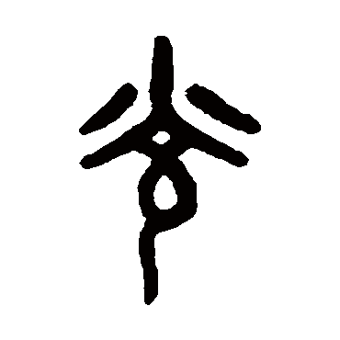
The Thirteen Taoist Principles of Craft

From the Huangdi Yinfu Jing (黃帝陰符經)
Or The Yellow Emperor’s Classics of the Esoteric Talisman
Or The Yellow Emperor’s Scripture for the Esoteric Talisman
1 | Align yourself with the Universe.
2 | All manifestations in the Universe can be generated through your own hand.
3 | Before every event, the Universe presents opportunities to change the path of nature.
4 | You can harness energy from the Universe and nature to help your own fate and luck, but it’s most effective only when the timing is proper and the approach is peaceful.
5 | To harness the energy of the Universe, your mind must be awakened. For your mind to be awakened, you must be spiritual. Those who are not spiritual are not awakened and therefore cannot harness the energy of the Universe.
6 | Your body can master your mind through isolated sensory focus; that is how you become spiritual.
7 | Use the binary of yin and yang energies to transform the path of nature.
8 | Harness energy of the Universe through Wu Xing (or the fundamental alchemical elements).
9 | From Qi energy came the eight elements that make up the I Ching Ba Gua.
10 | Harness energy of the Universe through the synthesis of astrology and numerology.
11 | No one holds special favor in the court of Heaven but anyone can gain favors from the court of Heaven.
12 | To harness energy from the Universe isn’t a supernatural act. It’s a form of philosophy of Heaven and Earth. If you want to understand how to harness energy from the Universe, first understand the four seasons and the four directions.
13 | To harness the energy of higher spirits, use yang. To harness the energy of lower spirits, use yin.

What are the Thirteen Taoist Principles of Craft?

The Thirteen Principles of Craft are derived from a Chinese occult text called 黃帝陰符經, the Yellow Emperor’s Classics of the Esoteric Talisman or Yellow Emperor’s Classics of the Hidden Talisman, depending on the translation. Documented references to it date to the Tang Dynasty, 618 AD to 907 AD, though apocryphally, the text is believed to date back to the Zhou Dynasty, 1046 BC to 256 BC. The text is considered to be both a philosophical work and also a medieval instructional manual on metaphysics or how to operate spell-crafting.

1. Align yourself with the Universe.

In lieu of “Universe,” you could also translate the original text’s language to “the Tao,” or “Divine” or “Heaven.” This is a reference to The Supreme One.

One interpretation of this point is alignment with a deity or deities that are representative of Heaven, or of the Divine. Most lineages of Taoist magical practice will align with a particular deity to venerate and call upon in all energetic workings. That would be the alignment that such practitioners seek.

Another interpretation is alignment with the Tao, with a cosmic Qi energy that represents the whole of the universe. That Qi is further expressed as yin and yang, and so there are also lineages that affiliate with two deities, one female and one male, as the anthropomorphized representations of yin and yang.

Whether you characterize the alignment as one with deity or deities or the Tao, or simply an alignment with a higher consciousness, that sense of greater alignment is imperative to craft.

2. All manifestations in the Universe can be generated through your own hand.

I interpret the essence here to suggest that magic and magicians exist. The practitioner can harness or call upon any manifestation or energy in the universe around him or her through the channel of the physical body, and the most powerful channel is through the practitioner’s hand.

How? Although I didn’t include it in the concise text of the thirteen principles, the Classics of the Esoteric Talisman also addresses the power of the practitioner’s will, and pairing intention with what you generate through your hand. The action, activities, ceremonies, and the purpose of craft is determined by the practitioner’s will. As for the theoretical and practical application of magic to harness or call upon the manifestations and energies of the universe, the practitioner does so through the mind, or through your intentions. Intent is everything.

3. Before every event, the Universe presents opportunities to change the path of nature.

Basically, the text acknowledges free will, which is fascinating, given the fatalism that many Chinese seem to subscribe to.

Here, the text is saying that prior to the occurrence of any event, the practitioner has a window of opportunity to affect the outcome and transform that event. How? Through triggering mechanisms, of course. What are triggering mechanisms? I interpret it as meaning spell-crafting or the power of manifestation (the law of attraction).

Note that: the concept referred to as “triggering mechanisms” throughout these points can also be understood as “spells,” “craft,” or “energetic workings.”

4. You can harness energy from the Universe and nature to help your own fate and luck, but it’s most effective only when the timing is proper and the approach is peaceful.

To me, this point is interesting because of the way it seems to suspend moral judgment. The point here is that the practitioner can pull metaphysical energy from the Universe and from nature for the practitioner’s own ends. Can, yes, meaning it is doable, but is it permissible?

According to the text, it is only permissible if the “timing is proper” and the craft is “peaceful.” Those are the two conditions the practitioner must adhere to if he or she intends to take energy from the Universe, or from Divinity, and from the natural world around you.

5. To harness the energy of the Universe, your mind must be awakened. For your mind to be awakened, you must be spiritual. Those who are not spiritual are not awakened and therefore cannot harness the energy of the Universe

To transcend beyond a layperson and thus be empowered to craft Fu sigils, a practitioner has to be spiritual. When the practitioner is spiritual, then the practitioner’s spirit will be awake. Without that awakening, a practitioner won’t be effectively positioned for energetic workings such as sigil crafting.

Per Eastern esotericism, you become spiritual through four practices: (1) meditation, (2) cultivation of the body, (3) sacred rituals, and (4) the sacred arts. Meditation teaches the practitioner how to be aware of consciousness. It is a form of self-regulation for the mind. Cultivation is a form of self-regulation for the body. Practices such as qi gong, tai chi, and martial arts are a few examples of Taoist cultivation. Cultivation is about attentiveness to the body, and learning to bring your mind and body into harmony. Sacred rituals raise the practitioner’s awareness of other realms beyond the physical plane that his or her body occupies. Sacred rituals bring together meditation and cultivation and enable a practitioner to transcend both consciousness and body. The sacred arts include ceremonial magic or thaumaturgy, feng shui, divination, the I Ching, necromancy, and the application of mystical knowledge.

6. Your body can master your mind through isolated sensory focus; that is how you become spiritual.

The original text’s translation may be better phrased as, “When you don’t use your eyes, you can hear what you couldn’t hear before. When you don’t use your ears, you can see what you couldn’t see before. That is how your body masters your mind. Then your mind can learn to use your eyes and ears to affect triggering mechanisms.”

This point seems to be counsel on the logistics of ritual. To enable yourself to metaphysical sight, you must first learn how to shut out your physical sight. To hear what needs to be heard on the metaphysical plane of sound, shut your ears out to physical sounds. One way to cultivate such mindfulness is through meditation. Thus, to follow this point, consider regular training by way of meditation.

7. Use the binary of yin and yang energies to transform the path of nature.

Another way to translate the text: “Yin and yang push each other. Through the concord and discord between yin and yang, the practitioner can manifest transformations in the path of nature (or fate).”

To better understand this principle, let’s turn to the Tao Te Ching, a seminal text in Taoist philosophy. “The Tao gave birth to one; one gave birth to two; two gave birth to three; three gave birth to the immeasurable.”

The one arising from Tao is Qi. Qi is in effect the spirit life force and consciousness that gives birth to the universe and all that is in the universe. From Qi comes the binary of yin and yang. The push and pull of yin with yang, how the two energies interact, will yield three, which is the holy trinity, the Three Pure Ones if expressed in deity form, or the Taoist cosmic trinity of Heaven, Earth, and Man. From that three, the rest of the universe arose. A master practitioner will understand how to work with yin and yang energies, both the powers of creation and destruction.

8. Harness energy of the Universe through Wu Xing (or the fundamental alchemical elements).

How does a practitioner take metaphysical energy from the Universe to manifest change, or to work with the law of attraction? How do you spell-craft effectively? According to the text, a metaphysician harnesses the powers of the Universe through the alchemical interaction and work with the Wu Xing.

The Wu Xing in Chinese cosmology represents the fundamental phases that all forms of change in this universe can be (must be) expressed by. Westerners might draw an equivalence of the Wu Xing to the four elements or the expression of five elements Fire, Water, Air, Earth, and Spirit. However, while Western elements describe states of being, the Wu Xing describe states of change—that “in-transit” period between states of being.

9. From Qi energy came the eight elements that make up the I Ching Ba Gua.

Now we get into the Ba Gua, the eight trigrams of the I Ching, which in Taoist cosmology represent the eight root dynamic processes that form life. Mathematical permutations of the Ba Gua form the 64 hexagrams of the I Ching Book of Changes. These eight trigrams are Heaven, Lake, Fire, Thunder, Wind, Water, Mountain, and Earth, which are concepts also utilized in feng shui.

10. Harness energy of the Universe through the synthesis of astrology and numerology.

Another way to translate this principle: “The sun, moon, and stars relate to the numbers (numerology), and knowing this can transform the path of nature through triggering mechanisms.”

For Chinese shamans, numerology has always been an integral expression of the universe, a practice that predates the invention of writing and language. Through numbers, a practitioner can understand the flow of Qi. That is why for most Eastern esoteric traditions, the Lo Shu square is fundamental to their form of craft. Likewise, a practitioner will be proficient in astrology. For practitioners of Eastern traditions, that astrological study will includes the Big Dipper, other constellations, the moon phases, and the Chinese zodiac.

The notion that a life path is influenced by the movements of celestial bodies and the spiral dance of the numbers touches upon a concept also found in Western occult traditions: “As above, so below.” Thus, to exercise triggering mechanisms, or practice effective craft, the practitioner must first understand astrology, numerology, how both relate to one another, and how both relate to any one specific individual.

11. No one holds special favor in the court of Heaven but anyone can gain favors from the court of Heaven.

I have always maintained that the most powerful practitioners of craft must have large egos. This point seems to echo that sentiment. A large ego is the fuel that runs the engine of personal will. The stronger the self is here, the greater the practitioner’s ability to take from the Universe and manifest through self-empowerment and the law of attraction, as noted in previous points. You are not born with any special favors in the court of Heaven; rather, you earn special favor by your merits.

According to the Thirteen Principles, no single practitioner is “chosen,” is “The One,” or is any more special than anyone else, objectively speaking. Another way to translate the original text: “Heaven holds no special favors for any practitioner.”

That being said, a practitioner can generate favor through the power of his or her mind. Intent is everything, a point that is emphasized several times in the original text. Beyond intent, the practitioner must be so fully convinced of his or her powers and abilities as a practitioner of craft that there is no shred of doubt in the practitioner’s mind that the outcome of the craft will be exactly as the practitioner willed it to be.

Here, there is also the sense that a practitioner is born on trial, or on probation, and must earn his or her special favors from the Universe. If you seek to attain the favors of the high spirit councils and master the ability to petition deities for spell-crafting assistance, then you must earn that favor. No practitioner is born with that favor.

12. To harness energy from the Universe isn’t a supernatural act. It’s a form of philosophy of Heaven and Earth. If you want to understand how to harness energy from the Universe, first understand the four seasons and the four directions.

The concept of magic or craft is not supernatural. It is natural. It is tapping into the metaphysical dimension of the physical world. It is an understanding of how to best utilize that window of opportunity before any given event occurs.

Since magic is natural, it operates by the same laws that physical nature abides by, and so to understand metaphysics, you have to understand physics. To raise energy for magic, do not look to the so-called supernatural. Instead, look to the natural world around you, the seasons, solstices and equinoxes, and the four cardinal directions, and geomancy. . More than that, understand change. The successful practitioner understands the philosophy of change. The four seasons and the four directions represent the winds of change. Magic is neither Heaven nor Earth; it is change. The metaphysician must understand the laws and powers of change to expertly control the Universe.

13. To harness the energy of higher spirits, use yang. To harness the energy of lower spirits, use yin.

The final point relates to Chinese cosmology and metaphysics. In the binary of yin and yang, higher vibrational realms are fueled by yang and lower vibrational realms are fueled by yin, whereas the earthly realm is the balance of yin and yang.

Spirits, saints, immortals, angels, or metaphysical energies of the Light are petitioned by the practitioner through the harnessing of yang energy, or the Light. Ghosts, hungry ghosts, demons, or metaphysical energies of the Dark are summoned by the practitioner through the harnessing of yin energy, or the Dark.
In other words, the final principle holds instructional value to the practitioner. It explains how to work with celestial spirits and how to work with demonic spirits.

光
Guāng

The above Chinese oracle bone script is the symbol for Light, or Luminescence. Etymologically, the root word relates to the Chinese character for halo.

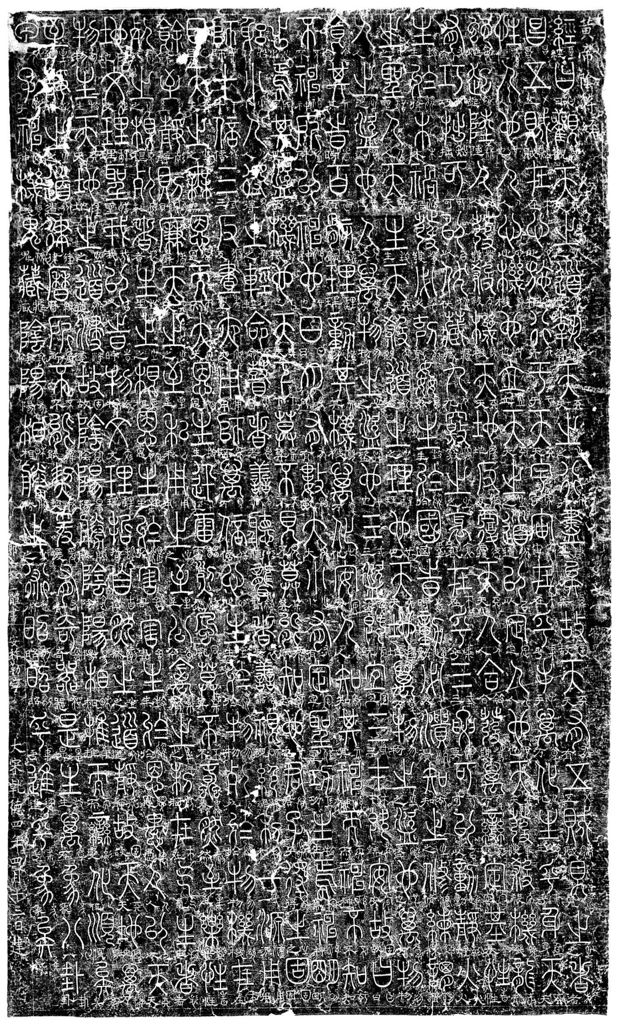
Inscription of the Huangdi Yinfu Jing (黃帝陰符經) (circa 10th century)
Harvard University, Fine Arts Library, Special Collection

