Formation of the Ba Gua Eight Trigrams

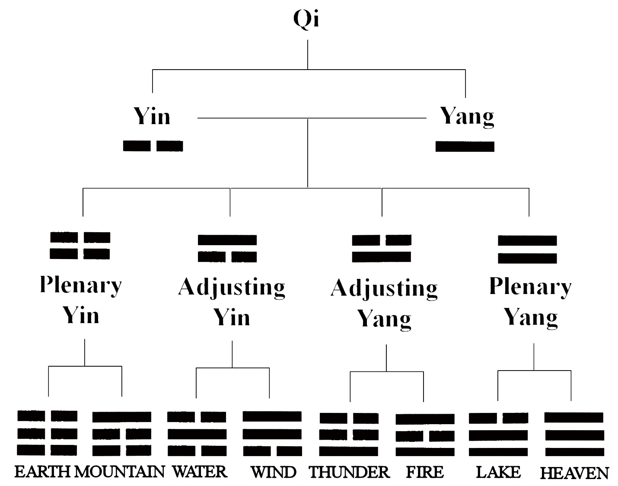

Ba Gua Trigrams and the Lo Shu Magic Square

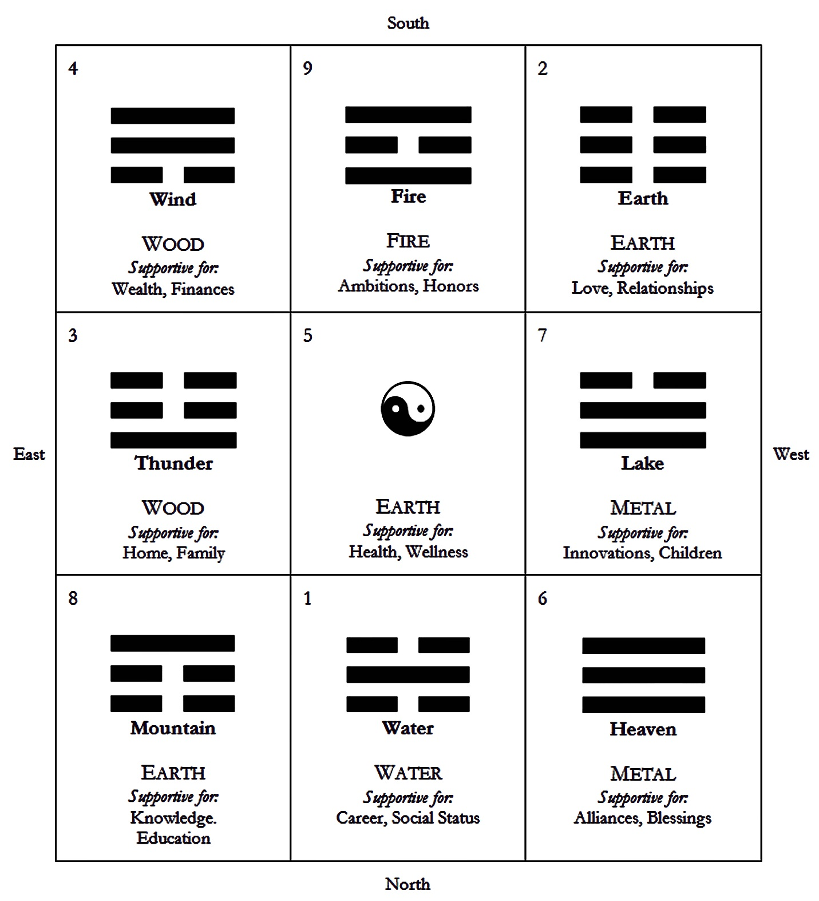

The Manifested Ba Gua
The Eight Trigrams of the Later Heaven Sequence

# | Trigram | Characterization | Correspondences
1 | 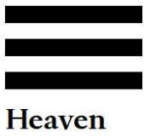  Heaven  Qian | The creative force. Divine Yang. Strength in creativity. Expansive energy, the sky. | Direction: Northwest  Life Aspect: Fatherhood; blessings; allies; friends; opportunities  Relationship: Father; parenting yang  Body Part: Head  Animal: Horse
2 | 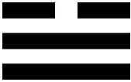  Lake  Dui | A fertile womb; receptivity for further growth. Nourishment, receiving pleasure, tranquility. Devotion. Joy, satisfaction, stagnation. | Direction: West  Life Aspect: Children; fertility, nurturing  Relationship: Third offspring, daughter or nurturing yin  Body Part: Mouth  Animal: Sheep; also Tiger
3 | 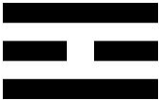  Fire  Li | Radiance; eminence; innovation and cultivation. Giving light; illumination. Clarity. Rapid movement, radiance, the sun. Clinging; dependent. | Direction: South  Life Aspect: Ambition, honor; fame; reputation  Relationship: Second offspring, daughter or nurturing yin  Body Part: Eyes  Animal: Phoenix; Pheasant
4 | 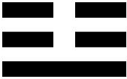  Thunder  Zhen | To shake or arouse. Inciting movement. Taking the initiative. Excitation, revolution, division. | Direction: East  Life Aspect: Family; ancestry  Relationship: First offspring, son or creative yang  Body Part: Foot  Animal: Dragon

The Manifested Ba Gua, continued

# | Trigram | Characterization | Correspondences
5 | 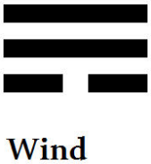  Wind  Xun | Gentle thoughts; entering gently; proceeding conscientiously. Flexibility. Adaptability. | Direction: Southeast  Life Aspect: Wealth, finances; assets  Relationship: First offspring, daughter or nurturing yin  Body Part: Thigh/legs  Animal: Fowl
6 | 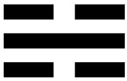  Water  Kan | Great depths; being submerged into the depths. Strong movement or momentum. The moon. Exercise caution: potential for danger. | Direction: North  Life Aspect: Career trajectory; life path  Relationship: Second offspring, son or creative yang  Body Part: Ear  Animal: Pig; also Tortoise
7 | 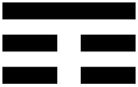  Mountain  Gen | Keeping still; preserving energy through stability. Resting. Respite. Completion. | Direction: Northeast  Life Aspect: Knowledge, education; skills; wisdom  Relationship: Third offspring, son or creative yang  Body Part: Hand  Animal: Wolf
8 | 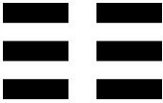  Earth  Kun | Receiving direction. Yielding. Receptive. Submission to Heaven. Nurturing force. Divine Yin. Receptive energy, that which yields. | Direction: Southwest  Life Aspect: Love and relationships; motherhood  Relationship: Mother; parenting yin  Body Part: Stomach  Animal: Bull

Hexagram Graph

 |  | 1 | 2 | 3 | 4
 | Upper Trigram | Heaven | Lake | Fire | Thunder
 | Lower Trigram
1 | Heaven | 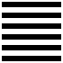  1 | 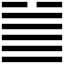  43 | 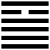  14 | 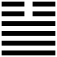  34
2 | Lake | 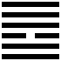  10 | 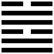  58 | 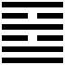  38 | 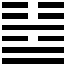  54
3 | Fire | 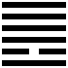  13 | 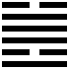  49 | 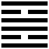  30 | 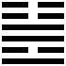  55
4 | Thunder | 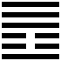  25 | 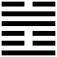  17 | 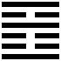  21 | 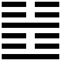  51
5 | Wind | 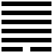  44 | 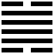  28 | 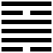  50 | 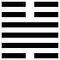  32
6 | Water | 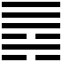  6 | 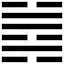  47 | 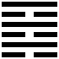  64 | 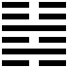  40
7 | Mountain | 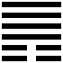  33 | 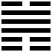  31 | 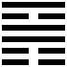  56 | 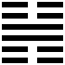  62
8 | Earth | 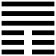  12 | 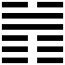  45 | 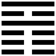  35 | 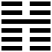  16

Hexagram Graph, continued

5 | 6 | 7 | 8
Wind | Water | Mountain | Earth | Upper Trigram
 |  |  |  | Lower Trigram
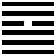  9 | 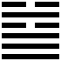  5 | 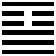  26 | 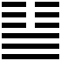  11 | Heaven | 1
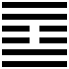  61 | 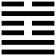  60 | 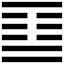  41 | 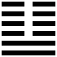  19 | Lake | 2
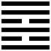  37 | 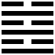  63 | 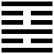  22 | 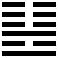  36 | Fire | 3
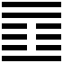  42 | 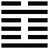  3 | 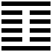  27 | 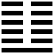  24 | Thunder | 4
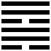  57 | 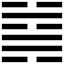  48 | 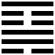  18 | 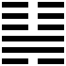  46 | Wind | 5
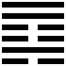  59 | 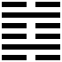  29 | 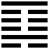  4 | 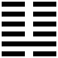  7 | Water | 6
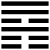  53 | 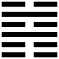  39 | 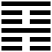  52 | 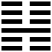  15 | Mountain | 7
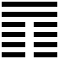  20 | 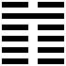  8 | 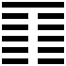  23 | 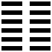  2 | Earth | 8

Divination Method: Three Coin Toss

Assign yang to one side of the coin and yin to the other. Typically, heads corresponds with yang and tails corresponds with yin. The following coin toss method will utilize three coins. | 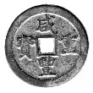  Yang  Heads | 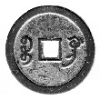  Yin  Tails
Clearly articulate the inquiry. Focus the entire mind on that inquiry.
Toss three coins together.
All 3 Yang: Yang Line (Plenary)

Yang (Heads) – Yang (Heads) – Yang (Heads)

Forms a solid line.
2 Yang, 1 Yin: Yang Line (Adjusting)

Yang (Heads) – Yang (Heads) – Yin (Tails)

Forms a solid line.
1 Yang, 2 Yin: Yin Line (Adjusting)

Yang (Heads) – Yin (Tails) – Yin (Tails)

Forms a broken line.
All 3 Yin: Yin Line (Plenary)

Yin (Tails) – Yin (Tails) – Yin (Tails)

Forms a broken line.
The first toss renders the first line (bottom-most).

Example. The first toss yields all heads. The outcome is Plenary Yang, i.e., solid line. | 
The second toss renders the second line (second from the bottom). Perform a total of six tosses, rendering each line atop the previous.
Divination Method: Three Coin Toss, continued
Example, continued. The second toss yields 2 heads and 1 tail. The outcome is Adjusting Yang, i.e., solid line. | 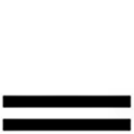
Assume for the example that the third toss yields 1 head and 2 tails. The outcome is Adjusting Yin, i.e., broken line. | 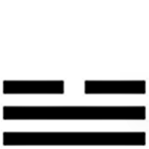
Note the lower trigram formed.
Example, continued. The lower trigram formed in the example is Lake. | Lake
Continue to the fourth toss. Assume the fourth toss yields 3 tails. The outcome is Plenary Yin, i.e., broken line. | 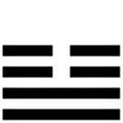
The fifth toss yields 2 heads and 1 tail again. The outcome is Adjusting Yang, i.e., solid line. | 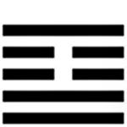
The sixth toss yields 1 head and 2 tails. The outcome is Adjusting Yin, i.e., broken line. | 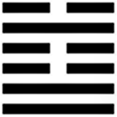
Note the upper trigram formed.
Example, continued. The upper trigram formed in the example is Water. | Water
In the example, the hexagram is the result of Water (the upper trigram) over Lake (the lower trigram).  Using the Hexagram Graph, a Cartesian diagram of how the 8 trigrams form the 64 hexagrams, identify the hexagram formed by the lower trigram along the vertical axis to the upper trigram along the horizontal axis. | Water  Lake
Divination Method: Three Coin Toss, continued  Example, continued. Water over Lake is Hexagram 60: Boundaries, Restraint, Regulation.  Turn to that hexagram in the book. The divination result for the inquiry is embedded in “The Oracle” section of the corresponding entry. Read only “The Oracle” section of the hexagram. | 60
Next, revisit the six lines cast and identify any Plenary lines. If there are no Plenary lines cast in the hexagram, then the hexagram cast is locked. The divination concludes.
A locked hexagram suggests a “locked fate.” All variables and events affecting the matter at hand have been set into motion already and now it is only a matter of navigating what is to come.
If there are Plenary lines cast, then the matter is still fluid, with variables and events that can affect the matter at hand still in flux.
When there are Plenary lines cast, note which lines are Plenary by marking the Plenary lines during the casting process.
Example, continued. Recall that the first and fourth lines in the hexagram casting were Plenary, i.e., in the first coin toss, the result was 3 heads and in the fourth coin toss, the result was 3 tails.  Here, the Plenary lines of the primary hexagram are marked by the taijitu (yin-yang) symbol as illustrated at right. | 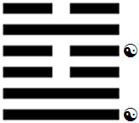
The text for the corresponding lines that were Plenary in the hexagram will offer insight on how to proceed from here so that the most favorable outcome will manifest. Read these lines together and the synthesis is the answer to how to proceed. Read only the sections corresponding with the lines that are Plenary.
Example, continued. In the entry for Hexagram 60, after reading “The Oracle” section, read the text under the “First Line” and the text for the “Fourth Line” sections.
The text for these two sections under Hexagram 60 will offer counsel on how to act going forward for the best possible outcome to the matter at hand.
Revisit the Plenary lines. Plenary lines in the primary hexagram will change to form a secondary hexagram.  Each Plenary Yang solid line will transmute into a Yin broken line.  Each Plenary Yin broken line will transmute into a Yang solid line. | The theoretical rationale for the transmutting lines is derived from the cosmological principle of the ba gua and how trigrams are formed from Yin and Yang.
When All 3 Yang: Yang Line (Plenary)

Forms a solid line for the primary hexagram. However, after the primary hexagram is cast, the line will transmute into a Yin line.
Divination Method: Three Coin Toss, continued
When All 3 Yin: Yin Line (Plenary)

Forms a broken line for the primary hexagram. However, after the primary hexagram is cast, the line will transmute into a Yang line.
Example. In the foregoing hexagram cast, the first toss yielded a Plenary Yang. The fourth toss yielded a Plenary Yin.
The first line Plenary Yang will transmute into a Yin broken line and the fourth line Plenary Yin will transmute into a Yang solid line. Now a new hexagram is formed. | 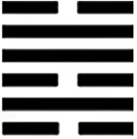
Identify the second hexagram by coordinating the new lower trigram with the new upper, using the Hexagram Graph.  In the example given, the two trigrams effectively switch positions, with the result of Lake (the upper trigram) over Water (the lower trigram). | Lake  Water
Lake over Water is Hexagram 47: Oppression; Iron Hand; Feeling Trapped.  In addition to reading the specified sections from the Hexagram 60 entry instructed earlier, look also to “The Oracle” section of Hexagram 47. | 47
“The Oracle” section of the primary hexagram is the answer to your inquiry. The corresponding line(s) to read for that primary hexagram offers an instructive message about the situation at hand.

“The Oracle” section of the secondary hexagram indicates an alternative outcome and what could happen in the situation at hand. Some practitioners will read the corresponding line(s) per the divination result, i.e., the Plenary Lines, for the secondary hexagram as well. These lines can offer an instructive message about the possible alternative outcome.
Example. The first and fourth lines of the primary hexagram, Hexagram 60: Boundaries, Restraint, Regulation, were read as part of the divination.
Likewise, the first and fourth lines of the secondary hexagram, Hexagram 47: Oppression; Iron Hand; Feeling Trapped, are also read as part of the divination.

