MEDIA KIT

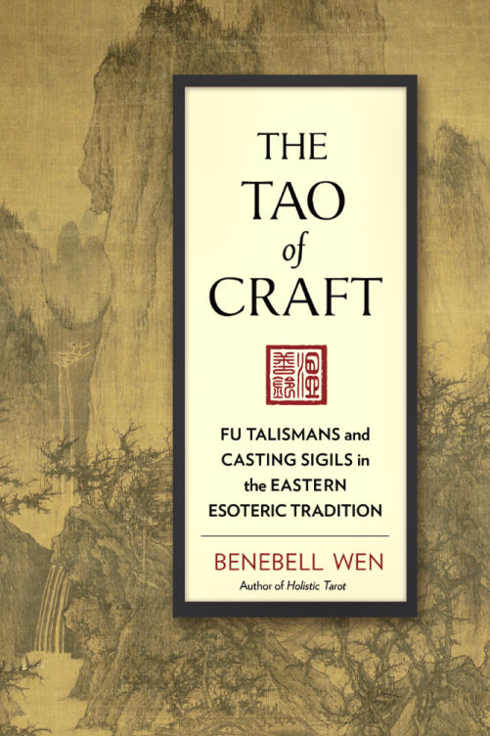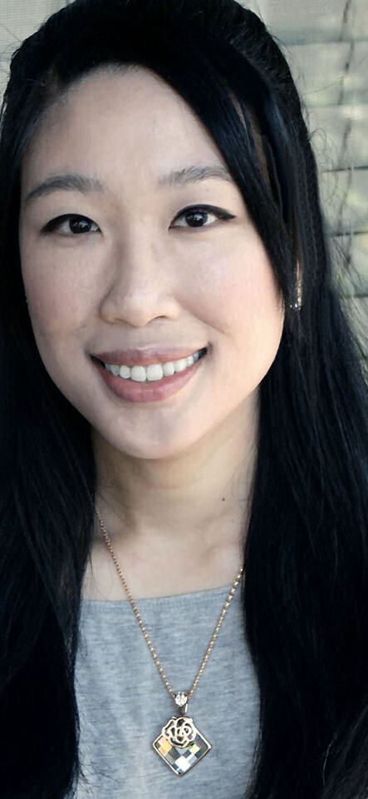

The TAO of CRAFT

Fu Talismans and Casting Sigils in the Eastern Esoteric Tradition

The Tao of Craft is about exploring the rich historic and cultural context of Chinese Taoist-based talisman crafting. May our histories teach us how to blend Old World magic into everyday modern life.

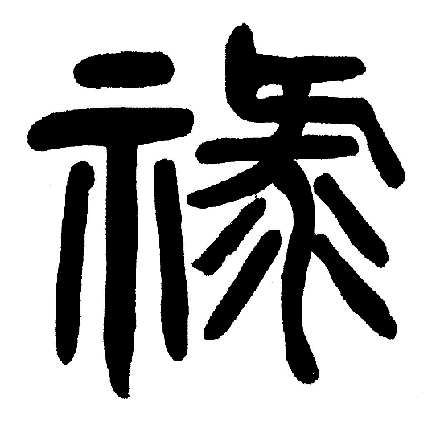
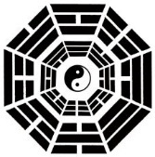

PRESS RELEASE

Four Thousand Years of Magic:
Fu Talismans and Taoist Sigil Crafting

BERKELEY, California, September 27, 2016— Explore the rich history of Taoist ceremonial magicians and witchcraft as it dates back to the Neolithic shamans of China. Under the reign of the Yellow Emperor, the mythic imperial historian Cangjie was said to have invented writing around 2650 BC, inspired by the footprints of birds. Upon the discovery of writing, demons howled in fear, because through writing, humans could now connect with Heaven and send prayers to the Divine, wielding power over the netherworld.

Fast forward to contemporary times, when those same writings of Neolithic shamans can be revived and used for the spiritual benefit of people today. Learn about the art of crafting Fu talismans for personal empowerment, self-help, and spiritual connections. Supplement your pursuit of aspirations with divinely-invoked metaphysical forces.

Through writing, or the earliest form of Fu talismans, prehistoric shamans, then alchemists of the Qin Dynasty, and later the priests and priestesses of the Jin developed a magical art of spell-crafting through sigils that facilitated communion between the physical world and the metaphysical. The Tao of Craft covers the development of Fu talismans as it was practiced among the varied Taoist lineages documented in history. It then reveals how a modern-day practitioner can render such talismans for personal empowerment.

Fu talismans are a form of metaphysical science that can be practiced outside of or even in conjunction with any religious faith or spiritual path because essentially, the Fu is a form of prayer. Pagans and practitioners of mystery traditions will find The Tao of Craft to be a fascinating read. Benebell Wen, author of Holistic Tarot and the recipient of four book awards is a metaphysician who is also a corporate lawyer practicing law in California and New York. She is of Taiwanese descent and currently lives in Northern California.

Publisher Contact:

Bevin Donahue
North Atlantic Books
2526 Martin Luther King Jr. Way
Berkeley, CA 94704
(510) 549-4270 x 26
bdonahue@northatlanticbooks.com

BOOK DESCRIPTION

For the first time in English, Benebell Wen reveals the rich history and theoretical principles underlying the ancient practice of crafting Fu talismans, or magical sigils, in the Chinese Taoist tradition and gives detailed instructions for modern practitioners who would like to craft their own Fu. Fu talismans are ideograms and writings typically rendered on paper and empowered by means of invocations, ritual, and transferences of energy, or Qi. Talismans can be used for many purposes, such as strengthening or weakening personality characteristics, finding love, earning more money, or easing emotional tensions in the home.

The Tao of Craft shows how metaphysical energy can be harnessed to amplify, strengthen, weaken, dispel, or block other metaphysical energy and to rectify perceived imbalances in the material plane. Supported by an abundance of detailed charts and images, this book serves as a step-by-step handbook that gives readers the knowledge and confidence to craft their own Fu talismans for personal empowerment.
Wen, author of Holistic Tarot, delves into historic and cultural contexts of the Fu, from the neolithic period of Chinese history to contemporary practices of esoteric Taoism. Providing a solid foundation in the principles of Eastern spellcrafting, she highlights the blending of Taoist metaphysical practices with Western approaches to magic by pointing out eclectic, integrating, and harmonizing facets from other cultures and religions.
Historically, Fu talismans were used by medieval Chinese for alleviating illness; averting misfortune, magical attacks, and curses; defending against assaults; and avoiding poverty. This book shows western practitioners that the skill and knowledge to develop an interactive relationship with spirit realms are still available to them today, and serves as a practical handbook for accumulating Qi energy from sources in the environment and channeling it in concentrated form into their own Fu talismans.

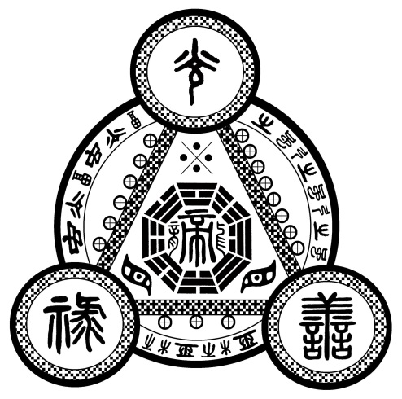

PRAISE

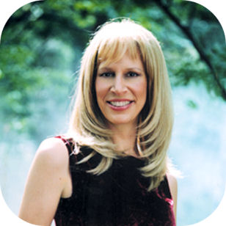  Phyllis Curott | “Benebell Wen has gifted us with an amazingly rich resource for a life of magic and fulfillment, revealing the sacred and empowering why behind the ancient Taoist art and practice of talisman crafting. Read and remember where you are and why you are here.”  —Phyllis Curott, priestess, attorney, and author of Book of Shadows, WitchCrafting, and the Love Spell

“The publication of any book in English on the creation and use of Fu talismans—among the most useful and accessible parts of the rich heritage of Chinese magic—is welcome, but when that book turns out to be readable, thoughtful, and eminently practical, that’s cause for celebration. Benebell Wen’s The Tao of Craft is all that and more, and deserves the attention of any reader interested in the theory and practice of operative magic.” | 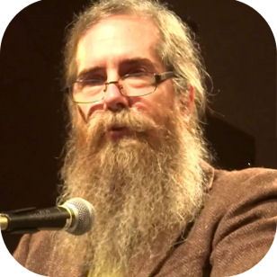  John Michael Greer

—John Michael Greer, author of The New Encyclopedia of the Occult and The Celtic Golden Dawn

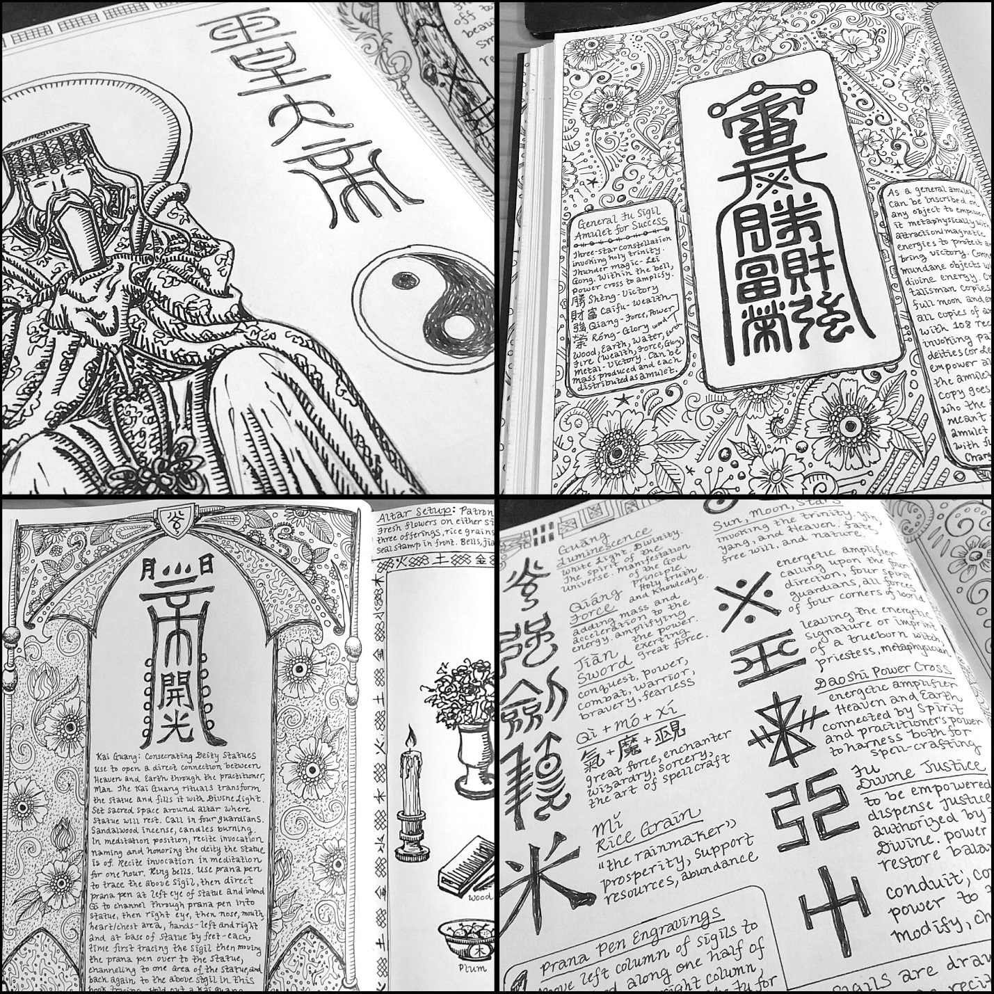

Glimpses into my personal Book of Methods, or grimoire

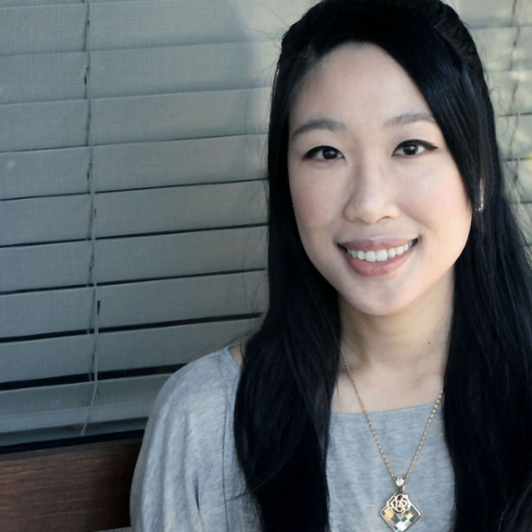

b e n e b e l l w e n

Author of Holistic Tarot and The Tao of Craft

Benebell Wen or Bell, as she is often called, is a practitioner of various metaphysical arts. She studies tarot, feng shui, the I Ching, numerology, and both Chinese and Hellenisic astrology. Wen is the author of Holistic Tarot: An Integrative Approach to Using Tarot for Personal Growth (North Atlantic Books, 2015). When not lecturing, teaching, or writing on metaphysics, Wen practices law in California and New York. She currently works in venture capital. Wen is of Taiwanese descent and lives in Northern California with her husband, James, a financial analyst, and the spirit of their beloved cat, Prince Marshall Rimbaud the Great.

 | Email:  benebellwen@live.com |  | Instagram:  @bellwen |  | Facebook Page:  facebook.com/benebellwentarot
 | Website:  www.benebellwen.com |  | Twitter:  @Tarotanalysis |  | YouTube Channel:  youtube.com/c/BenebellWen

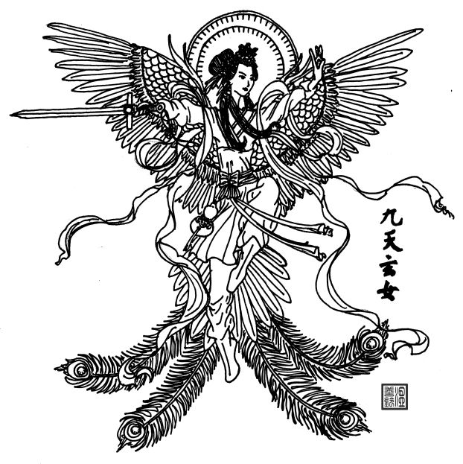

F A Q

FREQUENTLY ASKED QUESTIONS

What are Fu talismans?

Well first let’s acknowledge Qi energy. Taoists believe that in all things, there is inherent Qi energy, a life force. The craft of Fu is a form of alchemy that works with and transmutes that life force, or Qi. What you see is an ideograph, a written or drawn talisman that represents an intention. Most commonly, Fu talismans consist of written Chinese characters, or at least renderings that resemble Chinese characters, because one of the foundational principles of crafting these sigils is that the written word holds great power and is what allows us to gain control over natural and supernatural elements.

My mother is infinitely knowledgeable in these subjects, and I had asked her how I should explain Fu talismans to a Western audience. She is skeptical and doesn’t believe a Western audience can fully understand or appreciate the Fu, so she said, “Tell them it’s like lucky charms.” So, Fu talismans are like lucky charms.

How did you learn to craft Fu talismans?

It was a practice and tradition I had seen growing up, but because I didn’t understand it, I saw it as superstitious and even a bit comical. Only later in my adulthood when I delved into both history and theory could I come to appreciate the art of crafting the Fu talisman. I learned in part from observation over the years, since childhood, and I learned in part from books, reading—devouring, really—magical texts and grimoires, and just good old fashioned trial and error. How I instruct on the craft of Fu talismans in the book is how I learned the craft for myself.

When you say that you are a metaphysician, what does that mean?

I can only tell you what it means to me. To me, a metaphysician is someone who studies what it means to be that which we are, why we are here, and to explore what we metaphysicians come to know because we experience, but cannot ever prove. It’s a form of unscientific science and that paradox itself is metaphysics. I am resigned to the condition that there is no way to empirically prove the supernatural that I know and experience. I identify as a metaphysician because I dedicate my life’s work to exploring that realm of unscientific science and advancing our collective knowledge in it.

Do you ever feel that your identity as a lawyer and your identity as a metaphysician clash or are incompatible with each other?

I’m aware that socially, it’s not considered acceptable for a lawyer to be a metaphysician. Yet my legal training has been invaluable to my personal advancement in metaphysical studies, because legal training teaches you how to think. It teaches you induction and deduction. The practice of law is a mysterious blend of logical reasoning and intuitive art.

Without my legal background, I don’t believe I would have advanced as far along in my metaphysical work as I have. Likewise, my metaphysical skills have, in oh so many ways that I do not want to get into, enabled my legal work to be much easier for me. My identity as a lawyer and my identity as a metaphysician are, as they serve each other, compatible. However, as others looking in would view it, one does seem to discredit the other. You’re taken less seriously as a lawyer if people know you’re also a metaphysician, and it’s also assumed that you’re not that serious of a metaphysician if you’re also a lawyer.

Your first book was on tarot, so how did you come to write about Taoist magic for your second book?

I felt guided to it. It’s worth noting that I resisted, and there was a great deal of hesitation before I made the decision to publish The Tao of Craft. From an author branding or platform perspective, it may not be the best idea to take the route I’ve taken, but this route is authentic to who I am and a reflection of my journey. I made a conscious decision to reject marketing common sense and go with feels to be the truest reflection of me.

What was the biggest challenge you encountered while writing The Tao of Craft?

The greatest challenge I encountered was Chinese to English translations of archaic Taoist magical texts. Bear in mind that most of these texts are in Classical Chinese, which is not the same as the modern Chinese that is written today. I learned right away that exemplary Classical Chinese proficiency without metaphysical background meant you still couldn’t quite understand what the texts meant. A metaphysical background with less than exemplary Classical Chinese proficiency would also leave you stumped.

Imagine reading The Magus, that grimoire by Francis Barrett, in West Saxon (an 8th century dialect of Old English). In the modern English that it’s published in now, it’s already hard to understand for the greater majority of the English-speaking population. That’s because some foundational knowledge of ceremonial magic is presumed. So for someone to be able to make sense of The Magus if it were written in West Saxon, you would first need to find someone specially educated enough to read West Saxon, and then you would need that same person to have some basic knowledge of ceremonial magic. It’s a difficult combination to find.

However, I lucked out. My father is the most educated and sophisticated person I know, trained in the classics, while my mother is a metaphysician and attuned to all things magical, so between the two of them working together, I was able to make sense of the archaic Taoist texts.

What do you hope the impact of The Tao of Craft will be on the Western audience?

I hope it advances our collective knowledge and work with sigil crafting. I also hope that the book will inspire awe for the breadth, depth, and scope of Chinese history and esoteric Taoism’s contributions to the craft.

What do you say to those who are skeptical of magical talismans and casting spells?

Craft is not my religion, so I am not here to proselytize. Generally, it’s good practice to maintain an open mind and not be dismissive of what you don’t know or don’t understand. Throughout scientific history, magic has preceded science. Alchemy became chemistry. The continued exploration of alchemy is to study the metaphysical component of the physical science. Same with astrology. Astrology became astronomy, and the study of astrology is to explore the metaphysical dimension of celestial bodies—what they are and why they are here, and the reason for being. The myths and stories of gods that we once used to explain day and night, the four seasons, catastrophe, and weather or the magical properties we gave to stones and flora inspired the advancement of earth science. All realms that science cannot yet explain have always been considered magic. Eventually, through the perfect combination of human intelligence, ingenuity, and creative intuition, what was once considered magic becomes science. So who is to say what incredible discoveries are to come from our work with metaphysical craft?

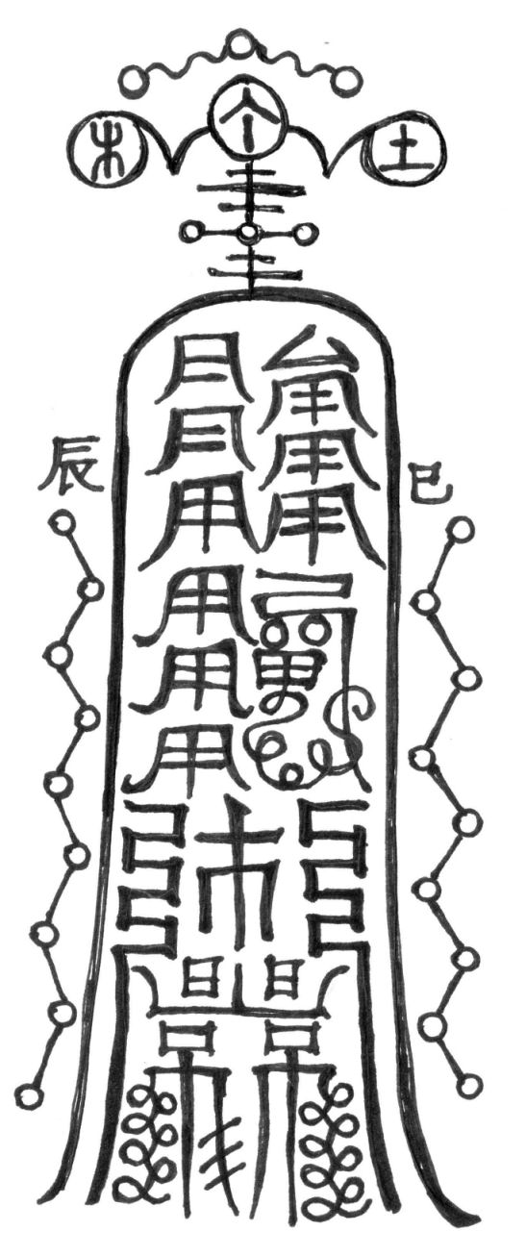

Figure K.11 from The Tao of Craft, page 513
Empowering the Magus Fu: A Fu sigil with stem and branch glyphs

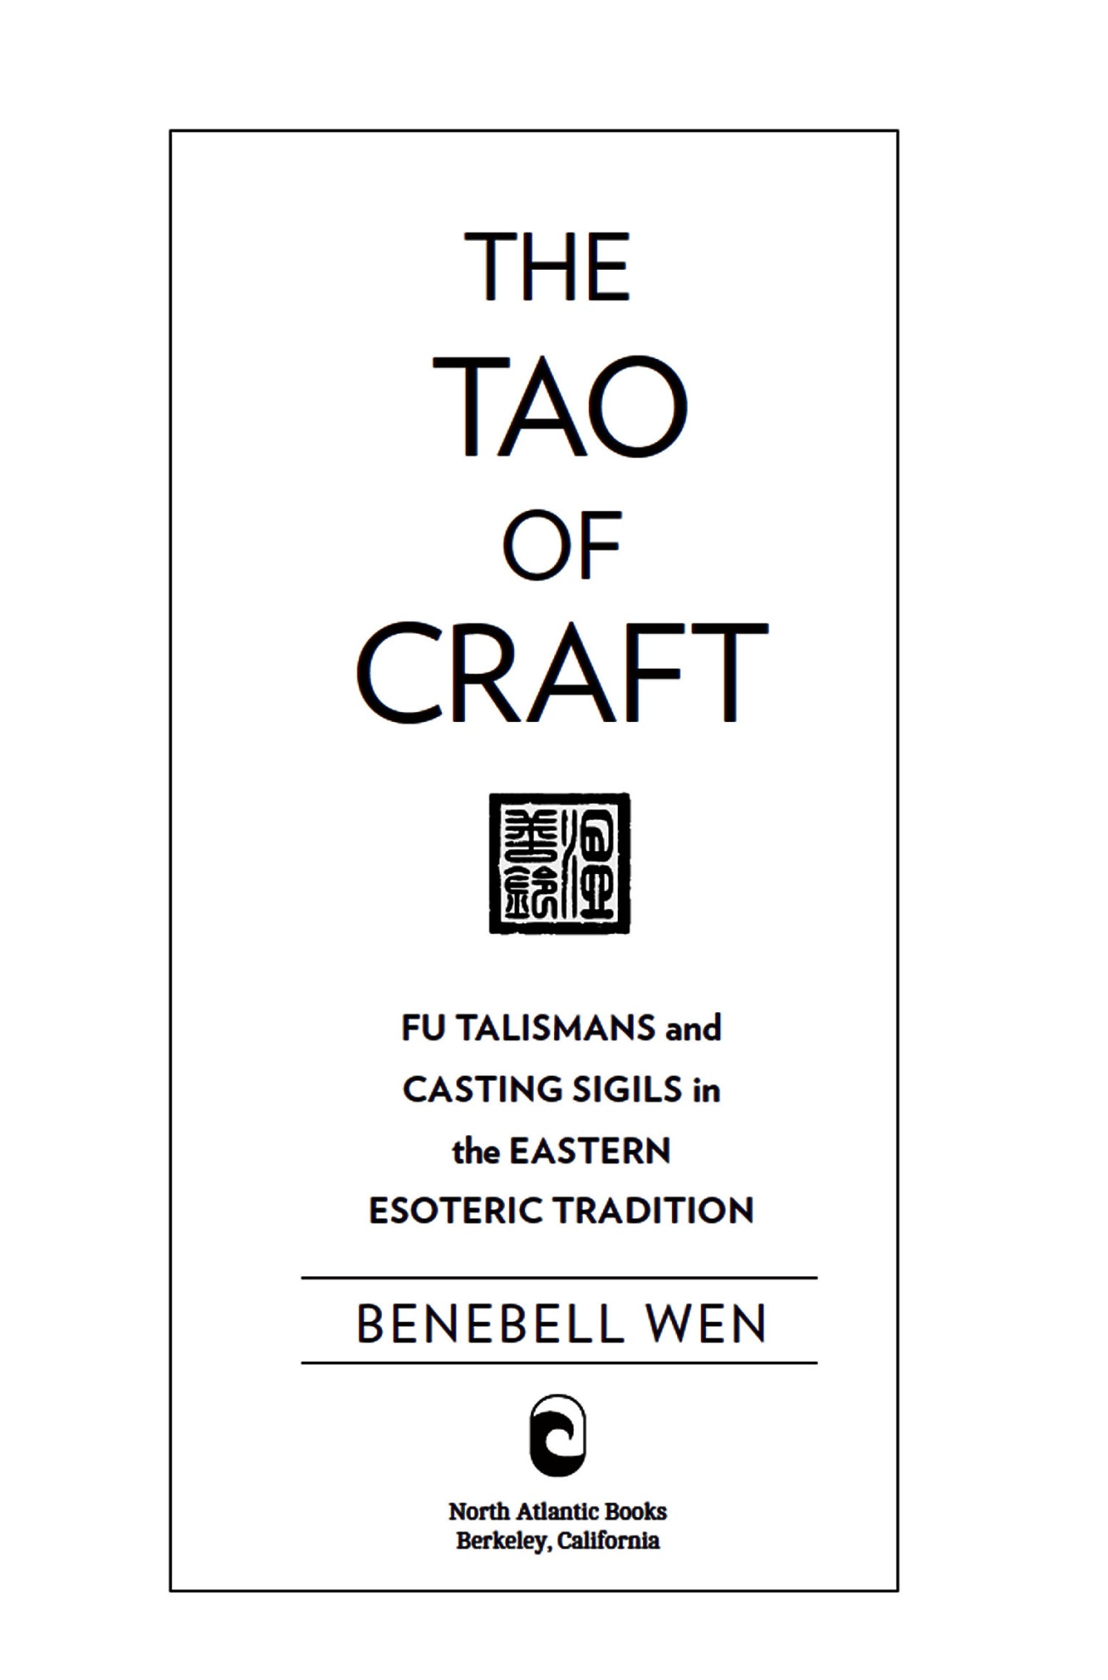
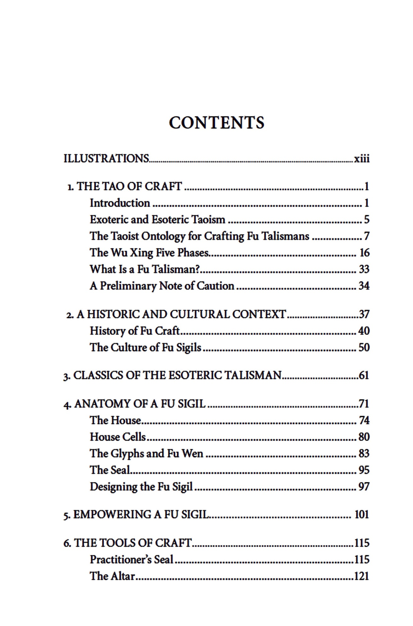
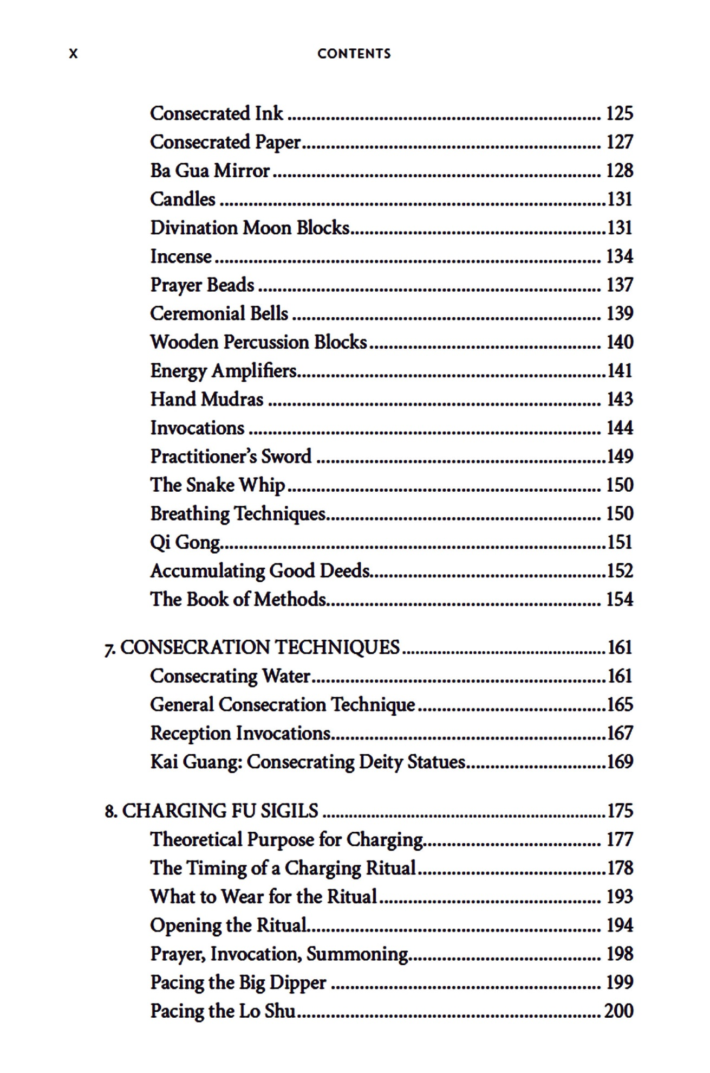
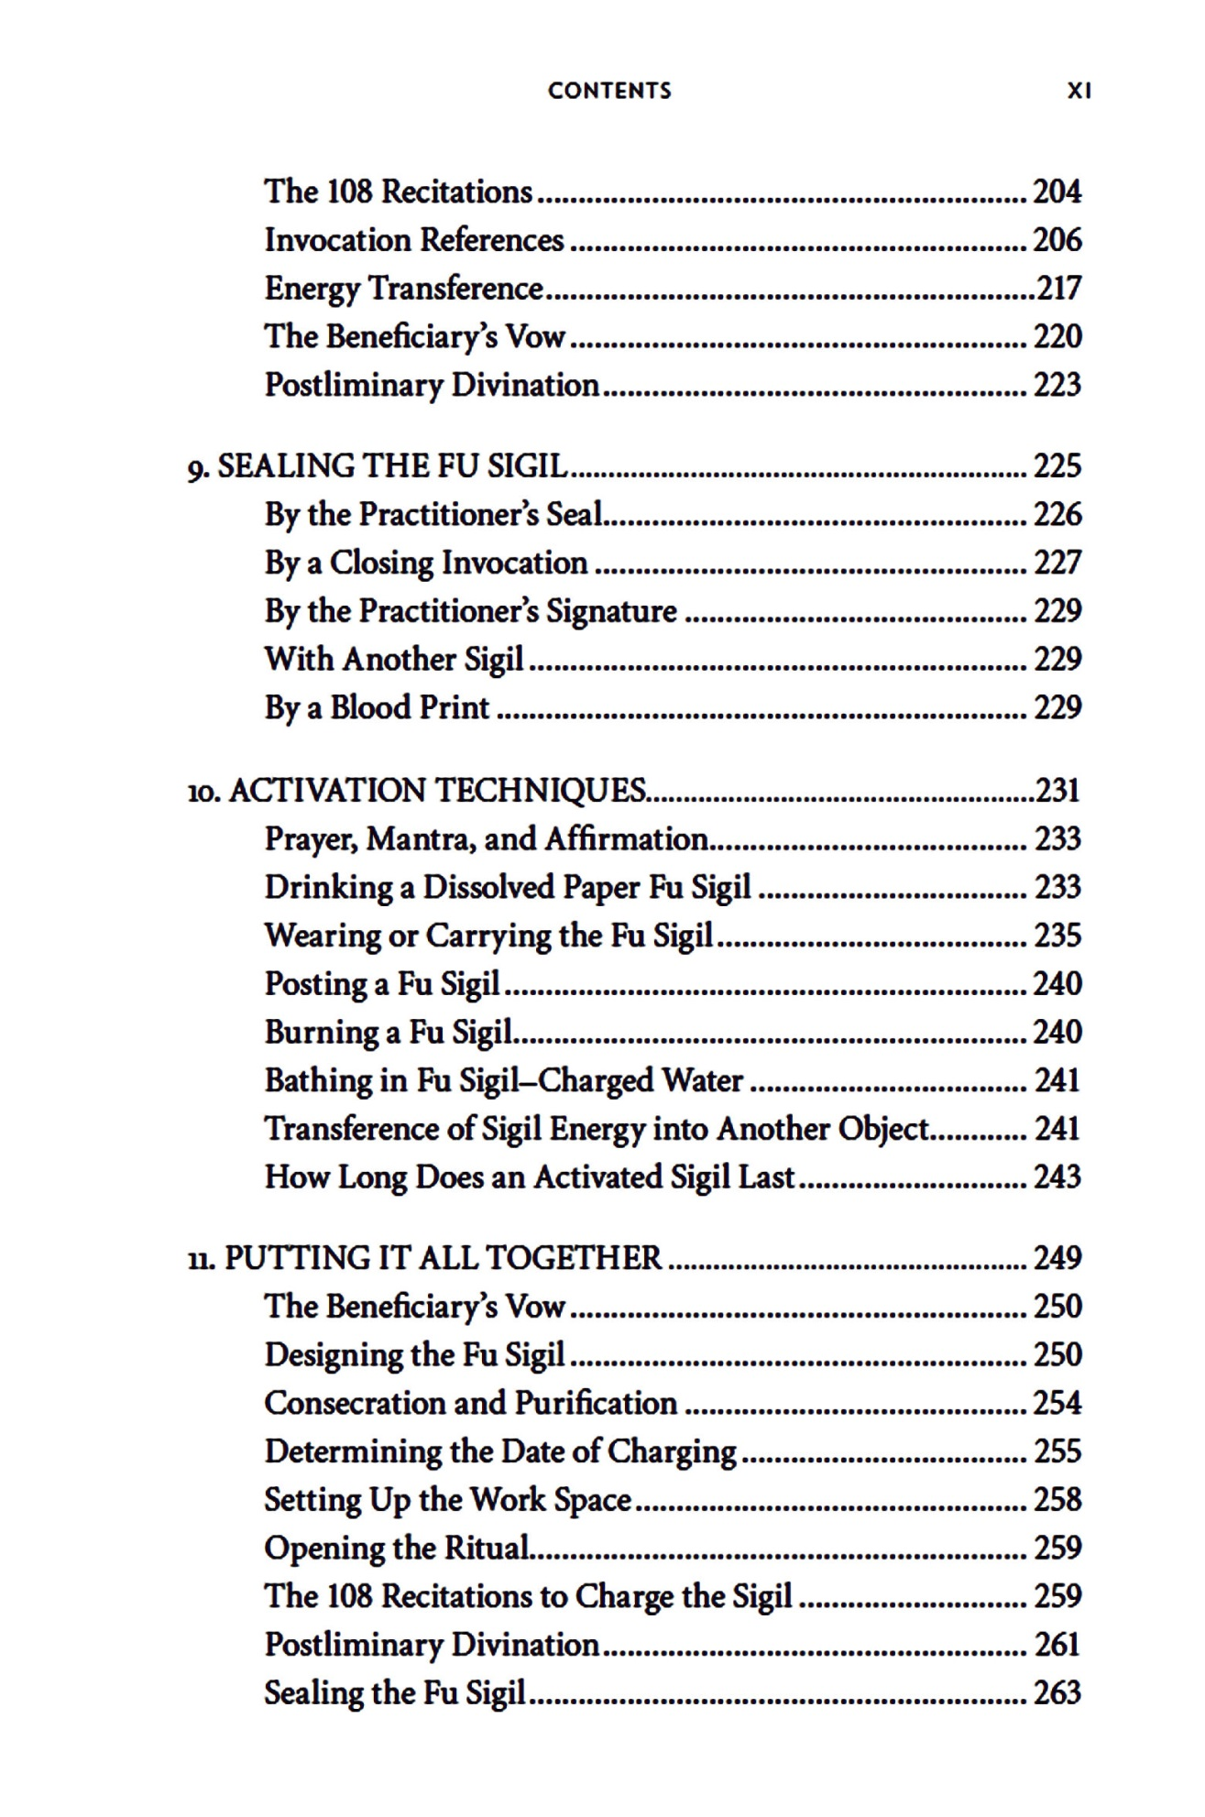
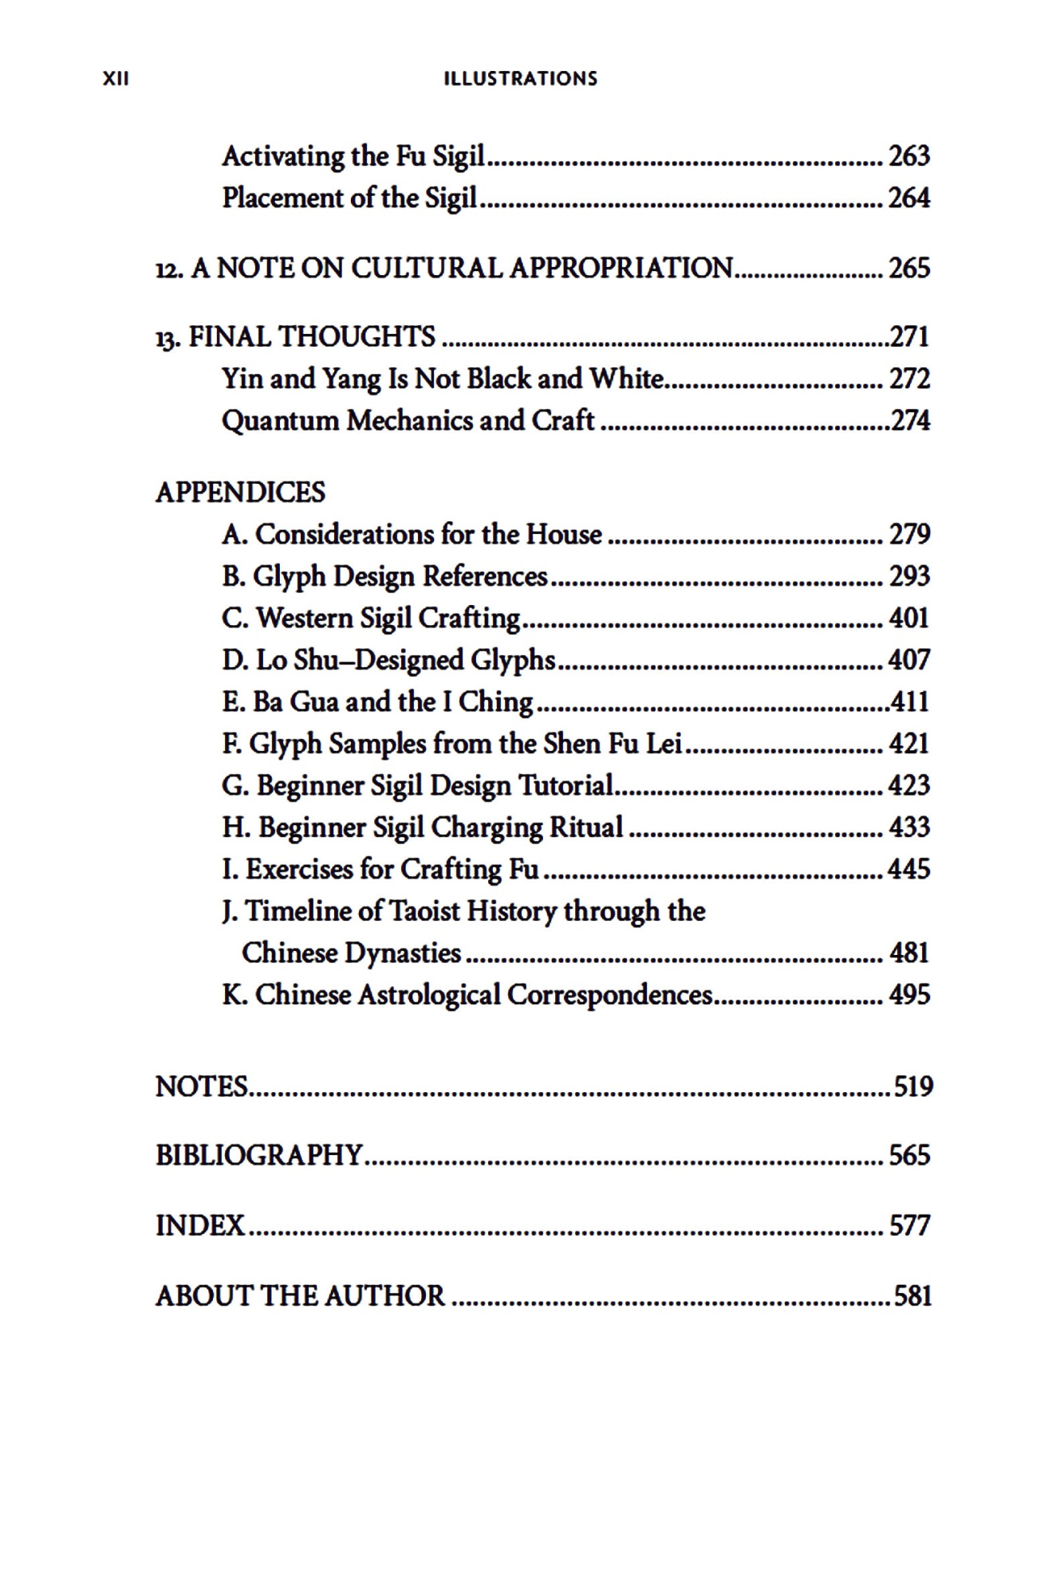

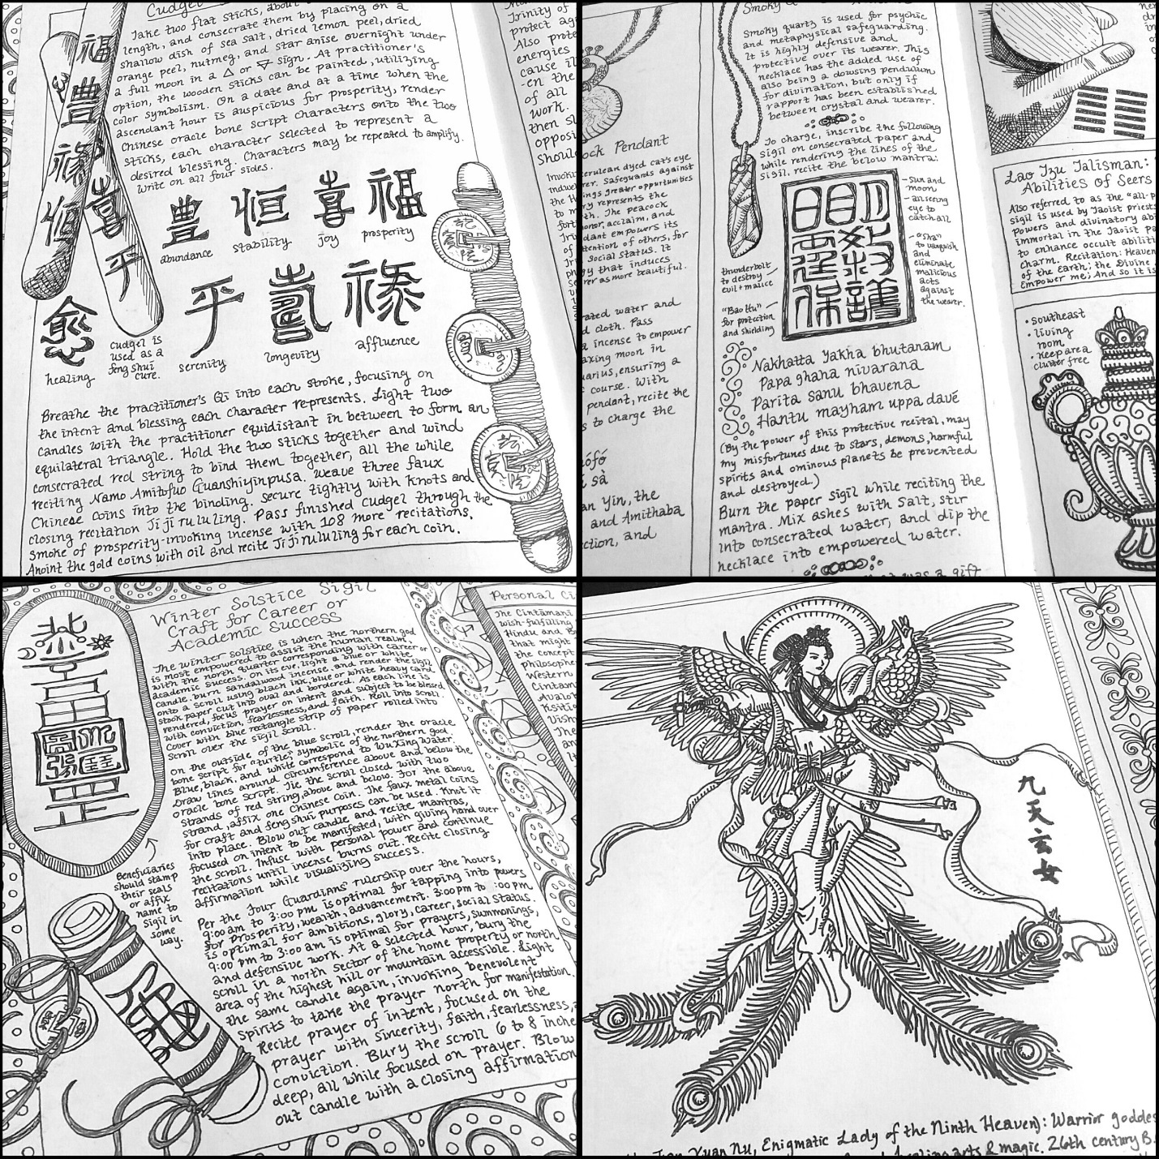

Glimpses into my personal Book of Methods, or grimoire

