

Publishing Nonfiction Books on Spirituality
benebell wen

Module 2

Completing Your Manuscript

Word Reference List

When writing a nonfiction book, especially one that will include an index, starting a word reference list will be immensely helpful not only to you, but to any future editors you work with on the publication of your book. A word reference list is a simple list of all keywords that you would want in an index. It will also show the style, capitalization, punctuation, etc. for all words, so that you remain consistent through your manuscript.

To use my first book Holistic Tarot as an example, I would have the following in my word list:

Ace of Wands
Antoine Court de Gébelin
Major Arcana
Minor Arcana
Pentacles (suit)
Ten of Pentacles
Swords (suit)
Three of Swords
tarot
Ten of Pentacles
Three of Swords
Three of Wands
Two of Wands
Wands (suit)
Ace of Wands
Two of Wands
Three of Wands

You’ll note that I had personally opted to not capitalize the word “tarot,” so in the word list, it would appear without capitalization so that I can refer back to the word list when in doubt and stay consistent. If, for example, a tarot author opted to use all lowercase for “Major Arcana,” then the word list would show “major arcana.” Writing a book on astrology is a great example. A running word list will keep you on track of whether you are opting to go with “House 1,” “House One,” or “house 1,” and whether it will be “Cardinal” or “cardinal” for you.

If you are using Microsoft Word on a PC, then you can automatically alphabetize your word list by highlighting the entire list, and then clicking the “Sort” option. See the screen shot below and the button circled in red over on the right.

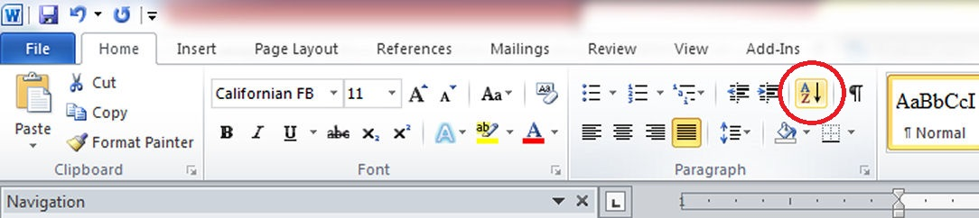

After hitting that button, there will be a prompt to set how you want to sort the text. See below.

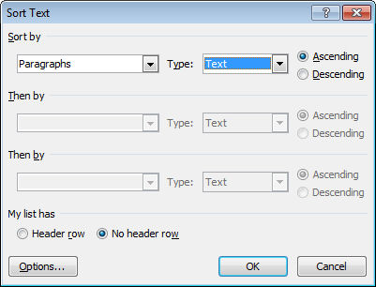

While writing Tao of Craft, my running word list at some point might have looked like this:

Bao Puzi
Bei Di (北帝)
Ben Ming Nian
Bu Dai
Celestial Master Zhang
Celestial Thunder Magic
datuk
Divine [n.]
dharani
Earth
earthly branch
Fang Shi (方士)
Fang Shu (方書)
fenghuang
feng shui
Five Celestials of Wealth
Five Emperors

You’ll note above that some keywords are italicized. That means every time that word appears in the manuscript, I should italicize it. Preserving style, capitalization, etc. exactly as it should be every time the word appears in text will make copyediting much easier later on down the road. In my word list for Tao of Craft, I included the Chinese equivalent next to the English.

The “[n.]” next to the word “Divine” is to indicate that the word is capitalized only when used as a noun. That is another consideration to include in your word list. In Holistic Tarot, for example, after the keyword “Judgement” I would include notation in brackets to reference the tarot card Key 20, and how “Judgement” is spelled on the card. E.g., Judgement [tarot card].

Your word reference list should definitely use any and all foreign words that appear in your book, and whether these words should appear in regular font or italicized, and note any applicable diacritical (or accent) marks.

Other examples include whether to use a hyphen. Will it be “e-mail” or “email” throughout your book?

A mistake I made while writing Holistic Tarot was not keeping a word list. Having no word list meant that sometimes I kept “tarot” all lowercase and other times I would absent-mindedly capitalize it as “Tarot.” It also meant sometimes, if I forgot the correct spelling of a notable figure’s name, I would end up wasting quite a bit of time hunting through old notes, papers, and a stack of books (or even trying to type in misspellings of the name into online search engines) to find the correct spelling. A word list will save you the trouble. It will also become a godsend when you go to work on your index, especially if you are self-publishing your book.

There is no specialized formatting for a word list. Just start a new document file and type in the keywords exactly as you want it to appear in your manuscript every time the word is referenced. On occasion, highlight the entire list and use the word processing function to automatically alphabetize the list. At some future point, if you work with a traditional publisher, your editor may ask if you have a style sheet. At that time, you can transform your word reference list into that requested style sheet.

If you prefer to keep a hard copy word list, or you’re not familiar with the “sort” function on your word editor, you can use the subsequent pages as a template for keeping your word list.

Not-related-to-nonfiction-but: For a fiction manuscript, your word list would include the spelling for character names, places, and in the case of fantasy, your made-up terminology.

WORD LIST
A | B
C | D
E | F
G | H
WORD LIST
I | J
K | L
M | N
P | H
WORD LIST
Q | R
S | T
U | V
W | X

WORD LIST
Y | Z

