

Publishing Nonfiction Books on Spirituality
benebell wen

Module 2

Completing Your Manuscript

The Logistics of Writing Your Book

Getting Started

After reading through this handout, start Module 2 by opening the file for Workbook C. Don’t start on it yet. Simply review it, page by page, noting the prompts. Skim and read per your interest. Then begin with the audio lecture “Does Word Count Matter?” and go from there. After completing the audio lecture “The First Sentence,” begin work on Workbook C. You can always go back and make revisions to Workbook C later, but for now, get something down and steer forward, to make progress.

As with Module 1 audio lectures, take notes while you listen to the audio files and incorporate those notes into your final binder of book notes. I’ve provided a template for note-taking under the Cornell Method, which is how I personally take notes.

Skim through Workbook D, a template for outlining each chapter of your book. In theory you’ll have multiple copies of Workbook D, one for each chapter of your book. For now, skim through it to get an idea of what outlining a chapter entails. Then continue with the audio lectures and listen to “Making Time to Write and Tracking Your Progress.” The “Getting Started” handout is a checklist that will help you organize the preliminary planning for your book.



About Forewords

Most works of nonfiction open with a Foreword, which is an introductory note about your book written by someone more famous than you. A Foreword is like an extended endorsement that seeks to make a case for why people should read your book, and usually, that endorsement comes from someone with established authority.

Finish writing your book before you start thinking too much about the Foreword. You’ll need a completed manuscript before querying for one anyway. After you have a complete manuscript, query your top choice author or expert. Pitch your book to that individual and explain why you have chosen to query that individual specifically. Do not send your manuscript right away. Ask for permission to send it and, only after you have been granted that permission, send your book files.

Big Name, capital B and capital N authors should be offered an honorarium, a token fee for their contribution. Another option is to wait until you are offered a publishing deal from a traditional publisher. Then during the negotiation phase of the contract, ask the publisher to help foot half the cost of an honorarium for Big Name author. Since it’s going to take about a year to get your book to print anyway, it won’t be too late to wait until you have a publishing deal to start work on the Foreword. At this stage, Workbook C only prompts you to think ahead about what you might want later down the road.

About Introductions or Prefaces

An Introduction or Preface is different from a Foreword. Generally it’s written by you, the author. Some books open with an Introduction, where you talk about how you came to write the book. It’s a chance to get personal and to draw a potential reader in and get them excited with a hook. A hook is designed to catch your target reader’s attention. It is a beckoning call to your target reader to read the rest of your book.

If you’re writing a reference or research-intensive book, then set out the full scope of your book in the introduction. Provide an outline of the book in that introductory chapter, like giving the reader a roadmap for where your book will be leading him or her. The Introduction or Preface is a preliminary chapter that sets your intention, explains the scope, and gives some interesting background information on how you came to write your book.

Your Introduction or Preface cannot simply be a summarized regurgitation of your book, or the contents of your book in short form. Rather, the chapter must present some content that does not appear anywhere else in the book that perhaps does not fit well anywhere else in your book.

There needs to be something personal, memoir-esque, and interesting about this preliminary chapter, otherwise skip it altogether and get straight to the point of your book. Readers tend to skip boring introductory chapters anyway, so there is no point in writing one unless you will be offering a hook and providing interesting, personalized insights.

Reviewing a Completed Chapter

After completing the first draft of any given chapter, read through it and ask yourself the following questions:

- What am I trying to say in this chapter?
- Have I said it?

What is the point of the chapter? Why are you including that chapter in your book? Identify for yourself what it is you are trying to say. Then review your draft to see whether you have actually made your point.

When reviewing a completed chapter, you’ll want to conduct an exercise called “Pulling Weeds.” Read each line of each chapter and spot adverbs (modifiers or qualifiers) to delete. Get rid of excess. Keep your writing clean. I am horrible at this. In retrospect, I did not do a good enough job pulling weeds in my first book, Holistic Tarot.

I was taught to begin chapter titles with a verb or noun, and to keep them as short, succinct phrases. I don’t always follow that rule myself, but it is a traditional writing rule you may want to keep in the back of your mind as you conceive your chapter titles.

Using Other People’s Work

When you use image files that are not created by you, that you don’t claim authorship over, you have to cite your source. If that image is copyrighted and not yet in the public domain, then you have to ask for permission before you can use it.

Module 2 provides a flow chart for determining whether a work is in the public domain. Whenever possible, stick to public domain works when incorporating images into your book. If the image is under copyright, then you’ll have to contact the author of that copyrighted image and ask for permission. Use the sample permissions query letters in one of the Module 2 handouts as a guide. Also check out the handout on fair use to guide you along the factors of consideration for determining whether your use of the work would be covered under fair use defense laws.

Back Up Your Files!

ALWAYS BACK UP YOUR FILES. Buy an external hard drive just for storing your book manuscript. To reduce confusion, date your file folders so you always know which folder contains the most recent version of your book files. On the same day each week that you log your word count progress, also back up all manuscript files in multiple locations, in a new file folder referenced by date of backup. Here’s an example of how I do it:

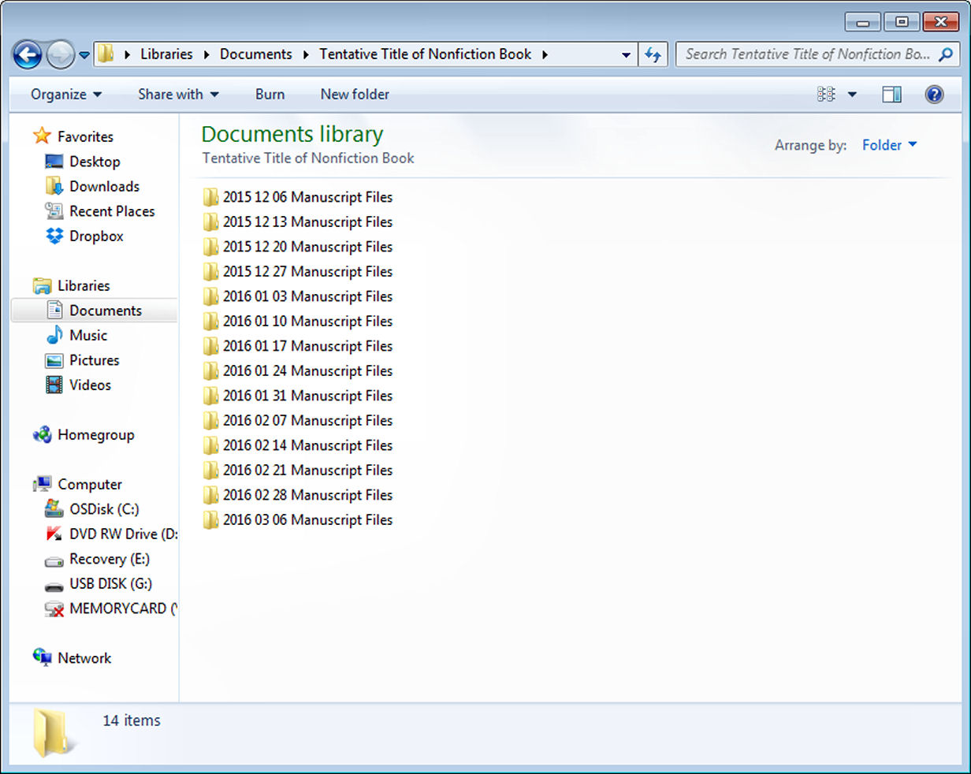

Let’s say I’ve finished writing a chapter, but later go back and make substantial revisions to the content of that chapter. I’ll save the original draft and in a new file folder, work on the revision of that chapter. That way in the event I flip flop and decide the old version is better, I still have it.

Routinely back up your book files. Losing months’ worth of writing because you were an idiot and didn’t back up your files is a very traumatic experience. Save yourself the trouble and always back up your files.

Next Step…

Skim through Workbook C, but don’t work on it yet. Then proceed with the order of audio lectures per the course outline.

