Major Arcana

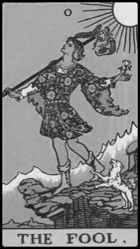 | 0 - Fool | 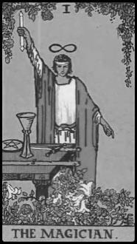 | 1 - Magician
 | Beginnings; Innocence  Clear Conscience |  | Power; Adroitness  Construction
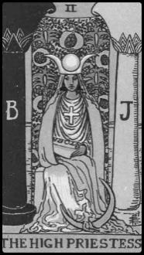 | 2 - High Priestess | 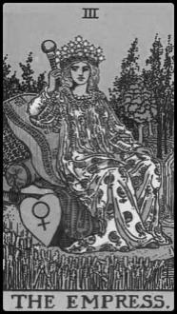 | 3 - Empress
 | Intuition; Clairvoyance  Premonition; Perceptivity |  | Fertility; Creativity  Maternity
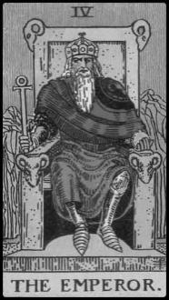 | 4 - Emperor |  | 5 - Hierophant
 | Authority; Government  Paternity |  | Tradition; Conventionalism  Institutionalism
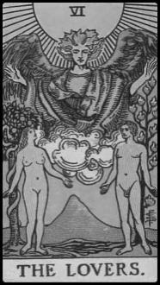 | 6 - Lovers | 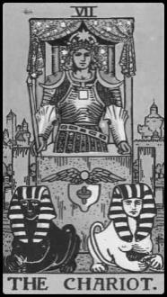 | 7 - Chariot
 | Passion; Partnership  The Primordial Choice |  | Victory; Control  Jurisdiction
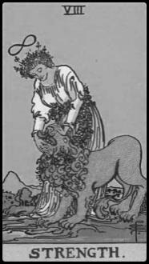 | 8 - Strength | 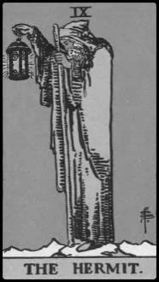 | 9 - Hermit
 | Compassion; Force  Fortitude; Security |  | Wisdom; Erudition  Mentorship
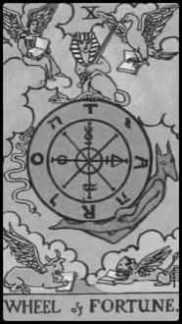 | 10 - Wheel of Fortune | 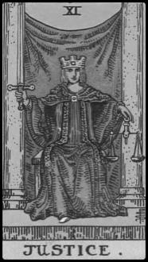 | 11 - Justice
 | Kismet; Destiny  Luck; Serendipity |  | Equilibrium; Equity  Fairness; Legality

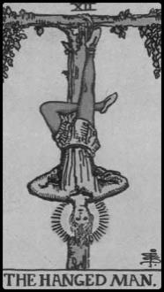 | 12 - Hanged Man | 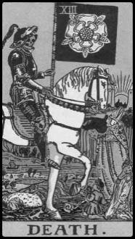 | 13 - Death
 | Self-Sacrifice; Suspension  Prophesy; Grace |  | Transformation  Mortality; Suffering
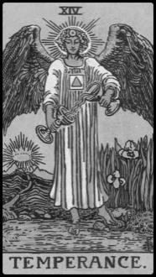 | 14 - Temperance | 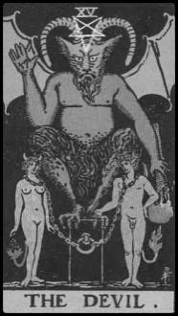 | 15 - Devil
 | Balance; Forbearance  Attune; Harmonize |  | Bondage; Temptation  Seduction
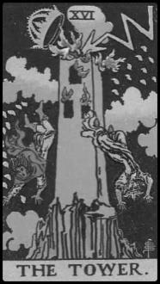 | 16 - Tower | 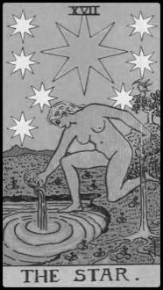 | 17 - Star
 | Hubris; Sudden Fall  Ego; Catastrophe |  | Hope; Optimism  Inspiration; Visionary
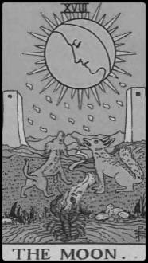 | 18 - Moon |  | 19 - Sun
 | Reflection; Changes  Imagination; Speculation |  | Attainment; Glory  Majesty; Celebrity; Eminence
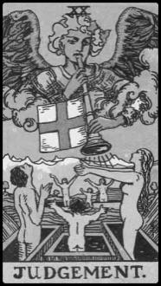 | 20 - Judgement |  | 21 - World
 | Awakening; Epiphany  Spiritual Realization |  | Fulfillment; Completion  Masterpiece; Consummation

Major Arcana, Reversed

 | 0 - Fool, Rev. |  | 1 - Magician, Rev.
 | Vanity; Foolishness  Indiscretion; Inanity |  | Destruction; Bane  Untapped Potential
 | 2 - High Priestess, Rev. |  | 3 - Empress, Rev.
 | Deceit; Duplicity  Hypocrisy; Secrets |  | Barren; Lacuna  Cavity; Omission
 | 4 - Emperor, Rev. |  | 5 - Hierophant, Rev.
 | Passivity; Overthrow  Coup d’état |  | Non-conformity; Unorthodox  Bohemian; Existentialist
 | 6 - Lovers, Rev. |  | 7 - Chariot, Rev.
 | Temptation; Interference  Discord; Moral Quandary |  | Riot; Turbulence  Wrong Direction
 | 8 - Strength, Rev. |  | 9 - Hermit, Rev.
 | Brute; Carnal  Physical; Obdurate |  | Ignorance; Immaturity  Petulant; Unreasonable
 | 10 - Wheel of Fortune, Rev. |  | 11 - Justice, Rev.
 | Flux; Unrest  Mischance; Misfortune |  | Prejudice; Bias  Chauvinism; Injustice

 | 12 - Hanged Man, Rev. |  | 13 - Death, Rev.
 | Selfishness  Martyrdom; Persecution |  | Conclusion; Cessation  Denouement; Windup
 | 14 - Temperance, Rev. |  | 15 - Devil, Rev.
 | Excess; Overflow |  | Defeat; Release  Severance
 | 16 - Tower, Rev. |  | 17 - Star, Rev.
 | Oppression; Cataclysm |  | Pessimism; Negativity  Maladies
 | 18 - Moon, Rev. |  | 19 - Sun, Rev.
 | Inconstancy; Risky  Confusion; Uncertainty |  | Disorientation  Quiescence
 | 20 - Judgement, Rev. |  | 21 - World, Rev.
 | Misinterpretation  Misreckoning |  | Hiatus; Agnosticism  Skeptic; Chagrin  Lacking Fulfillment

Minor Arcana, Wands

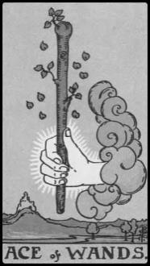 | Ace of Wands | 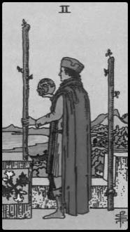 | Two of Wands
 | Venture; Opportunity |  | Accomplishment  Aspiration
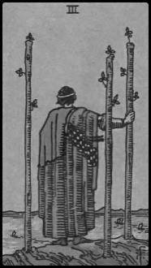 | Three of Wands | 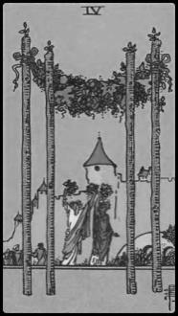 | Four of Wands
 | Validation; Effort  Productivity |  | Prosperity; Concord  Familial Bliss
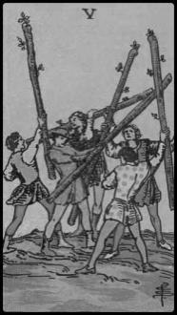 | Five of Wands | 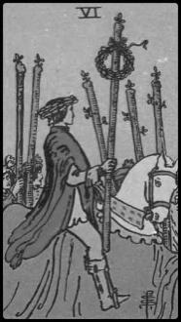 | Six of Wands
 | Competition; Rivalry  Contention |  | Success; Victory  Exalt; Tribute
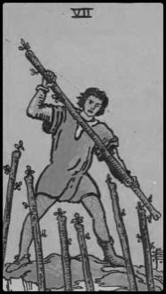 | Seven of Wands | 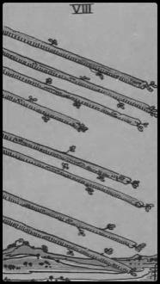 | Eight of Wands
 | Resistance; Opposition  Tenacity |  | Action; Vigor; Alacrity  Acceleration
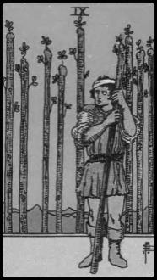 | Nine of Wands | 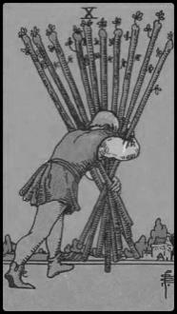 | Ten of Wands
 | Defensive; Protective |  | Burdened; Travail  Exhaustion; Labor
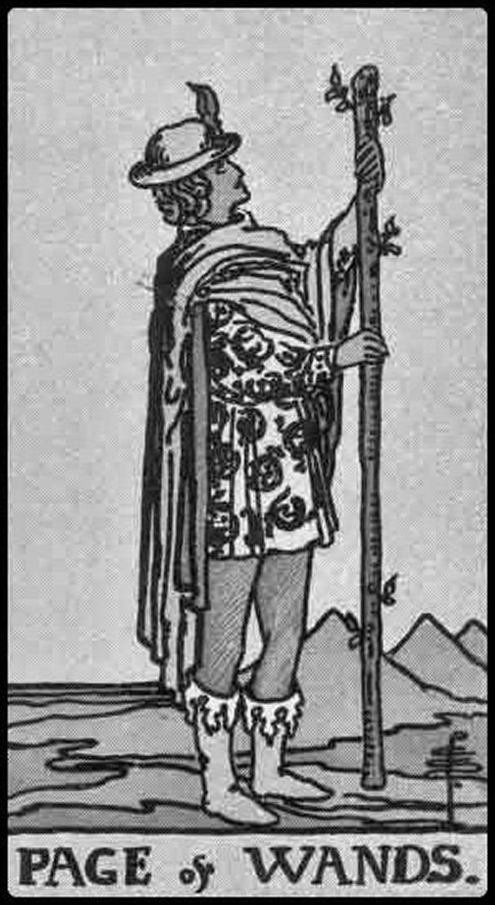 | Page of Wands | 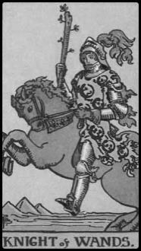 | Knight of Wands
 | Motivated; Energetic  Receipt of Project News |  | Impetuous; Competitive  Hot-Headed
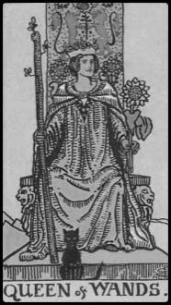 | Queen of Wands | 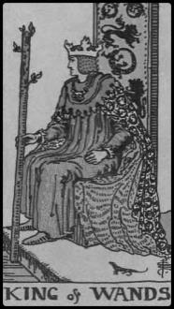 | King of Wands
 | Self-Assured; Naturalist  Down-to-Earth |  | Authoritarian; Demanding  Noble; Honest

Minor Arcana, Wands, Reversed

 | Ace of Wands, Rev. |  | Two of Wands, Rev.
 | Indolence  Procrastination |  | Impatience  Haste; Rush
 | Three of Wands, Rev. |  | Four of Wands, Rev.
 | Negligence; Careless  Setbacks; Mistakes |  | Attunement; Harmony  Rite of Passage
 | Five of Wands, Rev. |  | Six of Wands, Rev.
 | Opportunity; Reconciliation |  | Postponement  Pending Advancement
 | Seven of Wands, Rev. |  | Eight of Wands, Rev.
 | Indecision; Vulnerability  Lacking Confidence |  | Altercation  Regression; Rashness
 | Nine of Wands, Rev. |  | Ten of Wands, Rev.
 | Exhaustion; Battle  Depletion |  | Accountability  Reassessment
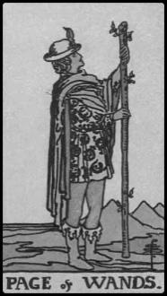 | Page of Wands, Rev. |  | Knight of Wands, Rev.
 | Passivity; Inarticulate |  | Insecurity; Hesitation
 | Queen of Wands, Rev. |  | King of Wands, Rev.
 | Capitulation; Yielding  Lacking Virtue |  | Tyranny; Despotic  Disciplinarian; Doctrinaire

Minor Arcana, Cups

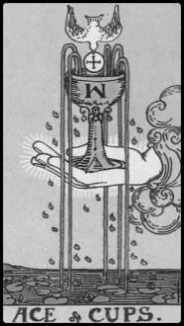 | Ace of Cups | 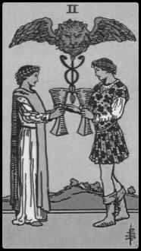 | Two of Cups
 | Abundance; Affirmation  Fountainhead |  | Friendship; Affinity  Cooperation
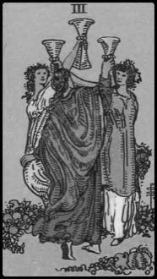 | Three of Cups | 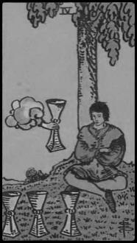 | Four of Cups
 | Celebration; Jubilee  Merriment |  | Introspection  Reflection; Contemplation
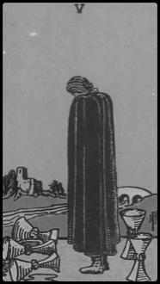 | Five of Cups | 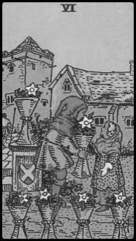 | Six of Cups
 | Loss; Mourning; Regrets |  | Nostalgia; Childhood  Reminiscence; Memories
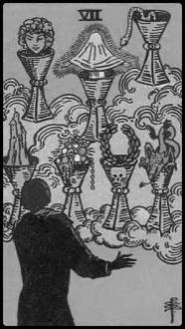 | Seven of Cups | 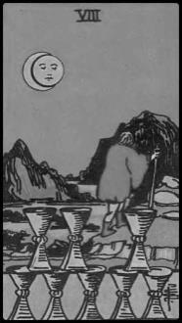 | Eight of Cups
 | Temptation; Superficiality  Enticement; Decoys |  | Abandonment; Detachment  Spiritual Journey
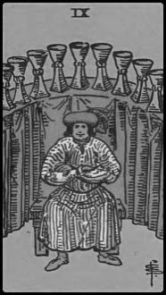 | Nine of Cups | 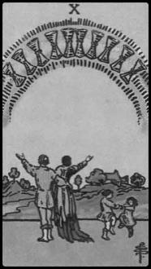 | Ten of Cups
 | Wishful; Wish Granted  Comfort; Material Success |  | Happiness; Joy; Felicity
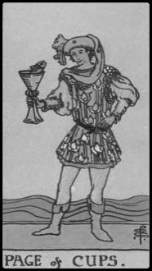 | Page of Cups | 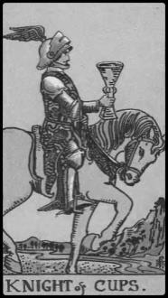 | Knight of Cups
 | Dreamer; Sensitive; Poetic  Receipt of Personal News |  | Charming; Affable  Equanimity
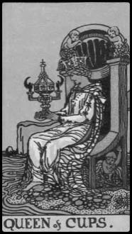 | Queen of Cups | 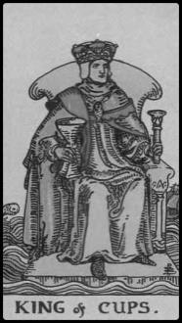 | King of Cups
 | Nurturing; Warm  Tender; Empathic |  | Diplomatic; Caring  Fatherhood

Minor Arcana, Cups, Reversed

 | Ace of Cups, Rev. |  | Two of Cups, Rev.
 | Superficiality  Rejection; Promiscuity |  | Imbalance; Quarreling  Misunderstandings
 | Three of Cups, Rev. |  | Four of Cups, Rev.
 | Hedonism; Indulgence  Sensualist |  | Regeneration; Emergence
 | Five of Cups, Rev. |  | Six of Cups, Rev.
 | Restoration; Acceptance |  | Clinging; Attachment; Puerility  Naiveté; Childishness
 | Seven of Cups, Rev. |  | Eight of Cups, Rev.
 | Determination  Decision; Purpose Revealed |  | Epicurean; Peripatetic  Drifting; Aimless
 | Nine of Cups, Rev. |  | Ten of Cups, Rev.
 | Overindulgence; Greed |  | Discord; Broken Family  Shattered Values
 | Page of Cups, Rev. |  | Knight of Cups, Rev.
 | Quixotic; Dreamer |  | Discouragement; Ennui  Unmotivated; Discomfiture
 | Queen of Cups, Rev. |  | King of Cups, Rev.
 | Manipulation; Jealousy |  | Overwrought; Distracted

Minor Arcana, Swords

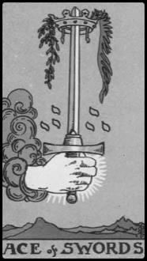 | Ace of Swords | 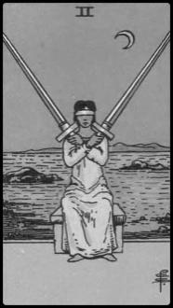 | Two of Swords
 | Conquest; Valiance |  | Stalemate; Catch-22  Difficult Choice
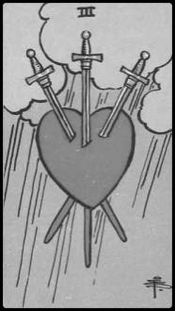 | Three of Swords | 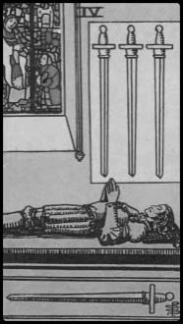 | Four of Swords
 | Strife; Loss  Heartbreak |  | Repose; Recovery  Illness
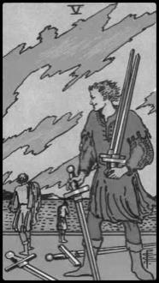 | Five of Swords | 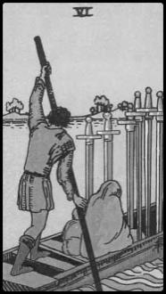 | Six of Swords
 | Corruption; Profiteering  Cunning; Machiavellian |  | Journey; Pilgrimage  Baggage
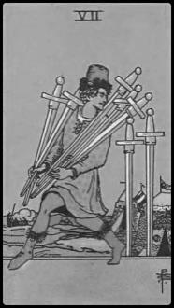 | Seven of Swords | 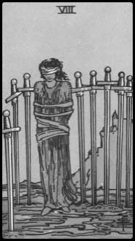 | Eight of Swords
 | Impulsiveness  Spontaneity; Deception |  | Imprisonment; Confinement  Captivity; Constraints
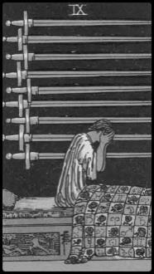 | Nine of Swords | 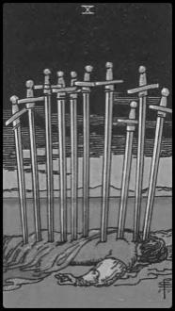 | Ten of Swords
 | Haunted; Grieving  Insomnia; Troubled |  | Retaliation; Reprisals  Revenge; Treachery
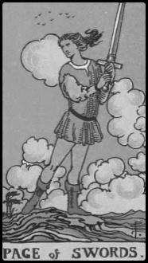 | Page of Swords | 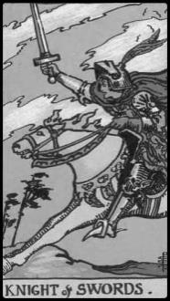 | Knight of Swords
 | Ambitions; Judicious  Communication |  | Aggressive; Charge  Warrior
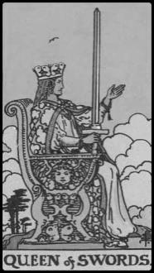 | Queen of Swords | 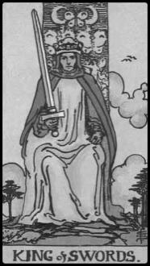 | King of Swords
 | Astute; High-Achieving  Executive; Striking |  | Intellectual; Analytical; Stern; Orderly

Minor Arcana, Swords, Reversed

 | Ace of Swords, Rev. |  | Two of Swords, Rev.
 | Disruption; Entropy; Chaos  Complications; Anarchy |  | Settlement; Decision  Arbitration
 | Three of Swords, Rev. |  | Four of Swords, Rev.
 | Disorder; Hurt |  | Caution; Social Unrest
 | Five of Swords, Rev. |  | Six of Swords, Rev.
 | Recompense; Contrition  Penance |  | Afflicted; Trapped  Yearning Escape
 | Seven of Swords, Rev. |  | Eight of Swords, Rev.
 | Reparation; Forfeiture  Requital |  | Emancipation  Release; Clemency
 | Nine of Swords, Rev. |  | Ten of Swords, Rev.
 | Recuperation  Healing; Infidelity |  | Endurance; Comeback
 | Page of Swords, Rev. |  | Knight of Swords, Rev.
 | Inhibition; Self-Conscious |  | Warpath  Aggression; Hostility
 | Queen of Swords, Rev. |  | King of Swords, Rev.
 | Spite; Snobbery  Elitism |  | Malice; Unyielding

Minor Arcana, Pentacles

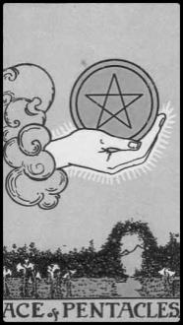 | Ace of Pentacles | 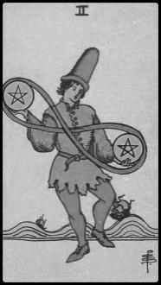 | Two of Pentacles
 | Offer; Investment  Small Financial Gain |  | Multitasking; Juggling  Prospects; Possibilities
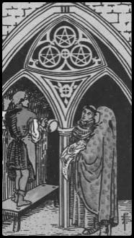 | Three of Pentacles | 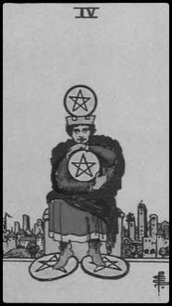 | Four of Pentacles
 | Endorsement; Recognition  Fraternity |  | Miser; Frugality
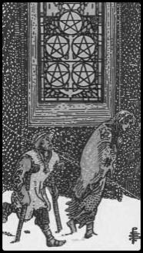 | Five of Pentacles | 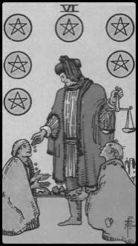 | Six of Pentacles
 | Destitution; Privation  Hardships |  | Charity; Benevolence  Alms; Philanthropy
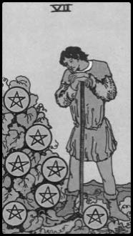 | Seven of Pentacles | 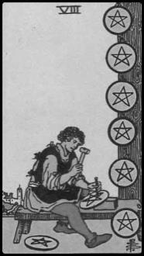 | Eight of Pentacles
 | Promotion; Harvest  Fiscal Responsibility |  | Aspiration; Apprenticeship  Natural Gifts in Craft
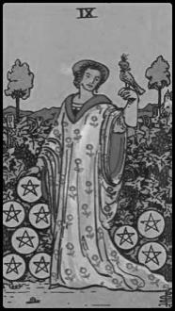 | Nine of Pentacles | 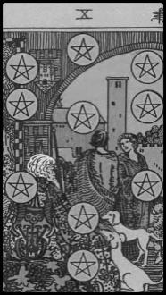 | Ten of Pentacles
 | Prosperity; Refinement  Independence |  | Stability; Prestige  Aristocracy; Urbanity
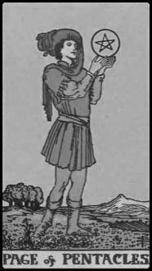 | Page of Pentacles | 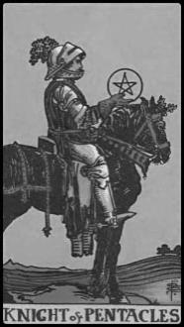 | Knight of Pentacles
 | Practical; Stylish; Scholarly  Receipt of Financial News |  | Methodical; Rational  Stable; Reliable
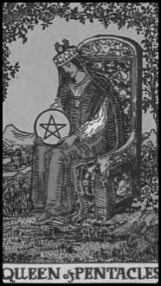 | Queen of Pentacles | 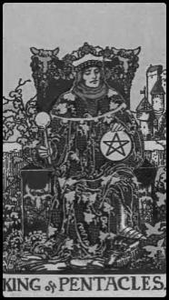 | King of Pentacles
 | Charitable; Noble  Opulence |  | Powerful; Enterprising  Established

Minor Arcana, Pentacles, Reversed

 | Ace of Pentacles, Rev. |  | Two of Pentacles, Rev.
 | Disillusionment  Financial Disappointment |  | Overwhelmed  Must Prioritize
 | Three of Pentacles, Rev. |  | Four of Pentacles, Rev.
 | Mediocrity  Displacement |  | Recession; Obstacles
 | Five of Pentacles, Rev. |  | Six of Pentacles, Rev.
 | Rehabilitation  Refurbish; Improvement |  | Ungracious; Indigence  Financial Hardship
 | Seven of Pentacles, Rev. |  | Eight of Pentacles, Rev.
 | Anxiety; Denial  Non-Confrontation |  | Squandering; Trifle; Idle
 | Nine of Pentacles, Rev. |  | Ten of Pentacles, Rev.
 | Dissatisfaction  Depression |  | Disengagement; Ostracism  Familial Disunion
 | Page of Pentacles, Rev. |  | Knight of Pentacles, Rev.
 | Materialism; Superficiality  Receipt of Financial News |  | Inertia; Timidity
 | Queen of Pentacles, Rev. |  | King of Pentacles, Rev.
 | Dependence; Indebtedness  Self-Preservation |  | Sophomoric; Stoic

